|  |  |
| --- | --- |
| |  | | --- | | **MINISTRY OF EDUCATION AND TRAINING** | |
| Capstone Project Document |
| Japanese Dictionary For Vietnamese |
|  |
| |  |  |  |  | | --- | --- | --- | --- | | 日本語辞書・チーム | | | | | **Group Members** | Lê Đình Nam | SE02316 | Namldse02316 | |  | Phạm Thị Minh | SE02300 | Minhptse02300 | |  | Phạm Tiến Đạt | SE02336 | Datptse02336 | |  | Nguyễn Ngọc Tuấn | SE02189 | Tuannnse02189 | | **Supervisor** | Mr. Nguyễn Văn Sang | Lecture at FPT University | | | **Ext Supervisor** |  | | | | **Capstone Project code** | **UJD_VN** | | | |
| **Hanoi, 15th August, 2014** |

# Table of contents

Table of contents 2

Table of figures 5

Definition and Acronyms 10

**1 Introduction 11**

1.1 Project information 11

1.2 Project members 11

1.2.1 Supervisors 11

1.2.2 Team members 11

1.3 Purposes 11

1.4 The existing system 12

1.4.1 Coffee price website 12

1.4.2 OTC Market Website 12

1.5 Our proposal 12

1.6 Product 13

1.6.1 Main Application 13

1.6.2 Administration application 13

**2 Software Project Management 14**

2.1 Project Overview 14

2.1.1 Project Description 14

2.1.2 Scope Statement 14

2.2 Project Organization 17

2.2.1 Organizational Structure 17

2.2.2 Software Process Model 19

2.3 Project Schedule 22

2.3.1 Milestone and Deliverables 22

2.3.2 Task Sheet 23

2.3.3 Meeting Minutes 23

2.4 Risk Management 26

2.4.1 Risk register 26

2.5 Communication Management 27

2.5.1 Communication between Team Members 27

2.5.2 Communication with the Supervisor 27

2.6 Tools and Infrastructure 27

2.6.1 Software 27

2.6.2 Hardware 28

2.6.3 Others infrastructures 28

2.7 Coding conventions 28

2.7.1 Naming conventions 28

2.7.2 Coding Style & Comment Style 29

**3 Software Requirement Specification 30**

3.1 SRS Overview 30

3.1.1 Purpose 30

3.1.2 Scope 30

3.2 User Requirements Specification 30

3.2.1 Business process 30

3.2.2 Product Features 31

3.3 System Requirements Specification 32

3.3.1 Interface Requirements 32

3.3.2 Functional Requirements 34

3.3.3 Screen Prototypes 64

3.3.4 Non-Functional Requirements 67

**4 Software Design Description 68**

4.1 SDD Overview 68

4.2 Architecture Design 68

4.2.1 System Overall Architecture 68

4.2.2 Software Architect 69

4.3 Class Design 71

4.4 Detail Design 73

4.4.1 User Interface Design 73

4.4.2 Object Transition 87

4.4.3 Model Design 100

4.5 Database design 129

**5 Software Source Code 130**

**6 Software Test Documentation 132**

6.1 Test Overview 132

6.1.1 Test Approach 132

6.1.2 Test Strategy 133

6.2 Test Plan 134

6.2.1 Feature to be tested 134

6.2.2 Feature not to be tested 136

6.2.3 Create test case plan 136

6.2.4 Execute test plan 136

6.2.5 Testing Environments 137

6.2.6 Resource 138

6.2.7 Test Milestones 138

6.3 Test Cases 140

6.3.1 Unit Test Cases 140

6.3.2 GUI Test Cases 144

6.3.3 Function Test Cases 144

6.3.4 Check List 159

6.4 Test Report 161

6.4.1 Defect Log 161

6.4.2 Test Report 165

**7 Software User Manual 166**

7.1 Installation Guide 166

7.1.1 Deployment website at Server side 166

7.1.2 Setting up the environment at Client side 176

7.1.3 Setup administration application 177

7.2 User Guide 180

7.2.1 Account management 181

7.2.2 Warehouse management 184

7.2.3 Trading floor 186

7.2.4 View news 192

Reference 194

# Table of figures

Figure 2‑1 Project organizational structure 17

Figure 2‑2 Rational Unified Process model 20

Figure 3‑1 Rice trading process 30

Figure 3‑2 The Main Application Use-case diagram 35

Figure 3‑3 Warehouse management Use-case diagram 41

Figure 3‑4 Work with posts Use-case diagram 45

Figure 3‑5 Posts processing Use-case diagram 47

Figure 3‑6 Order processing Use-case diagram 51

Figure 3‑7 Transaction processing Use-case diagram 54

Figure 3‑8 View news Use-case diagram 59

Figure 3‑9 The Administration Application Use-case diagram 63

Figure 3‑10 Home page screen prototype 65

Figure 4‑1 System Overall Architecture 68

Figure 4‑2 Layered architecture for RTF software system 69

Figure 4‑3 MAA analysis class diagrams 71

Figure 4‑4 MAA – Trading floor – Class diagram 72

Figure 4‑5 MAA screen flow 74

Figure 4‑6 Site Master screen design 75

Figure 4‑7 Home page screen design 76

Figure 4‑8 Registration page screen design 77

Figure 4‑9 Account page screen design 78

Figure 4‑10 Warehouse page screen design 79

Figure 4‑11 Transaction page screen design 80

Figure 4‑12 Post page screen design 81

Figure 4‑13 Order page screen design 82

Figure 4‑14 Post information page screen design 83

Figure 4‑15 Rice information page screen design 84

Figure 4‑16 Rice information detail page screen design 85

Figure 4‑17 Market news page screen design 85

Figure 4‑18 Market news detail page screen design 86

Figure 4‑19 Site Master Object transition diagram 87

Figure 4‑20 Home page Object transition diagram 88

Figure 4‑21 Registration page Object transition diagram 89

Figure 4‑22 Account page Object transition diagram 90

Figure 4‑23 Warehouse page Object transition diagram 91

Figure 4‑24 Transaction page Object transition diagram 93

Figure 4‑25 Post page Object transition diagram 94

Figure 4‑26 Order page Object transition diagram 95

Figure 4‑27 Post information page Object transition diagram 96

Figure 4‑28 Rice information page Object transition diagram 97

Figure 4‑29 Rice info detail page Object transition diagram 98

Figure 4‑30 Market news page Object transition diagram 98

Figure 4‑31 Market news detail page Object transition diagram 99

Figure 4‑32 RTF Table design diagram 129

Figure 5‑1 Sample of Source code (Home page) 130

Figure 5‑2 Sample of Log-4-net 131

Figure 6‑1 V-model 132

Table 1‑1 ドラえもん・team members 11

Table 2‑1 Project description 14

Table 2‑2 Main Application function list 15

Table 2‑3 Administration Application function list 16

Table 2‑4 Roles and Responsibilities 18

Table 2‑5 Milestone and Deliverables 22

Table 2‑6 Meeting Minutes 1 23

Table 2‑7 Risk register 26

Table 2‑8 Software needed for project 27

Table 3‑1 Main Application features 31

Table 3‑2 Administration Application features 32

Table 3‑3 Main Application Use-cases 34

Table 3‑4 Use-case UC-MAA-1-01 specification 36

Table 3‑5 Use-case UC-MAA-1-02 specification 37

Table 3‑6 Use-case UC-MAA-2-03 specification 38

Table 3‑7 Use-case UC-MAA-2-04 specification 39

Table 3‑8 Use-case UC-MAA-2-05 specification 40

Table 3‑9 Use-case UC-MAA-3-06 specification 42

Table 3‑10 Use-case UC-MAA-3-07 specification 43

Table 3‑11 Use-case UC-MAA-3-08 specification 44

Table 3‑12 Use-case UC-MAA-4-09 specification 45

Table 3‑13 Use-case UC-MAA-4-10 specification 46

Table 3‑14 Use-case UC-MAA-4-11 specification 47

Table 3‑15 Use-case UC-MAA-4-12 specification 48

Table 3‑16 Use-case UC-MAA-4-13 specification 50

Table 3‑17 Use-case UC-MAA-4-14 specification 51

Table 3‑18 Use-case UC-MAA-4-15 specification 52

Table 3‑19 Use-case UC-MAA-4-16 specification 53

Table 3‑20 Use-case UC-MAA-4-17 specification 55

Table 3‑21 Use-case UC-MAA-4-18 specification 56

Table 3‑22 Use-case UC-MAA-4-19 specification 57

Table 3‑23 Use-case UC-MAA-4-20 specification 58

Table 3‑24 Use-case UC-MAA-5-21 specification 59

Table 3‑25 Use-case UC-MAA-5-22 specification 60

Table 3‑26 Use-case UC-MAA-5-23 specification 61

Table 3‑27 Administration Application Use-cases 62

Table 3‑28 MAA screen list 64

Table 3‑29 ADA screen list 66

Table 4‑1 Site Master screen items 75

Table 4‑2 Home page screen items 76

Table 4‑3 Registration page screen items 77

Table 4‑4 Account page screen items 78

Table 4‑5 Warehouse page screen items 79

Table 4‑6 Transaction page screen items 80

Table 4‑7 Post page screen items 81

Table 4‑8 Post information page screen items 83

Table 4‑9 Rice information page screen items 84

Table 4‑10 Rice information detail page screen items 85

Table 4‑11 Market news page screen items 86

Table 4‑12 Market news detail page screen items 86

Table 4‑13 Site Master Object list 87

Table 4‑14 Home page Object list 88

Table 4‑15 Registration page Object list 89

Table 4‑16 Account page Object list 90

Table 4‑17 Warehouse page Object list 92

Table 4‑18 Transaction page Object list 93

Table 4‑19 Post page Object list 94

Table 4‑20 Order page Object list 95

Table 4‑21 Post information page Object list 96

Table 4‑22 Rice information page Object list 97

Table 4‑23 Rice info detail page Object list 98

Table 4‑24 Market news page Object list 98

Table 4‑25 Market news detail page Object list 99

Table 4‑26 Site master event list 100

Table 4‑27 On click LinkButton Login 100

Table 4‑28 Site master – BOL list 100

Table 4‑29 login action detail 101

Table 4‑30 Site master – DAL list 102

Table 4‑31 getAccInfo method detail 102

Table 4‑32 Home page event list 102

Table 4‑33 On click Button Search event detail 103

Table 4‑34 Home page – BOL list 104

Table 4‑35 searchPost action detail 105

Table 4‑36 Home page – DAL list 106

Table 4‑37 getPost method detail 107

Table 4‑38 Registration page event list 109

Table 4‑39 On click Button Register event detail 109

Table 4‑40 Registration page – BOL list 109

Table 4‑41 register action detail 110

Table 4‑42 Registration page – DAL list 110

Table 4‑43 insertAcc method detail 111

Table 4‑44 Account page event list 112

Table 4‑45 On click Button Save Edit event detail 112

Table 4‑46 Account page – BOL list 113

Table 4‑47 editAccount action detail 113

Table 4‑48 Account page – DAL list 114

Table 4‑49 updateAcc method detail 114

Table 4‑50 Warehouse page event list 115

Table 4‑51 On click Button Add event detail 115

Table 4‑52 Warehouse page – BOL list 115

Table 4‑53 addWhRice action detail 116

Table 4‑54 Warehouse page – DAL list 116

Table 4‑55 insertWhRice method detail 116

Table 4‑56 Transaction page event list 117

Table 4‑57 Transaction page – BOL list 117

Table 4‑58 Transaction page – DAL list 117

Table 4‑59 Post page event list 118

Table 4‑60 On click Button in dgvOrderBuyer event detail 118

Table 4‑61 Post page – BOL list 119

Table 4‑62 processTransaction action detail 119

Table 4‑63 Transaction page – DAL list 120

Table 4‑64 updatePost method detail 121

Table 4‑65 Order page event list 121

Table 4‑66 On click Button Cancel Order 121

Table 4‑67 Order page – BOL list 122

Table 4‑68 cancelOrder action detail 122

Table 4‑69 Order page – DAL list 123

Table 4‑70 deleteOrder method detail 123

Table 4‑71 Post information page event list 123

Table 4‑72 On click Button Order event detail 124

Table 4‑73 Post information page – BOL list 124

Table 4‑74 createOrder action detail 125

Table 4‑75 Post information page – DAL list 126

Table 4‑76 insertOrder method detail 127

Table 4‑77 Rice information page event list 128

Table 4‑78 Rice information page – BOL list 128

Table 4‑79 Rice information page – DAL list 128

Table 6‑1 Feature to be tested 134

Table 6‑2 Create test cases plan 136

Table 6‑3 Execute test plan 136

Table 6‑4 Software needed for testing 137

Table 6‑5 Resource and Responsibility in Test process 138

Table 6‑6 Test milestones 138

Table 6‑7 Unit Test Cases 140

Table 6‑8 Homepage Screen test cases 144

Table 6‑9 Post information Screen test cases 147

Table 6‑10 Check list 159

Table 6‑11 Bug list of Homepage Screen 161

Table 6‑12 Test report 165

# Definition and Acronyms

|  |  |  |
| --- | --- | --- |
| Acronym | Definition | Note |
| UJD_VN | Japanese Dictionary For Vietnamese |  |
| JP | Japanese |  |
| EN | English |  |
| VI | Vietnamese |  |
| PM | Project Manager |  |
| PTL | Project Technical Leader |  |
| QA | Quality Assurance |  |
| RUP | Rational Unified Process |  |
| PMP | Project Management Plan |  |
| SRS | Software Requirement Specification |  |
| SATD | Software Architecture Design | Design document, included in SDD |
| SDTD | Software Detail Design |
| SDD | Software Design Description |  |
| STD | Software Test Documentation |  |
| UT | Unit Test |  |
| IT | Integration Test |  |
| ST | System Test |  |
| AT | Acceptance Test |  |
| UC | Use-case |  |
| SC | Screen |  |
| UI | User Interface |  |
| GUI | Graphical User Interface |  |
| ERD | Entity-Relationship diagram |  |
| DB | Database |  |
| SUG | Software User Manual |  |

# Introduction

## Project information

* **Project Name:** Japanese Dictionary
* **Project Code:** UJD_VN
* **Project Type:** Web application
* **Duration:** From 12th May 2014 to 30th August 2014

## Project members

### Supervisors

|  |  |  |  |
| --- | --- | --- | --- |
| **Full name** | **Phone** | **E-Mail** | **Position** |
| Nguyễn Văn Sang | 0912210727 | sangnv@fpt.edu.vn | Supervisor |

### Team members

**Table 1‑1** 日本語辞書・team members

|  |  |  |  |  |
| --- | --- | --- | --- | --- |
| **Full name** | **Roll no.** | **Phone** | **E-mail** | **Position** |
| Lê Đình Nam | SE02316 | 01678 590905 | [Namldse02316@fpt.edu.vn](mailto:Namldse02316@fpt.edu.vn) | Leader |
| Phạm Thị Minh | SE02300 | 01677 690979 | [Minhptse02300@fpt.edu.vn](mailto:Minhptse02300@fpt.edu.vn) | Member |
| Phạm Tiến Đạt | SE02336 | 01667 404707 | [Datptse02336@fpt.edu.vn](mailto:Datptse02336@fpt.edu.vn) | Member |
| Nguyễn Ngọc Tuấn | SE02189 | 0976 218892 | [Tuannnse02189@fpt.edu.vn](mailto:Tuannnse02189@fpt.edu.vn) | Member |

## Purposes

This document is created as the introduction for project Useful Japanese Dictionary for Vietnamese – our Capstone Project at FPT University. In this document, we will descript the overview of some existing systems, the initial idea for our project, a brief description about our expected system and some potential risks, critical assumptions, constrains. Moreover, this document also shows opportunities what it offers for users.

## Abstract

In Viet Nam, Information Technology are strongly growing and Japan is the largest market. People who want to learn Japanese to work for Japan also increase more. Thus Japanese training center were opened very much. But not everyone can enough time to learn Japanese at training center. So website and application which can help people learn Japanese was created. By this way, people can learn online at their house with lower cost. Although website learn Japanese have lots but following survey of people who used website, they see some website have too much Kanji, other websites have too few examples for new word, or have to upgrade to use more, etc... It makes user dissatisfaction. With the aim of helping user learn Japanese easy and full way, the website is expected to sold this limit and add some other features to fit desiderate of user. Our website were created to solve this problem.

## The existing system

Japan is know that the country has information technology very development. And have a lot of software engineers want to work in Japan. So, website and application were created a lots to help them study Japanese. Moreover Japanese is used in Vietnam very much. However still have not website or application which really perfect to help user. For example: nhgo.net, lophoctiengnhat.com, romajidesu.com…

### Nhgo.net

Link: <http://nhgo.net/>

This website allows user search dictionary, kanji, grammar and post question. General, website is easy to use and search knowledge.

*Advantages:*

* Search with more option, it help user find expected result
* Kanji and grammar quite full
* Forum to post question, any member can comment to help each other

*Disadvantages:*

* Do not support search dictionary Viet – Nhat
* More words do not have mean with Vietnamese
* Example sentences do not have mean with Vietnamese
* Do not support listening, reading, conservation
* Support for JLPT not full

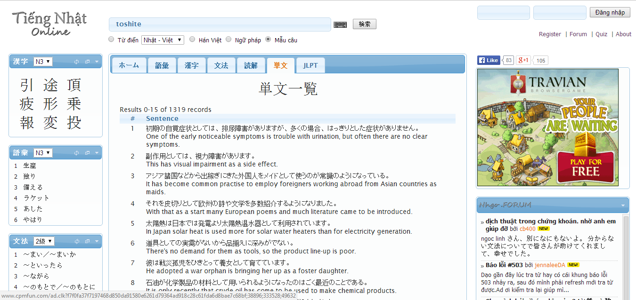

**Figure 1-1:** nhgo.net interface

Have a lot of words and example sentences do not mean with Vietnamese, it can make beginner hard to use or other users misunderstand. Website support very much option search but have not for Viet – Nhat, it will make user feel inconvenience.

### Lớp học tiếng Nhật

Link: http://lophoctiengnhat.com/

This website is not free, user have to log in to use resources, may be user have to upgrade account to study more. General, website help user learn JLPT with full listening, reading. It also support search.

*Advantages:*

* Support study JLPT full with level
* Support search

*Disadvantages:*

* User have to register, upgrade account
* Do not support more option for search, only search dictionary likes normal way

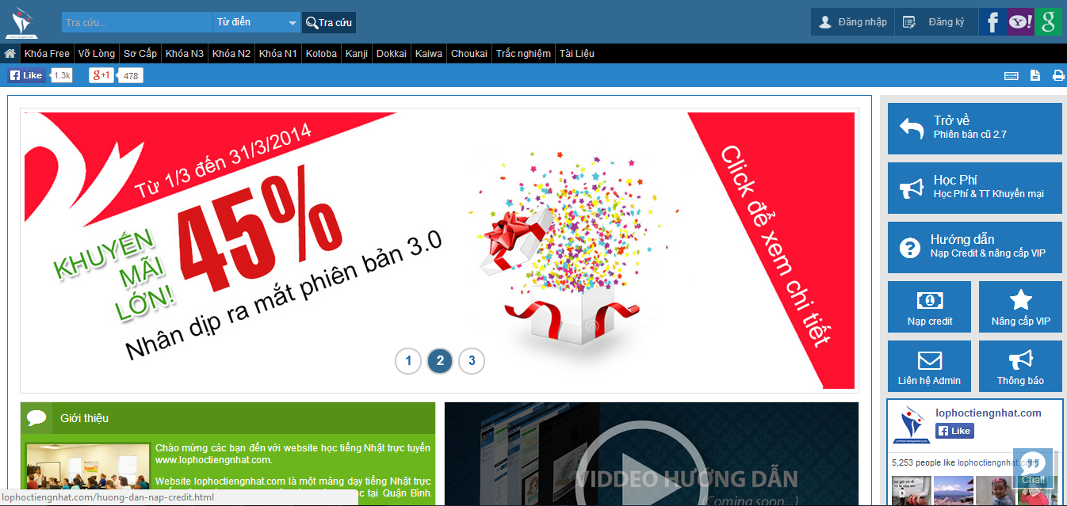

**Figure 1-2:** lophoctiengnhat.com interface

Because this is website of center, it will provide quite full document to user register and upgrade account to study. But if you do not register and upgrade, you can study more lesson. Moreover, search function is too simple, it can help user more while learning.

### RomajiDesu-Japanese dictionary and translator

Link: <http://www.romajidesu.com/>

In overview, this website have main function is search. Converting romaji to katakana or hiragana for beginner.

*Advantages:*

* Search kanji with more result and example sentences
* Search dictionary
* Search lookup with how to write kanji

*Disadvantages:*

* Do not support more language, only Japanese – English
* Result search by English
* Search do not have more option

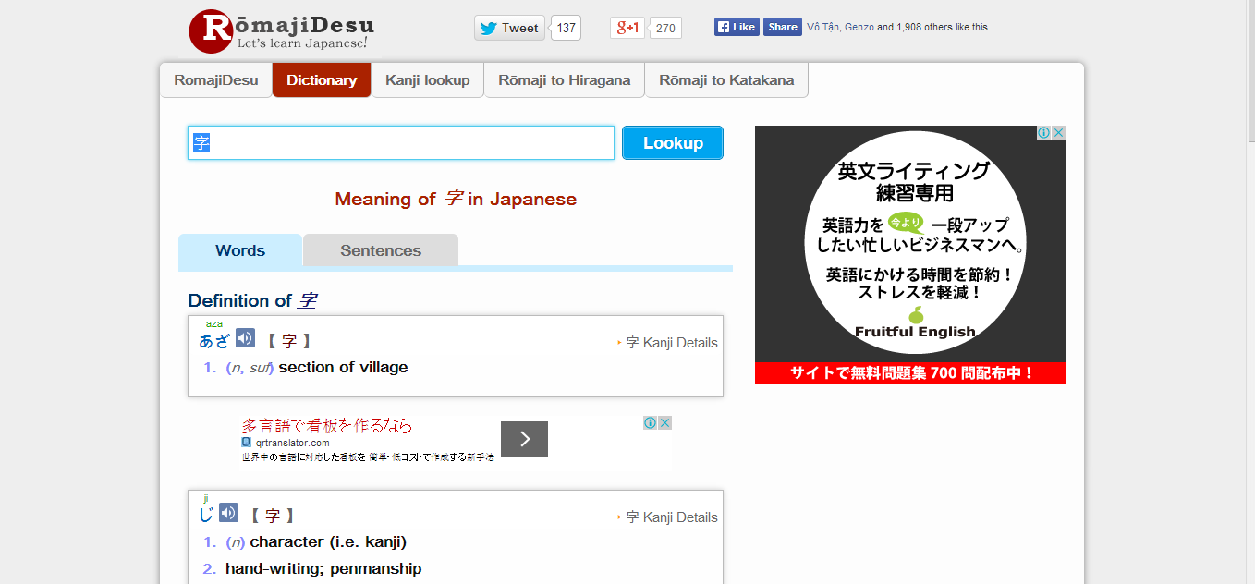

**Figure 1-3**: romajidesu.com interface

This website display by English, it is hard to user who do not know English, special beginner. Moreover it is not support test, JLPT. So users cannot study more such as listening, reading…

## Proposal

### The idea

Nowadays, there are many dictionaries which support Japanese. That can be a website or mobile application. All of them have been created for the purpose of helping users search vocabulary or studying Japanese more easily. But we found some disadvantages which existing in website which support users studying Japanese. So, our project – UJD_VN will include some main functions of existing dictionary website and add some special features such as showing examples by Vietnamese, supporting searching specialized vocabulary or users can contribute idea, good knowledge to make our database become larger. Moreover, we will provide freely website to users. Here, we toward provide website for Vietnamese who want to studying Japanese communication or who want to join Japanese certification exams.

### Objectives

This project is the Capstone Project in FPT University studying program. The first, this project is responsibility for all team member. So we must complete all requirements from teacher and FU. During the time doing project, we can learn how to develop a project, how to manage project, how to communicate better between team member, how to control time, how to perform teamwork effectively. Moreover, we also have experience about PHP, website design, test website… Therefore, we think this project is very necessary for us to improve skills, knowledge which we studied in FU. This project also make our CV more beautiful after graduating from FU. This is also an opportunity for us to prove capacity with recruiters.

The second, because we are in JS course. In studying’s progress, we realize some disadvantages of studying Japanese for Vietnamese. So we want to help users, especially Vietnamese users, to improve capacity Japanese of them, help them can communicate better with Japanese. The highlights of us are interface friendly, useful functions. Specially, website display completely in Vietnamese, so users can use functions easily, even though they do not know English.

### Brief description about system

This software is a web application. With friendly and simple interface, users can easily find out what they want without registration. This web help users to better understand about vocabulary, grammar, kanji, display the appropriate vocabulary and provide the other vocabulary have same meaning. Therefore, users can reference to make the best choice for themselves. It also help users review about skill reading, writing, speaking, listening. In addition, with a lot of exercise and small test, users can accurately assess their own capacity. And user also can send opinion to admin if there is anything that needs to be modified.

UJD uses familiar technologies as: JavaScript, PHP… It is support operating systems such as windows and current browsers as Firefox 20, Chrome 25 or above.

### System features

About the features of UJD, we focus to provide for users main features as searching, doing test, listening conversation, reading document, contributing good opinions. Moreover, admin can manage members, manage database, manage contribute database and manage Q & A. In here, we focus on features which can help users can understand the best way what user want to have with features of UJD. There are the detailed features of UJD:

* **Search**: User can search vocabulary and UJD will display example sentences or conversation, grammar or Japanese video which include vocabulary which user searched. With searching features, user can understand visually, apply easily in communication, and how to use vocabulary in the situations. This is very new point and useful of UJD when compare with other website which also provide user to study Japanese now. User have the following searching option:
* Searching with example sentences: user search a vocabulary and UJD display example sentences which include these vocabulary.
* Searching with conversation: user search a vocabulary and UJD display example conversation which include these vocabulary.
* Searching with grammar: user can search grammar of N2, N3, N4, N5. UJD will explain these grammar and give to user example about these grammar.
* Searching Japanese video: user can search Japanese video.
* Searching specialized Japanese: user can search specialized Japanese in many fields as IT, economic, mechanical, traffic, financial …
* **Contributing opinion**: User can contribute opinion about UJD website or contribute database as good sentences, good conversation, good video by using contributing feature. Admin of UJD will approve correctness and add to database. This is feature which will help us make a larger database for system.
* **Listening conversation**: User can improve ability listening by listening available conversation on UJD. Listening database of us is very diversity from everyday conversations, common conversational to conversations in a realistic situation. Especially, we provide conversations from elementary to intermediate for user can train to join Japanese certification exams.
* **Reading document**: User can find available Japanese document in UJD as elementary grammar, intermediate grammar, list kanji, readings, Minnano Nihongo lesson.
* **Doing test**: User can do tests at N2, N3, N4, N5 level. Then UJD will scored for user. This is an important feature of UJD. We want to help users toward Japanese certification exams.
* **Login/Logout**: User can login to use more features of UJD. User can register an account to login or login by using Facebook, Google account.
* **Changing password/Forgetting password**: User can change new password or require new password if user forgot current password.
* **Managing account**: Registered user can add, edit information or track mark.
* **Managing member**: Admin can view list members, ban or unban member, delete member.
* **Managing contribute database**: Admin can approve opinion of member or delete opinion.
* **Managing Q & A**: Admin can view, reply, delete Q & A.
* **Managing Data**: Admin can add, update, delete data of UJD.

## Benefit From Project

### For our group

After developing and implementing this project, our group will get some benefits:

● We have more experiences of managing a software project: how to manage plan, time, member and risk.

● Have more knowledge and skill about PHP programming

● Know how to communicate with team members and how to teamwork more effective

● Have more knowledge in Japan and improve Japanese proficiency

● If this application is developed, we will get a good mark in Capstone Project. It makes our grade better.

### For Community

Just need to have a device that connect to the internet and any web browser, user can:

● Easy search for vocabulary, specialized vocabulary, kanji

● Practice the skills: listening, reading, writing, speaking Japanese

● Review the grammar, vocabulary, kanji

● Do exam test N5, N4, N3, N2 and check point

● Users do not need to pay money for using. It is completely free for all users.

## Critical Assumption and Constraints

We realize some critical assumption after analyzing this project. The first, that is about our team. We assumed that all developer can train PHP in a short time. Before starting this project, nobody in our team have knowledge about PHP, but with programming techniques which we studied at FU, we have to try the best to not missing any deadline in project plan. Besides that, we also assumed that all member in team have a good healthy to do their tasks.

We also have some constraints in progress. The first, about the time and deadline, we must complete task on time. We do not have more time for us to complete developing and deliver application to teachers. Besides, we have to submit report documents before deadline to teacher can review. The second, that is about the quality. Our website must be run well when users perform main functions in Google Chrome, Firefox. Finally, we have problem about techniques. We is not in the high level in PHP. So, with the expected functions which we gave, we will try the best to complete our project successfully.

## Potential Risk

After studying about this project, we find out some problem that we may be encountered:

●It is the first time we manage a project like this , we have no experience in exchange information, managing and controlling work so we may be miss the deadline or out of scope

●We have not much knowledge in the framework and technique of PHP and web. Therefore, we have to study all of them from the beginning. This work takes a lot of times. The project team may face with the difficult technical problems that may requires long time to resolve so that causes the project be delayed.

●Knowledge of Japanese is extremely large, we have difficulty in providing sufficient information that users need to understand

●With the short duration - about 15 weeks - we cannot success to all functions and miss the deadline.

● In addition, we also have difficulty in using some tools such as Microsoft Project, Sublime Text, My SQL, Source code managing… Therefore, our work management may be not good.

● Sometime, because of careless, team members can lose data, source code… before uploading to server

# Software Project Management

## Project Overview

### Project Description

**Table 2‑1** Project description

|  |  |  |  |  |
| --- | --- | --- | --- | --- |
| **Project name:** | **Japanese Dictionary For Vietnamese** | | | |
| **Project Code:** | **UJD_VN** | | | |
| **Project manager:** | **Lê Đình Nam** | | | |
| **Project category:** | **🗹 New development** | | **🞎 Maintenance** | **🞎 Other** |
| **Application Type:** | **Website** | | | |
| **Business domain:** | **Education** | | | |
| **Project start date:** 12/05/2014 | | **Expected end date:** 30/08/2014 | | |
| **Planned duration:** | **81 days** | | | |

### Purposes of Project

This project is a capstone project of our group at FPT University. However we want to create a website not only we can pass capstone project but also we want it really useful for user. In study Japanese process we use Japanese website and see that have a lots inadequacy. So, our website is created with purpose to help user study Japanese by a fast and full way and it is absolute free. During 3 months of capstone project, we hope that all member can get more knowledge about processing of software development, skill do document, coding, testing. Moreover, soft skill also very important, we can get skill management time, working in group, skill communication… It is not long time for project but our group hope that can do this project successfully.

### Scope Statement

The scope of this project contains: Requirement Analysis, Design, Coding and Testing (Unit Test, Integration Test, System Test).

|  |  |  |  |
| --- | --- | --- | --- |
| **Use Case No.** | **Group of functions** | **Functions** | **Glossary** |
| **UJD_VN GUEST/MEMBER MODULE** | | | |
| **Common Module** | | | |
|  | Search | Search sentences | Search for example sentences |
|  | Search conversation | Search for conversations |
|  | Search grammar | Search for grammar |
|  | Search video | Search for video of Japanese |
|  | Search specialized Japanese | Search for Japanese specialized |
| **Account Management Module** | | | |
|  | Login | Login by Facebook account | Sign in with your Facebook account |
| Login by registered account | Sign in with you register account |
|  |  | Logout | Logout |
|  |  | Register | Register account for customers to use more features of the website |
|  |  | Edit Profile | Edit user’s profile |
|  |  | Forgot Password | Forgot password |
| **Contact Admin Module** | | | |
|  | Contact Admin | Contribute content | Contribute useful database for website |
|  | Contribute opinion | Feedback for website development |
|  | Send Q & A | Send any questions in the process of using Website |
| **Practice Management** | | | |
|  | Doing Test | Test | Doing test |
| Tracking mark | Tracking the learning process |
|  |  | Training Listening | Training listening level N2,N3,N4 |
|  |  | Listening conversation | Listening conversation |
|  |  | Reading Document | Reading document |
| **UJD_VN ADMIN MODULE** | | | |
|  | Admin’s account management | Add new admin | Add new admin |
|  | Edit profile | Edit admin’s profile |
|  | Delete admin | Delete admin |
|  | Management Member’s account | Search member | Search member |
|  | Ban/Unban Member’s account | Ban/Unban member’ account |
|  | Delete member | Delete member |
|  | Vocabulary Management | Search vocabulary | Search vocabulary |
|  | Add vocabulary | Add new vocabulary |
|  | Edit vocabulary | Edit vocabulary |
|  | Delete vocabulary | Delete vocabulary |
|  | Grammar Management | Search grammar | Search grammar |
|  | Add Grammar | Add Grammar |
|  | Edit grammar | Edit grammar |
|  | Delete Grammar | Delete Grammar |
|  | Reading Document Management | Search reading document | Search reading document |
|  | Add reading document | Add new reading document |
|  | Edit reading document | Edit reading document |
|  | Delete reading document | Delete reading document |
|  | Conversation management | Search conversation | Search conversation |
|  | Add conversation | Add new conversation |
|  | Edit conversation | Edit conversation |
|  | Delete conversation | Delete conversation |
|  | Video Management | Search Video | Search video by title |
|  | Add Video | Add new video |
|  | Edit Video | Edit video |
|  | Delete Video | Delete video |
|  | Listening Article Management | Search listening article | Search listening article |
|  | Add listening article | Add listening article |
|  | Edit listening article | Edit listening article |
|  | Delete listening article | Delete listening article |
|  | Doing test management | Search test | Search test |
|  | Add test | Add test |
|  | Edit test | Edit test |
|  | Delete test | Delete test |
| **Contact’s Content Management** | | | |
|  | Contributed content management | Search contribute content | Search contribute content |
| Approve content | Approve content |
| Reply user | Reply user |
| Delete content | Delete content |
|  | Contributed opinion management | Search contribute opinion | Search contribute opinion |
| Reply user | Reply user |
| Delete opinion | Delete opinion |
|  | Q & A Management | Search Q & A | Search Q & A |
| Reply Q & A | Reply Q & A |
| Delete Q & A | Delete Q & A |

## Project Organization

### Organizational Structure

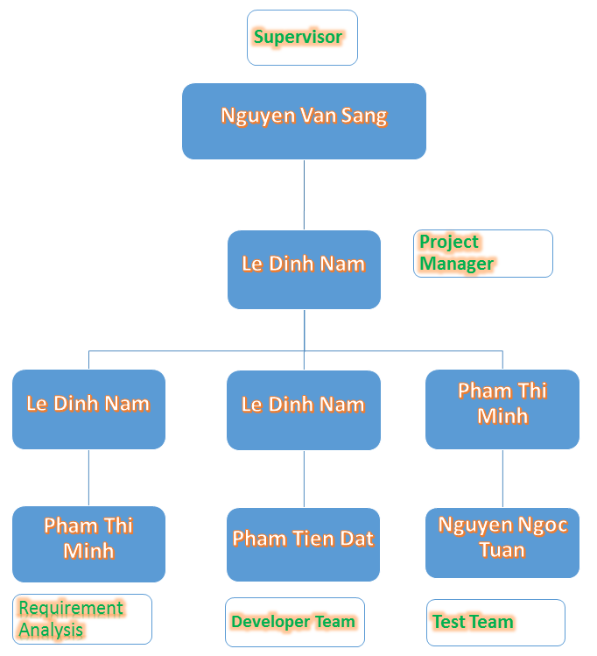

Figure ‑ Project organizational structure

**Table 2‑4** Roles and Responsibilities

|  |  |  |
| --- | --- | --- |
| Full name | Roles in project | Responsibilities |
| Nguyễn Trung Dũng | Project manager | Develop project plan  Manage project stakeholders, project team and resolve conflicts  Manage project schedule, project risk  Communication with members and supervisor, include weekly plan, weekly status report, hold meetings and assure to submit reports to supervisor on schedule.  Manage data synchronization in project |
| Requirement analysis | Create and co-operate with members to develop: SRS and SDD  Create document format standards and coding conventions. |
| Architect designer |
| Detail designer |
| Developer | Provide tools for project development process  Co-operate with members to coding and fix bug (auxiliary) |
| Quality assurance | Ensure that the project is completed on schedule and within scope  Review all documents, reports and assure product quality |
| Lại Minh Hiền | Requirement analysis | Co-operate with members to develop SRS  Co-operate with members to develop GUI for website |
| GUI designer |
| Developer | Co-operate with members to coding (auxiliary) |
| Tester | Execute test to ensure all functions fulfil requirements  Review all documents and reports. Translation, and check language grammar and spelling (on English) |
| Language translation | Translate to Japanese |
| Nguyễn Hữu Đạt | Requirement analysis leader | Conduct overall business process |
| Co-operate with members to develop SRS |
| Detail designer | Co-operate with members to develop SDD |
| Developer | Provide suitable technology solutions  Co-operate with members to coding and fix bug (main) |
| Lê Thị Ngọc Ánh | Requirement analysis | Co-operate with members to develop SRS |
| Test leader | Develop the test plan based on project plan, SRS and Design documents  Delegate testing tasks to testers and manage the rate of progress  Create test data for all functions  Write test report |
| Tester | Create test cases for the system, both in document and script  Execute test to ensure all functions fulfil requirements |
| Tô Mạnh Tân | Technical leader | Conduct research and demo function that related to the project  Configure coding environment  Create database base on Design document |
| Database designer | Perform database analysis and design |
| Developer | Provide suitable technology solutions  Co-operate with members to coding and fix bug (main) |

### Project Process

#### Fsoft Process Model



The software lifecycle is broken into *cycles*, each cycle working on a new generation of the product. The Fsoft process divides one development cycle in six consecutive *phases*:

* Initiation phase
* Definition phase
* Solution phase
* Construction phase
* Transition
* Termination

#### Project Life Cycle

Basing on Fsoft process and real-world project, we decided to divide the project into 4 phases: Initiation, Solution, Construction, Termination:

**- Initiation Phase:** This is the explanatory phase of the project. Project objective and description is described at this stage. The purpose of this phase is to collect and understand business requirements, detail the project plan and agree upon a high level statement of work. Our primary objectives are complete project identification and project plan. After these are completed, the project is checked against the following criteria:

* + Identify business functions of the system
  + Determining the scope, conditions and limitations of the project
  + List the main functions of the system
  + List one or more suitable architecture for the system
  + Identify project risks
  + Complete Report #1, and Report #2

**- Solution Phase:**

* + In this phase, the architecture of the system is designed. The goal is to translate requirements and specification into a technical solution to produce Technical Design. Our primary objectives are complete requirement specification, architecture design and database design.
  + Finally, the plan must provide (including estimates of cost and time) for the construction phase. The plan must ensure proper and accurate based on experience.
  + Complete Report #3 and Report #4

**- Construction Phase:**

* + This is the longest phase of a project life cycle.
  + In this phase, all functions of the system will be installed. The installation will be divided into small stages, each stage of the installation a few functions. The results of each phase will be the release of the module function can be executed.
  + Construction and improvement of products until the final product is ready to deliver to the user. During this phase, all the components and other features of the application is developed and integrated into the product.
  + This phase emphasizes the resource management and control operations to optimize cost, time and quality.
  + Complete software packages and Report #5, Report #6

**- Termination Phase:**

* + This is the final phase in the life cycle of a project.
  + Their products will be deployed to the client. The feedback received during the transfer process will be recorded and put on the new functional requirements or functionality enhancements in the next version of the product.
  + Phase transfer switch also includes the training system and the new system for the user.

## Project Schedule

The Effort estimation is documented in the table below.

|  |  |  |  |  |  |
| --- | --- | --- | --- | --- | --- |
|  | Initiation | Solution | Construction | Termination | Total |
| Effort(person/day) | 72.5 | 104 | 89.5 | 34 | 300 |
| Total % budgeted Effort Usage (%) | 100 | 100 | 100 | 100 |  |

### Milestone and Deliverables

**Table 2‑5** Milestone and Deliverables

| No | Stage | Committed Delivery date | Description of Deliverable | Delivery media |
| --- | --- | --- | --- | --- |
| Initiation | |  | Requirements agreed, Report 1 reviewed | |
| 1 | Develop project idea | 12-05-2014 | Project goals and scope defined, milestone description defined, resource committed |  |
| 2 | Q&A Management Sheet | 13-05-2014 | Criteria: Documentation reviewed |  |
| 3 | Submit report no.1 final | 20-5-2014 | Completed report no.1 |  |
| 4 | Project Plan | 28-05-2014 | Criteria: Documentation reviewed |  |
| 5 | Submit report no.2 final | 30-05-2014 | Completed report no.2 |  |
| Solution | |  |  | |
| 1 | Screen Prototype | 10-06-2014 | Criteria: Documentation reviewed |  |
| 2 | Architecture Design | 12-6-2014 | Criteria: Documentation reviewed |  |
| 3 | Screen Design | 10-06-2014 | Criteria: Documentation reviewed |  |
| 4 | Class Design | 11-06-2014 | Criteria: Documentation reviewed |  |
| 5 | Detail Data Design | 11-6-2014 | Criteria: Documentation reviewed |  |
| 6 | SRS | 20-06-2014 | Criteria: Documentation reviewed |  |
| 7 | Submit Report no.3 Final | 20-06-2014 | Completed report no.3 |  |
| 8 | Submit Test Plan Final | 23-06-2014 | Criteria: Documentation reviewed |  |
| 9 | Create Unit Test Case | 28-06-2014 | Criteria: Documentation reviewed |  |
| 10 | Submit Report no.4 Final | 30-06-2014 | Completed report no.4 |  |
| Construction | |  | Product developed & tested and released to supervisor, documentation reviewed. | |
| 1 | Review Test Document | 09-07-2014 | Criteria: Documentation reviewed |  |
| 2 | Submit report no.5 Final | 16-07-2014 | Completed report no.5 |  |
| 3 | Complete Coding and Unit Test | 24-07-2014 | Source code  Acceptance criteria: Product unit tested |  |
| 4 | Complete Testing | 31-07-2014 | Completed Test |  |
| 5 | Submit report no.6 Final | 11-08-2014 | Completed report no.6 |  |
| 6 | Submit the last document and CD source code | 21-08-2014 | Final Documents and Source Code |  |
| Termination | |  | Project post-mortem is conducted, Project assets archived and released to supervisor | |
| 1 | Lesson learned | 22-8-2014 | Criteria: Completed |  |
| 2 | Complete Presentation Slide | 28-8-2014 | Criteria: Completed |  |
| 3 | Represent capstone project | 30-08-2014 | Criteria: Completed |  |
| 4 | Project Complete | 30-8-2014 | Criteria: Completed |  |

### Gantt chart

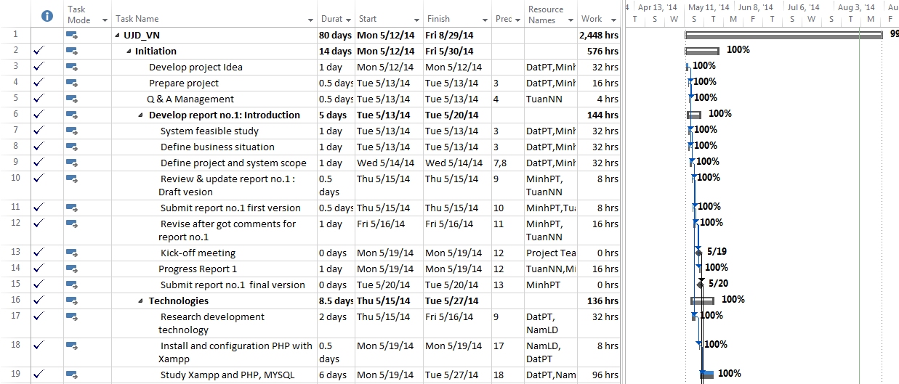

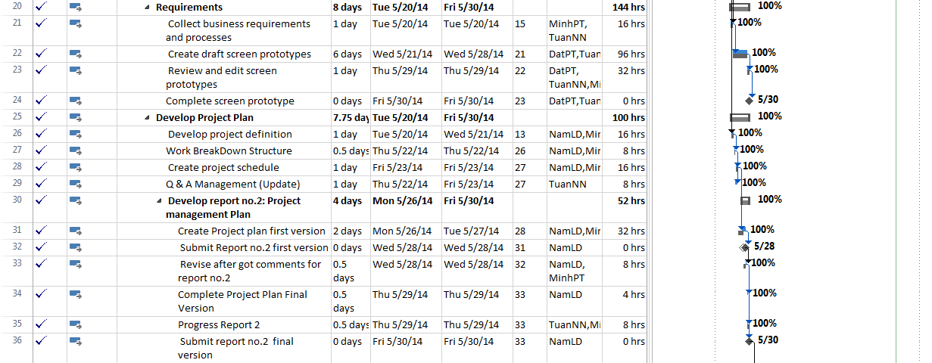

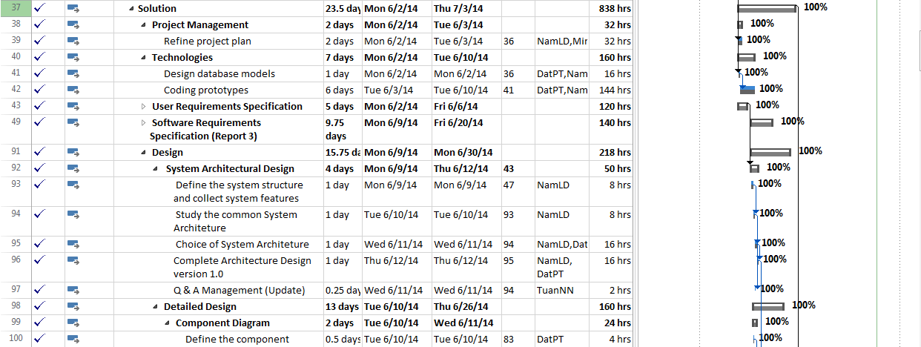

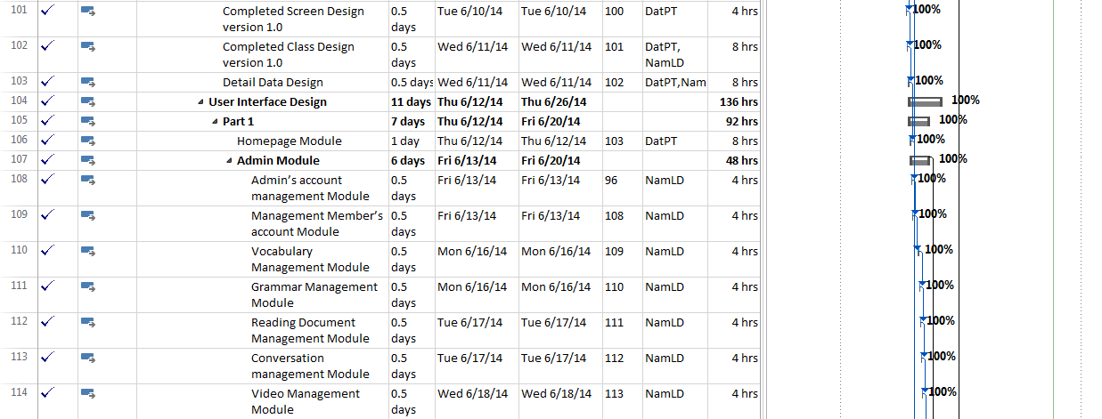

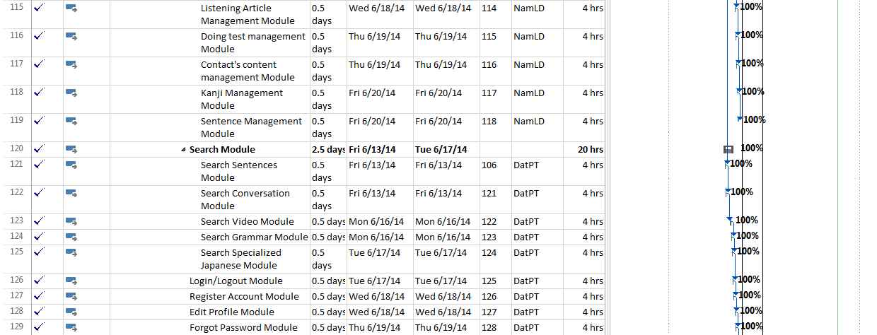

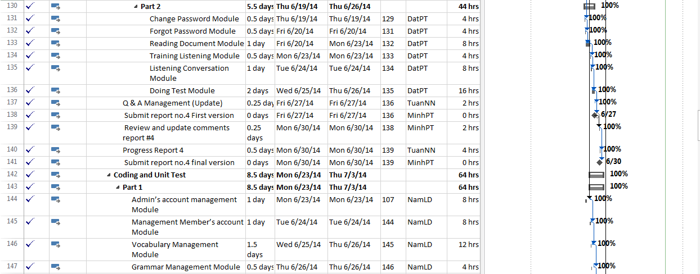

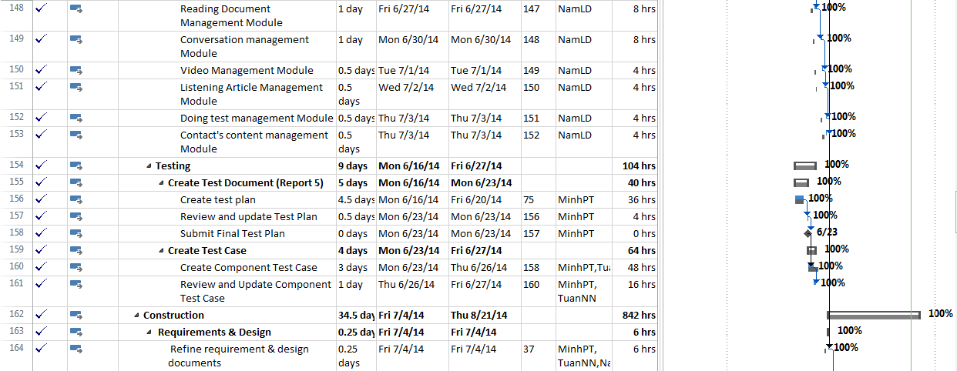

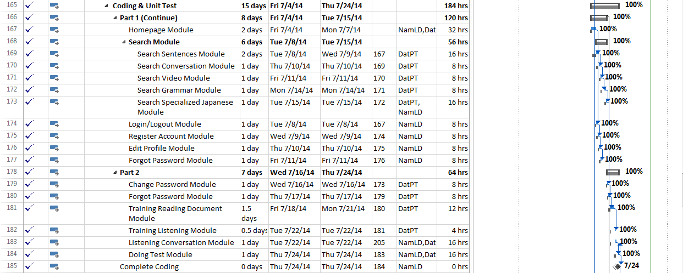

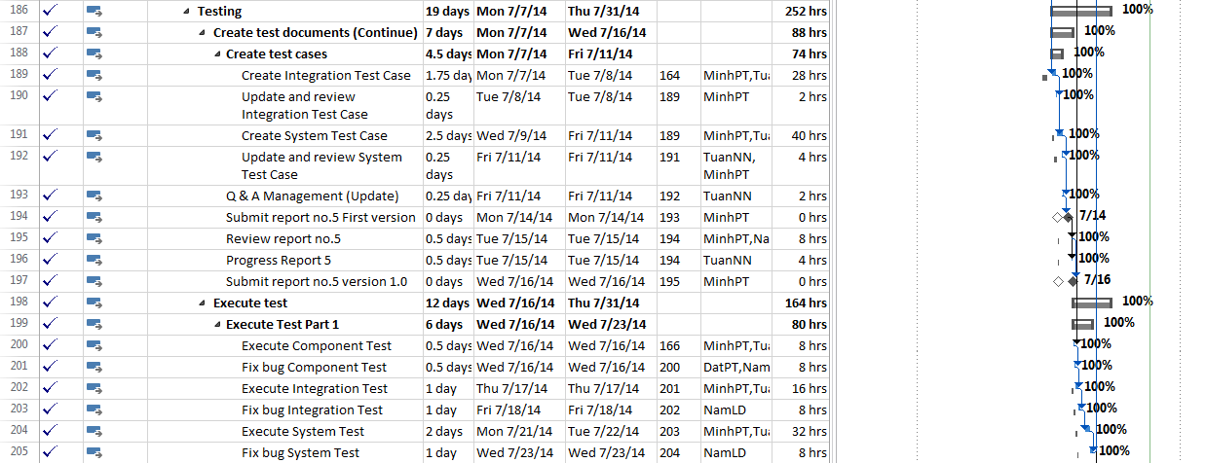

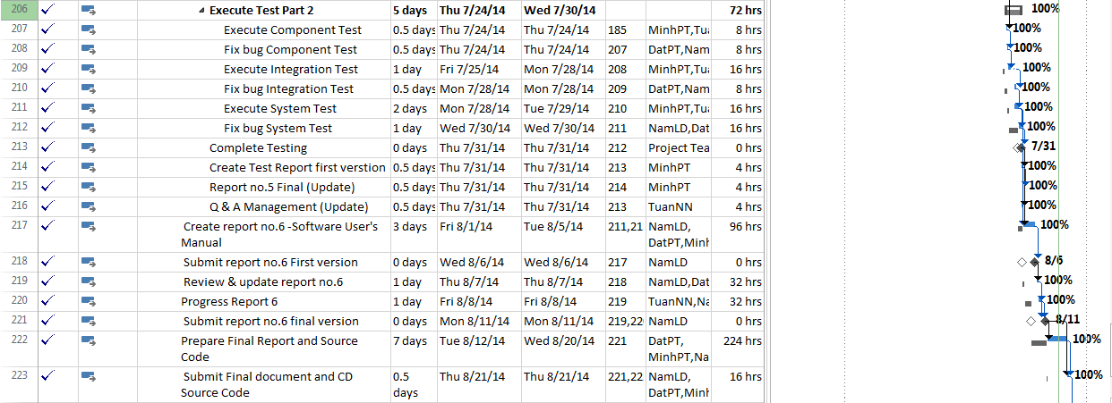

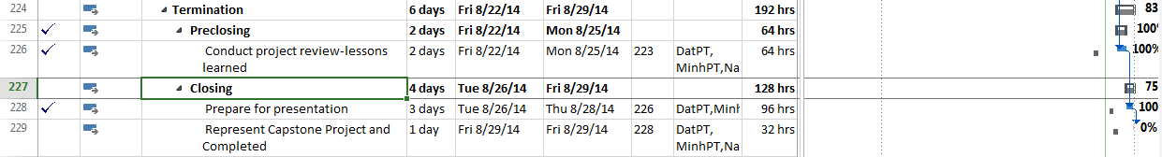

## Risk Management

|  |  |  |  |  |  |  |
| --- | --- | --- | --- | --- | --- | --- |
| **No.** | **Risk** | **Description** | **Category** | **Avoidance** | **Solution** | **Status** |
| 1 | Key member leaving | Key member leaves | People risk | Have a suitable treatment policy | Find other person | Closed |
| 2 | New technical | New technical is applied | Technology risk | Training | Ask for expert | Analyzed |
| 3 | Lack budget | Not enough money | Financial risk | Calculate carefully | Asking for more | Closed |
| 4 | Change requirement | Requirement is changed when designing/ coding or testing | Structure risk | Work with customer careful right from the start | Change design, code, test case | Analyzed |
| 5 | Not suitable schedule | Schedule is not suitable, duration is too long or too short | Structure risk | Use tool when create schedule | Change schedule | Analyzed |
| 6 | Miss requirement | The product of project cannot meet fully requirements | Structure risk | Analyze requirement clearly right from the start, review and confirm SRS | Add more into design, code, test case | Closed |
| 7 | Late deadline | Work/ process is late in comparison with deadline | Structure risk | Split the deadline, divide clearly work and responsibility | Over time | Known |
| 8 | Far about location | Members stay at far location | Structure risk | Select right from the start | Use tool | Analyzed |
| 9 | Developer of project doesn't have any experience about PHP language and unit test for PHP. | Developer has not worked or studied with PHP language before. | Technology risk | - Project may be late not as schedule. Because developer must spend much time to study PHP Language. | - Have plan for developer to study and code demo by PHP language before the project start.  - Refer unit test of Fsoft's project. | Occurred |
| 10 | Developer of project doesn't have experience about design website by PHP language. | Developer has not worked or studied with PHP language before. | Technology risk | - Project may have poor or wrong design. | - Due to DatPT has experience with Photoshop and DatPT has experience with css/html design,so it'is not hard to design with PHP. | Occurred |
| 11 | Tester of project may can't join with project full time. | Tester must work in SamSung Company fulltime. | People risk | - Website may not be tested clearly and fully. | - MinhPT will join full time in project when it is necessary. | Occurred |
| 12 | During the time doing project, member of project may have problem and can't do their job fully. | Individual Reason | People risk | - Their job may be late and affect project schedule. | - Always have the people to support for another when it is necessary | Occurred |

Table: Risk Management

## Communication Management

| Communication Type | Method / Tool | When | Information | Participants / Responsible |
| --- | --- | --- | --- | --- |
| Project Task Tracking | | | | |
| Task scheduling | MS Project Professional 2013 | At the beginning of every stage, and weekly  Refinement and rescheduling as necessary |  | PM |
| Task assignment | MS Project Professional 2013 | Weekly |  | PTL |
| Task status reporting | Daily Report | Daily |  | Project Team Members |
| Project Meeting | | | | |
| Kick-off Meeting | Face to face | Initiation stage | Project introduction; Project plan review; Risk identification; stakeholders identify. | PM, Project Team Members |
| Project Progress Review Meetings | Face to face | Weekly and on event | Communicate project status  Communicate and resolve any open issue, risks, and changes  Discuss any suggested improvement | PM, Project Team Members |
| Milestone Meetings | Face to face | 5 days After the completion of stages: Definition, Solution & Construction | Project objective review, evaluate project performance (quality, schedule, effort), Causal analysis, update project plan for next stage | PM, Project Team Members, QA, Supervisor |
| Transfer/Sharing of project documentation/information | Tortoise SVN | When available | All project documentation and information | PM, Project Team Members, QA |
| Supervisor Communication and Reporting: | | | | |
| Project Report | Agreed Fsoft and FU standard format | 5pm Monday, Weekly | Project status report, Issue requiring clarifications, escalation, if any | PM |
| Project Meetings with supervisor | Face to face | 12h45 Friday, Weekly | As above | PM |
| Requirement gathering/clarification | Face to face meeting | During requirement analysis phase | As in Q&A list | PM |
| Communication with Supervisor | | | | |
| Review Project Plan & Project schedule | By attend project meeting | Significant changes to WO, PP and Project schedule (scope, objectives Organization, HR, major milestone, deliverables ) |  | PM |
| Project Progress Review | By email and/or via Operation meeting at Group/Division level | Weekly | Project status report, Issue requiring clarifications, escalation, if any | PM |
| Project Milestone Review | By email and via project milestone review meeting | End of every stage | Project objective review, evaluate project performance (quality, schedule, effort), Causal analysis, update project plan for next stage | PM |

## Tools and Infrastructure

Below is the list of tools and infrastructure requirements needed for development environment.

| Item | Description | Expected Availability by | Note |
| --- | --- | --- | --- |
| Development Environment | | | |
| Operating System | Window 7 (32 bit, 64 bit), Window 8 |  |  |
| Browser | Google Chrome, CocCoc(all version) |  |  |
| Development language | PHP |  | for Web interface |
| Technology | | | |
| Development language | PHP, MVC Model |  |  |
| Server | Xampp 1.8.2 (server localhost) |  |  |
| Hardware Requirement | | | |
| Hardware Configuration | 2GB workspaces on server |  |  |
| Equipment & Tools | | | |
| Source Version Control | TortoiseSVN | Definition stage |  |
| Task Tracking | MS Project Professional 2013 | Initiation stage |  |
| SRS | Microsoft Office Word, Microsoft Office Excel, Microsoft Office Visio | Initiation stage |  |

## Coding conventions

### Code Source

Do not use any libraries or code from external sources without prior approval:

1) Similar code may already exist

2) Licensing may be an issue

3) Legibility and reusability can be issued

4) Performance concerns

### Conventions

Indenting:

Use an indent of 4 spaces, with no tabs. Please indent your code.

**Case**

* Use "lowerCamelCase" style (lowercase lettering on initial words and capitalization on subsequent words) to name functions, methods, and variables.

**Variables**

* Case should never be used to differentiate between variable names. Every variable name in the current scope should be absolutely unique. Variable names should describe the content that they (will) contain, using either complete words or understandable abbreviations.

#### Class Definitions

Class declarations have their opening brace on a new line:

<?php  
class Foo_Bar  
{  
    //... code goes here

}  
?>

#### Function Definitions

Function declarations follow the "**K&R style**":

<?php  
function fooFunction($arg1, $arg2 = '')  
{  
    if (condition) {  
        statement;  
    }  
    return $val;  
}  
?>

Arguments with default values go at the end of the argument list. Always attempt to return a meaningful value from a function if one is appropriate. Here is a slightly longer example:

<?php  
function connect(&$dsn, $persistent = false)  
{  
    if (is_array($dsn)) {  
        $dsninfo = &$dsn;  
    } else {  
        $dsninfo = DB::parseDSN($dsn);  
    }  
    if (!$dsninfo || !$dsninfo['phptype']) {  
        return $this->raiseError();  
    }  
    return true;  
}  
?>

**Function Calls**

Functions should be called with no spaces between the function name, the opening parenthesis, and the first parameter, spaces between commas and each parameter, and no space between the last parameter, the closing parenthesis, and the semicolon. Here's an *example*:

<?php  
$var = foo($bar, $baz, $quux);  
?>

As displayed above, there should be one space on either side of an equals sign used to assign the return value of a function to a variable. In the case of a block of related assignments, more space may be inserted to promote readability:

<?php  
$short = foo($bar);  
$long_variable = foo($baz);  
?>

To support readability, parameters in subsequent calls to the same function/method may be aligned by parameter name:

<?php  
  
$this->callSomeFunction('param1', 'second', true);  
$this->callSomeFunction('parameter2', 'third', false);  
$this->callSomeFunction('3', 'verrrrrrylong', true);  
?>

**Arrays**

Assignments in arrays may be aligned. When splitting array definitions onto several lines, the last value may also have a trailing comma. This is valid PHP syntax and helps to keep code diffs minimal:

<?php  
  
$some_array = array(  
    'foo'  => 'bar',  
    'spam'=>'ham'  
);  
?>

**PHP Code Tags**

**Always** use <?php ?> to delimit PHP code, not the <? ?> shorthand. This is required for PEAR compliance and is also the most portable way to include PHP code on differing operating systems and setups.

**HTML**

HTML Code should not be found anywhere in our code, other than the smarty templates. Mark places where you find it with a TODO, as well as any plain text outputted to screen. We will convert these to a multiple language format in next version.

**Control Structures**

* Place a single space between the control keyword (if, for, while, switch, etc.) and opening parenthesis to distinguish control statements from function calls
* Always use curly braces—even when technically optional (i.e., avoid PHP's alternative syntax for control structures, except the ternary operator noted below)
* Include break; after all switch case statements
* Use the Allman/BSD style for indentation and layout (braces appear alone and surrounding the indented code)

*Example if statement:*

<?php  
if ((condition1) || (condition2)) {  
    action1;  
} elseif ((condition3) && (condition4)) {  
    action2;  
} else {  
    defaultaction;  
}  
?>

*Example switch statement:*

<?php  
switch (condition) {  
case 1:  
    action1;  
    break;  
case 2:  
    action2;  
    break;  
default:  
    defaultaction;  
    break;  
}  
?>

*Or:*

<?php  
if (($condition1  
    || $condition2)  
    && $condition3  
    && $condition4  
) {  
    //code here  
}  
?>

**Ternary Operators**

Can be used for simple true/false/action checks.

($result)? echo "<result>success</result>":echo "<result>failure</result>" ;

**Database Tables and Fields**

* Lowercase words separated by underscores:
* Items
* item_specifications
* Do NOT make calls directly to native database functions (ie: mysql_insert_id, mysql_result,etc). Use ONLY adodb functions.

**Smarty plugins**

* function.smarty_plugin.php

**Directories, File Structure**

* Do not create new directories or class, library files without first discussing with team. Most functions, classes belong in existing files.
* New plugins, and files should follow existing layout and naming.

**Security**

**Passwords**

* Never hardcode passwords into any script
* Never put live data passwords into SVN
* Always get your database passwords from included csp config.

Configuration

* Never hard code paths to any file – use configuration files.

**Database**

* Do not distribute database information. (via email, download or otherwise)
* Do not connect to production server from home (only dev).
* Do not run test or live queries on production data.

**User Data**

* All Credit Card information should be encrypted.
* User data should be obfuscated before being used in development environments.

**Code Documentation**

Follow PHPDOC.org documentation style.

**Subversion**

Include comments for all commits to SVN. If you are fixing a bug, included the TICKET

ID in the Subversion Comments

**TODO**

Anytime you need to make comments regarding future modifications or requirement put a //TODO: comments. These will show up in PHPEclipse and give us an idea of things left unfinished (but functional).

*Example:*

// TODO: This code should be re-examined for increased performance

**CODE CLEANUP**

Where you see standard rules broken -> MARK CODE WITH A TODO

**PHP Comments**

Use C-style (/* */) comments for multi-line statements and C++ comments (//) for single-line statements.

Use <!-- --> in html mode.

*Database conventions*

* Tables will always be named singular names for most tables, except when dealing with a clear collection. Thus the foreign key relationship will hold true to table_id form
* Tables will be grouped by prefixes of primary related tables (itemProperties related to table item)
* Additional prefix grouping will be used for tables related to a particular functionality - "workspace", "sys" - this is only because there isn't a parent table, but the tables are in fact related, but by functionality.
* Primary keys of all tables will be lowercase table_id or write off name table_id, except in the case of composite keys (those will depend on the combination)
* Foreign keys will be table_id (so if primary table is "site", and its primary key is "table_id", when "table_id" is referenced in other tables, they will reference "site_id".
* Attribute of table always set name start with name table_or write off name table_ (example :u_id ( id of user), contact_id (id of contact)).

# Software Requirement Specification

## SRS Overview

### Purpose

This document is created as the introduction for project Useful Japanese Dictionary for Vietnamese – our Capstone Project at FPT University. In this document, we will descript the overview of function list, use case of our software, a brief description about function's screen. This document help user understand more about our system.

### Scope

The scope of this project contains Requirement Analysis, Design, Coding and Testing (Unit Test, Integration Test, and System Test).

## User Requirements Specification

### Business Process Overview

#### Search workflow

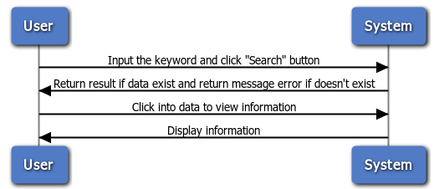

Figure :

**Brief description**: Everyone can do that search process. It is divided into these steps:

**Step 1**: User choose the type of search and input the key word into text box.

**Step 2**: After user click on search button, system will return result match with key word if it exists, and return error message if it does not exist.

**Step 3**: User can click on result to view information of key word.

#### Doing Test Workflow

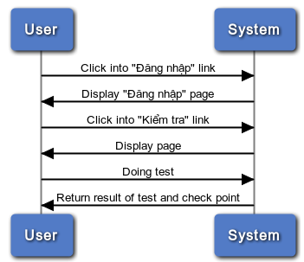

Figure 1-2: Doing test

**Brief description**: Only member can do test. It divided into these steps:

**Step 1**: Member click on the “Kiểm tra” link

**Step 2**: After member click on link, system will display all test on the website

**Step 3**: User click on any test link and doing test

**Step 4**: After member successful the test, system will return result of test and check point

#### Register workflow

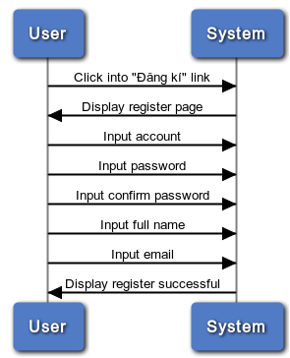

Figure 1-3: Register

**Brief description**: Only guest can register. It divided into these steps:

**Step 1**: User (Guest) click on register link

**Step 2**: System will display register page

**Step 3**: User insert into all required fields then click on register button. System will check the validation of all inserted fields. If it is invalid, display error message beside wrong fields. If ok, display successful message.

#### Contact Admin

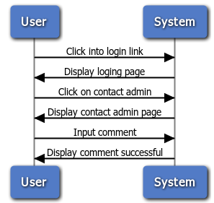

Figure 1-4: Contact admin

**Brief description**: Only member can contact admin. It is divided into these steps:

**Step 1**: Member click on contact admin link

**Step 2**: System will display contact page

**Step 3**: User input comment

**Step 4**: System will receive comments and display successful message

### Product Features

UJD_VN is an online system, user only connect to internet to use website. System provides these main functions:

* + **Manage admin account**

System just allows user who logins as Administrator have permission to manage admin account. So that they can add new admin, edit profile, delete admin as they want.

* + **Manage member account**

System just allows user who logins as Administrator have permission to manage member account. So that they can search member, ban/ unban member, delete member as they want.

* + **Manage vocabulary**

System just allows user who logins as Administrator have permission to manage vocabulary. So that they can search, add, edit, delete vocabulary as they want.

* + **Manage grammar**

System just allows user who logins as Administrator have permission to manage grammar. So that they can search, add, edit, delete grammar as they want.

* + **Manage reading document**

System just allows user who logins as Administrator have permission to manage reading document. So that they can search, add, edit, delete reading document as they want.

* + **Manage conversation**

System just allows user who logins as Administrator have permission to manage conversation. So that they can search, add, edit, delete conversation when they want.

* + **Manage video**

System just allows user who logins as Administrator have permission to manage video. So that they can search, add, edit, delete video as they want.

* + **Manage listening article**

System just allows user who logins as Administrator have permission to manage listening article. So that they can search, add, edit, delete listening article as they want.

* + **Manage doing test**

System just allows user who logins as Administrator have permission to manage doing test. So that they can search, add, edit, delete doing test as they want.

* + **Manage contributed content**

System just allows user who logins as Administrator have permission to manage contributed content. So that they can search, approve, reply, delete contributed content as they want.

* + **Manage contributed opinion**

System just allows user who logins as Administrator have permission to manage contributed opinion. So that they can search, reply, delete contributed opinion as they want.

* + **Manage Q&A**

System just allows user who logins as Administrator have permission to manage Q&A. So that they can search, reply, delete Q&A as they want.

* + **Search**

Everyone who uses that system can make search with five options: search sentences, search conversation, search grammar, search video, search specialized Japanese.

* + **Training listening**

Everyone who uses that system can make training listening.

* + **Listening conversation**

Everyone who uses that system can make listening conversation.

* + **Reading document**

Everyone who uses that system can make reading document such as: Fundamental Japanese document, Intermediate Japanese document, review Japanese document.

* + **Doing test**

When user registered successfully, user can make doing test then tracking their mark.

* + **Contact admin**

When user registered successfully, user can make contact admin such as: contribute content, contribute opinion and send any question to admin.

* + **Log in/ Log out**

When user registered successfully, user can make log in.

* + **Edit Profile**

When user registered successfully, user can make log in, when logged in, user can edit their profile, change password and track their mark.

* + **Forgot password**

If user forgot password, user can retake new password.

* + **Register**

If user do not have account on system, user can use make register.

## Sofware Requirements Specification

### Overall Description

#### System overview

Nowadays, there are many dictionaries which support Japanese. That can be a website or mobile application. All of them have been created for the purpose of helping users search vocabulary or studying Japanese more easily. But we found some disadvantages which existing in website which support users studying Japanese. So, our project – UJD_VN will include some main functions of existing dictionary website and add some special features such as showing examples by Vietnamese, supporting searching specialized vocabulary or users can contribute idea, good knowledge to make our database become larger. Moreover, we will provide freely website to users. Here, we toward provide website for Vietnamese who want to studying Japanese communication or who want to join Japanese certification exams.

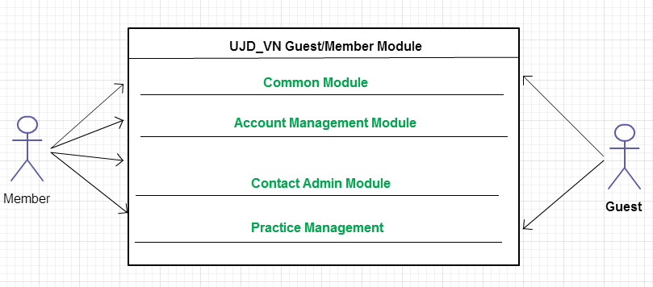

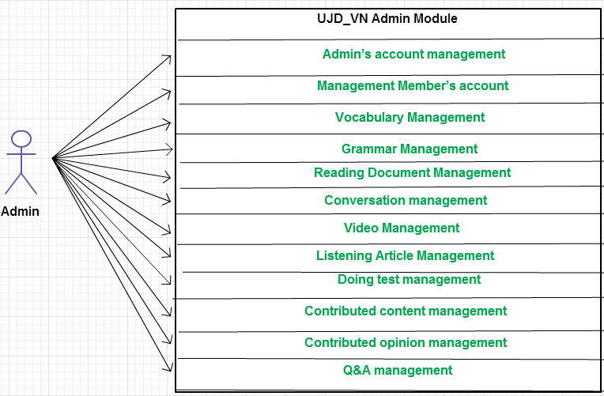

#### Product Features

|  |  |  |  |
| --- | --- | --- | --- |
| **Use Case No.** | **Group of functions** | **Functions** | **Glossary** |
| **UJD_VN GUEST/MEMBER MODULE** | | | |
| **Common Module** | | | |
|  | Search | Search sentences | Search for example sentences |
|  | Search conversation | Search for conversations |
|  | Search grammar | Search for grammar |
|  | Search video | Search for video of Japanese |
|  | Search specialized Japanese | Search for Japanese specialized |
| **Account Management Module** | | | |
|  | Login | Login by Facebook account | Sign in with your Facebook account |
| Login by registered account | Sign in with you register account |
|  |  | Logout | Logout |
|  |  | Register | Register account for customers to use more features of the website |
|  |  | Edit Profile | Edit user’s profile |
|  |  | Forgot Password | Forgot password |
| **Contact Admin Module** | | | |
|  | Contact Admin | Contribute content | Contribute useful database for website |
|  | Contribute opinion | Feedback for website development |
|  | Send Q & A | Send any questions in the process of using Website |
| **Practice Management** | | | |
|  | Doing Test | Test | Doing test |
| Tracking mark | Tracking the learning process |
|  |  | Training Listening | Training listening level N2,N3,N4 |
|  |  | Listening conversation | Listening conversation |
|  |  | Reading Document | Reading document |
| **UJD_VN ADMIN MODULE** | | | |
|  | Admin’s account management | Add new admin | Add new admin |
|  | Edit profile | Edit admin’s profile |
|  | Delete admin | Delete admin |
|  | Management Member’s account | Search member | Search member |
|  | Ban/Unban Member’s account | Ban/Unban member’ account |
|  | Delete member | Delete member |
|  | Vocabulary Management | Search vocabulary | Search vocabulary |
|  | Add vocabulary | Add new vocabulary |
|  | Edit vocabulary | Edit vocabulary |
|  | Delete vocabulary | Delete vocabulary |
|  | Grammar Management | Search grammar | Search grammar |
|  | Add Grammar | Add Grammar |
|  | Edit grammar | Edit grammar |
|  | Delete Grammar | Delete Grammar |
|  | Reading Document Management | Search reading document | Search reading document |
|  | Add reading document | Add new reading document |
|  | Edit reading document | Edit reading document |
|  | Delete reading document | Delete reading document |
|  | Conversation management | Search conversation | Search conversation |
|  | Add conversation | Add new conversation |
|  | Edit conversation | Edit conversation |
|  | Delete conversation | Delete conversation |
|  | Video Management | Search Video | Search video by title |
|  | Add Video | Add new video |
|  | Edit Video | Edit video |
|  | Delete Video | Delete video |
|  | Listening Article Management | Search listening article | Search listening article |
|  | Add listening article | Add listening article |
|  | Edit listening article | Edit listening article |
|  | Delete listening article | Delete listening article |
|  | Doing test management | Search test | Search test |
|  | Add test | Add test |
|  | Edit test | Edit test |
|  | Delete test | Delete test |
| **Contact’s Content Management** | | | |
|  | Contributed content management | Search contribute content | Search contribute content |
| Approve content | Approve content |
| Reply user | Reply user |
| Delete content | Delete content |
|  | Contributed opinion management | Search contribute opinion | Search contribute opinion |
| Reply user | Reply user |
| Delete opinion | Delete opinion |
|  | Q & A Management | Search Q & A | Search Q & A |
| Reply Q & A | Reply Q & A |
| Delete Q & A | Delete Q & A |

#### User Characteristics

This website developed towards those who have achieved elementary level Japanese and want to improve intermediate level. The website requires users to have the ability to use a browser with an internet connection. Use can easy use the functions in website, but if they want to use all function, they must be login.

#### User Documentation

List of document when delivering this application is in the table below:

|  |  |
| --- | --- |
| Name | Description |
| User Manual | Provide detailed explanation about the system, screens and guide users how to use all features of UJD_VN website. |

#### Assumption

* Receive the guidance and good support of teacher.
* No one of member got sick in the software development process.
* In the development process, no device got fail.
* Every report meets the deadline.
* Team member do not conflict in the work process.

### Functional Specification Requirements

#### Common Module

##### Use Case Diagram

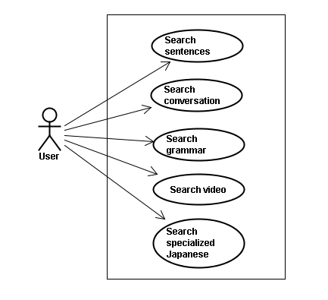

##### Screen description

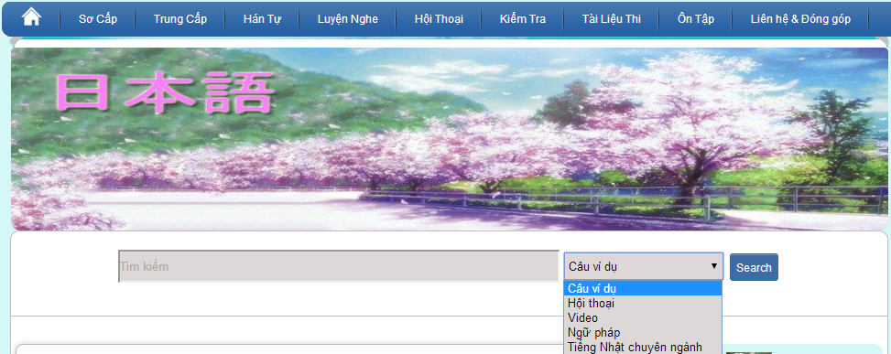

Figure 1: Search

Table 1: Search’s screen description:

|  |  |  |  |  |  |  |  |
| --- | --- | --- | --- | --- | --- | --- | --- |
| No | Field name | Field name in Vietnamese | Type | Require | Mandatory | Length | Description |
| 1 | Searcharea | Tìm kiếm | Text | Text | Y | 255 | User input a new word with length less than 255 characters |
| 2 | SearchOption | Kiểu tìm kiếm | Drop-down list | Click | Y |  | User choose type of search |
| 2 | Search | Search | Button | Click | Y |  | User click on search button |

##### Use Case Specification

###### UC001: <Common module> Search sentences

|  |  |  |  |  |
| --- | --- | --- | --- | --- |
| **UC001 – Search sentences** | | | | |
| **Use-case No.** | <UC001> | **Use-case Version** | | <1.0> |
| **Use-case Name** | Search sentences | | | |
| **Author** | Tuan NN | | | |
| **Date** | 09/06/2014 | **Priority** | <High > | |
| **Actor:**  Guest, Member, Administrator  **Summary:**  When Guest, Member, Administrator want to search by sentences in database successfully if it is existed  **Triggers**  Click on search area , input sentences in the text area, choose type of search and then click “Search” button  **Preconditions:**   * Website is available * User have to input data in search area   **Post Conditions:**  Display detail information of sentences  **Main Success Scenario:**   |  |  |  | | --- | --- | --- | | **Step** | **User** | **System** | | 1 | Enter website link on web browser | Display Home page screen | | 2 | Input data in search area and choose “Câu ví dụ” type then click button Search | Display “sentences information” screen that contains the information of chosen sentences with these elements:   * Serial number * Name of sentences by hiragana * Name of sentences by romaji * Meaning of sentences |     **Alternative Scenario:**   |  |  |  | | --- | --- | --- | | **At Step** | **User** | **System** | | 2 | Input data in search area and choose “Câu ví dụ” type then click on another link | Switch to selected page |   **Exceptions:**   |  |  |  | | --- | --- | --- | | **At Step** | **User** | **System** | | 2 | Fill data that they want to find (that do not exist in database) into these fields then click “Search” button | Return Error message to inorm that sentences cannot be found | | | | | |

###### UC002: <Common module> Search conversation

|  |  |  |  |  |
| --- | --- | --- | --- | --- |
| **UC002 – Search conversation** | | | | |
| **Use-case No.** | <UC002> | **Use-case Version** | | <1.0> |
| **Use-case Name** | Search conversation | | | |
| **Author** | Tuan NN | | | |
| **Date** | 09/06/2014 | **Priority** | <High > | |
| **Actor:**  Guest, Member, Administrator  **Summary:**  When Guest, Member, Administrator want to search by conversation in database successfully if it is existed  **Triggers**  Click on search area , input conversation in the text area, choose type of search and then click “Search” button  **Preconditions:**   * Website is available * User have to input data in search area   **Post Conditions:**  Display detail information of conversation  **Main Success Scenario:**   |  |  |  | | --- | --- | --- | | **Step** | **User** | **System** | | 1 | Enter website link on web browser | Display Home page screen | | 2 | Input data in search area and choose “Hội thoại” type then click button Search | Display “conversation information” screen that contains the information of chosen conversation with these elements:   * Serial number * Name of conversation by hiragana * Name of conversation by romaji * Meaning of conversation |     **Alternative Scenario:**   |  |  |  | | --- | --- | --- | | **At Step** | **User** | **System** | | 2 | Input data in search area and choose “Hội thoại” type then click on another link | Switch to selected page |   **Exceptions:**   |  |  |  | | --- | --- | --- | | **At Step** | **User** | **System** | | 2 | Fill data that they want to find (that do not exist in database) into these fields then click “Search” button | Return Error message to inform that conversation cannot be found | | | | | |

###### UC003: <Common module> Search grammar

|  |  |  |  |  |
| --- | --- | --- | --- | --- |
| **UC003 – Search grammar** | | | | |
| **Use-case No.** | <UC003> | **Use-case Version** | | <1.0> |
| **Use-case Name** | Search grammar | | | |
| **Author** | Tuan NN | | | |
| **Date** | 09/06/2014 | **Priority** | <High > | |
| **Actor:**  Guest, Member, Administrator  **Summary:**  When Guest, Member, Administrator want to search by grammar in database successfully if it is existed  **Triggers**  Click on search area , input grammar in the text area, choose type of search and then click “Search” button  **Preconditions:**   * Website is available * User have to input data in search area   **Post Conditions:**  Display detail information of grammar  **Main Success Scenario:**   |  |  |  | | --- | --- | --- | | **Step** | **User** | **System** | | 1 | Enter website link on web browser | Display Home page screen | | 2 | Input data in search area and choose “Ngữ pháp” type then click button Search | Display “grammar information” screen that contains the information of chosen grammar with these elements:   * Serial number * Name of grammar by hiragana * Name of grammar by romaji * Meaning of grammar |     **Alternative Scenario:**   |  |  |  | | --- | --- | --- | | **At Step** | **User** | **System** | | 2 | Input data in search area and choose “Ngữ pháp” type then click on another link | Switch to selected page |   **Exceptions:**   |  |  |  | | --- | --- | --- | | **At Step** | **User** | **System** | | 2 | Fill data that they want to find (that do not exist in database) into these fields then click “Search” button | Return Error message to inform that grammar cannot be found | | | | | |

###### UC004: <Common module> Search video

|  |  |  |  |  |
| --- | --- | --- | --- | --- |
| **UC004 – Search video** | | | | |
| **Use-case No.** | <UC004> | **Use-case Version** | | <1.0> |
| **Use-case Name** | Search video | | | |
| **Author** | Tuan NN | | | |
| **Date** | 09/06/2014 | **Priority** | <High > | |
| **Actor:**  Guest, Member, Administrator  **Summary:**  When Guest, Member, Administrator want to search by video in database successfully if it is existed  **Triggers**  Click on search area , input video in the text area, choose type of search and then click “Search” button  **Preconditions:**   * Website is available * User have to input data in search area   **Post Conditions:**  Display detail information of video  **Main Success Scenario:**   |  |  |  | | --- | --- | --- | | **Step** | **User** | **System** | | 1 | Enter website link on web browser | Display Home page screen | | 2 | Input data in search area and choose “Video” type then click button Search | Display “video information” screen that contains the information of chosen video with these elements:   * Serial number * Name of video by hiragana * Name of video by romaji * Meaning of video |     **Alternative Scenario:**   |  |  |  | | --- | --- | --- | | **At Step** | **User** | **System** | | 2 | Input data in search area and choose “Video” type then click on another link | Switch to selected page |   **Exceptions:**   |  |  |  | | --- | --- | --- | | **At Step** | **User** | **System** | | 2 | Fill data that they want to find (that do not exist in database) into these fields then click “Search” button | Return Error message to inform that video cannot be found | | | | | |

###### UC005: <Common module> Search specialized Japanese

|  |  |  |  |  |
| --- | --- | --- | --- | --- |
| **UC005 – Search specialized Japanese** | | | | |
| **Use-case No.** | <UC005> | **Use-case Version** | | <1.0> |
| **Use-case Name** | Search specialized Japanese | | | |
| **Author** | Tuan NN | | | |
| **Date** | 09/06/2014 | **Priority** | <High > | |
| **Actor:**  Guest, Member, Administrator  **Summary:**  When Guest, Member, Administrator want to search by specialized Japanese in database successfully if it is existed  **Triggers**  Click on search area , input specialized Japanese in the text area, choose type of search and then click “Search” button  **Preconditions:**   * Website is available * User have to input data in search area   **Post Conditions:**  Display detail information of video  **Main Success Scenario:**   |  |  |  | | --- | --- | --- | | **Step** | **User** | **System** | | 1 | Enter website link on web browser | Display Home page screen | | 2 | Input data in search area and choose “Tiếng Nhật chuyên ngành” type then click button Search | Display “specialized Japanese information” screen that contains the information of chosen specialized Japanese with these elements:   * Serial number * Name of specialized Japanese by hiragana * Name of specialized Japanese by romaji * Meaning of specialized Japanese |     **Alternative Scenario:**   |  |  |  | | --- | --- | --- | | **At Step** | **User** | **System** | | 2 | Input data in search area and choose “Tiếng Nhật chuyên ngành” type then click on another link | Switch to selected page |   **Exceptions:**   |  |  |  | | --- | --- | --- | | **At Step** | **User** | **System** | | 2 | Fill data that they want to find (that do not exist in database) into these fields then click “Search” button | Return Error message to inform that specialized Japanese cannot be found | | | | | |

#### Account management Module

##### Use Case Diagram

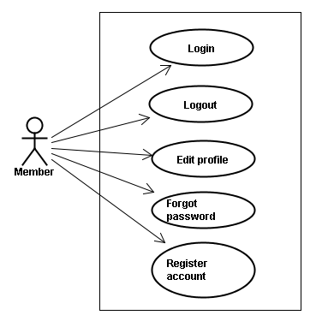

##### Use Case Specification

###### UC006: <Account management module> Login



Figure 2.1: Login

Table 2.1: Login’s screen description:

|  |  |  |  |  |  |  |  |
| --- | --- | --- | --- | --- | --- | --- | --- |
| No | Field name | Field name in Vietnamese | Type | Require | Mandatory | Max-Length | Description |
| 1 | Username | Tên đăng nhập | Text | Text | Y | 32 | User input username with length less than 32 character |
| 2 | Password | Mật khẩu | Password | Text | Y | 32 | User input their password with length less than 32 characters |
| 3 | Login | Đăng nhập | Button | Click | Y |  | User click on Login button |

|  |  |  |  |  |
| --- | --- | --- | --- | --- |
| **UC006 – Login** | | | | |
| **Use-case No.** | <UC006> | **Use-case Version** | | <1.0> |
| **Use-case Name** | Login | | | |
| **Author** | Tuan NN | | | |
| **Date** | 09/06/2014 | **Priority** | <High > | |
| **Actor:**  Member, Administrator  **Summary:**  When Member, Administrator want to login by Facebook/Register account to use more functions in website  **Triggers**  User choose the login method, input data and click on login button  **Preconditions:**   * Website is available * Account Facebook/Register must be exist and correctly   **Post Conditions:**  Login successfully and redirect user to previous page.  **Main Success Scenario:**   |  |  |  | | --- | --- | --- | | **Step** | **User** | **System** | | 1 | Enter website link on web browser | Display Homepage screen | | 2 | Choose login method ( login by Facebook/register account), input account and password and then click “Đăng nhập” button | Validate information and log user into system. |     **Alternative Scenario:**   |  |  |  | | --- | --- | --- | | **At Step** | **User** | **System** | | 2 | Input data in username and password area then click on another link | Switch to selected page |   **Exceptions:**   |  |  |  | | --- | --- | --- | | **At Step** | **User** | **System** | | 3 | Fill incorrect or missing information “Tên đăng nhập”/ “Mật khẩu” field | Return Error message beside “Tên đăng nhập”/ “Mật khẩu” field. | | | | | |

###### UC007: <Account management module> Logout



Figure 2.2: Logout

Table 2.2: Logout’s screen description:

|  |  |  |  |  |  |  |
| --- | --- | --- | --- | --- | --- | --- |
| No | Field name | Type | Require | Mandatory | Max-Length | Description |
| 1 | Logout | Button | Click | Y |  | User click on Logout button |

|  |  |  |  |  |
| --- | --- | --- | --- | --- |
| **UC007 – Logout** | | | | |
| **Use-case No.** | <UC007> | **Use-case Version** | | <1.0> |
| **Use-case Name** | Logout | | | |
| **Author** | Tuan NN | | | |
| **Date** | 09/06/2014 | **Priority** | <High > | |
| **Actor:**  Member, Admin  **Summary:**  When Member, Admin want to logout their account  **Triggers**  Click on logout button  **Preconditions:**   * Website is available * Member, Admin must be login   **Post Conditions:**  Redirect user to previous page.  **Main Success Scenario:**   |  |  |  | | --- | --- | --- | | **Step** | **User** | **System** | | 1 | Click on logout button | Redirect to homepage | | | | | |

###### UC008: <Account management Module>: Register account

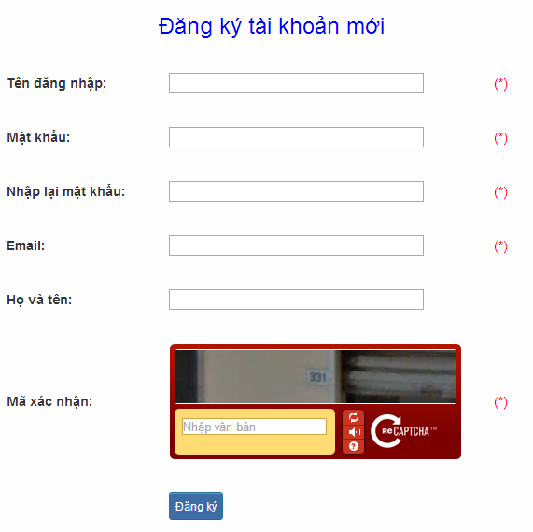

Figure 2.3: Register

Table 2.3: Register’s screen description:

|  |  |  |  |  |  |  |  |
| --- | --- | --- | --- | --- | --- | --- | --- |
| No | Field name | Field name in Vietnamese | Type | Require | Mandatory | Max-Length | Description |
| 1 | Username | Tên đăng nhập | Text | Text | Y | 32 | User input username with length less than 32 characters |
| 2 | Password | Mật khẩu | Password | Text | Y | 32 | User input their password with length less than 32 characters |
| 3 | Re-password | Nhập lại mật khẩu | Password | Text | Y | 32 | User re-input password with length less than 32 characters |
| 4 | Name | Họ và tên | Text | Text | Y | 50 | User input their name with length less than 50 characters |
| 5 | Email | Email | Text | Text | Y | 100 | User input email with length less than 32 characters |
| 6 | Capcha | Mã xác nhận | Text | Text | Y | 100 | User input the verification code |
| 7 | Register | Đăng ký | Button | Click | Y |  | User click Register button |

|  |  |  |  |  |
| --- | --- | --- | --- | --- |
| **UC008 – Register account** | | | | |
| **Use-case No.** | <UC008> | **Use-case Version** | | <1.0> |
| **Use-case Name** | Register | | | |
| **Author** | Tuan NN | | | |
| **Date** | 09/06/2014 | **Priority** | <High > | |
| **Actor:**  Guest  **Summary:**  Visitor can create new account to use more function as a register user  **Triggers**  Click on register link on the website  **Preconditions:**   * Website is available   **Post Conditions:**  Create account for guest  **Main Success Scenario:**   |  |  |  | | --- | --- | --- | | **Step** | **User** | **System** | | 1 | Enter website link on web browser | Display Homepage screen | | 2 | Click on register link | Display register form | | 3 | Enter necessary and mandatory information and click "Đăng kí" button. | Display message to register successfully and redirect to homepage |     **Alternative Scenario:**   |  |  |  | | --- | --- | --- | | **At Step** | **User** | **System** | | 3 | Enter necessary and mandatory information and click another link | Switch to selected page |   **Exceptions:**   |  |  |  | | --- | --- | --- | | **At Step** | **User** | **System** | | 3 | Missing “Tên đăng nhập” field and click “Đăng kí” button | Display error message beside “Tên đăng nhập” field. | | 3 | Enter incorrect information or missing “Mật khẩu” field and click “Đăng kí” button | Display error message beside “Mật khẩu” field. | | 3 | Missing “Họ và tên” field and click “Đăng kí” button | Display error message beside “Họ và tên” field. | | 3 | Missing “Email” field and click “Đăng kí” button | Display error message eside “Email” field. | | 3 | Enter incorrect information or missing “Mã xác nhận” field and click “Đăng kí” button | Display error message beside “Mã xác nhận” field. | | | | | |

###### UC009: <Account management Module>: Edit profile

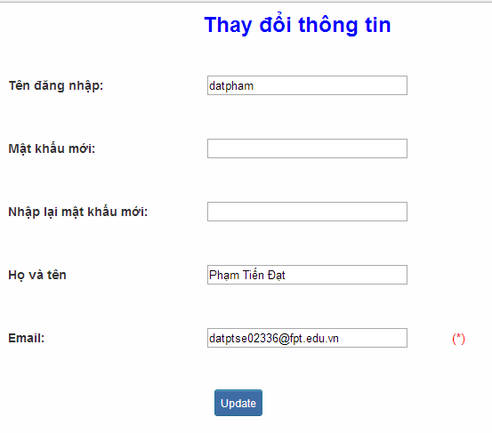

Figure 2.4: Edit profile

Table 2.4: Edit profile’s screen description:

|  |  |  |  |  |  |  |  |
| --- | --- | --- | --- | --- | --- | --- | --- |
| No | Field name | Field name in Vietnamese | Type | Require | Mandatory | Max-Length | Description |
| 1 | Name | Họ và tên | Text | Text | Y | 32 | User input their name with length less than 32 characters |
| 2 | Old-Password | Mật khẩu cũ | Password | Text | Y | 32 | User input their old password with length less than 32 characters |
| 3 | New-password | Mật khẩu mới | Password | Text | Y | 32 | User input new password with length less than 32 characters |
| 4 | Re-password | Nhập lại mật khẩu mới | Password | Text | Y | 32 | User re-input password with length less than 32 characters |
| 5 | Email | Email | Text | Text | Y | 100 | User input email to with length less than 100 characters |
| 6 | Edit | Thay đổi thông tin | Button | Click | Y |  | User click on Edit button |

|  |  |  |  |  |
| --- | --- | --- | --- | --- |
| **UC009 – Edit profile** | | | | |
| **Use-case No.** | <UC009> | **Use-case Version** | | <1.0> |
| **Use-case Name** | Edit profile | | | |
| **Author** | Tuan NN | | | |
| **Date** | 09/06/2014 | **Priority** | <High > | |
| **Actor:**  Member  **Summary:**  When member want to change their profile  **Triggers**  Login the website and click on the edit profile link  **Preconditions:**   * Website is available * Member login the website   **Post Conditions:**  Edit profile successful and redirect user to edited profile page  **Main Success Scenario:**   |  |  |  | | --- | --- | --- | | **Step** | **User** | **System** | | 1 | Enter website link on web browser | Display Homepage screen | | 2 | Enter necessary and mandatory information and click "Login” | Redirect to previous page and logged user into system. | | 3 | Click on "Trang cá nhân" link. | Display “Trang cá nhân” page | | 4 | User changes profile and click “Lưu” button | Update new profile |     **Alternative Scenario:**   |  |  |  | | --- | --- | --- | | **t Step** | **User** | **System** | | 4 | Enter necessary and mandatory information and click another link | Switch to selected page |   **Exceptions:**   |  |  |  | | --- | --- | --- | | **At Step** | **User** | **System** | | 4 | Enter new password that incorrect form or missing information and click “Lưu” button | Display error message | | 4 | Enter new email that incorrect form or missing information and click “Lưu” button | Display error message | | | | | |

###### UC010: <Account management Module>: Forgot password

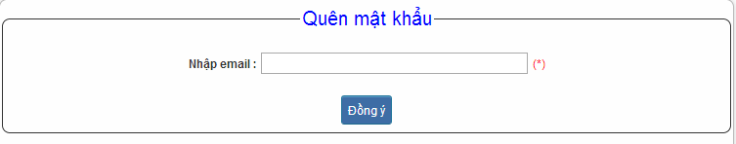

Figure 2.5: Forgot password

Table 2.5: Forgot password’s screen description:

|  |  |  |  |  |  |  |  |
| --- | --- | --- | --- | --- | --- | --- | --- |
| No | Field name | Field name in Vietnamese | Type | Require | Mandatory | Max-Length | Description |
| 1 | Email | Email | Text | Text | Y | 32 | User input email with length less than 100 characters |
| 2 | Send | Đồng ý | Button | Click | Y |  | Click to receive password |

|  |  |  |  |  |
| --- | --- | --- | --- | --- |
| **UC010 – Forgot password** | | | | |
| **Use-case No.** | <UC010> | **Use-case Version** | | <1.0> |
| **Use-case Name** | Forgot password | | | |
| **Author** | Tuan NN | | | |
| **Date** | 09/06/2014 | **Priority** | <High > | |
| **Actor:**  Member, Admin  **Summary:**  When Member, Admin forgot their password to login the system, this function will receiving their password to email  **Triggers**  Click on forgot password link on the website  **Preconditions:**   * Website is available   **Post Conditions:**  Receiving their password to their email  **Main Success Scenario:**   |  |  |  | | --- | --- | --- | | **Step** | **User** | **System** | | 1 | Enter website link on web browser | Display Homepage screen | | 2 | Click on “Quên mật khẩu link. | Display “Quên mật khẩu” page | | 3 | Enter necessary and mandatory information in the “Quên mật khẩu” form and click "Gửi yêu cầu" button. | System will send the password into your email. |     **Alternative Scenario:**   |  |  |  | | --- | --- | --- | | **At Step** | **User** | **Syste** | | 3 | Enter necessary and mandatory information and click another link | Switch to selected page |   **Exceptions:**   |  |  |  | | --- | --- | --- | | **At Step** | **User** | **System** | | 3 | Enter email incorrect with email that use to register account | Display error message and request to re-enter email | | | | | |

#### Contact admin Module

##### Use case diagram

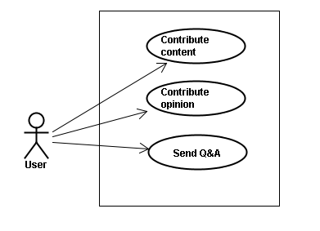

##### Use Case Specification

###### UC011 <Contact admin Module>: Contribute content

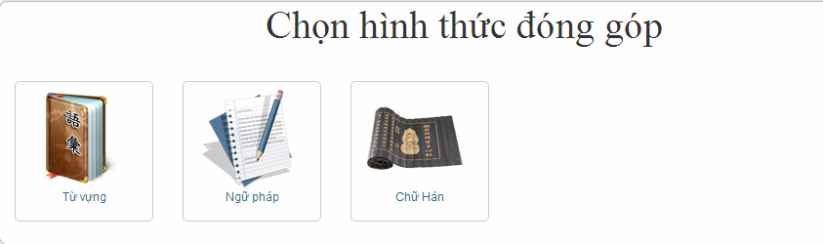

Figure 3.1: Contribute content

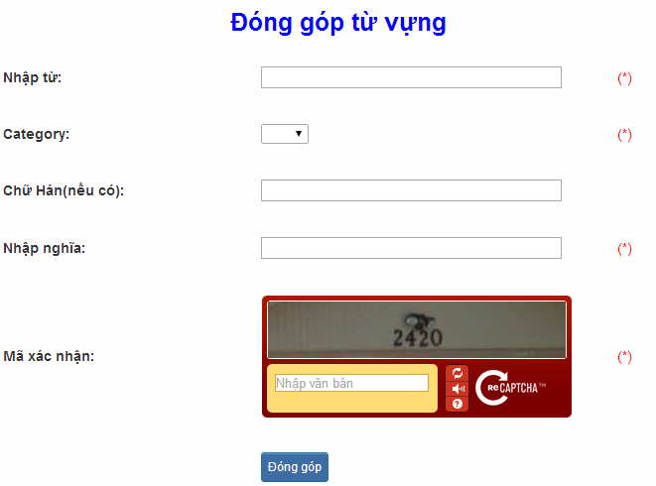

Figure 3.1.1: Contribute vocabulary

Table 3.1: Contribute vocabulary’s screen description:

|  |  |  |  |  |  |  |  |  |  |  |  |  |
| --- | --- | --- | --- | --- | --- | --- | --- | --- | --- | --- | --- | --- |
| No | | Field name | Field name in Vietnamese | | Type | Require | Mandatory | | Max-Length | | Description | |
| 1 | | Vocabulary | Từ | | Text | Text | Y | | 200 | | User input vocabulary with length less than 200 characters | |
| 2 | | Category | Loại từ | | Drop-down list | Click | Y | |  | | User choose type of category | |
| 3 | | Kanji | Chữ Hán | | Text | Text | Y | | 10 | | User input kanji of vocabulary (if exist) with length less than 10 characters | |
| 4 | | Mean | Nhập nghĩa | | Text | Text | Y | | 500 | | User input mean of vocabulary with length less than 500 characters | |
| 5 | | Capcha | Mã xác nhận | | Text | Text | Y | |  | | User input the verification code | |
| 6 | | Contribute | Đóng góp | | Button | Click | Y | |  | | User click on contribute button | |
| **UC011 – Contribute content** | | | | | | | | | | | | |
| **Use-case No.** | | | <UC011> | | | | **Use-case Version** | | | | <1.0> | |
| **Use-case Name** | | | Contribute content | | | | | | | | | |
| **Author** | | | Tuan NN | | | | | | | | | |
| **Date** | | | 09/06/2014 | | | | **Priority** | | <High > | | | |
| **Actor:**  Member  **Summary:**  When Member want to contribute content for website  **Triggers**  User enter website link and click on “Liên hệ” link on the website  **Preconditions:**   * Website is available * User must be login to the website   **Post Conditions:**  Receive opinions and redirect user to contact page  **Main Success Scenario:**   |  |  |  | | --- | --- | --- | | **Step** | **User** | **System** | | 1 | Enter website link on web browser | Display Homepage screen | | 2 | Enter necessary and mandatory information and click "Login” | Redirect to previous page and logged user into system. | | 3 | Click on “Liên hệ”->”Đóng góp database” section | Display “Đóng góp database” page | | 4 | Enter information that member want to contribute for the website then click “Đóng góp” | System will receive contributions |     **Alternative Scenario:**   |  |  |  | | --- | --- | --- | | **At Step** | **User** | **ystem** | | 4 | Enter necessary and mandatory information and click another link | Switch to selected page |   **Exceptions:**   |  |  |  | | --- | --- | --- | | **At Step** | **User** | **System** | | 4 | Missing “Nhập từ” field and click “Đóng góp” button | Display error message beside “Nhập từ” field. | | 4 | Missing “Loại từ” field and click “Đóng góp” button | Display error message beside “Loại từ” field. | | 4 | Missing “Nhập nghĩa” field and click “Đóng góp” button | Display error message beside “Nhập nghĩa” field. | | 4 | Enter incorrect information or missing “Mã xác nhận” field and click “Đóng góp” button | Display error message beside “Mã xác nhận” field. | | | | | | | | | | | | | |

###### UC012 <Contact admin Module>: Contribute opinion

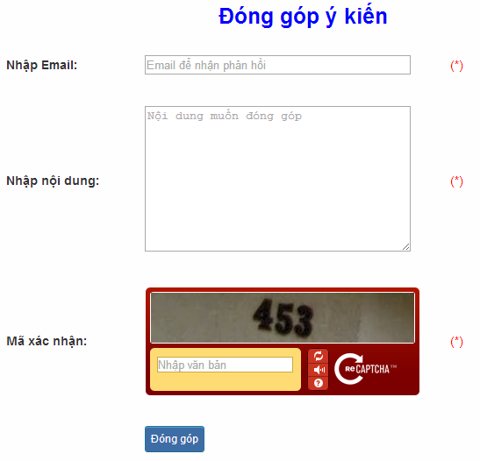

Figure 3.2: Contribute opinion

Table 3.2 : Contribute opinion’s screen description:

|  |  |  |  |  |  |  |  |
| --- | --- | --- | --- | --- | --- | --- | --- |
| No | Field name | Field name in Vietnamese | Type | Require | Mandatory | Max-Length | Description |
| 1 | Email | Email | Text | Text | Y | 100 | User input email with length less than100 characters |
| 2 | Content | Nhập nội dung | Text | Text | Y | 1000 | User input content with length less than1000 characters |
| 3 | Capcha | Mã xác nhận | Text | Text | Y |  | User input the verification code |
| 4 | Contribute | Đóng góp | Button | Click | Y |  | User click on contribute button |

|  |  |  |  |  |
| --- | --- | --- | --- | --- |
| **UC012 – Contribute opinion** | | | | |
| **Use-case No.** | <UC012> | **Use-case Version** | | <1.0> |
| **Use-case Name** | Contribute opinion | | | |
| **Author** | Tuan NN | | | |
| **Date** | 09/06/2014 | **Priority** | <High > | |
| **Actor:**  Member  **Summary:**  When Member want to contribute opinion for website  **Triggers**  User enter website link and click on “Liên hệ” link on the website  **Preconditions:**   * Website is available * User must be login to the website   **Post Conditions:**  Receive opinions and redirect user to contact page  **Main Success Scenario:**   |  |  |  | | --- | --- | --- | | **Step** | **Use** | **System** | | 1 | Enter website link on webbrowser | Display Homepage screen | | 2 | Enter necessary and mandatory information and click "Login” | Redirect to previous page and logged user into system. | | 3 | Click on “Liên hệ”->”Đóng góp ý kiến” tab | Display “Đóng góp ý kiến” page | | 4 | Enter information that member want to contribute for the website then click “Đóng góp” | System will receive contributions |   **Alternative Scenario:**   |  |  |  | | --- | --- | --- | | **At Step** | **User** | **System** | | 4 | Enter necessary and mandatory information and click another link | Switch to selected page |   **Exceptions:**   |  |  |  | | --- | --- | --- | | **At Step** | **User** | **System** | | 4 | Missing “Nhập email” field and click “Đóng góp” button | Display error message beside “Nhập email” field. | | 4 | Missing “Nhập nội dung:” field and click “Đóng góp” button | Display error message beside “Nhập nội dung:” field. | | 4 | Enter incorrect information or missing “Mã xác nhận” field and click “Đóng góp” button | Display error message beside “Mã xác nhận” field. | | | | | |

###### UC013 <Contact admin Module>: Send Q&A

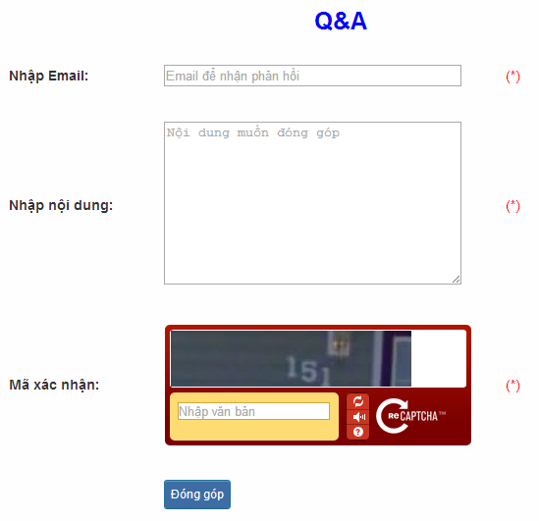

Figure 3.3: Send Q&A

Table 3.3: Send Q&A’s screen description:

|  |  |  |  |  |  |  |  |
| --- | --- | --- | --- | --- | --- | --- | --- |
| No | Field name | Field name in Vietnamese | Type | Require | Mandatory | Max-Length | Description |
| 1 | QA | Q&A | Text | Text | Y | 1000 | User input Q&A with length less than 1000 characters |
| 2 | Email | Email | Text | Text | Y | 100 | User input email with length less than 100 characters |
| 3 | Capcha | Mã xác nhận | Text | Text | Y |  | User input the verification code |
| 4 | Contribute | Đóng góp | Button | Click | Y |  | User click on contribute button |

|  |  |  |  |  |
| --- | --- | --- | --- | --- |
| **UC013 – Send Q&A** | | | | |
| **Use-case No.** | <UC013> | **Use-case Version** | | <1.0> |
| **Use-case Name** | Send Q&A | | | |
| **Author** | Tuan NN | | | |
| **Date** | 09/06/2014 | **Priority** | <High > | |
| **Actor:**  Member  **Summary:**  When Member have the question, they can create Q&A  **Triggers**  Click on “Liên hệ” link on the website  **Preconditions:**   * Website is available * User must be login to the website   **Post Conditions:**  Add new Q&A into the website  **Main Success Scenario:**   |  |  |  | | --- | --- | --- | | **Step** | **User** | **System** | | 1 | Enter website link on web browser | Display Homepage screen | | 2 | Enter necessary and mandatory information and click "Login” | Redirect to previous page and logged user into system. | | 3 | Click on “Q&A” tab | Display “Q&A” page | | 4 | Enter necessary and mandatory information in the “Q&A” form and click "Gửi" button. | Display this Q&A in the “Q&A”section. |     **Alternative Scenario:**   |  |  |  | | --- | --- | --- | | **At Step** | **User** | **System** | | 4 | Enter necessary and mandatory information and click another link | Switch to selected page |   **Exceptions:**   |  |  |  | | --- | --- | --- | | **At Step** | **User** | **System** | | 4 | Missing “Nhập email” field and click “Đóng góp” button | Display error message beside “Nhập email” field. | | 4 | Missing “Q&A” field and click “Đóng góp” button | Display error message beside “Q&A” field. | | 4 | Enter incorrect information or missing “Mã xác nhận” field and click “Đóng góp” button | Display error message beside “Mã xác nhận” field. | | | | | |

#### Practice management Module

##### Use case diagram

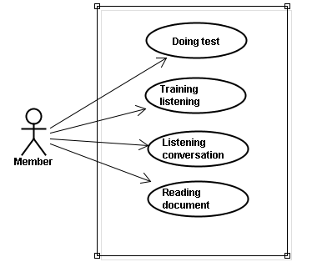

##### Use case specification

###### UC014 <Practice management Module>: Doing test

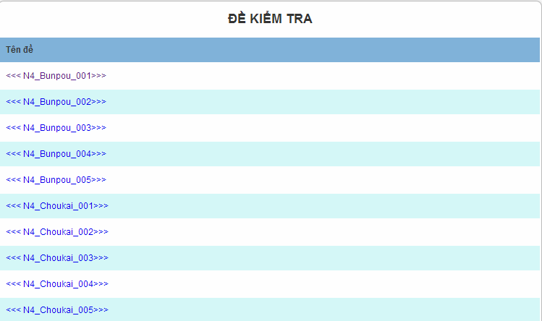

Figure 4.1: Doing test

Screen description: This is doing test screen ( N4 test screen). At here, user can doing test in the website, they click on one of test link

|  |  |  |  |  |
| --- | --- | --- | --- | --- |
| **UC014 – Doing test** | | | | |
| **Use-case No.** | <UC014> | **Use-case Version** | | <1.0> |
| **Use-case Name** | Doing test | | | |
| **Author** | Tuan NN | | | |
| **Date** | 09/06/2014 | **Priority** | <High > | |
| **Actor:**  Member  **Summary:**  This function will help users do the online quiz and check the answers, grading and evaluation capabilities  **Triggers**  User going to website, login and then click on “Kiểm tra” link on the website  **Preconditions:**   * Website is available * User must be login to the website   **Post Conditions:**  Doing test in the website  **Main Success Scenario:**   |  |  |  | | --- | --- | --- | | **Step** | **User** | **System** | | 1 | Enter website link on web browser | Display Homepage screen | | 2 | Enter necessary and mandatory information and click "Login” | Redirect to previous page and logged user into system. | | 3 | Click on “Kiểm tra” section | Display “Kiểm tra” page | | 4 | Choose one of items that you want to doing test | Display that item’s page | | 5 | Doing test | Check the answer, grading after finish |     **Alternative Scenario:**   |  |  |  | | --- | --- | --- | | **At Step** | **User** | **System** | | 5 | While doing test, click another link | Switch to selected page | | | | | |

###### UC015 <Practice management Module>: Trainng listening

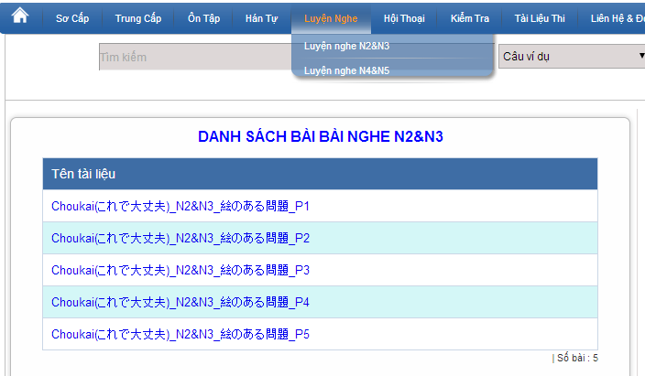

Figure 4.2: Training listening

Screen description:

|  |  |  |  |  |  |  |
| --- | --- | --- | --- | --- | --- | --- |
| No | Field name | Type | Require | Mandatory | Max-Length | Description |
| 1 | Choukai_P1 | Hyperlink | Click | N |  | Display information of listening |
| 2 | Choukai_P2 | Hyperlink | Click | N |  | Display information of listening |
| 3 | Choukai_P3 | Hyperlink | Click | N |  | Display information of listening |
| 4 | Choukai_P4 | Hyperlink | Click | N |  | Display information of listening |
| 5 | Choukai_P5 | Hyperlink | Click | N |  | Display information of listening |

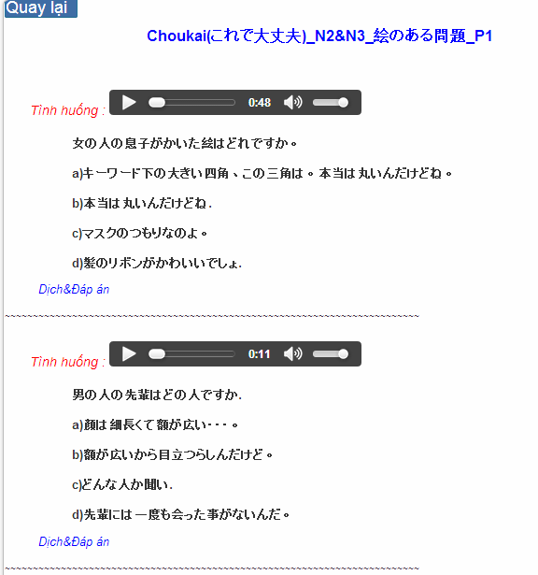

Figure 4.2.1: Training listening content

Table 4.2.1 : Training listening content’s screen description:

|  |  |  |  |  |  |  |
| --- | --- | --- | --- | --- | --- | --- |
| No | Field name | Field name in Vietnamese | Type | Require | Mandatory | Description |
| 1 | Audio | Audio | Audio | Click | Y | User click play button |
| 2 | Translation and Answer | Dịch và đáp án | Link | Click | Y | User click to display translation and answer |

|  |  |  |  |  |
| --- | --- | --- | --- | --- |
| **UC015 – Training listening** | | | | |
| **Use-case No.** | <UC015> | **Use-case Version** | | <1.0> |
| **Use-case Name** | Training listening | | | |
| **Author** | Tuan NN | | | |
| **Date** | 09/06/2014 | **Priority** | <High > | |
| **Actor:**  Guest, Member  **Summary:**  This function provide users some the listening of level N2, N3, N4 to help users training listening skill  **Triggers**  User going to website and click on “Luyện nghe” link on the website  **Preconditions:**   * Website is available   **Post Conditions:**  Training listening in the website  **Main Success Scenario:**   |  |  |  | | --- | --- | --- | | **Step** | **User** | **System** | | 1 | Enter website link on web browser | Display Homepage screen | | 2 | Click on “Luyện nghe” section | Display “Luyện nghe” page |     **Alternative Scenario:**   |  |  |  | | --- | --- | --- | | **At Stp** | **User** | **System** | | 4 | While listening, click another link | Switch to selected page | | | | | |

###### UC016 <Practice management Module>: Listening conversation

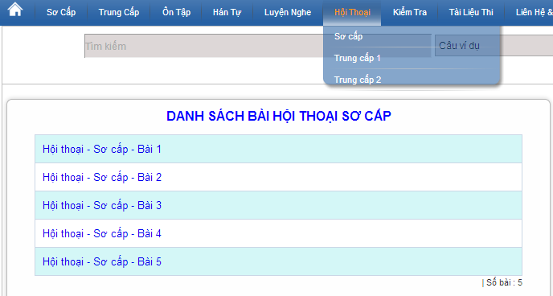

Figure 4.3: Listening conversation

Screen description:

|  |  |  |  |  |  |
| --- | --- | --- | --- | --- | --- |
| No | Field name | Type | Require | Mandatory | Description |
| 1 | SC_P1 | Hyperlink | Click | N | Display information of conversation |
| 2 | SC_P2 | Hyperlink | Click | N | Display information of conversation |
| 3 | SC_P3 | Hyperlink | Click | N | Display information of conversation |
| 4 | SC_P4 | Hyperlink | Click | N | Display information of conversation |
| 5 | SC_P5 | Hyperlink | Click | N | Display information of conversation |

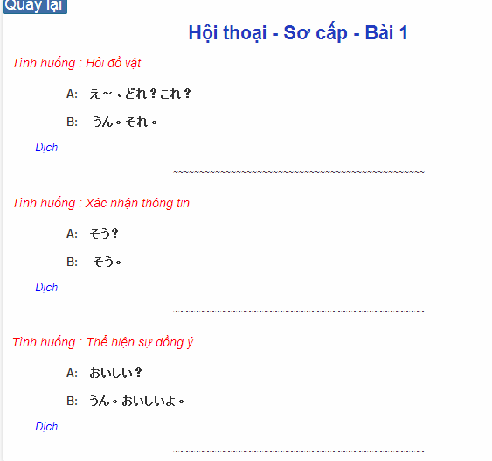

Figure 4.3.1: Conversation content

Table 4.2.1 : Training listening content’s screen description:

|  |  |  |  |  |  |  |
| --- | --- | --- | --- | --- | --- | --- |
| No | Field name | Field name in Vietnamese | Type | Require | Mandatory | Description |
| 1 | Translation | Dịch | Link | Click | Y | User click to display translation |

|  |  |  |  |  |
| --- | --- | --- | --- | --- |
| **UC016 – Listening conversation** | | | | |
| **Use-case No.** | <UC016> | **Use-case Version** | | <1.0> |
| **Use-case Name** | Listening conversation | | | |
| **Author** | Tuan NN | | | |
| **Date** | 09/06/2014 | **Priority** | <High > | |
| **Actor:**  Guest, Member  **Summary:**  This function provide users some the conversation in everyday life and common situations (eg: restaurants, shopping, in hospital ..)  **Triggers**  Click on “Hội thoại” link on the website  **Preconditions:**   * Website is available   **Post Conditions:**  Listening conversation in the website  **Main Success Scenario:**   |  |  |  | | --- | --- | --- | | **Step** | **User** | **System** | | 1 | Enter websie link n web browser | Display Homepage screen | | 2 | Click on “Hội thoại” section | Display “Hội thoại” page |     **Alternative Scenario:**   |  |  |  | | --- | --- | --- | | **At Step** | **User** | **System** | | 4 | While listening, click another link | Switch to selected page | | | | | |

###### UC017 < Practice management Module>: Reading document

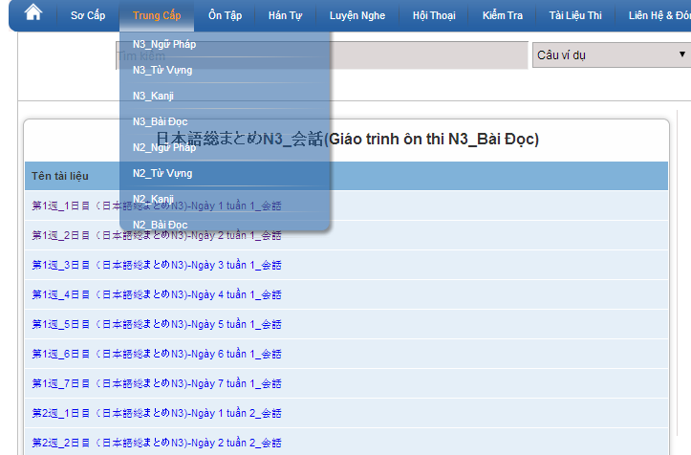

Figure 4.4: Reading document

Screen description: This is reading screen. At here, user can read document in the website, there are some lesson to reading in the reading document.

|  |  |  |  |  |
| --- | --- | --- | --- | --- |
| **UC017 – Reading document** | | | | |
| **Use-case No.** | <UC017> | **Use-case Version** | | <1.0> |
| **Use-case Name** | Reading document | | | |
| **Author** | Tuan NN | | | |
| **Date** | 09/06/2014 | **Priority** | <High > | |
| **Actor:**  Guest, Member  **Summary:**  This function provides users some document: elementary, intermediate and review.  **Triggers**  Click on “N3/N2 Bài đọc” link on the website  **Preconditions:**   * Website is available   **Post Conditions:**  Reading document in the website  **Main Success Scenario:**   |  |  |  | | --- | --- | --- | | **Step** | **User** | **System** | | 1 | Enter website link on web browser | Display Homepage screen | | 2 | Click on “Bài đọc” section | Display “Bài đọc” page |     **Alternative Scenario:**   |  |  |  | | --- | --- | --- | | **At Step** | **User** | **System** | | 4 | While reading, click another link | Switch to selected page | | | | | |

#### Admin’s account management

##### Use case diagram

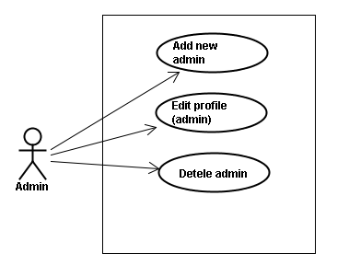

##### Use case specifications

###### UC018 <Admin’s account management>: Add new admin

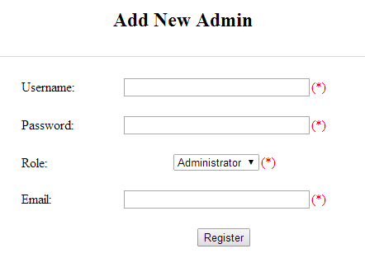

Figure 5.1: Add new admin

Table 5.1: Add new admin’s screen description:

|  |  |  |  |  |  |  |
| --- | --- | --- | --- | --- | --- | --- |
| No | Field name | Type | Require | Mandatory | Max-Length | Description |
| 1 | Username | Text | Text | Y | 32 | Admin input username of admin’s account with length less than 32 characters |
| 2 | Password | Text | Text | Y | 100 | Admin input password of admin’s account with length less than 32 characters |
| 3 | Roll | Drop-down list | Choose | Y |  | Admin choose the roll of account |
| 4 | Email | Text | Text | Y | 100 | Admin input email of admin’s account with length less than 100 characters |
| 5 | Register | Button | Click | Y |  | Admin add new admin |

|  |  |  |  |  |
| --- | --- | --- | --- | --- |
| **UC018 – Add new admin** | | | | |
| **Use-case No.** | <UC018> | **Use-case Version** | | <1.0> |
| **Use-case Name** | Add new admin | | | |
| **Author** | Tuan NN | | | |
| **Date** | 09/06/2014 | **Priority** | <High > | |
| **Actor:**  Admin  **Summary:**  Administrator can add new admin  **Triggers**  Admin login the website and click on add new admin link on the website  **Preconditions:**   * Website is available * Admin login to the website   **Post Conditions:**  New admin be added successfully  **Main Success Scenario:**   |  |  |  | | --- | --- | --- | | **Step** | **User** | **System** | | 1 | Enter website link on web browser | Display Homepage screen | | 2 | Enter necessary and mandatory information and click "Login” | Redirect to previous page and logged admin into system. | | 3 | Click on add new admin button | Display “Add New Admin” screen that contains these elements:   * Username * Password * Roll * Email | | 4 | Fill test information into all necessary or mandatory fields and click “Add” button | The system validates the input data and then save new test data into database |     **Alternative Scenario:**   |  |  |  | | --- | --- | --- | | **At Step** | **User** | **System** | | 4 | Input data in account area then click on another link | Switch to selected page |   **Exceptions:**   |  |  |  | | --- | --- | --- | | **At Step** | **User** | **System** | | 4 | Fill incorrect account name | Return Error message | | | | | |

###### UC019 <Admin’s account management>: Edit profile (admin)

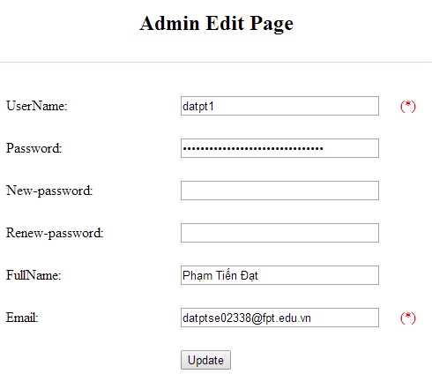

Figure 5.2: Edit profile admin

Table 5.2: Edit profile admin’s screen description:

|  |  |  |  |  |  |  |
| --- | --- | --- | --- | --- | --- | --- |
| No | Field name | Type | Require | Mandatory | Max-Length | Description |
| 1 | Username | Text | Text | N |  | Username of admin’s account |
| 2 | New-password | Text | Text | Y | 32 | Admin input new password with length less than 32 characters |
| 3 | Renew-password | Text | Text | Y | 32 | Admin re-input new password with length less than 32 characters |
| 4 | Fullname | Text | Text | Y | 100 | Admin input full name with length less than 100 characters |
| 5 | Email | Text | Text | Y | 100 | Admin input email with length less than 100 characters |
| 6 | Update | Button | Click | Y |  | User click to edit vocabulary |

|  |  |  |  |  |
| --- | --- | --- | --- | --- |
| **UC019 – Edit profile(admin)** | | | | |
| **Use-case No.** | <UC019> | **Use-case Version** | | <1.0> |
| **Use-case Name** | Edit profile admin | | | |
| **Author** | Tuan NN | | | |
| **Date** | 09/06/2014 | **Priority** | <High > | |
| **Actor:**  Administrator  **Summary:**  Administrator want to change their profile  **Triggers**  Administrator login the website and click on the edit profile link  **Preconditions:**   * Website is available * Administrator login the website   **Post Conditions:**  Edit admin profile and redirect to edited profile page  **Main Success Scenario:**   |  |  |  | | --- | --- | --- | | **Step** | **User** | **System** | | 1 | Enter website link on web browser | Display Homepage screen | | 2 | Enter necessary and mandatory information and click "Login” | Redirect to previous page and logged admin into system. | | 3 | Click on edit profile tab | Display “Edit profile” screen that contains these elements:   * Username * Password * New-Password * Renew-Password * Full name * Email | | 4 | Fill test information into all necessary or mandatory fields and click “Add” button | The system validates the input data and then save new test data into database |   **Alternative Scenario:**   |  |  |  | | --- | --- | --- | | **At Step** | **User** | **System** | | 4 | Enter necessary and mandatory information and click another link | Switch to selected page |   **Exceptions:**   |  |  |  | | --- | --- | --- | | **At Step** | **User** | **System** | | 4 | Enter new password that incorrect form or missing information and click “Lưu” button | Display error message | | 4 | Enter new email that incorrect form or missing information and click “Lưu” button | Display error message | | | | | |

###### UC020 <Admin’s account management>: Delete admin

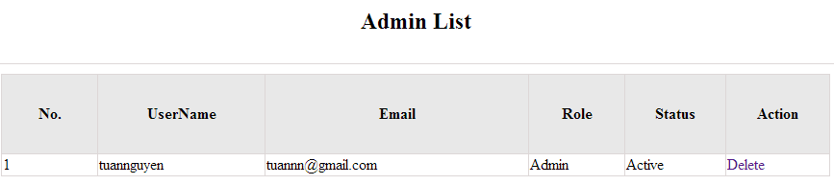

Figure 5.3: Delete admin

|  |  |  |  |  |
| --- | --- | --- | --- | --- |
| **UC020 – Delete admin** | | | | |
| **Use-case No.** | <UC020> | **Use-case Version** | | <1.0> |
| **Use-case Name** | Delete admin | | | |
| **Author** | Tuan NN | | | |
| **Date** | 09/06/2014 | **Priority** | <High > | |
| **Actor:**  Administrator  **Summary:**  Administrators can remove administrator rights of other admin  **Triggers**  Login the website and click on the delete admin link  **Preconditions:**   * Website is available * Admin login the website   **Post Conditions:**  Admin will be remove administrator rights  **Main Success Scenario:**   |  |  |  | | --- | --- | --- | | **Step** | **User** | **System** | | 1 | Enter website link on web browser | Display Homepage screen | | 2 | Enter necessary and mandatory information and click "Login” | Redirect to previous page and logged admin into system. | | 3 | Click on delete admin link. | Display delete admin page | | 4 | Enter the account that you want to remove administrator rights | Remove administrator rights of account and display message to remove successfully |     **Alternative Scenario:**   |  |  |  | | --- | --- | --- | | **At Step** | **User** | **System** | | 4 | Input data in account area then click on another link | Switch to selected page |   **Exceptions:**   |  |  |  | | --- | --- | --- | | **At Step** | **User** | **System** | | 4 | Fill incorrect account name | Return Error message | | | | | |

#### Management Member’s account

##### Use case diagram

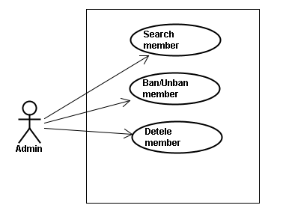

##### Screen description

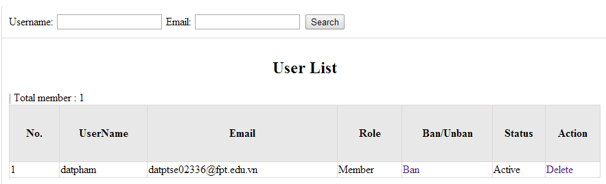

Figure 6: Management Member

Table 6: Management member’s screen description:

|  |  |  |  |  |  |  |
| --- | --- | --- | --- | --- | --- | --- |
| No | Field name | Type | Require | Mandatory | Max-Length | Description |
| 1 | Username | Text | Text | Y | 32 | Admin input username to search member by username |
| 2 | Email | Text | Text | Y | 100 | Admin input email to search member by email |
| 3 | Ban/Unban | Button | Click | N |  | Admin click ban/unban member |
| 4 | Delete | Button | Click | N |  | Admin click delete member |

##### Use case specifications

###### UC021 <Management Member’s account>: Search member

Search member screen:

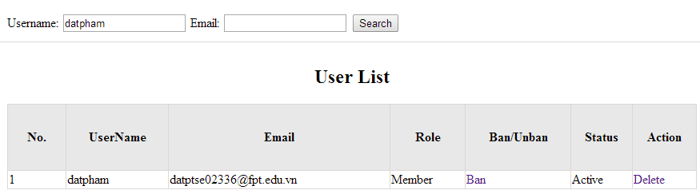

|  |  |  |  |  |
| --- | --- | --- | --- | --- |
| **UC021 – Search member** | | | | |
| **Use-case No.** | <UC021> | **Use-case Version** | | <1.0> |
| **Use-case Name** | Search member | | | |
| **Author** | Tuan NN | | | |
| **Date** | 09/06/2014 | **Priority** | <High > | |
| **Actor:**  Admin  **Summary:**  When admin want to search by member’s account in database successfully if it is existed  **Triggers**  Admin login the website and click on search member , input member’s account in the right text box then click “Search” button  **Preconditions:**   * Website is available * Admin must be login * Input data must be correctly   **Post Conditions:**  Display detail information of member  **Main Success Scenario:**   |  |  |  | | --- | --- | --- | | **Step** | **User** | **System** | | 1 | Enter website link on web browser | Display Homepage screen | | 2 | Enter necessary and mandatory information and click "Login” | Redirect to previous page and logged admin into system. | | 3 | Click on "Search member" button and input member’s account or email | Display “member information” screen that contains the information :   * No * User Name * Email * Roll * Ban/Unban * Status * Delete |     **Alternative Scenario:**   |  |  |  | | --- | --- | --- | | **At Step** | **User** | **System** | | 3 | Fill information of the member that they want to find into these fields then click on another link | Switch to selected page |   **Exceptions:**   |  |  |  | | --- | --- | --- | | **At Step** | **User** | **System** | | 3 | Fill information of the member that they want to find (that do not exist in database) into these fields then click “Search” button | Return Error message to inform that member cannot be found | | | | | |

###### UC022 <Management Member’s account>: Ban/Unban member

|  |  |  |  |  |
| --- | --- | --- | --- | --- |
| **UC022 – Search member** | | | | |
| **Use-case No.** | <UC022> | **Use-case Version** | | <1.0> |
| **Use-case Name** | Ban/Unban member | | | |
| **Author** | Tuan NN | | | |
| **Date** | 09/06/2014 | **Priority** | <High > | |
| **Actor:**  Admin  **Summary:**  When admin can ban user who violated rule of website and unban member  **Triggers**  Admin login the website and click on member’s account and then click “Ban/Unban” button  **Preconditions:**   * Website is available * Admin must be login * Input data must be correctly   **Post Conditions:**  Member’s account will be ban/unban by administrator  **Main Success Scenario:**   |  |  |  | | --- | --- | --- | | **Step** | **User** | **System** | | 1 | Enter website link on web browser | Display Homepage screen | | 2 | Enter necessary and mandatory information and click "Login” | Redirect to previous page and logged admin into system. | | 3 | Click on "Search member" button and input member’s account or email | Display “member information” screen that contains the information | | 4 | Click “Ban/Unban” link | Ban/Unban member |   **Alternative Scenario:**   |  |  |  | | --- | --- | --- | | **At Step** | **User** | **System** | | 3 | Fill information of the member that they want to find into these fields then click on another link | Switch to selected page |   **Exceptions:**   |  |  |  | | --- | --- | --- | | **At Step** | **User** | **System** | | 3 | Fill information of the member that they want to find (that do not exist in database) into these fields then click “Search” button | Return Error message to inform that member cannot be found | | | | | |

###### UC023 <Management Member’s account>: Delete member

|  |  |  |  |  |
| --- | --- | --- | --- | --- |
| **UC023 – Delete member** | | | | |
| **Use-case No.** | <UC023> | **Use-case Version** | | <1.0> |
| **Use-case Name** | Delete member | | | |
| **Author** | Tuan NN | | | |
| **Date** | 09/06/2014 | **Priority** | <High > | |
| **Actor:**  Admin  **Summary:**  Administrators can delete member who violated rule of website  **Triggers**  Admin login the website and click on the delete member link  **Preconditions:**   * Website is available * Admin must be login * Input data must be correctly   **Post Conditions:**  Member’s account will be removed from system  **Main Success Scenario:**   |  |  |  | | --- | --- | --- | | **Step** | **User** | **System** | | 1 | Enter website link on web browser | Display Homepage screen | | 2 | Enter necessary and mandatory information and click "Login” | Redirect to previous page and logged admin into system. | | 3 | Click on "Search member" button and input member’s account or email | Display information of member | | 4 | Click on delete link corresponding with member want to delete | Remove member from list |     **Alternative Scenario:**   |  |  |  | | --- | --- | --- | | **At Step** | **User** | **System** | | 3 | Fill information of the member that they want to find into these fields then click on another link | Switch to selected page |   **Exceptions:**   |  |  |  | | --- | --- | --- | | **At Step** | **User** | **System** | | 3 | Fill information of the member that they want to find (that do not exist in database) into these fields then click “Search” button | Return Error message to inform that member cannot be found | | | | | |

#### Vocabulary Management

##### Use case diagram

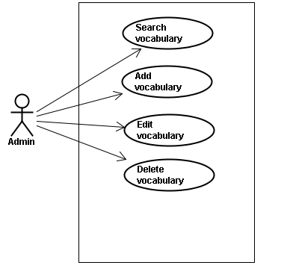

##### Screen description

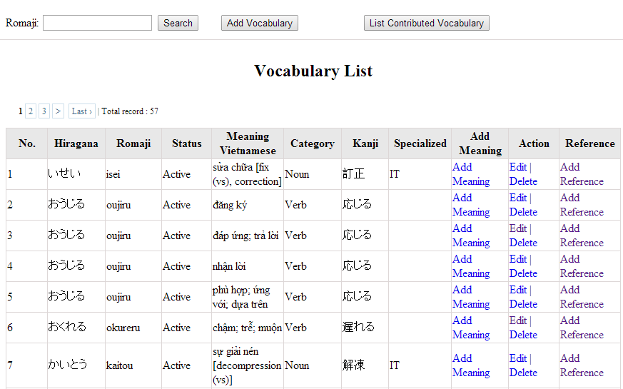

Figure 7: Vocabulary management

Table 7.1: Vocabulary management’s screen description:

|  |  |  |  |  |  |  |
| --- | --- | --- | --- | --- | --- | --- |
| No | Field name | Type | Require | Mandatory | Max-Length | Description |
| 1 | Romaji | Text | Text | Y | 100 | Admin input romaji with length less than 100 character |
| 2 | Search | Button | Click | Y |  | Admin click to search vocabulary |
| 2 | Add-new | Button | Click | N |  | Admin add new vocabulary into database |
| 3 | Add meaning | Button | Click | Y |  | Admin add meaning of vocabulary |
| 4 | Edit | Button | Click | N |  | Admin click edit vocabulary |
| 5 | Delete | Button | Click | N |  | Admin click delete vocabulary |
| 6 | Add-reference | Button | Click | N |  | Admin add reference of vocabulary if reference exist |
| 7 | List-contribute | Button | Click | N |  | Admin click to view list contribute |

##### Use case specifications

###### UC024 <Vocabulary Management>: Search vocabulary

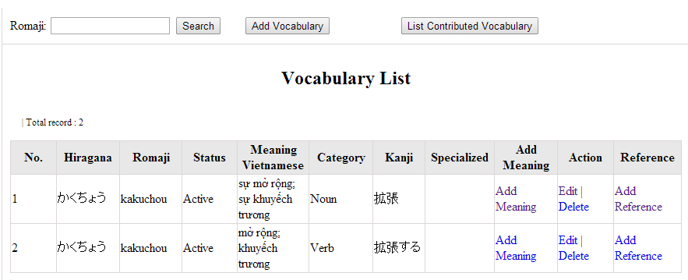

Figure 7.1: Search vocabulary

|  |  |  |  |  |
| --- | --- | --- | --- | --- |
| **UC0024 – Specification** | | | | |
| **Use-case No.** | <UC0024> | **Use-case Version** | | <1.0> |
| **Use-case Name** | Search vocabulary | | | |
| **Author** | TuanNN | | | |
| **Date** | 09/06/2014 | **Priority** | <High > | |
| **Actor:**  Admin  **Summary:**  When Administrator want to search a vocabulary on database  **Goal:**  Administrator can search vocabulary in database successfully if it is existed  **Triggers**  Admin login the website and click on “Vocabulary management” tab, input vocabulary in the right text box then click “Search” button  **Preconditions:**   * Website is available * Admin must be login * Input data must be correctly   **Post Conditions:**  Display detail information of vocabulary  **Main Success Scenario:**   |  |  |  | | --- | --- | --- | | **Step** | **User** | **System** | | 1 | Enter website link on web browser | Display Homepage screen | | 2 | Enter necessary and mandatory information and click "Login” | Redirect to previous page and logged admin into system. | | 4 | Click on “vocabulary management” tab | Displays criteria search screen | | 5 | Fill information of the vocabulary that they want to find into these fields then click “Search” button | Displays search result as a table with these elements:   * No * Hiragana * Romaji * Status * Meaning * Category * Kanji * Specialized * Add meaning * Edit * Delete * Add reference |     **Alternative Scenario:**   |  |  |  | | --- | --- | --- | | **At Step** | **User** | **System** | | 5 | Fill information of the vocabulary that they want to find into these fields then click on another link | Switch to selected page |   **Exceptions:**   |  |  |  | | --- | --- | --- | | **At Step** | **User** | **System** | | 5 | Fill information of the vocabulary that they want to find (that do not exited in database) into these fields then click “Search” button | Return Error message to inform that vocabulary structure cannot be found | | | | | |

###### UC025 <Vocabulary Management>: Add vocabulary

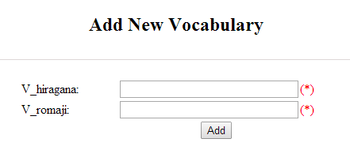

Figure 7.2: Add new vocabulary

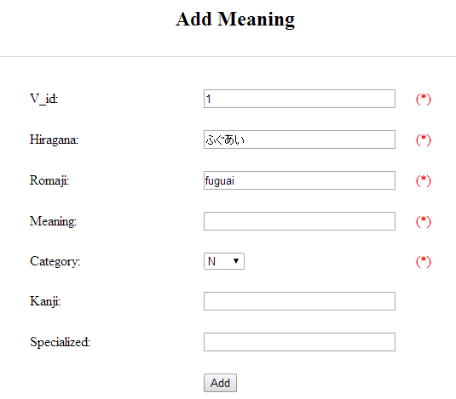

Figure 7.2.1: Add vocabulary meaning

Table 7.2: Add new vocabulary & meaning’s screen description:

|  |  |  |  |  |  |  |
| --- | --- | --- | --- | --- | --- | --- |
| No | Field name | Type | Require | Mandatory | Max-Length | Description |
| 1 | Hiragana | Text | Text | Y | 200 | Admin input vocabulary by hiragana with length less than 200 characters |
| 2 | Romaji | Text | Text | Y | 200 | Admin input vocabulary by romaji with length less than 200 characters |
| 3 | Meaning | Text | Text | Y | 500 | Admin input mean of vocabulary with length less than 500 characters |
| 4 | Category | Drop-down list | Click | Y |  | Admin choose category of vocabulary |
| 5 | Kanji | Text | Text | Y | 10 | Admin input vocabulary by kanji with length less than 10 characters |
| 6 | Specialized | Text | Text | Y | 200 | Admin input specialized of vocabulary with length less than 200 characters |
| 7 | Add | Button | Click | Y |  | Admin add new vocabulary |

|  |  |  |  |  |
| --- | --- | --- | --- | --- |
| **UC0025 - Specification** | | | | |
| **Use-case No.** | <UC0025> | **Use-case Version** | | <1.0> |
| **Use-case Name** | Add vocabulary | | | |
| **Author** | Tuan NN | | | |
| **Date** | 09/06/2014 | **Priority** | <High > | |
| **Actor:**  Admin  **Summary:**  When Administrator want to add a vocabulary into database. They have to insert all necessary data of vocabulary into “Add new vocabulary” screen  **Goal:**  Administrator can add new vocabulary information in database successfully  **Triggers**  User must click on “Vocabulary management/ Add new” tab and input all necessary information of vocabulary into the right fields then click on “Add new” button  **Preconditions:**   * Website is available * User have logged into system as an admin. * All mandatory fields have been filled * All input data must be valid and have not existed in system   **Post Conditions:**  New vocabulary has been saved into system database successfully  **Main Success Scenario:**   |  |  |  | | --- | --- | --- | | **Step** | **User** | **System** | | 1 | Enter website link on web browser | Display Homepage screen | | 2 | Enter necessary and mandatory information and click "Login” | Redirect to previous page and logged admin into system. | | 3 | Click on “Vocabulary management/Add new” tab | Display “Add New Vocabulary” screen that contains these elements:   * Hiragana * Romaji | | 4 | Fill information into all necessary or mandatory fields and click “Add” button | The system validates the input data and then save new vocabulary data into database | | 5 | Click on “Vocabulary management/Add meaning” tab | Display “Add meaning” screen that contains these elements:   * Hiragana * Romaji * Meaning * Category * Kanji * Specialized | | 6 | Fill information into all necessary or mandatory fields and click “Add” button | The system validates the input data and then save new vocabulary data into database | | 7 | Click on “Vocabulary management/Add reference” tab | Display “Add meaning” screen that contains these elements:   * Vocabulary * Meaning * Sentence | | 8 | Choose sentence and click “Add” button | The system validates the input data and then save new vocabulary data into database |     **Alternative Scenario:**   |  |  |  | | --- | --- | --- | | **At Step** | **User** | **System** | | 4 | Click on another link | Do not save new vocabulary data into database then redirect to selected page | | 6 | Click on another link | Do not save meaning data into database then redirect to selected page | | 8 | Click on another link | Do not save reference into database then redirect to selected page |   **Exceptions:**   |  |  |  | | --- | --- | --- | | **At Step** | **User** | **System** | | 4 | Do not fill full information into fields then click “Add” button | Return Error message beside empty field and ask if user want to add with empty field. | | 6 | Do not fill full information into fields then click “Add” button | Return Error message beside empty field and ask if user want to add with empty field. | | 8 | Do not fill full information into fields then click “Add” button | Return Error message beside empty field and ask if user want to add with empty field. | | | | | |

###### UC026 <Vocabulary Management>: Edit vocabulary

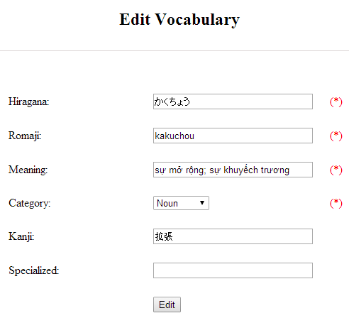

Figure 7.3: Edit vocabulary

Table 7.3: Edit vocabulary’s screen description:

|  |  |  |  |  |  |  |
| --- | --- | --- | --- | --- | --- | --- |
| No | Field name | Type | Require | Mandatory | Max-Length | Description |
| 1 | Hiragana | Text | Text | Y | 200 | Admin input vocabulary by hiragana with length less than 200 characters |
| 2 | Romaji | Text | Text | Y | 200 | Admin input vocabulary by romaji with length less than 200 characters |
| 3 | Meaning | Text | Text | Y | 500 | Admin input mean of vocabulary with length less than 500 characters |
| 4 | Category | Drop-down list | Click | Y |  | Admin choose category of vocabulary |
| 5 | Kanji | Text | Text | Y | 10 | Admin input vocabulary by kanji with length less than 10 characters |
| 6 | Specialized | Text | Text | Y | 200 | Admin input specialized of vocabulary with leng less than 200 characters |
| 7 | Edit | Button | Click | Y |  | Admin edit vocabulary |

|  |  |  |  |  |
| --- | --- | --- | --- | --- |
| **UC0026 - Specification** | | | | |
| **Use-case No.** | <UC0026> | **Use-case Version** | | <1.0> |
| **Use-case Name** | Edit vocabulary | | | |
| **Author** | TuanNN | | | |
| **Date** | 09/06/2014 | **Priority** | <High > | |
| **Actor:**  Admin  **Summary:**  When Administrator want to edit a vocabulary on database which has some new meanings or errors  **Goal:**  Administrator can edit vocabulary information in database successfully  **Triggers**  User must click on “Vocabulary management” then search for the vocabulary. User click on “Edit” link on corresponding vocabulary. They edit necessary information in the right fields then click on “Edit” button.  **Preconditions:**   * Website is available * User have logged into system as an admin. * All mandatory fields have been filled * All input data must be valid and have not existed in system   **Post Conditions:**  Changed information of vocabulary has been saved into system database successfully  **Main Success Scenario:**   |  |  |  | | --- | --- | --- | | **Step** | **User** | **System** | | 1 | Enter website link on web browser | Display Homepage screen | | 2 | Enter necessary and mandatory information and click "Login” | Redirect to previous page and logged admin into system. | | 3 | Click on “Vocabulary management ” then search for the vocabulary that they want to edit | Displays search result as a table | | 4 | Click on “Edit” link | Display “Edit Vocabulary” screen that contains the information of chosen vocabulary with these elements:   * Hiragana * Romaji * Meaning * Category * Kanji * Specialized | | 5 | Edit vocabulary information and click “Edit” button | The system validates the input data and then save data into database |     **Alternative Scenario:**   |  |  |  | | --- | --- | --- | | **At Step** | **User** | **System** | | 4 | Edit vocabulary information then click to another link | Do not save edited data then redirect to selected page |   **Exceptions:**   |  |  |  | | --- | --- | --- | | **At Step** | **User** | **System** | | 4 | Edit vocabulary information to be similar to another existed grammar and click “Edit” button | The system validates the input data and return Error message and do not save edited data into database |   **Reference:**  UC0024 - Search Vocabulary | | | | |

###### UC027 <Vocabulary Management>: Delete vocabulary

|  |  |  |  |  |
| --- | --- | --- | --- | --- |
| **UC0027 - Specification** | | | | |
| **Use-case No.** | <UC0027> | **Use-case Version** | | <1.0> |
| **Use-case Name** | Delete vocabulary | | | |
| **Author** | TuanNN | | | |
| **Date** | 09/06/2014 | **Priority** | <High > | |
| **Actor:**  Admin  **Summary:**  When Administrator want to delete a vocabulary on database  **Goal:**  Administrator can delete selected vocabulary in database successfully  **Triggers**  User must click on “Vocabulary management” then search for the vocabulary. User click on “Delete” link on corresponding vocabulary.  **Preconditions:**   * Website is available * User have logged into system as an admin. * All mandatory fields have been filled * All input data must be valid and have existed in system   **Post Conditions:**  Vocabulary has been deleted from system database successfully  **Main Success Scenario:**   |  |  |  | | --- | --- | --- | | **Step** | **User** | **System** | | 1 | Enter website link on web browser | Display Homepage screen | | 2 | Enter necessary and mandatory information and click "Login” | Redirect to previous page and logged admin into system. | | 3 | Click on “Vocabulary management ” then search for the vocabulary that they want to delete | Displays search result as a table | | 4 | Click on “Delete” link beside that vocabulary row | Remove that vocabulary from list |   **Exceptions:**   |  |  |  | | --- | --- | --- | | **At Step** | **User** | **System** | |  |  |  |   **Reference:**  UC0024 - Search vocabulary | | | | |
|  | | | | |

#### Grammar Management

##### Use case diagram

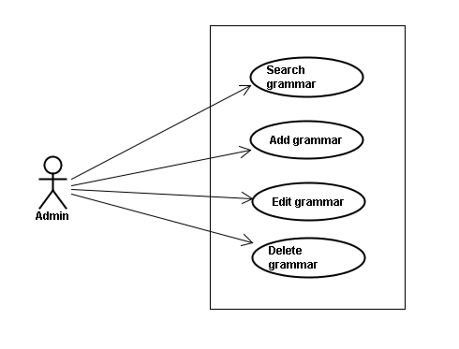

##### Screen description

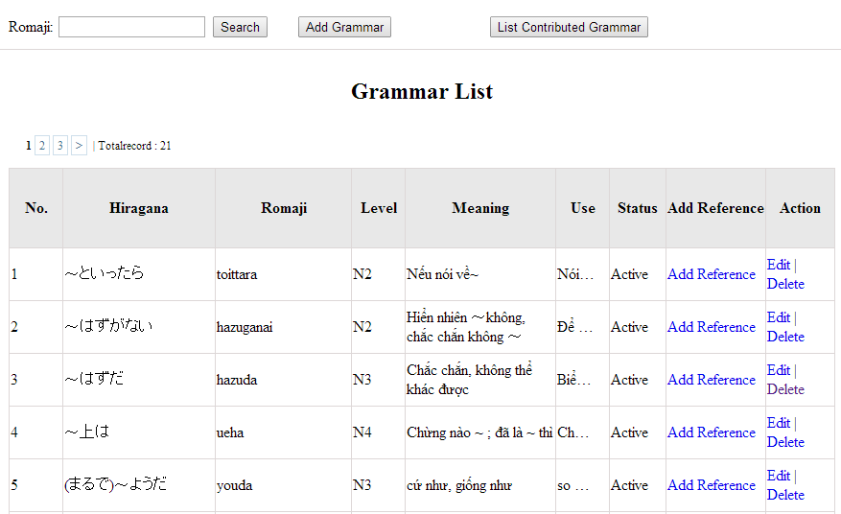

Figure 8: Grammar management

Table 8.1: Grammar management’s screen description:

|  |  |  |  |  |  |  |
| --- | --- | --- | --- | --- | --- | --- |
| No | Field name | Type | Require | Mandatory | Max-Length | Description |
| 1 | Romaji | Text | Text | Y | 100 | Admin input romaji with length less than 100 character |
| 2 | Add-new | Button | Click | N |  | Admin add new grammar into database |
| 3 | Edit | Button | Click | N |  | Admin click edit grammar |
| 4 | Delete | Button | Click | N |  | Admin click delete grammar |
| 5 | Add-reference | Button | Click | N |  | Admin add reference of grammar |
| 6 | List-contribute | Button | Click | N |  | Admin click to view list contribute |

##### Use case specifications

###### UC0028: <Admin> Search grammar

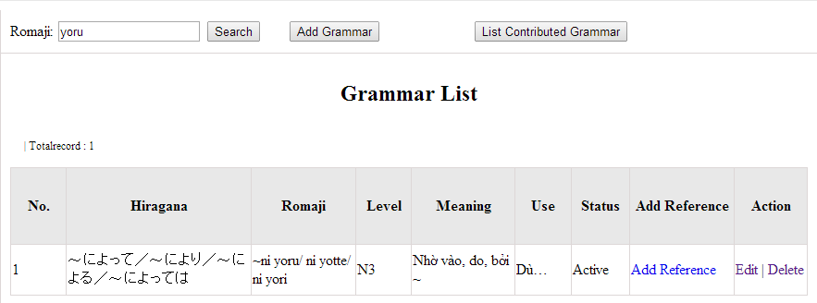

Figure 8.1: Search grammar

|  |  |  |  |  |
| --- | --- | --- | --- | --- |
| **UC0028 - Specification** | | | | |
| **Use-case No.** | <UC0028> | **Use-case Version** | | <1.0> |
| **Use-case Name** | Search grammar | | | |
| **Author** | Minh PT | | | |
| **Date** | 09/06/2014 | **Priority** | <High > | |
| **Actor:**  Admin  **Summary:**  When Administrator wants to search a grammatical structure in database, Admin can input a grammatical structure by “romaji” letter then click button “Search”. If that grammatical structure is existed, system will return meaning.  **Triggers**  Click on “Grammar management” tab, input grammatical structure in the right text box then click “Search” button  **Preconditions:**   * Website is available * User has to login as Administrator * User has to input data in search area   **Post Conditions:**  Display detail information of grammatical structure  **Main Success Scenario:**   |  |  |  | | --- | --- | --- | | **Step** | **User** | **System** | | 1 | Have logged into system as an admin |  | | 2 | Click on “Grammar management” tab | Displays criteria search screen | | 3 | Fill information of the grammatical structure that they want to find into these fields then click “Search” button | Displays search result as a table with these elements:   * No * Hiragana * Romaji * Level * Meaning * Use * Status * Add reference * Edit * Delete |     **Alternative Scenario:**   |  |  |  | | --- | --- | --- | | **At Step** | **User** | **System** | | 3 | Fill information of the grammatical structure that they want to find into these fields then click on another link | Switch to selected page |   **Exceptions:**   |  |  |  | | --- | --- | --- | | **At Step** | **User** | **System** | | 3 | Fill information of the grammatical structure that they want to find (that do not exited in database) into these fields then click “Search” button | Return Error message to inform that grammatical structure cannot be found | | | | | |

###### UC0029: <Admin> Add grammar

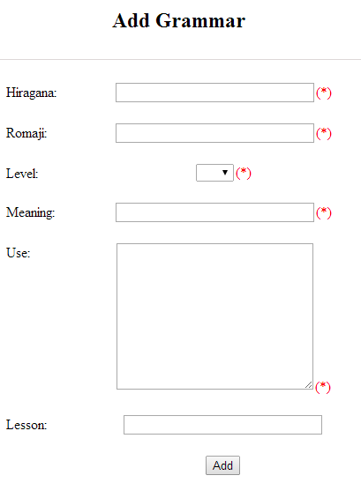

Figure 8.2: Add grammar

Table 8.2: Add grammar’s screen description:

|  |  |  |  |  |  |  |
| --- | --- | --- | --- | --- | --- | --- |
| No | Field name | Type | Require | Mandatory | Max-Length | Description |
| 1 | Hiragana | Text | Text | Y | 200 | Admin input grammar by hiragana with length less than 200 characters |
| 2 | Romaji | Text | Text | Y | 200 | Admin input grammar by romaji with length less than 200 characters |
| 3 | Meaning | Text | Text | Y | 200 | Admin input mean of grammar with length less than 200 characters |
| 4 | Use | Text | Text | Y | 1000 | Admin input use of grammar with length less than 1000 characters |
| 5 | Level | Drop-down list | Choose | Y |  | Admin choose level of grammar |
| 6 | Lesson | Text | Text | Y | 20 | Admin input lesson |
| 7 | Add | Button | Click | Y |  | Admin add new grammar |

|  |  |  |  |  |
| --- | --- | --- | --- | --- |
| **UC0029 - Specification** | | | | |
| **Use-case No.** | <UC0029> | **Use-case Version** | | <1.0> |
| **Use-case Name** | Add grammar | | | |
| **Author** | Minh PT | | | |
| **Date** | 09/06/2014 | **Priority** | <High > | |
| **Actor:**  Admin  **Summary:**  When Administrator wants to add a grammar into database. They have to insert all necessary data of grammar into “Add Grammar” screen then click “Add” button  **Triggers**  User must click on “Grammar management/ Add New” and input all necessary information of grammar into the right fields then click on “Add” button  **Preconditions:**   * Website is available * User has to login as Administrator * All mandatory fields have been filled * All input data must be valid and have not existed in system   **Post Conditions:**  New grammatical structure has been saved into system database successfully  **Main Success Scenario:**   |  |  |  | | --- | --- | --- | | **Step** | **User** | **System** | | 1 | Have logged into system as an admin |  | | 2 | Click on “Grammar management/Add New” | Display “Add Grammar” screen that contains these elements:   * Hiragana * Romaji * Level * Meaning * Use * Lesson | | 3 | Fill grammar information into all necessary or mandatory fields and click “Add” button | The system validates the input data and then save new grammar data into database | | 4 | Click on “Grammar management/Add Reference” | Display “Add Grammar” screen that contains these elements:   * Grammar * Meaning * Reference | | 5 | Fill grammar information into all necessary or mandatory fields and click “Add” button | The system validates the input data and then save new grammar data into database |     **Alternative Scenario:**   |  |  |  | | --- | --- | --- | | **At Step** | **User** | **System** | | 3 | Click on another link | Do not save new grammar data into database then redirect to selected page | | 5 | Click on another link | Do not save new reference data into database then redirect to selected page |   **Exceptions:**   |  |  |  | | --- | --- | --- | | **At Step** | **User** | **System** | | 3 | Do not fill full information into fields then click “Add” button | Return Error message and request user input data into all fields | | 5 | Do not fill full information into fields then click “Add” button | Return Error message and request user input data into all fields | | | | | |

###### UC0030: <Admin> Edit grammar

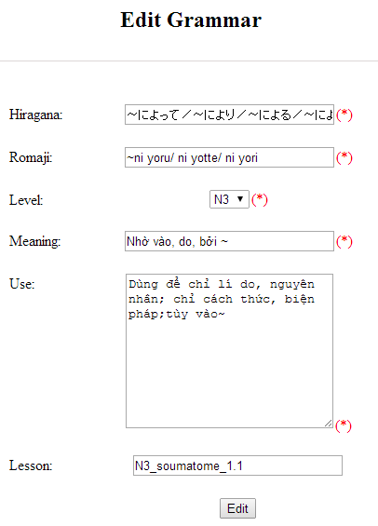

Figure 8.3: Edit grammar

Table 8.3: Edit vocabulary’s screen description:

|  |  |  |  |  |  |  |
| --- | --- | --- | --- | --- | --- | --- |
| No | Field name | Type | Require | Mandatory | Max-Length | Description |
| 1 | Hiragana | Text | Text | Y | 200 | Admin input grammar by hiragana with length less than 200 characters |
| 2 | Romaji | Text | Text | Y | 200 | Admin input grammar by romaji with length less than 200 characters |
| 3 | Meaning | Text | Text | Y | 200 | Admin input mean of grammar with length less than 200 characters |
| 4 | Use | Text | Text | Y | 1000 | Admin input use of grammar with length less than 1000 characters |
| 5 | Level | Drop-down list | Choose | Y |  | Admin choose level of grammar |
| 6 | Lesson | Text | Text | Y | 20 | Admin input lesson |
| 7 | Add | Button | Click | Y |  | Admin add new grammar |

|  |  |  |  |  |
| --- | --- | --- | --- | --- |
| **UC0030 - Specification** | | | | |
| **Use-case No.** | <UC0030> | **Use-case Version** | | <1.0> |
| **Use-case Name** | Edit grammar | | | |
| **Author** | Minh PT | | | |
| **Date** | 09/06/2014 | **Priority** | <High > | |
| **Actor:**  Admin  **Summary:**  When Administrator want to edit a grammatical structure in database which has some new meanings or errors. Admin will search that grammar then click “Edit” link. When edit finished, new meaning of that grammar will be updated.  **Triggers**  User must click on “Grammar management” then search for the grammatical structure. User click on “Edit” link corresponding with grammar which want to edit. Users edit necessary information of grammar in the right fields then click on “Edit” button.  **Preconditions:**   * Website is available * User has to login as Administrator * All mandatory fields have been filled * All input data must be valid and have not existed in system   **Post Conditions:**  Changed information of grammar has been saved into system database successfully  **Main Success Scenario:**   |  |  |  | | --- | --- | --- | | **Step** | **User** | **System** | | 1 | Have logged into system as an admin |  | | 2 | Click on “Management grammar ” then search for the grammatical structure that they want to edit | Displays search result as a table | | 3 | Click on “Edit” link corresponding with grammar | Display “Edit Grammar” screen that contains the information of chosen grammar with these elements:   * Hiragana * Romaji * Level * Meaning * Use * Lesson | | 4 | Edit grammar information and click “Edit” button | The system validates the input data and then save data into database |     **Alternative Scenario:**   |  |  |  | | --- | --- | --- | | **At Step** | **User** | **System** | | 4 | Edit grammar information then click to another link | Do not save edited data then redirect to selected page |   **Exceptions:**   |  |  |  | | --- | --- | --- | | **At Step** | **User** | **System** | | 4 | Edit grammar information to be similar to another existed grammar and click “Edit” button | The system validates the input data and return Error message and do not save edited data into database |   **Reference:**  UC0028 - <Admin> Search Grammar | | | | |

###### UC0031: <Admin> Delete grammar

|  |  |  |  |  |
| --- | --- | --- | --- | --- |
| **UC0031 - Specification** | | | | |
| **Use-case No.** | <UC0031> | **Use-case Version** | | <1.0> |
| **Use-case Name** | Delete grammar | | | |
| **Author** | Minh PT | | | |
| **Date** | 09/06/2014 | **Priority** | <High > | |
| **Actor:**  Admin  **Summary:**  When Administrator want to delete a grammar in database. Admin will search that grammar then click “Delete” link. When deleted finished, that grammar no longer exist in database.  **Triggers**  User must click on “Grammar management” then search for the grammatical structure. User click on “Delete” link corresponding with grammar which want to delete.  **Preconditions:**   * Website is available * User has to login as Administrator   **Post Conditions:**  Grammar has been deleted from system database successfully  **Main Success Scenario:**   |  |  |  | | --- | --- | --- | | **Step** | **User** | **System** | | 1 | Have logged into system as an admin |  | | 2 | Click on “Grammar management ” then search for the grammar that they want to delete | Displays search result as a table | | 3 | Click on “Delete” link corresponding with grammar | Remove that grammar in database |   **Reference:** UC0028 - <Admin> Search grammar | | | | |
|  | | | | |

#### Reading Document Management

##### Use case diagram

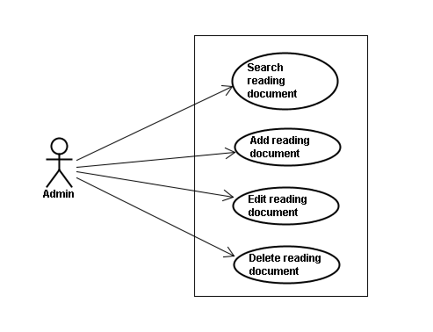

##### Screen description

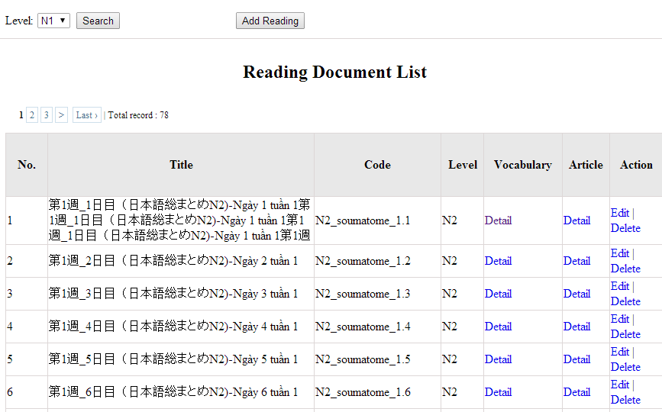

Figure 9: Reading document

Table 9: Reading document’s screen description:

|  |  |  |  |  |  |  |
| --- | --- | --- | --- | --- | --- | --- |
| No | Field name | Type | Require | Mandatory | Max-Length | Description |
| 1 | Level | Drop-down list | Click | Y |  | Admin choose the level |
| 2 | Search | Button | Click | Y |  | Admin click to search |
| 3 | Add-new | Button | Click | N |  | Admin add new into database |
| 4 | Edit | Button | Click | N |  | Admin click edit grammar |
| 5 | Delete | Button | Click | N |  | Admin click delete grammar |
| 6 | Detail-Vocab | Hyperlink | Click | N |  | Details of vocabulary |
| 7 | Detail-Article | Hyperlink | Click | N |  | Details of article |

##### Use case specifications

###### UC0032: <Admin> Search reading document

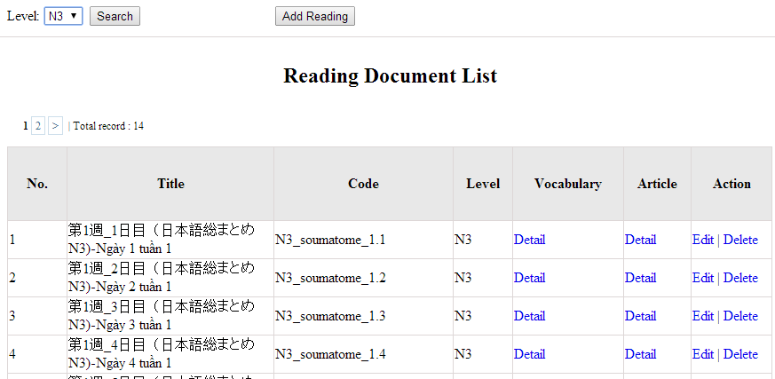

Figure 9.1 : Search reading document

|  |  |  |  |  |
| --- | --- | --- | --- | --- |
| **UC0032 - Specification** | | | | |
| **Use-case No.** | <UC0032> | **Use-case Version** | | <1.0> |
| **Use-case Name** | Search document | | | |
| **Author** | Minh PT | | | |
| **Date** | 09/06/2014 | **Priority** | <High > | |
| **Actor:**  Admin  **Summary:**  When Administrator want to search reading document in database and Administrator can search reading document in database successfully if it is existed  **Triggers**  Click on “Reading management” tab, choose level of reading document in the right text box then click “Search” button  **Preconditions:**  User has to login as Administrator user  **Post Conditions:**  Display detail information of reading document  **Main Success Scenario:**   |  |  |  | | --- | --- | --- | | **Step** | **User** | **System** | | 1 | Have logged into system as an admin |  | | 2 | Click on “Reading management” tab | Displays criteria search screen | | 3 | Choose level of the reading document that they want to find then click “Search” button | Displays search result as a table with these elements:   * No * Title * Code * Level * Vocabulary * Article * Edit * Delete |     **Alternative Scenario:**   |  |  |  | | --- | --- | --- | | **At Step** | **User** | **System** | | 3 | Choose level of the reading document that they want to find into these fields then click on another link | Switch to selected page |   **Exceptions:**   |  |  |  | | --- | --- | --- | | **At Step** | **User** | **System** | | 3 | Choose level of the reading document that they want to find (that do not exited in database) into these fields then click “Search” button | Return Error message to inform that reading document cannot be found | | | | | |

###### UC0033: <Admin> Add reading document

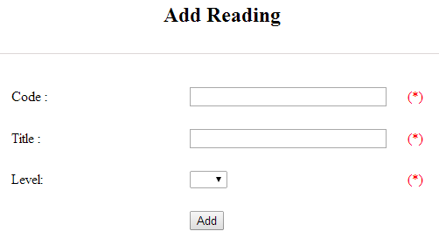

Figure 9.2 : Add reading document

Table 9.2 : Add reading document’s screen description:

|  |  |  |  |  |  |  |
| --- | --- | --- | --- | --- | --- | --- |
| No | Field name | Type | Require | Mandatory | Max-Length | Description |
| 1 | Code | Text | Text | Y | 50 | Admin input code with length less than 50 character |
| 2 | Title | Text | Text | Y | 100 | Admin input title with length less than 100 characters |
| 3 | Level | Drop-down list | Click | Y |  | Admin choose the level |
| 4 | Add | Button | Click | Y |  | Admin click to add reading |

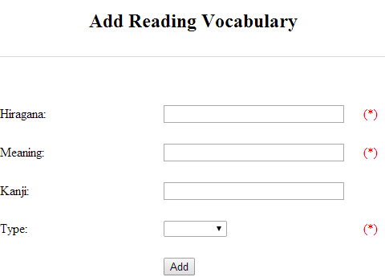

Figure 9.2.1: Add reading vocabulary

Table 9.2.1: Add reading vocabulary’s screen description:

|  |  |  |  |  |  |  |
| --- | --- | --- | --- | --- | --- | --- |
| No | Field name | Type | Require | Mandatory | Max-Length | Description |
| 1 | Hiragana | Text | Text | Y | 100 | Admin input hiragana with length less than 100 character |
| 2 | Meaning | Text | Text | Y | 100 | Admin input meaning with length less than 100 characters |
| 3 | Kanji | Text | Text | N | 10 | Admin input kanji with length less than 10 characters |
| 4 | Type | Drop-down list | Click | Y |  | Admin choose the type |
| 5 | Add | Button | Click | Y |  | Admin click to add reading vocabulary |

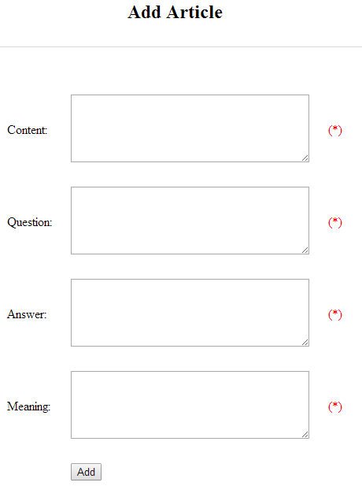

Figure 9.2.2: Add article

Table 9.2.2: Add article’s screen description:

|  |  |  |  |  |  |  |
| --- | --- | --- | --- | --- | --- | --- |
| No | Field name | Type | Require | Mandatory | Max-Length | Description |
| 1 | Content | Text | Text | Y | 5000 | Admin input content with length less than 5000 character |
| 2 | Question | Text | Text | Y | 5000 | Admin input question with length less than 5000 characters |
| 3 | Answer | Text | Text | Y | 5000 | Admin input answer with length less than 5000 characters |
| 4 | Meaning | Text | Text | Y | 5000 | Admin input meaning with length less than 5000 characters |
| 5 | Add | Button | Click | Y |  | Admin click to add article |

|  |  |  |  |  |
| --- | --- | --- | --- | --- |
| **UC0030 - Specification** | | | | |
| **Use-case No.** | <UC0030> | **Use-case Version** | | <1.0> |
| **Use-case Name** | Add document | | | |
| **Author** | Minh PT | | | |
| **Date** | 09/06/2014 | **Priority** | <High > | |
| **Actor:**  Admin  **Summary:**  When Administrator want to add new reading document into database. They have to insert all necessary data of reading document into “Add new reading” screen  **Triggers**  User must click on “Reading management/ Add new” tab and input all necessary information of grammar into the right fields then click on “Add new” button  **Preconditions:**   * User have logged into system as an admin. * All mandatory fields have been filled * All input data must be valid and have not existed in system   **Post Conditions:**  New reading document has been saved into system database successfully  **Main Success Scenario:**   |  |  |  | | --- | --- | --- | | **Step** | **User** | **System** | | 1 | Have logged into system as an admin |  | | 2 | Click on “Reading management/Add new” tab | Display “Add New Reading” screen that contains these elements:   * Code * Title * Level | | 3 | Fill reading document information into all necessary or mandatory fields and click “Add ” button | The system validates the input data and then save new reading document data into database | | 4 | Click on “Reading management/Vocabulary Details” | Display “Vocabulary Details” screen that contains these elements:   * Hiragana * Meaning * Kanji * Type | | 5 | Fill reading document information into all necessary or mandatory fields and click “Add ” button | The system validates the input data and then save new reading document data into database | | 6 | Click on “Reading management/Article Details” | Display “Article Details” screen that contains these elements:   * Content * Question * Answer * Meaning | | 7 | Fill reading document information into all necessary or mandatory fields and click “Add ” button | The system validates the input data and then save new reading document data into database |     **Alternative Scenario:**   |  |  |  | | --- | --- | --- | | **At Step** | **User** | **System** | | 3 | Click on another link | Do not save new reading document data into database then redirect to selected page | | 5 | Click on another link | Do not save vocabulary details data into database then redirect to selected page | | 7 | Click on another link | Do not save article details data into database then redirect to selected page |   **Exceptions:**   |  |  |  | | --- | --- | --- | | **At Step** | **User** | **System** | | 3 | Do not fill full information into fields then click “Add new” button | Return Error message beside empty field and ask if user want to add with empty field. | | 5 | Do not fill full information into fields then click “Add new” button | Return Error message beside empty field and ask if user want to add with empty field. | | 7 | Do not fill full information into fields then click “Add new” button | Return Error message beside empty field and ask if user want to add with empty field. | | | | | |

###### UC0034: <Admin> Edit reading document

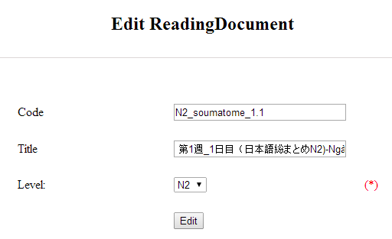

Figure 9.3: Edit reading document

Table 9.3: Edit reading document’s screen description:

|  |  |  |  |  |  |  |
| --- | --- | --- | --- | --- | --- | --- |
| No | Field name | Type | Require | Mandatory | Max-Length | Description |
| 1 | Code | Text | Text | Y | 50 | Admin input code with length less than 50 character |
| 2 | Title | Text | Text | Y | 100 | Admin input title with length less than 100 characters |
| 3 | Level | Drop-down list | Click | Y |  | Admin choose the level |
| 4 | Edit | Button | Click | Y |  | Admin click to edit reading |

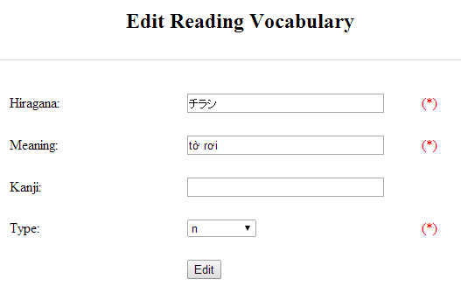

Figure 9.3.1: Add reading vocabulary

Table 9.3.1: Add reading vocabulary’s screen description:

|  |  |  |  |  |  |  |
| --- | --- | --- | --- | --- | --- | --- |
| No | Field name | Type | Require | Mandatory | Max-Length | Description |
| 1 | Hiragana | Text | Text | Y | 100 | Admin input hiragana with length less than 100 character |
| 2 | Meaning | Text | Text | Y | 100 | Admin input meaning with length less than 100 characters |
| 3 | Kanji | Text | Text | N | 10 | Admin input kanji with length less than 10 characters |
| 4 | Type | Drop-down list | Click | Y |  | Admin choose the type |
| 5 | Edit | Button | Click | Y |  | Admin click to edit reading vocabulary |

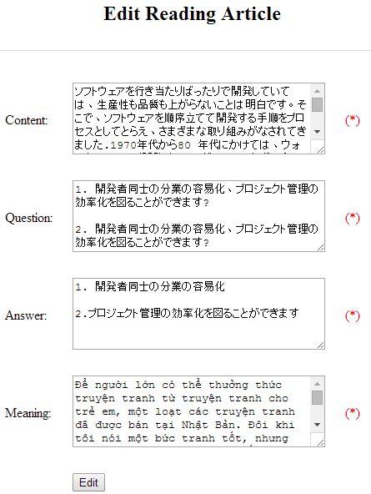

Figure 9.3.2: Add article

Table 9.3.2: Add article’s screen description:

|  |  |  |  |  |  |  |
| --- | --- | --- | --- | --- | --- | --- |
| No | Field name | Type | Require | Mandatory | Max-Length | Description |
| 1 | Content | Text | Text | Y | 5000 | Admin input content with length less than 5000 character |
| 2 | Question | Text | Text | Y | 5000 | Admin input question with length less than 5000 characters |
| 3 | Answer | Text | Text | Y | 5000 | Admin input answer with length less than 5000 characters |
| 4 | Meaning | Text | Text | Y | 5000 | Admin input meaning with length less than 5000 characters |
| 5 | Edit | Button | Click | Y |  | Admin click to edit article |

|  |  |  |  |  |
| --- | --- | --- | --- | --- |
| **UC0034 - Specification** | | | | |
| **Use-case No.** | <UC0034> | **Use-case Version** | | <1.0> |
| **Use-case Name** | Edit reading document | | | |
| **Author** | Minh PT | | | |
| **Date** | 09/06/2014 | **Priority** | <High > | |
| **Actor:**  Admin  **Summary:**  When Administrator want to edit reading document on database which has some new meanings or errors  **Triggers**  User must click on “Reading management” then search for the reading document. User click on “Edit” link to corresponding reading document. They edit necessary information of reading document in the right fields then click on “Edit” button.  **Preconditions:**   * User have logged into system as an admin. * All mandatory fields have been filled * All input data must be valid and have not existed in system   **Post Conditions:**  Changed information of reading document has been saved into system database successfully  **Main Success Scenario:**   |  |  |  | | --- | --- | --- | | **Step** | **User** | **System** | | 1 | Have logged into system as an admin |  | | 2 | Click on “Reading management ” then search for the reading document that they want to edit | Displays search result as a table | | 3 | Click on “Edit” link | Display “Edit reading” screen that contains the information of chosen reading with these elements:   * Code * Title * Level | | 4 | Edit reading document information and click “Edit” button | The system validates the input data and then save data into database | | 5 | Click on “VocabularyEdit” link | Display “Edit vocabulary” screen that contains the information of chosen reading with these elements:   * Hiragana * Meaning * Kanji * Type | | 6 | Edit reading document information and click “Edit” button | The system validates the input data and then save data into database | | 7 | Click on “ArticleEdit” link | Display “Edit article” screen that contains the information of chosen reading with these elements:   * Content * Question * Answer * Meaning | | 8 | Edit reading document information and click “Edit” button | The system validates the input data and then save data into database |     **Alternative Scenario:**   |  |  |  | | --- | --- | --- | | **At Step** | **User** | **System** | | 4 | Edit reading information then click to another link | Do not save edited data then redirect to selected page | | 6 | Edit reading information then click to another link | Do not save edited data then redirect to selected page | | 8 | Edit reading information then click to another link | Do not save edited data then redirect to selected page |   **Exceptions:**   |  |  |  | | --- | --- | --- | | **At Step** | **User** | **System** | | 4 | Edit reading information to be similar to another existed reading and click “Edit” button | The system validates the input data and return Error message and do not save edited data into database | | 6 | Edit reading information to be similar to another existed reading and click “Edit” button | The system validates the input data and return Error message and do not save edited data into database | | 8 | Edit reading information to be similar to another existed reading and click “Edit” button | The system validates the input data and return Error message and do not save edited data into database |   **Reference:**  UC0032- <Admin> Search reading document | | | | |

###### UC0035: <Admin> Delete reading document

|  |  |  |  |  |
| --- | --- | --- | --- | --- |
| **UC0035 - Specification** | | | | |
| **Use-case No.** | <UC0035> | **Use-case Version** | | <1.0> |
| **Use-case Name** | Delete reading document | | | |
| **Author** | Minh PT | | | |
| **Date** | 09/06/2014 | **Priority** | <High > | |
| **Actor:**  Admin  **Summary:**  When Administrator want to delete reading document on database  **Triggers**  User must click on “Reading management” then search for the reading document. User click on “Delete” link on corresponding reading document.  **Preconditions:**   * User have logged into system as an admin. * All mandatory fields have been filled * All input data must be valid and have existed in system   **Post Conditions:**  Reading document has been deleted from system database successfully  **Main Success Scenario:**   |  |  |  | | --- | --- | --- | | **Step** | **User** | **System** | | 1 | Have logged into system as an admin |  | | 2 | Click on “Reading management ” then search for the reading document that they want to delete | Displays search result as a table | | 3 | Click on “Delete” link beside that reading document row | Displays pop up to confirm if they really want to remove that reading document | | 4 | Click “Yes” button on popup | Closes the popup then remove that reading document name from reading list |     **Alternative Scenario:**   |  |  |  | | --- | --- | --- | | **At Step** | **User** | **System** | | 4 | Click close icon of the popup | Only closes the popup, does not remove that reading document |   **Exceptions:**   |  |  |  | | --- | --- | --- | | **At Step** | **User** | **System** | | 4 | Click “Cancel” button on popup | Only closes the popup, does not remove that reading document |   **Reference:**  UC0032 - <Admin> Search reading document | | | | |
|  | | | | |

#### Conversation management

##### Use case diagram

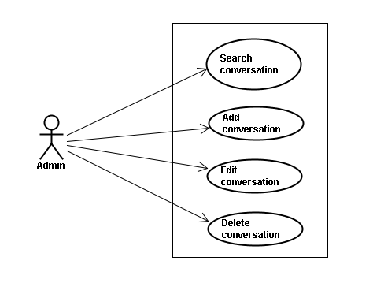

##### Screen description

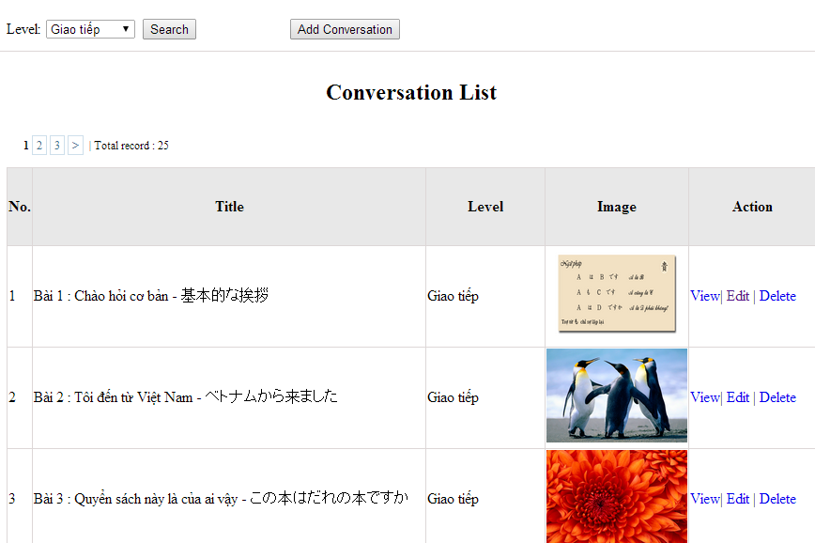

Figure 10: Conversation management

Table 10: Conversation management’s screen description:

|  |  |  |  |  |  |  |
| --- | --- | --- | --- | --- | --- | --- |
| No | Field name | Type | Require | Mandatory | Max-Length | Description |
| 1 | Level | Drop-down list | Click | N |  | Admin choose the level |
| 2 | Search | Button | Click | N |  | Admin click to search conversation |
| 3 | Add-new | Button | Click | N |  | Admin click to add new conversation |
| 4 | View | Hyperlink | Click | N |  | Admin click to view content |
| 5 | Edit | Hyperlink | Click | N |  | Admin click edit conversation |
| 6 | Delete | Hyperlink | Click | N |  | Admin click delete conversation |

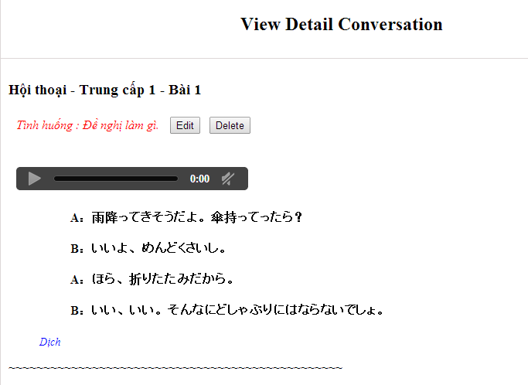

##### Use case specifications

###### UC0036: <Admin> Search conversation

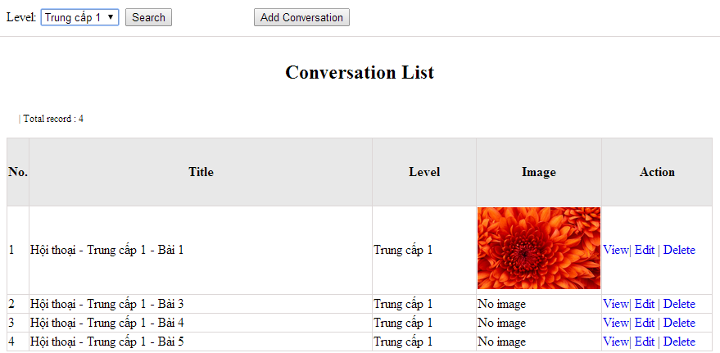

Figure 10.1: Search conversation

|  |  |  |  |  |
| --- | --- | --- | --- | --- |
| **UC0036 - Specification** | | | | |
| **Use-case No.** | <UC0036> | **Use-case Version** | | <1.0> |
| **Use-case Name** | Search conversation | | | |
| **Author** | Minh PT | | | |
| **Date** | 09/06/2014 | **Priority** | <High > | |
| **Actor:**  Admin  **Summary:**  When Administrator wants to search conversation in database. User choose level of conversation or level then click “Search” button  **Triggers**  Click on “Conversation management” tab, choose level of conversation in the right text box then click “Search” button  **Preconditions:**   * Website is available * User has to login as Administrator * User has to input data in search area   **Post Conditions:**  Display detail information of conversation  **Main Success Scenario:**   |  |  |  | | --- | --- | --- | | **Step** | **User** | **System** | | 1 | Have logged into system as an admin |  | | 2 | Click on “Conversation management” tab | Displays criteria search screen | | 3 | Choose level of the conversation that they want to find then click “Search” button | Displays search result as a table with these elements:   * No * Title * Level * Image * View * Edit * Delete |     **Alternative Scenario:**   |  |  |  | | --- | --- | --- | | **At Step** | **User** | **System** | | 3 | Choose level of the conversation that they want to find into these fields then click on another link | Switch to selected page |   **Exceptions:**   |  |  |  | | --- | --- | --- | | **At Step** | **User** | **System** | | 3 | Choose level of the conversation that they want to find (that do not exited in database) into these fields then click “Search” button | Return Error message to inform that conversation cannot be found | | | | | |

###### UC0037: <Admin> Add conversation

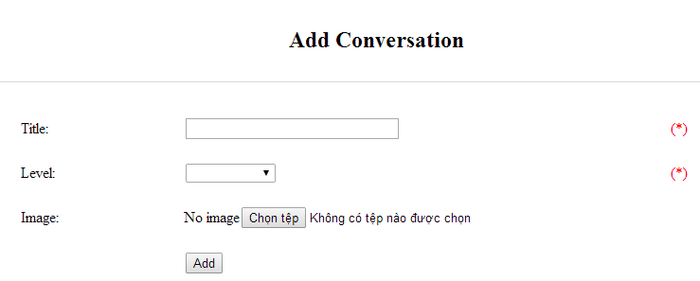

Figure 10.2.1: Add conversation

Table 10.2.1: Add conversation’s screen description:

|  |  |  |  |  |  |  |
| --- | --- | --- | --- | --- | --- | --- |
| No | Field name | Type | Require | Mandatory | Max-Length | Description |
| 1 | Title | Text | Text | Y | 100 | Admin input title of conversation with length less than 100 characters |
| 3 | Level | Drop-down list | Text | Y |  | Admin choose the level |
| 4 | Image | Button | Click | N |  | Admin choose the image |
| 5 | Add | Button | Click | Y |  | Admin add new conversation |

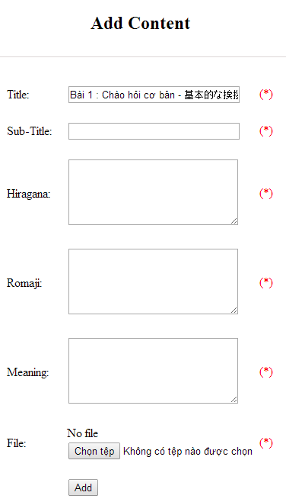

Figure 10.2.2: Add new conversation content

Table 10.2.2: Add conversation content’s screen description:

|  |  |  |  |  |  |  |
| --- | --- | --- | --- | --- | --- | --- |
| No | Field name | Type | Require | Mandatory | Max-Length | Description |
| 1 | Title |  |  |  |  |  |
| 2 | Sub-title | Text | Text | Y | 200 | Admin input subtitle with length less than 200 characters |
| 3 | Hiragana | Text | Text | Y | 5000 | Admin input hiragana with length less than 5000 characters |
| 4 | Romaji | Text | Text | Y | 5000 | Admin input conversation by romaji with length less than 5000 characters |
| 5 | Meaning | Text | Text | Y | 5000 | Admin input conversation’s meaning with length less than 5000 characters |
| 6 | File | Button | Click | Y |  | Admin choose the file |
| 7 | Add | Button | Click | Y |  | Admin add new content |

|  |  |  |  |  |
| --- | --- | --- | --- | --- |
| **UC0037 - Specification** | | | | |
| **Use-case No.** | <UC0037> | **Use-case Version** | | <1.0> |
| **Use-case Name** | Add conversation | | | |
| **Author** | Minh PT | | | |
| **Date** | 09/06/2014 | **Priority** | <High > | |
| **Actor:**  Admin  **Summary:**  When Administrator wants to add new conversation into database. They have to insert all necessary data of conversation into “Add Conversation” screen  **Triggers**  User must click on “Conversation management/ Add New” and input all necessary information of conversation into the right fields then click on “Add” button  **Preconditions:**   * Website is available * User have logged into system as an admin. * All mandatory fields have been filled * All input data must be valid and have not existed in system   **Post Conditions:**  New conversation has been saved into system database successfully  **Main Success Scenario:**   |  |  |  | | --- | --- | --- | | **Step** | **User** | **System** | | 1 | Have logged into system as an admin |  | | 2 | Click on “Conversation management/Add New” | Display “Add Conversation” screen that contains these elements:   * Title * Level * Image | | 3 | Fill conversation information into all necessary or mandatory fields and click “Add” button | The system validates the input data and then save new conversation data into database | | 4 | Click on “Conversation management/View/Add new content” | Display “Add Content” screen that contains these elements:   * Title * Subtitle * Hiragana * Romaji * Meaning * File | | 5 | Fill conversation information into all necessary or mandatory fields and click “Add” button | The system validates the input data and then save new conversation data into database |     **Alternative Scenario:**   |  |  |  | | --- | --- | --- | | **At Step** | **User** | **System** | | 3 | Click on another link | Do not save new conversation data into database then redirect to selected page | | 5 | Click on another link | Do not save new content conversation data into database then redirect to selected page |   **Exceptions:**   |  |  |  | | --- | --- | --- | | **At Step** | **User** | **System** | | 3 | Do not fill full information into fields then click “Add” button | Return Error message and request user input data into all fields | | 5 | Do not fill full information into fields then click “Add” button | Return Error message and request user input data into all fields | | | | | |

###### UC0038: <Admin> Edit conversation

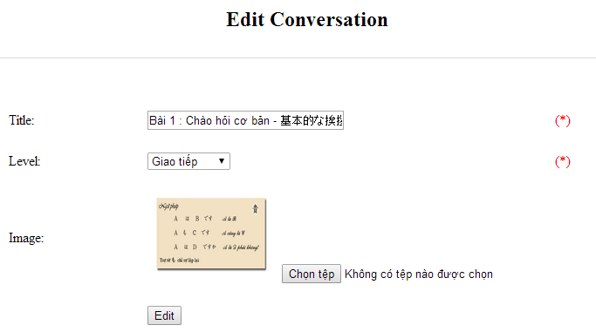

Figure 10.3.1: Edit conversation

Table 10.3.1: Edit conversation’s screen description

|  |  |  |  |  |  |  |
| --- | --- | --- | --- | --- | --- | --- |
| No | Field name | Type | Require | Mandatory | Max-Length | Description |
| 1 | Title | Text | Text | Y | 100 | Admin input title of conversation with length less than 100 characters |
| 3 | Level | Drop-down list | Text | Y |  | Admin choose the level |
| 4 | Image | Button | Click | N |  | Admin choose the image |
| 5 | Edit | Button | Click | Y |  | Admin add edit conversation |

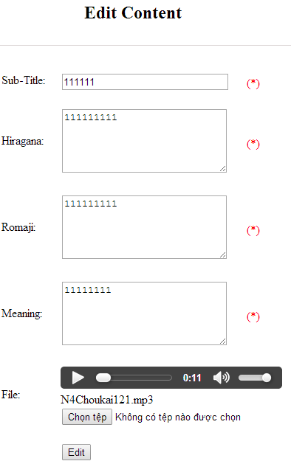

Figure 10.3.2: Edit new conversation content

Table 10.3.2: Edit conversation content’s screen description:

|  |  |  |  |  |  |  |
| --- | --- | --- | --- | --- | --- | --- |
| No | Field name | Type | Require | Mandatory | Max-Length | Description |
| 1 | Sub-title | Text | Text | Y | 200 | Admin input subtitle with length less than 200 characters |
| 2 | Hiragana | Text | Text | Y | 5000 | Admin input hiragana with length less than 5000 characters |
| 3 | Romaji | Text | Text | Y | 5000 | Admin input conversation by romaji with length less than 5000 characters |
| 4 | Meaning | Text | Text | Y | 5000 | Admin input conversation’s meaning with length less than 5000 characters |
| 5 | File | Button | Click | Y |  | Admin choose the file |
| 6 | Edit | Button | Click | Y |  | Admin edit conversation |

|  |  |  |  |  |
| --- | --- | --- | --- | --- |
| **UC0038 - Specification** | | | | |
| **Use-case No.** | <UC0038> | **Use-case Version** | | <1.0> |
| **Use-case Name** | Edit conversation | | | |
| **Author** | Minh PT | | | |
| **Date** | 09/06/2014 | **Priority** | <High > | |
| **Actor:**  Admin  **Summary:**  When Administrator want to edit conversation in database which has some new meanings or errors. When edit finished, new meaning will be updated  **Triggers**  User must click on “Conversation management” then search for the conversation. User click on “Edit” link on corresponding conversation. They edit necessary information of conversation in the right fields then click on “Edit” button.  **Preconditions:**   * Website is available * User have logged into system as an admin. * All mandatory fields have been filled * All input data must be valid and have not existed in system   **Post Conditions:**  Changed information of conversation has been saved into system database successfully  **Main Success Scenario:**   |  |  |  | | --- | --- | --- | | **Step** | **User** | **System** | | 1 | Have logged into system as an admin |  | | 2 | Click on “Conversation management ” then search for the conversation that they want to edit | Displays search result as a table | | 3 | Click on “Edit” link corresponding | Display “Edit conversation” screen that contains the information of chosen conversation with these elements:   * Title * Level * Image | | 4 | Edit conversation information and click “Edit” button | The system validates the input data and then save data into database | | 5 | Click “View/Edit content” | Display “Edit Conversation Content” screen that contains the information of chosen conversation with these elements:   * Sub-title * Hiragana * Romaji * Meaning * File | | 6 | Edit conversation content information and click “Edit” button | The system validates the input data and then save data into database |     **Alternative Scenario:**   |  |  |  | | --- | --- | --- | | **At Step** | **User** | **System** | | 4 | Edit conversation then click to another link | Do not save edited data then redirect to selected page | | 6 | Edit conversation content then click to another link | Do not save edited data then redirect to selected page |   **Exceptions:**   |  |  |  | | --- | --- | --- | | **At Step** | **User** | **System** | | 4 | Edit conversation to be similar to another existed conversation |  | | 6 | Click “Edit” button | The system validates the input data and return Error message and do not save edited data into database |   **Reference:**  UC0036- <Admin> Search conversation | | | | |

###### UC0039: <Admin> Delete conversation

|  |  |  |  |  |
| --- | --- | --- | --- | --- |
| **UC0039 - Specification** | | | | |
| **Use-case No.** | <UC0039> | **Use-case Version** | | <1.0> |
| **Use-case Name** | Delete conversation | | | |
| **Author** | Minh PT | | | |
| **Date** | 09/06/2014 | **Priority** | <High > | |
| **Actor:**  Admin  **Summary:**  When Administrator want to delete conversation in database  **Triggers**  User must click on “Conversation management” then search for the conversation. User click on “Delete” link on corresponding conversation.  **Preconditions:**   * Website is available * User have logged into system as an admin.   **Post Conditions:**  Conversation has been deleted from system database successfully  **Main Success Scenario:**   |  |  |  | | --- | --- | --- | | **Step** | **User** | **System** | | 1 | Have logged into system as an admin |  | | 2 | Click on “Conversation management ” then search for the conversation that they want to delete | Displays search result as a table | | 3 | Click on “Delete” link corresponding with conversation | Remove that conversation in database |   **Exceptions:**   |  |  |  | | --- | --- | --- | | **At Step** | **User** | **System** | | 3 | Click on “Delete” link corresponding with conversation (conversation content is existing) | Return Error message and request user remove conversation content first |   **Reference:**  UC0036 - <Admin> Search conversation | | | | |
|  | | | | |

#### Video Management

##### Use case diagram

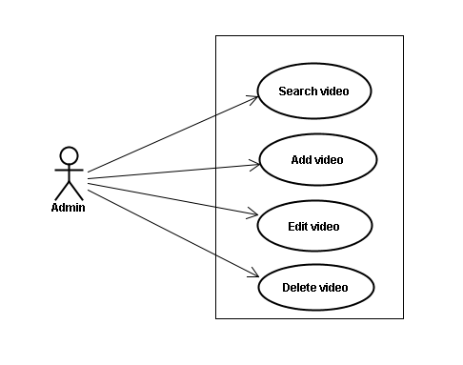

##### Screen description

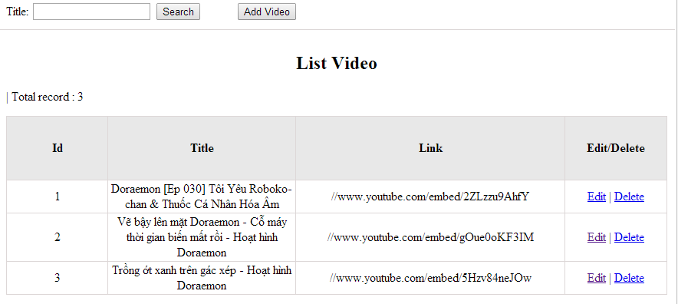

Figure 11: Video management

Table 11.1: Video management’s screen description:

|  |  |  |  |  |  |  |
| --- | --- | --- | --- | --- | --- | --- |
| No | Field name | Type | Require | Mandatory | Max-Length | Description |
| 1 | Title | Text | Text | Y | 100 | Admin input title with length less than 100 character |
| 2 | Add new | Button | Click | N |  | Admin add new video into database |
| 3 | Edit | Button | Click | N |  | Admin click edit video |
| 4 | Delete | Button | Click | N |  | Admin click delete video |

##### Use case specifications

###### UC040 <Video management>: Search video

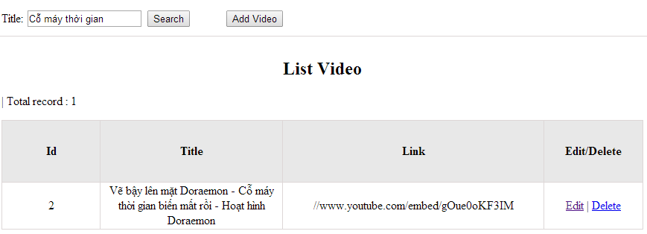

Figure 11.1: Search video

|  |  |  |  |  |
| --- | --- | --- | --- | --- |
| **UC0040 - Specification** | | | | |
| **Use-case No.** | <UC0040> | **Use-case Version** | | <1.0> |
| **Use-case Name** | Search video | | | |
| **Author** | Minh PT | | | |
| **Date** | 09/06/2014 | **Priority** | <High > | |
| **Actor:**  Admin  **Summary:**  When Administrator wants to search video in database. User input title of video then click “Search” button  **Triggers**  Click on “Video management” tab, input title of video in the right text box then click “Search” button  **Preconditions:**   * Website is available * User has to login as Administrator * User has to input data in search area   **Post Conditions:**  Display detail information of video  **Main Success Scenario:**   |  |  |  | | --- | --- | --- | | **Step** | **User** | **System** | | 1 | Have logged into system as an admin |  | | 2 | Click on “Video management” tab | Displays criteria search screen | | 3 | Fill information of the video that they want to find into these fields then click “Search” button | Displays search result as a table with these elements:   * No * Title * Link * Edit * Delete |     **Alternative Scenario:**   |  |  |  | | --- | --- | --- | | **At Step** | **User** | **System** | | 3 | Fill information of the video that they want to find into these fields then click on another link | Switch to selected page |   **Exceptions:**   |  |  |  | | --- | --- | --- | | **At Step** | **User** | **System** | | 3 | Fill information of the video that they want to find (that do not exited in database) into these fields then click “Search” button | Return Error message to inform that video cannot be found | | | | | |

###### UC041 <Video management>: Add video

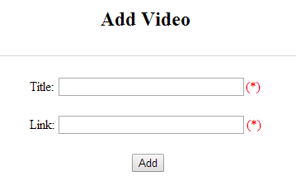

Figure 11.2: Add video

Table 11.2: Add video’s screen description:

|  |  |  |  |  |  |  |
| --- | --- | --- | --- | --- | --- | --- |
| No | Field name | Type | Require | Mandatory | Max-Length | Description |
| 1 | Title | Text | Text | Y | 200 | Admin input title with length less than 200 characters |
| 2 | Link | Text | Text | Y |  | Admin input hyperlink |
| 3 | Add | Button | Click | Y |  | Admin add new video |
| 4 | Reset | Button | Click | N |  | Admin reset information |

|  |  |  |  |  |
| --- | --- | --- | --- | --- |
| **UC0041 - Specification** | | | | |
| **Use-case No.** | <UC0041> | **Use-case Version** | | <1.0> |
| **Use-case Name** | Add video | | | |
| **Author** | Minh PT | | | |
| **Date** | 09/06/2014 | **Priority** | <High > | |
| **Actor:**  Admin  **Summary:**  When Administrator wants to add new video into database. They have to insert all necessary data of video into “Add Video” screen  **Triggers**  User must click on “Video management/ Add New” tab and input all necessary information of video into the right fields then click on “Add” button  **Preconditions:**   * Website is available * User have logged into system as an admin. * All mandatory fields have been filled * All input data must be valid and have not existed in system   **Post Conditions:**  New video has been saved into system database successfully  **Main Success Scenario:**   |  |  |  | | --- | --- | --- | | **Step** | **User** | **System** | | 1 | Have logged into system as an admin |  | | 2 | Click on “Video management/Add New” tab | Display “Add Video” screen that contains these elements:   * Title * Link | | 3 | Fill video information into all necessary or mandatory fields and click “Add” button | The system validates the input data and then save new video data into database |     **Alternative Scenario:**   |  |  |  | | --- | --- | --- | | **At Step** | **User** | **System** | | 3 | Click on another link | Do not save new video data into database then redirect to selected page |   **Exceptions:**   |  |  |  | | --- | --- | --- | | **At Step** | **User** | **System** | | 3 | Do not fill full information into fields then click “Add” button | Return Error message and request user input data into all fields | | | | | |

###### UC042 <Video management>: Edit video

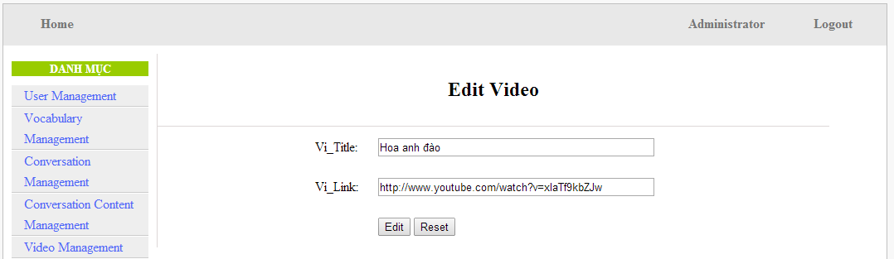

Figure 11.3: Edit video

Table 11.3: Edit video’s screen description:

|  |  |  |  |  |  |  |
| --- | --- | --- | --- | --- | --- | --- |
| No | Field name | Type | Require | Mandatory | Max-Length | Description |
| 1 | Title | Text | Text | Y | 200 | Admin input title with length less than 200 characters |
| 2 | Link | Text | Text | Y | 1000 | Admin input hyperlink |
| 3 | Add | Button | Click | Y |  | Admin edit video |

|  |  |  |  |  |
| --- | --- | --- | --- | --- |
| **UC0042 - Specification** | | | | |
| **Use-case No.** | <UC0042> | **Use-case Version** | | <1.0> |
| **Use-case Name** | Edit video | | | |
| **Author** | Minh PT | | | |
| **Date** | 09/06/2014 | **Priority** | <High > | |
| **Actor:**  Admin  **Summary:**  When Administrator wants to edit video in database which has some new meanings or errors. When edit finished, new meaning will be updated  **Triggers**  User must click on “Video management” then search for the video. User click on “Edit” link corresponding with video. User edits necessary information of video in the right fields then click on “Edit” button.  **Preconditions:**   * Website is available * User have logged into system as an admin. * All mandatory fields have been filled * All input data must be valid and have not existed in system   **Post Conditions:**  Changed information of video has been saved into system database successfully  **Main Success Scenario:**   |  |  |  | | --- | --- | --- | | **Step** | **User** | **System** | | 1 | Have logged into system as an admin |  | | 2 | Click on “Video management ” then search for the video that they want to edit | Displays search result as a table | | 3 | Click on “Edit” link corresponding | Display “Edit video” screen that contains the information of chosen video with these elements:   * Title * Link | | 4 | Edit video information and click “Edit” button | The system validates the input data and then save data into database |     **Alternative Scenario:**   |  |  |  | | --- | --- | --- | | **At Step** | **User** | **System** | | 4 | Edit video then click to another link | Do not save edited data then redirect to selected page |   **Exceptions:**   |  |  |  | | --- | --- | --- | | **At Step** | **User** | **System** | | 4 | Edit video to be similar to another existed video and click “Edit” button | The system validates the input data and return Error message and do not save edited data into database |   **Reference:**  UC0040- <Admin> Search video | | | | |

###### UC043 <Video management>: Delete video

|  |  |  |  |  |
| --- | --- | --- | --- | --- |
| **UC0043 - Specification** | | | | |
| **Use-case No.** | <UC0043> | **Use-case Version** | | <1.0> |
| **Use-case Name** | Delete video | | | |
| **Author** | Minh PT | | | |
| **Date** | 09/06/2014 | **Priority** | <High > | |
| **Actor:**  Admin  **Summary:**  When Administrator wants to delete video in database  **Triggers**  User must click on “Video management” then search for the video. User click on “Delete” link on corresponding video.  **Preconditions:**   * Website is available * User have logged into system as an admin.   **Post Conditions:**  Video has been deleted from system database successfully  **Main Success Scenario:**   |  |  |  | | --- | --- | --- | | **Step** | **User** | **System** | | 1 | Have logged into system as an admin |  | | 2 | Click on “Video management ” then search for the video that they want to delete | Displays search result as a table | | 3 | Click on “Delete” link corresponding with conversation | Remove that video in database |     **Reference:**  UC0040 - <Admin> Search video | | | | |
|  | | | | |

#### Training Listening Management

##### Use case diagram

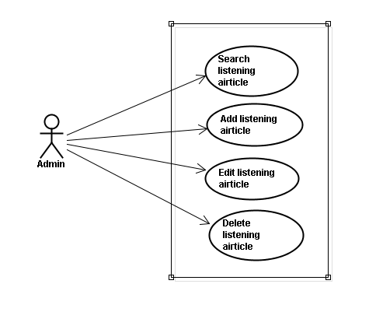

##### Screen description

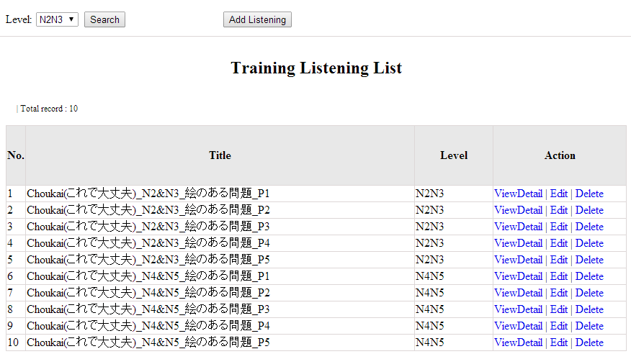

Figure 12: Listening article management

Table 12.1: Conversation management’s screen description:

|  |  |  |  |  |  |  |
| --- | --- | --- | --- | --- | --- | --- |
| No | Field name | Type | Require | Mandatory | Max-Length | Description |
| 1 | Level | Drop-down list | Click | Y |  | Admin choose the level |
| 2 | Search | Button | Click | Y |  | Admin click to search |
| 3 | Addnew | Button | Click | N |  | Admin add new listening into database |
| 4 | ViewDetail | Hyperlink | Click | N |  | Admin click to view details of listening |
| 5 | Edit | Button | Click | N |  | Admin click edit listening article |
| 6 | Delete | Button | Click | N |  | Admin click delete article |

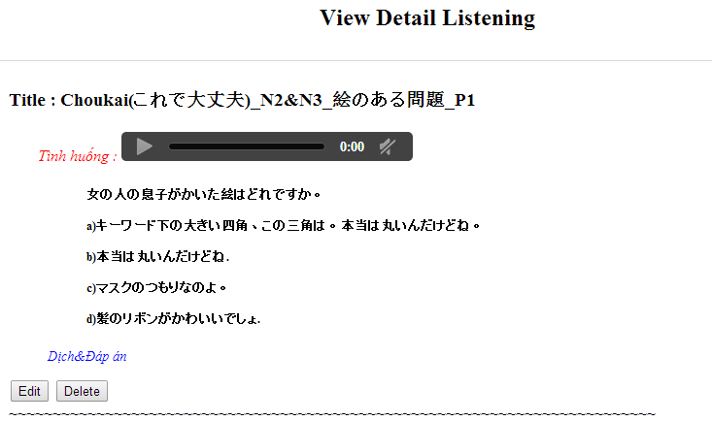

##### Use case specifications

###### UC044 <Listening Article Management>: Search listening article

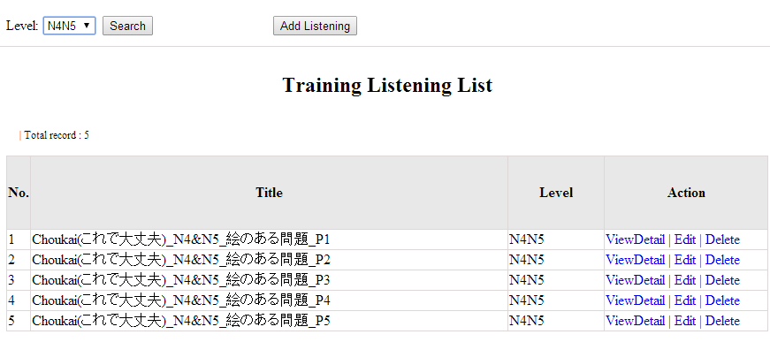

Figure 12.1: Search listening article

|  |  |  |  |  |
| --- | --- | --- | --- | --- |
| **UC0044 - Specification** | | | | |
| **Use-case No.** | <UC0044> | **Use-case Version** | | <1.0> |
| **Use-case Name** | Search listening article | | | |
| **Author** | Minh PT | | | |
| **Date** | 09/06/2014 | **Priority** | <High > | |
| **Actor:**  Admin  **Summary:**  When Administrator wants to search listening article in database. User choose level of listening level then click “Search” button  **Triggers**  Click on “Listening practice management” tab, choose level in the right text box then click “Search” button  **Preconditions:**   * Website is available * User has to login as Administrator * User has to input data in search area   **Post Conditions:**  Display detail information of listening article  **Main Success Scenario:**   |  |  |  | | --- | --- | --- | | **Step** | **User** | **System** | | 1 | Have logged into system as an admin |  | | 2 | Click on “Listening article management” tab | Displays criteria search screen | | 3 | Choose level of the listening article that they want to find then click “Search” button | Displays search result as a table with these elements:   * No * Title * Level * View details * Edit * Delete |     **Alternative Scenario:**   |  |  |  | | --- | --- | --- | | **At Step** | **User** | **System** | | 3 | Choose level of the listening article that they want to find into these fields then click on another link | Switch to selected page |   **Exceptions:**   |  |  |  | | --- | --- | --- | | **At Step** | **User** | **System** | | 3 | Choose level of the listening article that they want to find (that do not exited in database) into these fields then click “Search” button | Return Error message to inform that listening article cannot be found | | | | | |

###### UC045 <Listening Article Management>: Add listening article

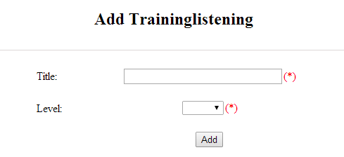

Figure 12.2: Add listening :

Table 12.2: Add listening’s screen description:

|  |  |  |  |  |  |  |
| --- | --- | --- | --- | --- | --- | --- |
| No | Field name | Type | Require | Mandatory | Max-Length | Description |
| 1 | Title | Text | Text | Y | 500 | Admin input id with length less than 500 characters |
| 2 | Level | Drop-down list | Choose | Y |  | Admin choose level |
| 3 | Add | Button | Click | Y |  | Admin add new listening |

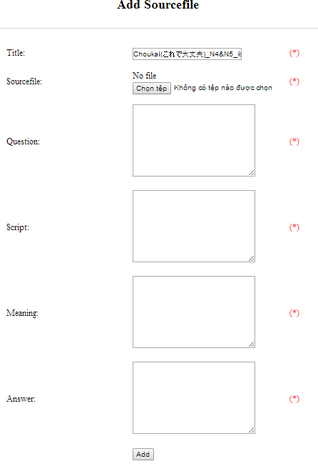

Figure 12.2.1: Add listening source file:

Table 12.2.1: Add listening source file’s screen description:

|  |  |  |  |  |  |  |
| --- | --- | --- | --- | --- | --- | --- |
| No | Field name | Type | Require | Mandatory | Max-Length | Description |
| 1 | Source_file | Button | Click | Y |  | Admin choose the file |
| 2 | Question | Text | Text | Y | 5000 | Admin input question of listening with length less than 5000 characters |
| 3 | Script | Text | Text | Y | 5000 | Admin input script of listening with length less than 5000 characters |
| 4 | Meaning | Text | Text | Y | 5000 | Admin input meaning of listening with length less than 5000 characters |
| 5 | Answer | Text | Text | Y | 5000 | Admin input answer of listening with length less than 5000 characters |
| 6 | Add | Button | Click | Y |  | Admin add source file |

|  |  |  |  |  |
| --- | --- | --- | --- | --- |
| **UC0045 - Specification** | | | | |
| **Use-case No.** | <UC0045> | **Use-case Version** | | <1.0> |
| **Use-case Name** | Add listening article | | | |
| **Author** | Minh PT | | | |
| **Date** | 09/06/2014 | **Priority** | <High > | |
| **Actor:**  Admin  **Summary:**  When Administrator wants to add new listening article into database. They have to insert all necessary data of listening article into “Add new listening” screen  **Triggers**  User must click on “Listening management/ Add New” and input all necessary information of listening article into the right fields then click on “Add” button  **Preconditions:**   * Website is available * User have logged into system as an admin. * All mandatory fields have been filled * All input data must be valid and have not existed in system   **Post Conditions:**  New listening article has been saved into system database successfully  **Main Success Scenario:**   |  |  |  | | --- | --- | --- | | **Step** | **User** | **System** | | 1 | Have logged into system as an admin |  | | 2 | Click on “Listening article management/Add New” | Display “Add New Listening” screen that contains these elements:   * Title * Level | | 3 | Fill listening article information into all necessary or mandatory fields click “Add” button | The system validates the input data and then save new listening article data into database | | 4 | Click on “Listening article management/View details/ Add source file” | Display “Add source file” screen that contains these elements:   * Title * Source file * Question * Script * Meaning * Answer | | 5 | Fill listening article information into all necessary or mandatory fields click “Add” button | The system validates the input data and then save new listening article data into database |     **Alternative Scenario:**   |  |  |  | | --- | --- | --- | | **At Step** | **User** | **System** | | 3 | Click on another link | Do not save new listening article data into database then redirect to selected page | | 5 | Click on another link | Do not save new source file data into database then redirect to selected page |   **Exceptions:**   |  |  |  | | --- | --- | --- | | **At Step** | **User** | **System** | | 3 | Do not fill full information into fields then click “Add” button | Return Error message and request user input data into all fields | | 5 | Do not fill full information into fields then click “Add” button | Return Error message and request user input data into all fields | | | | | |

###### UC046 <Listening Article Management>: Edit listening article

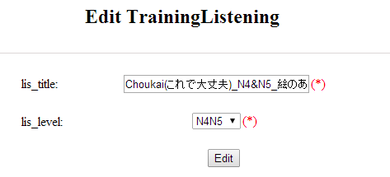

Figure 12.3: Edit listening:

Table 12.3: Edit listening ’s screen description:

|  |  |  |  |  |  |  |
| --- | --- | --- | --- | --- | --- | --- |
| No | Field name | Type | Require | Mandatory | Max-Length | Description |
| 1 | Title | Text | Text | Y | 500 | Admin input id with length less than 500 characters |
| 2 | Level | Drop-down list | Choose | Y |  | Admin choose level |
| 3 | Edit | Button | Click | Y |  | Admin edit listening |

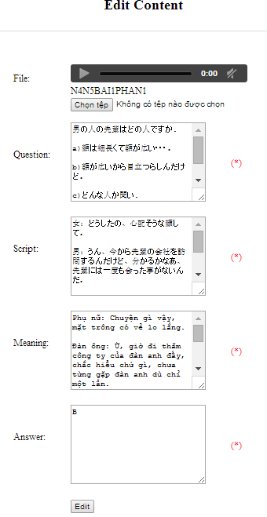

Figure 12.3.1: Edit listening source file:

Table 12.3.1: Edit listening source file’s screen description:

|  |  |  |  |  |  |  |
| --- | --- | --- | --- | --- | --- | --- |
| No | Field name | Type | Require | Mandatory | Max-Length | Description |
| 1 | Source_file | Button | Click | Y |  | Admin choose the file |
| 2 | Question | Text | Text | Y | 5000 | Admin input question of listening with length less than 5000 characters |
| 3 | Script | Text | Text | Y | 5000 | Admin input script of listening with length less than 5000 characters |
| 4 | Meaning | Text | Text | Y | 5000 | Admin input meaning of listening with length less than 5000 characters |
| 5 | Answer | Text | Text | Y | 5000 | Admin input answer of listening with length less than 5000 characters |
| 6 | Edit | Button | Click | Y |  | Admin edit source file |

|  |  |  |  |  |
| --- | --- | --- | --- | --- |
| **UC0046 - Specification** | | | | |
| **Use-case No.** | <UC0046> | **Use-case Version** | | <1.0> |
| **Use-case Name** | Edit listening article | | | |
| **Author** | Minh PT | | | |
| **Date** | 09/06/2014 | **Priority** | <High > | |
| **Actor:**  Admin  **Summary:**  When Administrator wants to edit listening article in database which has some new meanings or errors. When edit finished, new meaning will be updated  **Triggers**  User must click on “Listening management” then search for the listening article. User click on “Edit” link corresponding with listening article. They edit necessary information of listening article in the right fields then click on “Edit” button.  **Preconditions:**   * Website is available * User have logged into system as an admin. * All mandatory fields have been filled * All input data must be valid and have not existed in system   **Post Conditions:**  Changed information of listening article has been saved into system database successfully  **Main Success Scenario:**   |  |  |  | | --- | --- | --- | | **Step** | **User** | **System** | | 1 | Have logged into system as an admin |  | | 2 | Click on “Training listening” then search for the listening article that they want to edit | Displays search result as a table | | 3 | Click on “Edit” link corresponding | Display “Edit listening” screen that contains the information of chosen listening article with these elements:   * Title * Level | | 4 | Edit listening article information and click “Edit” button | The system validates the input data and then save data into database | | 5 | Click on “View details/ Edit” link corresponding | Display “Edit listening” screen that contains the information of chosen listening article with these elements:   * File * Question * Script * Meaning * Answer | | 6 | Edit listening article information and click “Edit” button | The system validates the input data and then save data into database |     **Alternative Scenario:**   |  |  |  | | --- | --- | --- | | **At Step** | **User** | **System** | | 4 | Edit listening article then click to another link | Do not save edited data then redirect to selected page | | 6 | Edit listening article then click to another link | Do not save edited data then redirect to selected page |   **Exceptions:**   |  |  |  | | --- | --- | --- | | **At Step** | **User** | **System** | | 4 | Edit listening article to be similar to another existed listening article click “Edit” button | The system validates the input data and return Error message and do not save edited data into database | | 6 | Edit listening article to be similar to another existed listening article click “Edit” button | The system validates the input data and return Error message and do not save edited data into database |   **Reference:**  UC0044- <Admin> Search listening article | | | | |

###### UC047 <Listening Article Management>: Delete listening article

|  |  |  |  |  |
| --- | --- | --- | --- | --- |
| **UC0047 - Specification** | | | | |
| **Use-case No.** | <UC0047> | **Use-case Version** | | <1.0> |
| **Use-case Name** | Delete listening article | | | |
| **Author** | Minh PT | | | |
| **Date** | 09/06/2014 | **Priority** | <High > | |
| **Actor:**  Admin  **Summary:**  When Administrator want to delete listening article inn database  **Triggers**  User must click on “Listening article management” then search for the listening article. User click on “Delete” link corresponding with listening article.  **Preconditions:**   * Website is available * User have logged into system as an admin.   **Post Conditions:**  Listening article has been deleted from system database successfully  **Main Success Scenario:**   |  |  |  | | --- | --- | --- | | **Step** | **User** | **System** | | 1 | Have logged into system as an admin |  | | 2 | Click on “Listening article management ” then search for the listening article that they want to delete | Displays search result as a table | | 3 | Click on “Delete” link corresponding | Remove that listening article in database |     **Reference:**  UC0044 - <Admin> Search listening article | | | | |
|  | | | | |

#### Test management

##### Use case diagram

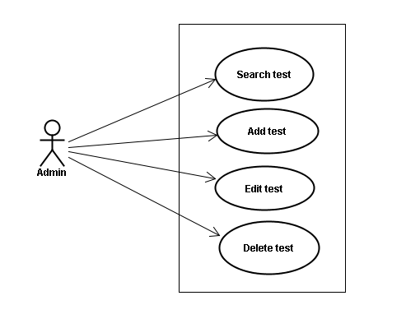

##### Screen description

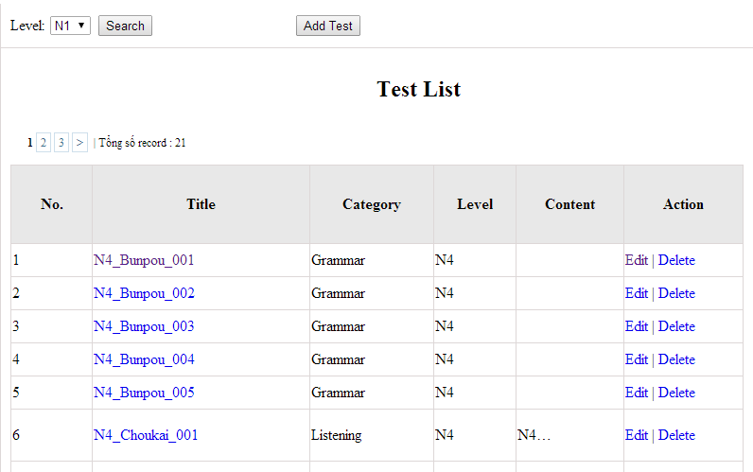

Figure 13: Doing test management

Table 13.1: Doing test management’s screen description:

|  |  |  |  |  |  |  |
| --- | --- | --- | --- | --- | --- | --- |
| No | Field name | Type | Require | Mandatory | Max-Length | Description |
| 1 | Level | Drop-down list | Click | N |  | Admin choose the level |
| 2 | Search | Button | Click | N |  | Admin click to search |
| 3 | List | Hyperlink | Click | N |  | Admin click to view details |
| 4 | Edit | Button | Click | N |  | Admin click edit test |
| 5 | Delete | Button | Click | N |  | Admin click delete test |

##### Use case specifications

###### UC048 <Test management>: Search test

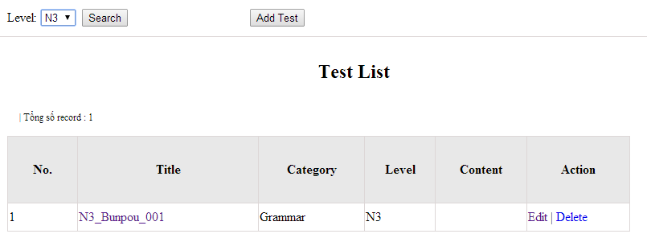

Figure 13.1: Search test:

|  |  |  |  |  |
| --- | --- | --- | --- | --- |
| **UC0048 - Specification** | | | | |
| **Use-case No.** | <UC0048> | **Use-case Version** | | <1.0> |
| **Use-case Name** | Search test | | | |
| **Author** | Minh PT | | | |
| **Date** | 09/06/2014 | **Priority** | <High > | |
| **Actor:**  Admin  **Summary:**  When Administrator wants to search test article in database. User choose test level then click “Search” button.  **Triggers**  Click on “Test management” tab, choose level in the right text box then click “Search” button  **Preconditions:**   * Website is available * User has to login as Administrator * User has to input data in search area   **Post Conditions:**  Display detail information of that test  **Main Success Scenario:**   |  |  |  | | --- | --- | --- | | **Step** | **User** | **System** | | 1 | Have logged into system as an admin |  | | 2 | Click on “Test management” tab | Displays criteria search screen | | 3 | Choose level of the test that they want to find then click “Search” button | Displays search result as a table with these elements:   * No * Title * Category * Level * Content * Edit * Delete |     **Alternative Scenario:**   |  |  |  | | --- | --- | --- | | **At Step** | **User** | **System** | | 3 | Choose level of the test that they want to find into these fields then click on another link | Switch to selected page |   **Exceptions:**   |  |  |  | | --- | --- | --- | | **At Step** | **User** | **System** | | 3 | Choose level of the test that they want to find (that do not exited in database) into these fields then click “Search” button | Return Error message to inform that test cannot be found | | | | | |

###### UC049 <Test management>: Add test

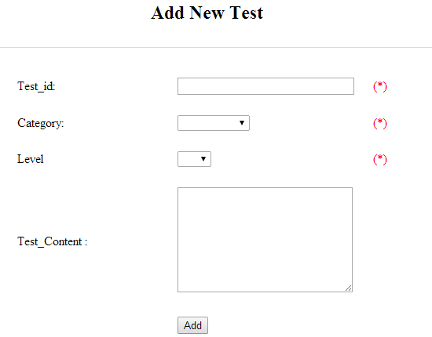

Figure 13.2: Add test

Table 13.2 : Add test’s screen description:

|  |  |  |  |  |  |  |
| --- | --- | --- | --- | --- | --- | --- |
| No | Field name | Type | Require | Mandatory | Max-Length | Description |
| 1 | ID | Text | Text | Y | 100 | Admin input id with length less than 100 characters |
| 2 | Category | Drop-down list | Click | Y |  | Admin choose category |
| 3 | Level | Drop-down list | Click | Y |  | Admin choose level of test |
| 4 | Test content | Text | Text | Y | 5000 | Admin input content with length less than 5000 characters |
| 5 | Add | Button | Click | Y |  | Admin click to add test |

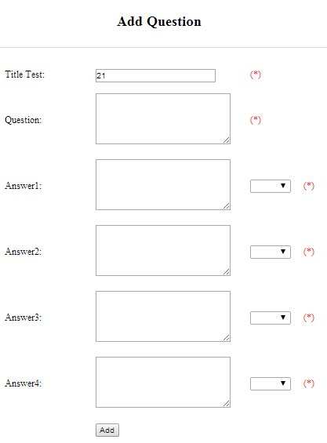

Figure 13.2.1: Add question

Table 13.2.1: Add question’s screen description:

|  |  |  |  |  |  |  |
| --- | --- | --- | --- | --- | --- | --- |
| No | Field name | Type | Require | Mandatory | Max-Length | Description |
| 1 | Question | Text | Text | Y | 200 | Admin input question with length less than 200 characters |
| 2 | Answer 1 | Text | Text | Y | 200 | Admin input answer 1 with length less than 200 characters |
| 3 | Correct answer 1 | Drop-down list | Click | Y |  | Admin choose correct answer |
| 4 | Answer 2 | Text | Text | Y | 200 | Admin input answer 2 with length less than 200 characters |
| 5 | Correct answer 2 | Drop-down list | Click | Y |  | Admin choose correct answer |
| 6 | Answer 3 | Text | Text | Y | 200 | Admin input answer 3 with length less than 200 characters |
| 7 | Correct answer 3 | Drop-down list | Click | Y |  | Admin choose correct answer |
| 8 | Answer 4 | Text | Text | Y | 200 | Admin input answer 4 with length less than 200 characters |
| 9 | Correct answer 4 | Drop-down list | Click | Y |  | Admin choose correct answer |
| 10 | Add | Button | Click | Y |  | Admin click to add |

|  |  |  |  |  |
| --- | --- | --- | --- | --- |
| **UC0049 - Specification** | | | | |
| **Use-case No.** | <UC0049> | **Use-case Version** | | <1.0> |
| **Use-case Name** | Add test | | | |
| **Author** | Minh PT | | | |
| **Date** | 09/06/2014 | **Priority** | <High > | |
| **Actor:**  Admin  **Summary:**  When Administrator want to add new test into database. They have to insert all necessary data of test into “Add new test” screen  **Triggers**  User must click on “Test management/ Add New” and input all necessary information of test into the right fields then click on “Add” button  **Preconditions:**   * Website is available * User have logged into system as an admin. * All mandatory fields have been filled * All input data must be valid and have not existed in system   **Post Conditions:**  New test has been saved into system database successfully  **Main Success Scenario:**   |  |  |  | | --- | --- | --- | | **Step** | **User** | **System** | | 1 | Have logged into system as an admin |  | | 2 | Click on “Test management/Add New” | Display “Add New Test” screen that contains these elements:   * Title * Category * Level * Content | | 3 | Fill test information into all necessary or mandatory fields and click “Add” button | The system validates the input data and then save new test data into database | | 4 | Click on “Title link/Add new question” | Display “Add New Question” screen that contains these elements:   * Title * Question * Answer 1 * Correct answer 1 * Answer 2 * Correct answer 2 * Answer 3 * Correct answer 3 * Answer 4 * Correct answer 4 | | 5 | Fill test information into all necessary or mandatory fields and click “Add” button | The system validates the input data and then save new test data into database |     **Alternative Scenario:**   |  |  |  | | --- | --- | --- | | **At Step** | **User** | **System** | | 3 | Click on another link | Do not save new test data into database then redirect to selected page | | 5 | Click on another link | Do not save new question data into database then redirect to selected page |   **Exceptions:**   |  |  |  | | --- | --- | --- | | **At Step** | **User** | **System** | | 3 | Do not fill full information into fields then click “Add” button | Return Error message and request user input data into all fields | | 5 | Do not fill full information into fields then click “Add” button | Return Error message and request user input data into all fields | | | | | |

###### UC050 <Test management>: Edit test

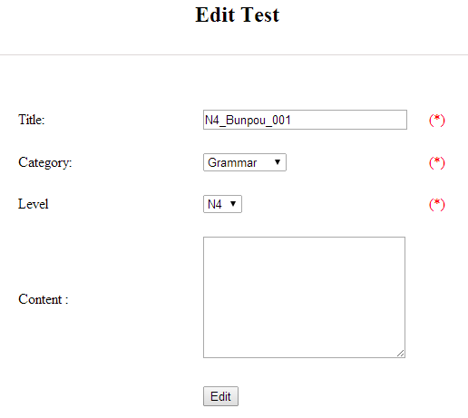

Figure 13.3: Edit test

Table 13.3: Edit test’s screen description:

|  |  |  |  |  |  |  |
| --- | --- | --- | --- | --- | --- | --- |
| No | Field name | Type | Require | Mandatory | Max-Length | Description |
| 1 | ID | Text | Text | Y | 100 | Admin input id with length less than 100 characters |
| 2 | Category | Drop-down list | Click | Y |  | Admin choose category |
| 3 | Level | Drop-down list | Click | Y |  | Admin choose level of test |
| 4 | Test content | Text | Text | Y | 5000 | Admin input content with length less than 5000 characters |
| 5 | Edit | Button | Click | Y |  | Admin click to edit test |

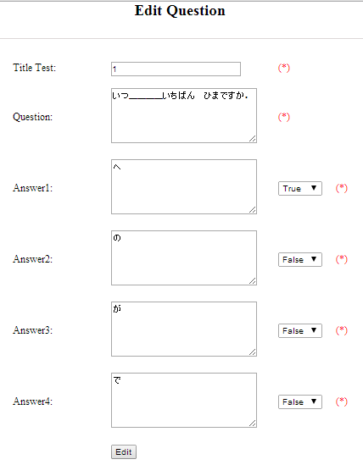

Figure 13.3.1: Edit question

Table 13.3.1: Edit question’s screen description:

|  |  |  |  |  |  |  |
| --- | --- | --- | --- | --- | --- | --- |
| No | Field name | Type | Require | Mandatory | Max-Length | Description |
| 1 | Question | Text | Text | Y | 200 | Admin input question with length less than 200 characters |
| 2 | Answer 1 | Text | Text | Y | 200 | Admin input answer 1 with length less than 200 characters |
| 3 | Correct answer 1 | Drop-down list | Click | Y |  | Admin choose correct answer |
| 4 | Answer 2 | Text | Text | Y | 200 | Admin input answer 2 with length less than 200 characters |
| 5 | Correct answer 2 | Drop-down list | Click | Y |  | Admin choose correct answer |
| 6 | Answer 3 | Text | Text | Y | 200 | Admin input answer 3 with length less than 200 characters |
| 7 | Correct answer 3 | Drop-down list | Click | Y |  | Admin choose correct answer |
| 8 | Answer 4 | Text | Text | Y | 200 | Admin input answer 4 with length less than 200 characters |
| 9 | Correct answer 4 | Drop-down list | Click | Y |  | Admin choose correct answer |
| 10 | Edit | Button | Click | Y |  | Admin click to edit |

|  |  |  |  |  |
| --- | --- | --- | --- | --- |
| **UC0050 - Specification** | | | | |
| **Use-case No.** | <UC0050> | **Use-case Version** | | <1.0> |
| **Use-case Name** | Edit test | | | |
| **Author** | Minh PT | | | |
| **Date** | 09/06/2014 | **Priority** | <High > | |
| **Actor:**  Admin  **Summary:**  When Administrator want to edit test in database that has some new meanings or errors. When edit finished, new meaning will be updated  **Triggers**  User must click on “Test management” then search for the test. User click on “Edit” link on corresponding test. User edits necessary information of test in the right fields then click on “Edit” button.  **Preconditions:**   * Website is available * User have logged into system as an admin. * All mandatory fields have been filled * All input data must be valid and have not existed in system   **Post Conditions:**  Changed information of test has been saved into system database successfully  **Main Success Scenario:**   |  |  |  | | --- | --- | --- | | **Step** | **User** | **System** | | 1 | Have logged into system as an admin |  | | 2 | Click on “Test management ” then search for the test that they want to edit | Displays search result as a table | | 3 | Click on “Edit” link corresponding | Display “Edit Test” screen that contains the information of chosen test with these elements:   * Title * Category * Level * Content | | 4 | Edit test information and click “Edit” button | The system validates the input data and then save data into database |     **Alternative Scenario:**   |  |  |  | | --- | --- | --- | | **At Step** | **User** | **System** | | 4 | Edit test then click to another link | Do not save edited data then redirect to selected page |   **Exceptions:**   |  |  |  | | --- | --- | --- | | **At Step** | **User** | **System** | | 4 | Edit test to be similar to another existed test and click “Edit” button | The system validates the input data and return Error message and do not save edited data into database |   **Reference:**  UC0048- <Admin> Search test | | | | |

###### UC051 <Test management>: Delete test

|  |  |  |  |  |
| --- | --- | --- | --- | --- |
| **UC0051 - Specification** | | | | |
| **Use-case No.** | <UC0051> | **Use-case Version** | | <1.0> |
| **Use-case Name** | Delete test | | | |
| **Author** | Minh PT | | | |
| **Date** | 09/06/2014 | **Priority** | <High > | |
| **Actor:**  Admin  **Summary:**  When Administrator want to delete test in database  **Triggers**  User must click on “Test management” then search for the test. User click on “Delete” link corresponding with test.  **Preconditions:**   * Website is available * User have logged into system as an admin.   **Post Conditions:**  Test has been deleted from system database successfully  **Main Success Scenario:**   |  |  |  | | --- | --- | --- | | **Step** | **User** | **System** | | 1 | Have logged into system as an admin |  | | 2 | Click on “Test management ” then search for the test that they want to delete | Displays search result as a table | | 3 | Click on “Delete” link corresponding | Remove that test in database |     **Reference:**  UC0048 - <Admin> Search test | | | | |
|  | | | | |

#### Contact management

##### Use case diagram

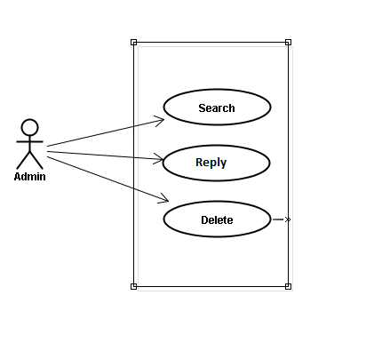

##### Use case specifications

###### UC052 <Opinion/Q&A Management>: Search question

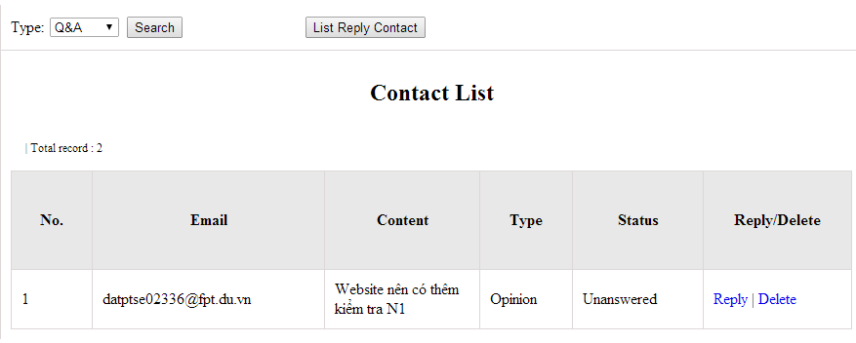

Figure 14.1: Search contact management’s screen

Table 14.1: Search contact management’s screen description

|  |  |  |  |  |  |  |
| --- | --- | --- | --- | --- | --- | --- |
| No | Field name | Type | Require | Mandatory | Max-Length | Description |
| 1 | Type | Drop-down list | Click | N |  | Admin choose the typ |
| 2 | Search | Button | Click | N |  | Admin click to search |
| 3 | Reply | Button | Click | N |  | Admin click reply the question |
| 4 | Delete | Button | Click | N |  | Admin click delete question |
| 5 | List reply | Button | Click | N |  | Admin click to view list reply |

|  |  |  |  |  |
| --- | --- | --- | --- | --- |
| **UC0055 – Specification** | | | | |
| **Use-case No.** | <UC0055> | **Use-case Version** | | <1.0> |
| **Use-case Name** | Search question | | | |
| **Author** | Minh PT | | | |
| **Date** | 09/06/2014 | **Priority** | <High > | |
| **Actor:**  Admin  **Summary:**  When administrator wants to search question from member. User choose data then click “Search” button.  **Triggers**  Click on “Contact Management ” tab, choose type of data in the right text box then click “Search” button  **Preconditions:**   * Website is available * User has to login as Administrator * User has to input data in search area   **Post Conditions:**  Display detail information of question  **Main Success Scenario:**   |  |  |  | | --- | --- | --- | | **Step** | **User** | **System** | | 1 | Have logged into system as an admin |  | | 2 | Click on “Contact Management ” tab | Displays criteria search screen | | 3 | Choose type of contact that they want to find then click “Search” button | Displays search result as a table with these elements:   * No * Email * Content * Type * Status * Reply * Delete |     **Alternative Scenario:**   |  |  |  | | --- | --- | --- | | **At Step** | **User** | **System** | | 3 | Fill information that they want to find into these fields then click on another link | Switch to selected page |   **Exceptions:**   |  |  |  | | --- | --- | --- | | **At Step** | **User** | **System** | | 3 | Fill information that they want to find (that do not exited in database) into these fields then click “Search” button | Return Error message to inform that cannot be found | | | | | |

###### UC053 <Opinion/Q&A Management>: Reply question

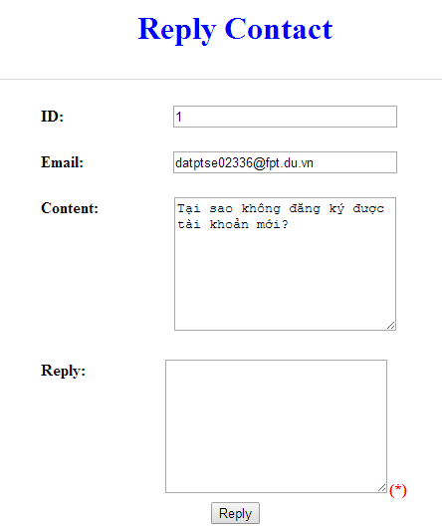

Figure 16.2: Reply contact

Table 16.2: Reply contact’s screen description:

|  |  |  |  |  |  |  |
| --- | --- | --- | --- | --- | --- | --- |
| No | Field name | Type | Require | Mandatory | Max-Length | Description |
| 1 | Email |  |  |  |  | Email of admin’s account |
| 2 | Content |  |  |  |  | Question |
| 3 | Reply | Text | Text | Y |  | Admin input reply of question |
| 4 | Reply | Button | Click | N |  | Admin click send reply question |

|  |  |  |  |  |
| --- | --- | --- | --- | --- |
| **UC0056 - Specification** | | | | |
| **Use-case No.** | <UC0056> | **Use-case Version** | | <1.0> |
| **Use-case Name** | Search question | | | |
| **Author** | Minh PT | | | |
| **Date** | 09/06/2014 | **Priority** | <High > | |
| **Actor:**  Admin  **Summary:**  When administrator wants to reply question from member.  **Triggers**  Click on “Opinion/Q&A Management ” tab, User search question then click “Reply” link corresponding  **Preconditions:**   * Website is available * User has to login as Administrator * User has to input answer   **Post Conditions:**  Answer be sent to user  **Main Success Scenario:**   |  |  |  | | --- | --- | --- | | **Step** | **User** | **System** | | 1 | Have logged into system as an admin |  | | 2 | Click on “Opinion/Q&A Management ” tab | Displays criteria search screen | | 3 | Click “Reply” link corresponding | Displays Reply screen with these elements:   * Email * Content * Reply | | 4 | Input the answer and click “Reply” button | The answer of question will be sent to member |     **Alternative Scenario:**   |  |  |  | | --- | --- | --- | | **At Step** | **User** | **System** | | 4 | Input answer then click on another link | Switch to selected page |   **Exceptions:**   |  |  |  | | --- | --- | --- | | **At Step** | **User** | **System** | |  |  |  |   **Reference:**  UC0052 - < Opinion/Q&A Management > Search question | | | | |

###### UC054 <Opinion/Q&A Management>: Delete question

|  |  |  |  |  |
| --- | --- | --- | --- | --- |
| **UC0054 - Specification** | | | | |
| **Use-case No.** | <UC0051> | **Use-case Version** | | <1.0> |
| **Use-case Name** | Delete question | | | |
| **Author** | Minh PT | | | |
| **Date** | 09/06/2014 | **Priority** | <High > | |
| **Actor:**  Admin  **Summary:**  When Administrator want to delete question  **Triggers**  User must click on “Contact management” then search for the test. User click on “Delete” link corresponding with test.  **Preconditions:**   * Website is available * User have logged into system as an admin.   **Post Conditions:**  Question has been deleted from system database successfully  **Main Success Scenario:**   |  |  |  | | --- | --- | --- | | **Step** | **User** | **System** | | 1 | Have logged into system as an admin |  | | 2 | Click on “Contact management ” then search for the test that they want to delete | Displays search result as a table | | 3 | Click on “Delete” link corresponding | Remove that test in database |     **Reference:**  UC0052 - <Admin> Search contact | | | | |
|  | | | | |

#### Contributed content management

##### Use case diagram

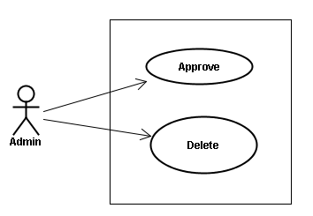

##### Use case specifications

###### UC055 <Contact’s content Management>: Approve contribute content

Approve contribute content screen:

1. Approve contribute kanji screen:

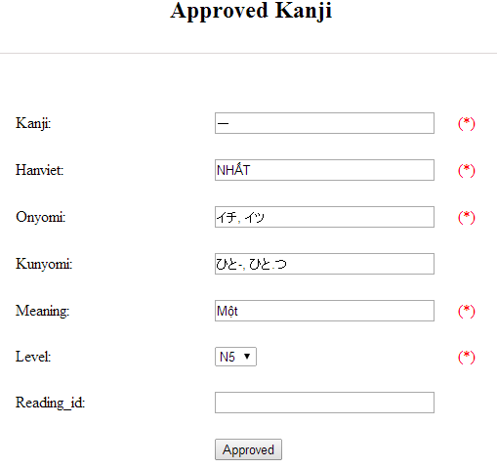

Figure 15.1: Approved kanji’s screen

Table 15.1: Approved kanji’s screen description

|  |  |  |  |  |  |  |  |
| --- | --- | --- | --- | --- | --- | --- | --- |
| No | Field name | File name in Vietnamese | Type | Require | Mandatory | Max-Length | Description |
| 1 | Kanji | Kanji | Text | Text | Y | 10 | Admin input kanji with length less than 10 characters |
| 2 | HanViet | Hán Việt | Text | Text | N | 50 | Admin input to the field with length less than 50 characters |
| 3 | Onyomi | Âm Onyomi | Text | Text | Y | 100 | Admin input onyomi with length less than 100 characters |
| 4 | Kunyomi | Âm kunyomi | Text | Text | Y | 100 | Admin input kunyomi with length less than 100 characters |
| 5 | Meaning | Nghĩa | Text | Text | Y | 200 | Admin input meaning with length less than 200 characters |
| 6 | Level | Level | Drop-down list | Click | Y |  | Admin choose the level |
| 7 | Reading_id |  | Text | Text | N | 20 | Admin input reading id with length less than 20 characters |
| 8 | Approved | Approved | Button | Click | Y |  | Admin click to approved contribute |

1. Approve contribute grammar screen:

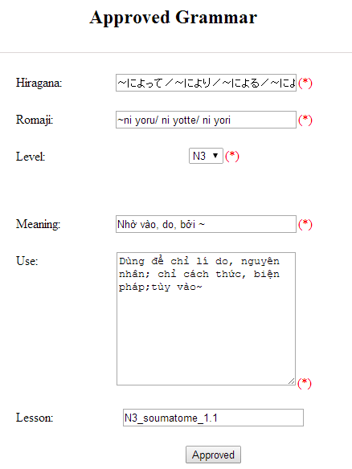

Figure 15.2: Approved grammar screen

Table 15.2: Approved grammar’s screen description:

|  |  |  |  |  |  |  |
| --- | --- | --- | --- | --- | --- | --- |
| No | Field name | Type | Require | Mandatory | Max-Length | Description |
| 1 | Hiragana | Text | Text | Y | 200 | Admin input hiragana with length less than 200 characters |
| 2 | Romaji | Text | Text | Y | 200 | Admin input romaji with length less than 200 characters |
| 3 | Meaning | Text | Text | Y | 200 | Admin input meaning with length less than 200 characters |
| 4 | Level | Drop-down list | Click | Y |  | Admin choose the level |
| 5 | Use | Text | Text | Y | 1000 | Admin input how to use with length less than 1000 characters |
| 6 | Lesson | Text | Text | N | 20 | Admin input lesson with length less than 20 characters |
| 7 | Approved | Button | Click | Y |  | Admin click to approved contribute |

1. Approve contribute vocabulary screen:

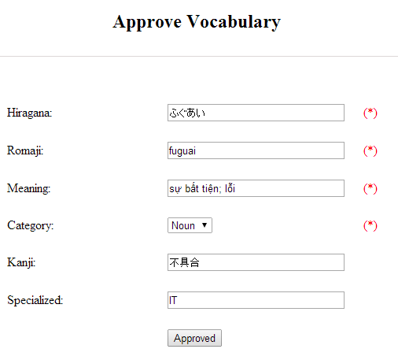

Table 15.3: Approved vocabulary

Table 15.3: Approved vocabulary’s screen description:

|  |  |  |  |  |  |  |
| --- | --- | --- | --- | --- | --- | --- |
| No | Field name | Type | Require | Mandatory | Max-Length | Description |
| 1 | Hiragana | Text | Text | Y | 200 | Admin input hiragana with length less than 200 characters |
| 2 | Romaji | Text | Text | N | 200 | Admin input romaji with length less than 200 characters |
| 3 | Meaning | Text | Text | Y | 500 | Admin input meaning with length less than 500 characters |
| 4 | Category | Drop-down list | Click | Y | 10 | Admin choose category |
| 5 | Kanji | Text | Text | N | 10 | Admin input kanji with length less than 10 characters |
| 6 | Specialized | Text | Text | N | 200 | Admin input specialized with length less than 200 characters |
| 7 | Approved | Button | Click | Y |  | Admin click to approved contribute |

|  |  |  |  |  |
| --- | --- | --- | --- | --- |
| **UC0053 - Specification** | | | | |
| **Use-case No.** | <UC0053> | **Use-case Version** | | <1.0> |
| **Use-case Name** | Approve contribute content | | | |
| **Author** | Minh PT | | | |
| **Date** | 09/06/2014 | **Priority** | <High > | |
| **Actor:**  Admin  **Summary:**  When administrator wants to approve contribute content include kanji, grammar, vocabulary in database. User click on link corresponding with kanji, grammar, vocabulary  **Triggers**  Click on “Contribute Kanji Management” or “Contribute Grammar Management” or “Contribute Vocabulary Management” tab, input data in the right text box then click “Search” button. Click on link corresponding with kanji, grammar, vocabulary which want to approve to database  **Preconditions:**   * Website is available * User has to login as Administrator * All mandatory fields have been filled * All input data must be valid and have not existed in system   **Post Conditions:**  Display detail information of contribute content  **Main Success Scenario:**   |  |  |  | | --- | --- | --- | | **Step** | **User** | **System** | | 1 | Have logged into system as an admin |  | | 2 | Click on “Kanji Management/List contribute kanji” or “Grammar Management/List contribute grammar” or “Vocabulary/List contribute vocabulary” tab | Displays criteria search screen | | 3 | Fill information that they want to find into text box then click “Search” button | Displays search result | | 4 | Click “Approved” link corresponding want to update into database | Display Approve kanji screen with these elements:   1. Kanji - Kanji - Âm hán - Âm Onyomi - Âm Kunyoumi - Meaning - level - Reading_id - Approved 2. Grammar: - Hiragana - Romaji - Level - Meaning - Use - Lesson - Approved 3. Vocabulary: - Hiragana - Romaji - Meaning - Category - Kanji - Specialized - Approved | | 5 | Edit or add more information and Click “Approved” button | The system validates the input data and then save data into database |     **Alternative Scenario:**   |  |  |  | | --- | --- | --- | | **At Step** | **User** | **System** | | 5 | Fill information then click on another link | Switch to selected page |   **Exceptions:**   |  |  |  | | --- | --- | --- | | **At Step** | **User** | **System** | | 5 | Fill information that exited in database into fields then click “Approved” button | Return Error message to inform that data is exiting in database |   **Reference:** | | | | |

###### UC0056: < Contact’s content Management > Delete contribute content

|  |  |  |  |  |
| --- | --- | --- | --- | --- |
| **UC0054 - Specification** | | | | |
| **Use-case No.** | <UC0054> | **Use-case Version** | | <1.0> |
| **Use-case Name** | Delete contribute content | | | |
| **Author** | Minh PT | | | |
| **Date** | 09/06/2014 | **Priority** | <High > | |
| **Actor:**  Admin  **Summary:**  When Administrator wants to delete a contribute content. Admin will search that content then click “Delete” link corresponding.  **Triggers**  User must click on “Contribute Kanji Management” or “Contribute Grammar Management” or “Contribute Vocabulary Management” tab then search for the contribute content. User click on “Delete” link corresponding with kanji, grammar, vocabulary which want to delete.  **Preconditions:**   * Website is available * User has to login as Administrator   **Post Conditions:**  Kanji, grammar, vocabulary have been deleted from list successfully  **Main Success Scenario:**   |  |  |  | | --- | --- | --- | | **Step** | **User** | **System** | | 1 | Have logged into system as an admin |  | | 2 | Click on “Contribute Kanji Management ” or “Contribute Grammar Management ” or “Contribute Vocabulary Management ” tab | Displays search result as a table | | 3 | Click on “Delete” link corresponding with kanji, grammar, vocabulary | Remove that kanji, grammar, vocabulary from list |   **Reference:** | | | | |
|  | | | | |

### Non-Functional Specification Requirements

#### Reliability

* Mean time between failures: The mean time between each failure is expected to be about 480 hours of using.
* Mean time to repair: Immediately when Administrator finds out problem or website is attacked/hacked by someone. Average 1 day.
* The maximum bugs per function are 2 bugs/a function when user uses software within 2 months. The average number of bugs in the software during system testing is about to be around 1 bugs/1000 LOC.
* The database must be backed up daily and can be recovered if necessary

#### Performance Requirements

##### Availability

The application must be available 95% of time. Users can access to it everywhere from their

Web browser with internet connection.

##### Response time

In term of response time, waiting time of processing will be 2 to 5 seconds; time to process any functions will not exceed 7 seconds.

#### User Interface

● **Color:** The background color will be white and blue in default. The color of text will be black or white.

● **Text:** All texts bases on Helvetica style and title or label will use upper case with the first letter.

#### Maintainability

* **Coding standards and naming conventions**
  + Output of the project must include coding standards and naming conventions documentations. Implementation code must be easy to maintain.
  + All code must be clearly commented, including class, method documentations.
  + If some components are reused, the documentations of those components must also be included.
* **Design**
  + The design of the system must be loosely coupled that chances on some module will not affect others.
* **Logging**
  + All the errors should be logged, supporting for bug fixing and maintenance.
  + All strange or sensitive situations should also be logged.

#### Usability

Usability Requirements support the following from the perspective of its primary users:

● **Efficiency of use:** user can complete each function in less than 12 actions

● **Intuitiveness:** all help/error messages are simple to understand; user can know exactly how to do each feature after one time using it.

#### Security Requirements

In order to avoid unwanted access by strangers, the security implemented in various ways:

* **User layer**: Each function must be distributed system access and manipulate the individual parts. To edit information, user must declare their username and password before the operation. Functions will be show after users login dependencies user’s role and permission of each user.
* **Manage Data Layer**: Only Administrator can modify database system.
* **Stored Data**: All data about information of user, tested, etc… will be saved in My SQL Server, and be easy for data classification or backup.

#### Hardware/Software Requirements

● **Hardware requirement:** PC/Laptop (window 7, window 8, window XP…)

● **Software requirements:** Web browser (Chrome, Firefox, IE…) with internet connection

# Software Design Description

## SDD Overview

This document provides the software design description of the RTF system. It relies on requirements in section 3 and includes all of important information that describes how the system does.

The RTF system includes two main sub systems:

* Main application – the RTF website
* Administration application for administrator

These subsystems use the same database.

Developers and testers will base on this design to develop source code and perform tests.

This section of document is the **software design description** of the project in order to develop the software, it includes four main parts: Architecture Design, Class Design, Detail Design, and Database design.

## Architecture Design

### System Overall Architecture

**Client**

**(Web browser)**

**Application Server**

**ManagementSystem**

**RTF website**

**Images:**

* News Image
* Profile Image
* Rice Image
* Web Image

**Storage**

**File System**

**Database**

Figure ‑ System Overall Architecture

### Software Architect

#### Layered Architecture

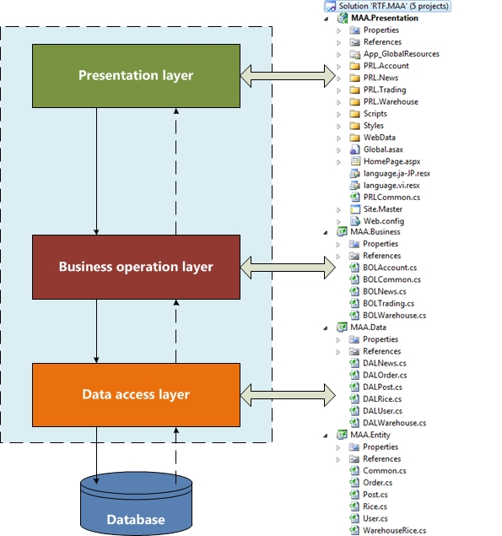

Figure ‑ Layered architecture for RTF software system

##### Layered Architecture Style

Layered software architecture is a hierarchical architecture that uses many layers for allocating the different responsibilities of a software product.

The system is decomposed into a number of higher and lower layers in a hierarchy; each layer consists of a group of related classes that are encapsulated in a package, in a deployed component, or as a group of subroutines in the format of method library or header file. Also, each layer has its own responsibility in the system.

RTF software system is decomposed into layers that are Presentation layer, Business operation layer, and Data access layer. Each layer has its own responsibility as follow:

###### Presentation Layer

The top-most level of the application is the user interface. The main function of the interface is to translate tasks and results to something the user can understand.

Presentation layer provides user interface, handles the interaction with the user and sometimes call the GUI or client view or front-end. Specially, presentation layer shout not contain business logic or data access code.

The presentation layer is responsible for the delivery and formatting of information to the application layer for further processing or display.

It relieves the application layer of concern regarding syntactical differences in data representation within the end-user systems.

Presentation Layer will receive input data from users and response the result again users. This layer contents aspx files and css file used to design application’s GUI, catch Events while users interacting with application.

###### Business Operation Layer

Business layer will set of rules for processing information, can accommodate many users, and should not contain presentation or data access code.

This layer coordinates the application, process commands, makes logical decisions and evaluations and performs calculations, it also moves and processes data between the two surrounding layers.

Business Layer is a mediate layer; it lies between Data Access Layer and Presentation Layer. It has responsibility as a bridge, when users interact with the application; Presentation Layer will receive input data and pass them to Business Layer, then Business Layer processes these data and requests before they were transferred down to Data Access Layer. Similarly, Business Layer will receive the results from Data Access Layer and processing them, and then transfer up to Presentation Layer.

Additional, Business Layer also processes the logic operation, calculation and other operations.

###### Data access layer

Here is information is stored and retrieved from a database or file system. The information is then passed back to the logic tier for processing, and then eventually back to the user.

Data access tier is physical storage layer for data persistence. It manages access to Database or file system, and should not contain presentation or business logic code.

Data Access Layer is responsible for interacting with Database Management System (SQL Server). Main activities of this layer are retrieving data, inserting, updating or deleting data, then response to users.

Database Layer: is a place where store the data of application; it includes relational tables. We had decided SQLite to organize and store data.

##### Advantages of Layered Architecture

* Incremental software development base on increasing levels of abstraction.
* Enhanced independence of upper layer to lower layer since there is no impact from the changes of lower layer services as long as their interfaces remain unchanged.
* Enhanced flexibility: interchange ability and reusability are enhanced due to the separation of the standard interface and its implementation.
* Component-based technology is a suitable technology to implement layered architecture; this makes it much easier for the system to allow for plug-and-play of new components. Components are reusable, easier to maintain and fast development. Web designer does presentation, Software engineer does logic and Database admin does data model.
* Promotion of portability: each layer can be an abstract machine deployed independently.

## Class Design

Below is overall analysis class diagram for MAA. For more detail analysis class diagrams of MAA, refer to [MAA Class Design](../Report_4_Design/MAA_Class_Design).

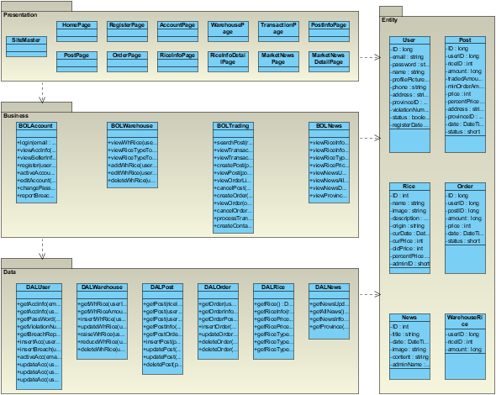

Figure ‑ MAA analysis class diagram

With analysis class diagrams of ADA, refer to [ADA Class Design](../Report_4_Design/ADA_Class_Design).

Below is class diagram for **trading floor** function group of MAA. All class diagrams of MAA refer to [MAA Class Design](../Report_4_Design/MAA_Class_Design)

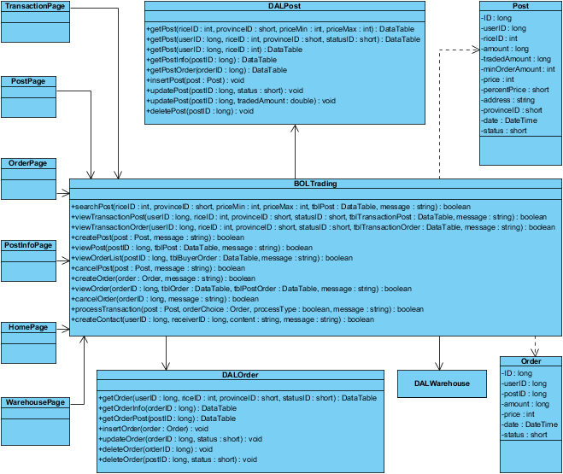

Figure ‑ MAA – Trading floor – Class diagram

## Detail Design

Below is detail design for Main Application

With detail design for ADA, refer to [ADA Detail Design](../Report_4_Design/ADA_Detail_Design) for screen design.

### User Interface Design

#### Screen flow

|  |  |  |  |
| --- | --- | --- | --- |
| Screen no. | Screen name | Screen no. | Screen name |
| SC-MAA-00 | Site Master | SC-MAA-06 | Post page |
| SC-MAA-01 | Home page | SC-MAA-07 | Order page |
| SC-MAA-02 | Registration page | SC-MAA-09 | Rice information page |
| SC-MAA-03 | Account page | SC-MAA-10 | Rice info detail page |
| SC-MAA-04 | Warehouse page | SC-MAA-11 | Market news page |
| SC-MAA-05 | Transaction page | SC-MAA-12 | Market news detail page |
| SC-MAA-08 | Post information page |  |  |

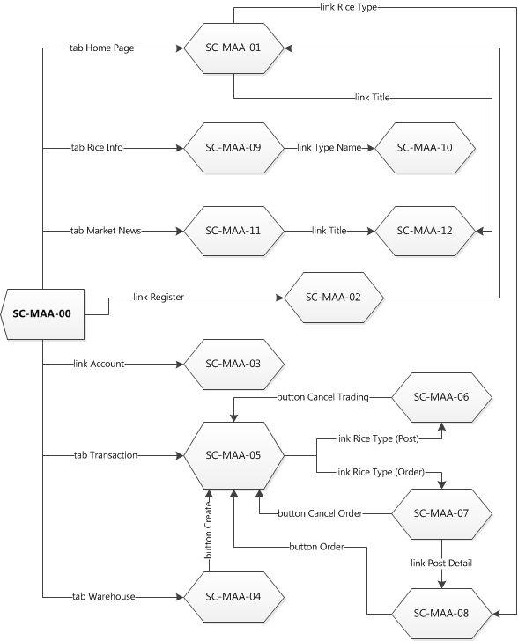

Figure ‑ MAA screen flow

#### Screen Design

##### Site Master

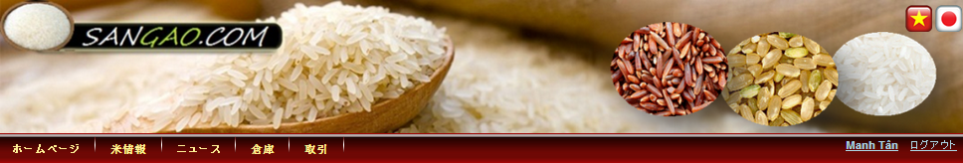

Figure ‑ Site Master screen design

**Table 4‑1** Site Master screen items

|  |  |  |  |  |  |  |  |  |  |  |  |
| --- | --- | --- | --- | --- | --- | --- | --- | --- | --- | --- | --- |
| **No.** | **Item** | **ID** |  |  |  | **Display type** | |  |  |  | **I/O** |
| 1 | Textbox Email | tbxEmail |  |  |  | Textbox | | | | | I |
| 2 | Textbox Password | txtPassword |  |  |  | Textbox | | | | | I |
| 3 | LinkButton Login | lbtLogin |  |  |  | LinkButton | | | | | I |
| 4 | LinkButton Register | lbtRegister |  |  |  | LinkButton | | | | | I |
| 5 | LinkButton Account | lbtAccount |  |  |  | LinkButton | | | | | I |
| 6 | LinkButton Logout | lbtLogout |  |  |  | LinkButton | | | | | I |
| 7 | Tab Home Page | tabHomePage |  |  |  | HyperLink |  |  |  |  | I |
| 8 | Tab Rice Information | tabRiceInfoPage |  |  |  | HyperLink |  |  |  |  | I |
| 9 | Tab Market News | tabNewsPage |  |  |  | HyperLink |  |  |  |  | I |
| 10 | Tab Warehouse | tabWarehouse |  |  |  | HyperLink |  |  |  |  | I |
| 11 | Tab Transaction | tabTrading |  |  |  | HyperLink |  |  |  |  | I |
| 12 | RadioButton Vietnamese | rbtVn |  |  |  | RadioButton | |  |  |  | I |
| 13 | RadioButton Japanese | rbtJp |  |  |  | RadioButton | |  |  |  | I |

##### Home Page

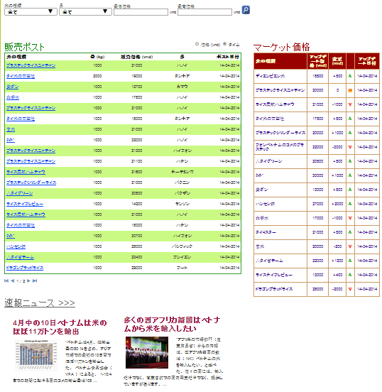

Figure ‑ Home page screen design

**Table 4‑2** Home page screen items

|  |  |  |  |  |  |  |  |  |  |  |  |
| --- | --- | --- | --- | --- | --- | --- | --- | --- | --- | --- | --- |
| **No.** | **Item** | |  | **ID** |  | **Display type** |  |  |  |  | **I/O** |
| 1 | DropDownList Rice Type | |  | ddlRiceType |  | DropDownList | | | | | I |
| 2 | DropDownList Province | |  | ddlProvince |  | DropDownList | | | | | I |
| 3 | Textbox Minimum Price | |  | tbxMinPrice |  | Textbox | | | | | I |
| 4 | Textbox Maximum Price | |  | tbxMaxPrice |  | Textbox | | | | | I |
| 5 | Button Search | |  | btnSearch |  | Button | | | | | I |
| 6 | RadioButton Price | |  | rbtPrice |  | RadioButton |  |  |  |  | I |
| 7 | RadioButton Time | |  | rbtTime |  | RadioButton |  |  |  |  | I |
| 8 | DataGridView Selling Posts | |  | dgvPosts |  | DataGridView | | | | | O |
| 9 | DataGridView Rice Price | |  | dgvRicePrice |  | DataGridView | | | | | O |
| 10 | LinkButton Title | |  | lbtTitle |  | LinkButton | | | | | O |
| 11 | ImageMap News Picture | |  | impPicture |  | ImageMap | | | | | O |
| 12 | Label Brief Description |  |  | lblBriefDescription |  | Label | | | | | O |

##### Registration Page

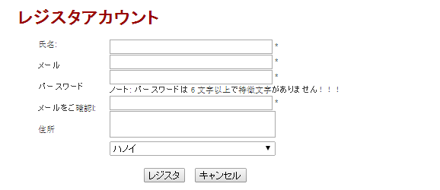

Figure ‑ Registration page screen design

**Table 4‑3** Registration page screen items

|  |  |  |  |  |  |  |  |  |  |  |
| --- | --- | --- | --- | --- | --- | --- | --- | --- | --- | --- |
| **No.** | **Item** |  | **ID** |  |  | **Display type** |  |  |  | **I/O** |
| 1 | Textbox Name |  | tbxName |  |  | Textbox | | | | I |
| 2 | Textbox Email |  | tbxEmail |  |  | Textbox | | | | I |
| 3 | Textbox Password |  | tbxPassword |  |  | Textbox | | | | I |
| 4 | Textbox Confirm Password |  | tbxConfirmPassword |  |  | Textbox | | | | I |
| 5 | Textbox Address |  | tbxAddress |  |  | Textbox | | | | I |
| 6 | DropDownList Province |  | ddlProvince |  |  | DropDownList | | | | I |
| 7 | Button Register |  | btnOK |  |  | Button | | | | I |
| 8 | Button Cancel |  | btnCalcel |  |  | Button | | | | I |

##### Account Page

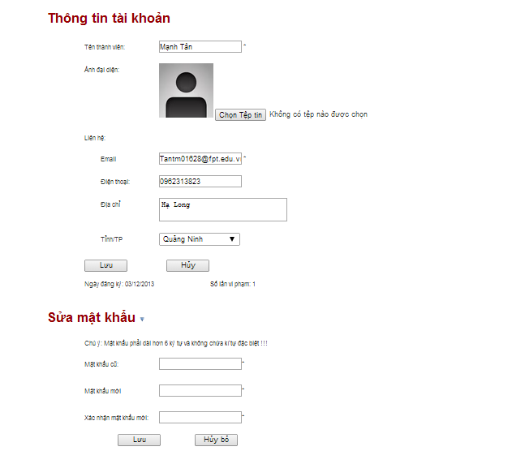

Figure ‑ Account page screen design

**Table 4‑4** Account page screen items

|  |  |  |  |  |  |  |  |  |  |  |
| --- | --- | --- | --- | --- | --- | --- | --- | --- | --- | --- |
| **No.** | **Item** | | **ID** |  | **Display type** | |  |  |  | **I/O** |
| 1 | Label Name | | lblName |  | Label | | | | | O |
| 2 | ImageMap Profile Picture | | impProfilePicture |  | ImageMap | | | | | O |
| 3 | Lable Email | | lblEmail |  | Label | | | | | O |
| 4 | Label Phone | | lblPhone |  | Label | | | | | O |
| 5 | Label Address | | lblAddress |  | Label | | | | | O |
| 6 | Label Province | | lblProvince |  | Label | | | | | O |
| 7 | Textbox Name | | tbxName |  | Textbox | | | | | I |
| 8 | FileUpload Profile Picture | | fupProfilePicture |  | FileUpload |  |  |  |  | I |
| 9 | Textbox Email | | tbxEmail |  | Textbox | | | | | I |
| 10 | Textbox Phone | | tbxPhone |  | Textbox | | | | | I |
| 11 | Textbox Address | | tbxAddress |  | Textbox | | | | | I |
| 12 | DropDownList Province |  | ddlProvince |  | DropDownList | | | | | I |
| 13 | Button Edit | | btnEdit |  | Button | | | | | I |
| 14 | Button Save Edit | | btnSaveEdit |  | Button | | | | | I |
| 15 | Button Cancel Edit | | btnCancelEdit |  | Button | | | | | I |
| 16 | Textbox Old Password | | tbxOldPass |  | Textbox | | | | | I |
| 17 | Textbox New Password | | tbxNewPass |  | Textbox | | | | | I |
| 18 | Textbox Confirm New Password | | tbxConfirmNewPass |  | Textbox | | | | | I |
| 19 | Button Save Change Password | | btnSaveChangePass |  | Button | | | | | I |
| 20 | Button Cancel Change Password | | btnCancelChangePass |  | Button | | | | | I |
| 21 | Label Register date | | lblRegisterDate |  | Label | | | | | O |
| 22 | Label Current violation number | | lblViolationNum |  | Label | | | | | O |

##### Warehouse Page

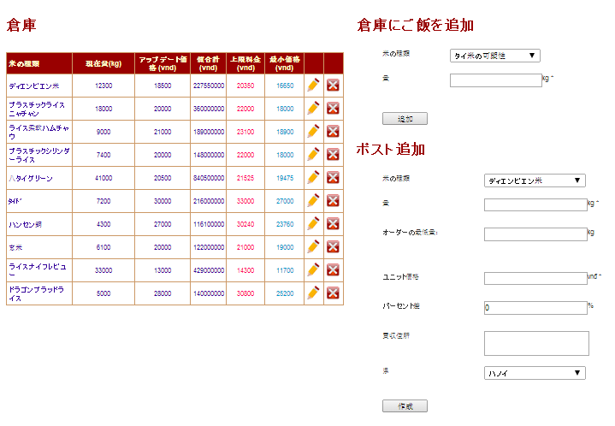

Figure ‑ Warehouse page screen design

**Table 4‑5** Warehouse page screen items

|  |  |  |  |  |  |  |  |  |  |
| --- | --- | --- | --- | --- | --- | --- | --- | --- | --- |
| **No.** | **Item** | | **ID** |  | **Display type** |  |  |  | **I/O** |
| 1 | DataGridView Warehouse | | dgvWarehouse |  | DataGridView | | | | O |
| 2 | Button Edit |  | btnEdit |  | Button | | | | I |
| 3 | Button Delete |  | btnDelete |  | Button | | | | I |
| 4 | Button Save Edit |  | btnSaveEdit |  | Button | | | | I |
| 5 | Button Cancel Edit |  | btnCancelEdit |  | Button | | | | I |
| 6 | DropDownList Rice type Add | | ddlRiceTypeAdd |  | DropDownList | | | | I |
| 7 | Textbox Amount Add | | tbxAmountAdd |  | Textbox | | | | I |
| 8 | Button Add |  | btnAdd |  | Button | | | | I |
| 9 | DropDownList Rice Type To Create | | ddlRiceTypeCreate |  | DropDownList | | | | I |
| 10 | Textbox Amount Create | | tbxAmountCreate |  | Textbox | | | | I |
| 11 | Textbox Min Order Amount Create | | tbxMinCreate |  | Textbox | | | | I |
| 12 | Textbox Price Create | | tbxPriceCreate |  | Textbox | | | | I |
| 13 | Textbox Percent Price Create | | tbxPercentCreate |  | Textbox | | | | I |
| 14 | Textbox Address Create | | tbxAddressCreate |  | Textbox | | | | I |
| 15 | DropDownList Province Create | | ddlProvinceCreate |  | DropDownList | | | | I |
| 16 | Button Create | | btnCreate |  | Button | | | | I |

##### Transaction Page

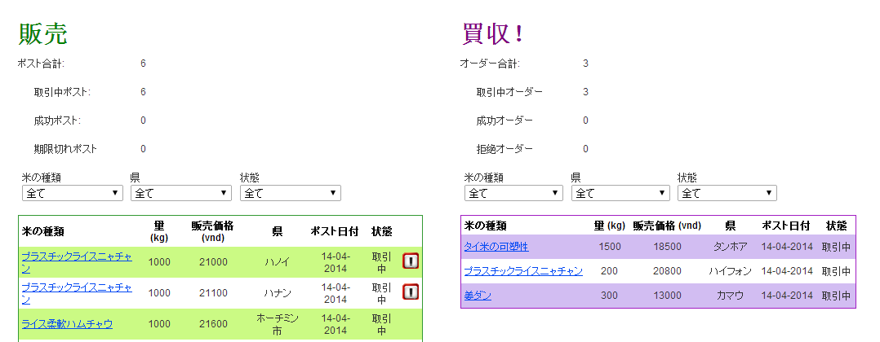

Figure ‑ Transaction page screen design

**Table 4‑6** Transaction page screen items

|  |  |  |  |  |  |  |  |  |  |  |  |  |  |
| --- | --- | --- | --- | --- | --- | --- | --- | --- | --- | --- | --- | --- | --- |
| **No.** | **Item** |  |  |  |  | **ID** |  |  | **Display type** | | |  | **I/O** |
| 1 | Label Num Of Post | | | |  | lblNumPost |  |  | Label |  |  |  | O |
| 2 | Label Num Of Trading Post | | | | | lblNumPostTrading |  |  | Label |  |  |  | O |
| 3 | Label Num Of Success Post | | | | | lblNumPostSuccess |  |  | Label |  |  |  | O |
| 4 | Label Num Of Expired Post | | | | | lblNumPostExpired |  |  | Label |  |  |  | O |
| 5 | Label Num Of Order | | | | | lblNumOrder |  |  | Label |  |  |  | O |
| 6 | Label Num Of Pending Order | | | | | lblNumOrderPending |  |  | Label |  |  |  | O |
| 7 | Label Num Of Accepted Order | | | | | lblNumOrderAccept |  |  | Label |  |  |  | O |
| 8 | Label Num Of Rejected Order | | | | | lblNumOrderReject |  |  | Label |  |  |  | O |
| 9 | DropDownList Rice Type Of Post | | | | | ddlPostRiceType |  |  | DropDownList | | |  | O |
| 10 | DropDownList Post Province | | | | | ddlPostProvince |  |  | DropDownList | | |  | O |
| 11 | DropDownList Post Status | | | | | ddlPostStatus |  |  | DropDownList | | |  | O |
| 12 | DataGridView Post | | | |  | dgvPost |  |  | DataGridView | | |  | O |
| 13 | DropDownList Rice Type Of Order | | | | | ddlOrderRiceType |  |  | DropDownList | | |  | O |
| 14 | DropDownList Order Province | | | | | ddlOrderProvince |  |  | DropDownList | | |  | O |
| 15 | DropDownList Order Status | | | | | ddlOrderStatus |  |  | DropDownList | | |  | O |
| 16 | DataGridView Order | | | |  | dgvOrder |  |  | DataGridView | | |  | O |

##### Post Page

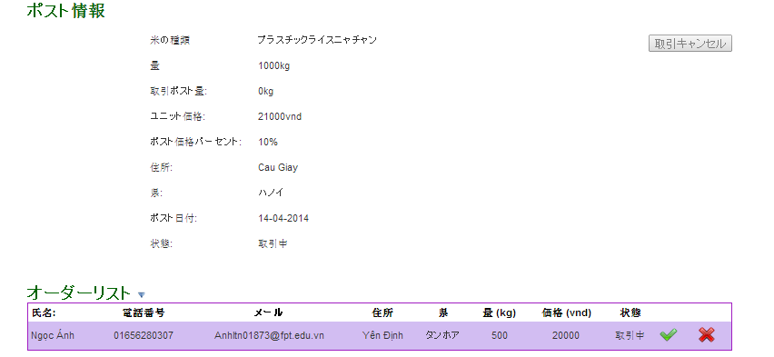

Figure ‑ Post page screen design

**Table 4‑7** Post page screen items

|  |  |  |  |  |  |  |  |  |  |  |  |  |
| --- | --- | --- | --- | --- | --- | --- | --- | --- | --- | --- | --- | --- |
| **No.** | **Item** |  | **ID** |  |  | **Display type** | | |  |  |  | **I/O** |
| 1 | Label Rice Type |  | lblRiceType |  |  | Label |  |  |  |  |  | O |
| 2 | Label Amount |  | lblAmount |  |  | Label |  |  |  |  |  | O |
| 3 | Label Traded Amount |  | lblTradedAmount |  |  | Label |  |  |  |  |  | O |
| 4 | Label Price |  | lblPrice |  |  | Label |  |  |  |  |  | O |
| 5 | Label Percent Price |  | lblPerPrice |  |  | Label |  |  |  |  |  | O |
| 6 | Label Address |  | lblAddress |  |  | Label |  |  |  |  |  | O |
| 7 | Label Province |  | lblProvince |  |  | Label |  |  |  |  |  | O |
| 8 | Label Create Date |  | lblCreateDate |  |  | Label |  |  |  |  |  | O |
| 9 | Label Status |  | lblStatus |  |  | Label |  |  |  |  |  | O |
| 10 | Button Cancel Trading |  | btnCancelTrade |  |  | Button |  |  |  |  |  | I |
| 11 | DataGridView Order-Buyer |  | dgvOrderBuyer |  |  | DataGridView | | |  |  |  | O |
| 12 | Button Accept |  | btnAccept |  |  | Button |  |  |  |  |  | I |
| 13 | Button Reject |  | btnReject |  |  | Button |  |  |  |  |  | I |

##### Order Page

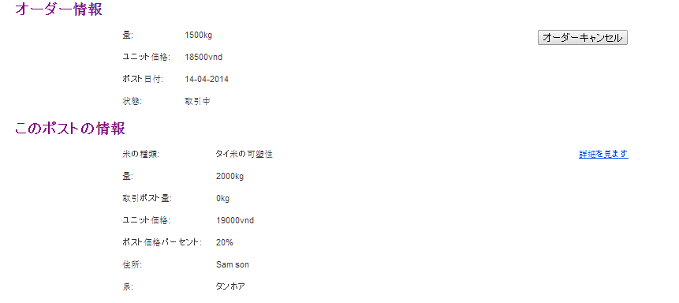

Figure ‑ Order page screen design

|  |  |  |  |  |  |  |  |  |  |  |
| --- | --- | --- | --- | --- | --- | --- | --- | --- | --- | --- |
| **No.** | **Item** |  | **ID** | **Display type** | | |  |  |  | **I/O** |
| 1 | Label Order Amount |  | lblOrderAmount | Label |  |  |  |  |  | O |
| 2 | Label Order Price |  | lblOrderPrice | Label |  |  |  |  |  | O |
| 3 | Label Order Created Date |  | lblOrderDate | Label |  |  |  |  |  | O |
| 4 | Label Order Status |  | lblOrderStatus | Label |  |  |  |  |  | O |
| 5 | Button Cancel Order |  | btnCancelOrder | Button |  |  |  |  |  | I |
| 6 | Label Post Rice Type |  | lblPostRice | Label |  |  |  |  |  | O |
| 7 | HyperLink Post Detail |  | hplPostDetail | HyperLink | |  |  |  |  | O |
| 8 | Label Post Amount |  | lblPostAmount | Label |  |  |  |  |  | O |
| 9 | Label Post Traded Amount |  | lblPostTradedAmount | Label |  |  |  |  |  | O |
| 10 | Label Post Price |  | lblPostPrice | Label |  |  |  |  |  | O |
| 11 | Label Post Address |  | lblPostAddress | Label |  |  |  |  |  | O |
| 12 | Label Post Province |  | lblPostProvince | Label |  |  |  |  |  | O |

##### Post Information Page

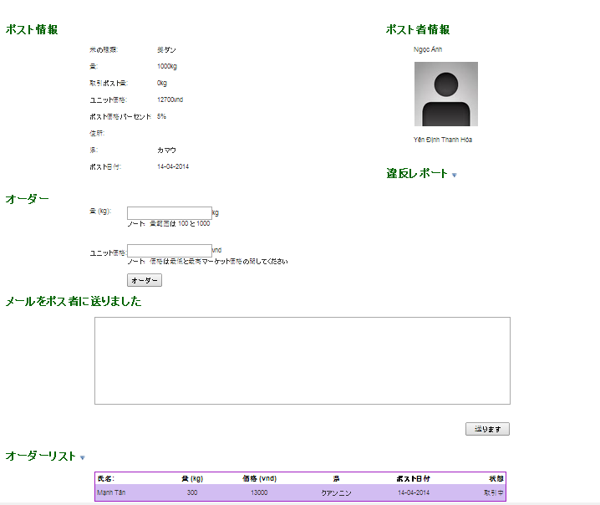

Figure ‑ Post information page screen design

**Table 4‑8** Post information page screen items

|  |  |  |  |  |  |  |  |  |  |  |  |
| --- | --- | --- | --- | --- | --- | --- | --- | --- | --- | --- | --- |
| **No.** | **Item** |  | **ID** |  | **Display type** | | |  |  |  | **I/O** |
| 1 | Label Post Rice Type |  | lblPostRice |  | Label |  |  |  |  |  | O |
| 2 | Label Post Amount |  | lblPostAmount |  | Label |  |  |  |  |  | O |
| 3 | Label Post Traded Amount |  | lblPostTradedAmount |  | Label |  |  |  |  |  | O |
| 4 | Label Post Price |  | lblPostPrice |  | Label |  |  |  |  |  | O |
| 5 | Label Post Percent Price |  | lblPostPerPrice |  | Label |  |  |  |  |  | O |
| 6 | Label Post Address |  | lblPostAddress |  | Label |  |  |  |  |  | O |
| 7 | Label Post Province |  | lblPostProvince |  | Label |  |  |  |  |  | O |
| 8 | Label Post Create Date |  | lblPostCreateDate |  | Label |  |  |  |  |  | O |
| 9 | Textbox Order Amount |  | tbxOrderAmount |  | Textbox | |  |  |  |  | I |
| 10 | Textbox Order Price |  | tbxOrderPrice |  | Textbox | |  |  |  |  | I |
| 11 | Button Order |  | btnOrder |  | Button |  |  |  |  |  | I |
| 12 | Label Seller Name |  | lblSellerName |  | Label |  |  |  |  |  | O |
| 13 | ImageMap Seller Picture |  | impSellerPicture |  | ImageMap | |  |  |  |  | O |
| 14 | Label Seller Email |  | lblSellerEmail |  | Label |  |  |  |  |  | O |
| 15 | Label Seller Phone |  | lblSellerPhone |  | Label |  |  |  |  |  | O |
| 16 | Label Seller Address |  | lblSellerAddress |  | Label |  |  |  |  |  | O |
| 17 | Label Seller Province |  | lblSellerProvince |  | Label |  |  |  |  |  | O |
| 18 | Textbox Reason |  | tbxReason |  | Textbox | |  |  |  |  | I |
| 19 | Button Report Breach |  | btnReportBreach |  | Button |  |  |  |  |  | I |
| 20 | Button Cancel Report |  | btnCancelReport |  | Button |  |  |  |  |  | I |
| 21 | Textbox Contact Content |  | tbxContactContent |  | Textbox | |  |  |  |  | I |
| 22 | Button Send Contact |  | btnContact |  | Button |  |  |  |  |  | I |
| 23 | DataGridView Order-Buyer |  | dgvOrderBuyer |  | DataGridView | | |  |  |  | O |

##### Rice Information Page

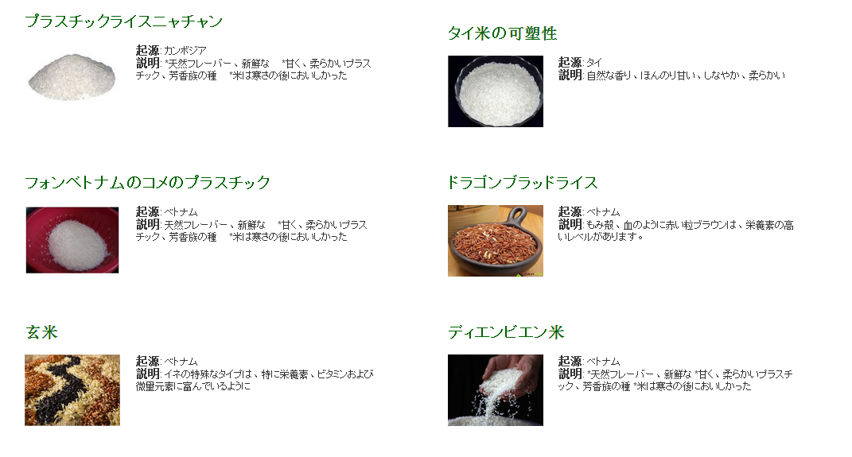

Figure ‑ Rice information page screen design

**Table 4‑9** Rice information page screen items

|  |  |  |  |  |  |  |  |  |  |  |  |  |  |
| --- | --- | --- | --- | --- | --- | --- | --- | --- | --- | --- | --- | --- | --- |
| **No.** | **Item** | |  |  |  |  | **ID** | **Display type** | | |  |  | **I/O** |
| 1 | LinkButton Type Name | | | | | | lbtTypeName | LinkButton | |  |  |  | O |
| 2 | ImageMap Rice Picture |  |  |  |  |  | impPicture | ImageMap | |  |  |  | O |
| 3 | Label Origin | | | |  |  | lblOrigin | Label |  |  |  |  | O |
| 4 | Label Brief Description | | | | | | lblBriefDescription | Label |  |  |  |  | O |

##### Rice Info Detail Page

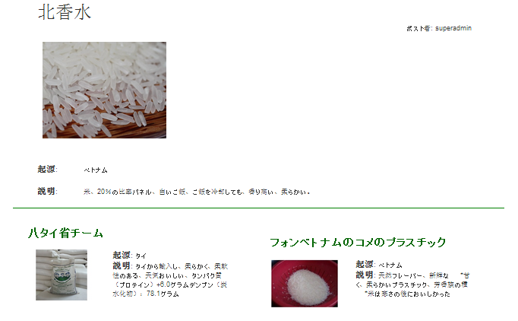

Figure ‑ Rice information detail page screen design

**Table 4‑10** Rice information detail page screen items

|  |  |  |  |  |  |  |  |  |  |  |  |  |  |
| --- | --- | --- | --- | --- | --- | --- | --- | --- | --- | --- | --- | --- | --- |
| **No.** | **Item** | |  |  |  |  | **ID** | **Display type** | | |  |  | **I/O** |
| 1 | Label Type Name | | | | |  | lblTypeName | Label |  |  |  |  | O |
| 2 | ImageMap Rice Picture |  |  |  |  |  | impPicture | ImageMap | |  |  |  | O |
| 3 | Label Origin | | | |  |  | lblOrigin | Label |  |  |  |  | O |
| 4 | Label BriefDescription | | | | | | lblBriefDescription | Label |  |  |  |  | O |

##### Market News Page

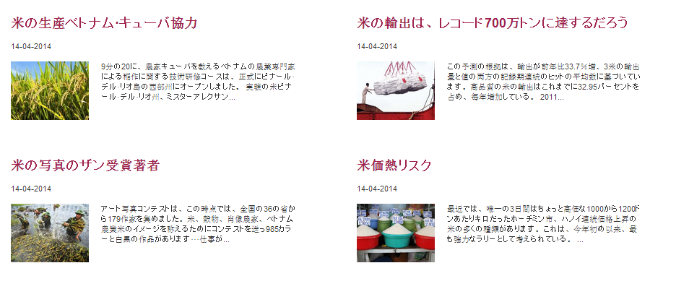

Figure ‑ Market news page screen design

**Table 4‑11** Market news page screen items

|  |  |  |  |  |  |  |  |  |  |  |  |  |  |  |
| --- | --- | --- | --- | --- | --- | --- | --- | --- | --- | --- | --- | --- | --- | --- |
| **No.** | **Item** | |  |  |  |  | **ID** |  | **Display type** | | |  |  | **I/O** |
| 1 | LinkButton Title | | | | |  | lbtTitle |  | LinkButton | |  |  |  | O |
| 2 | ImageMap News Picture |  |  |  |  |  | impPicture |  | ImageMap | |  |  |  | O |
| 3 | Label Brief Content | | | | | | lblBriefContent |  | Label |  |  |  |  | O |

##### Market News Detail Page

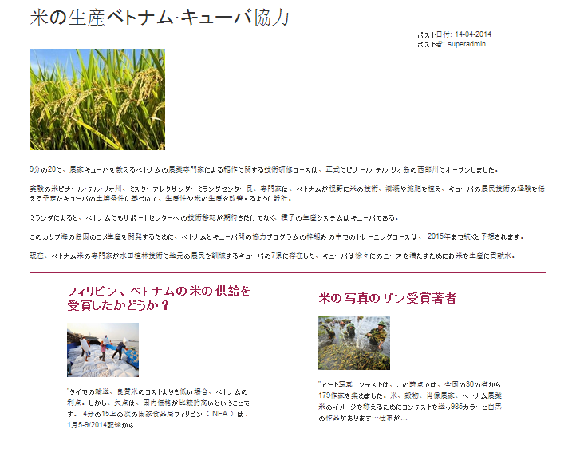

Figure ‑ Market news detail page screen design

**Table 4‑12** Market news detail page screen items

|  |  |  |  |  |  |  |  |  |  |  |  |  |  |
| --- | --- | --- | --- | --- | --- | --- | --- | --- | --- | --- | --- | --- | --- |
| **No.** | **Item** | |  |  |  |  | **ID** |  | **Display type** | | |  | **I/O** |
| 1 | Label Title | | |  |  |  | lblTitle |  | Label |  |  |  | O |
| 2 | Label Post Date | | | | |  | lblPostDate |  | Label |  |  |  | O |
| 3 | Label Poster Name | | | | |  | lblPosterName |  | Label |  |  |  | O |
| 4 | ImageMap News Picture |  |  |  |  |  | impPicture |  | ImageMap | |  |  | O |
| 5 | Label BriefDescription | | | | | | lblBriefDescription |  | Label |  |  |  | O |

### Object Transition

#### Site Master

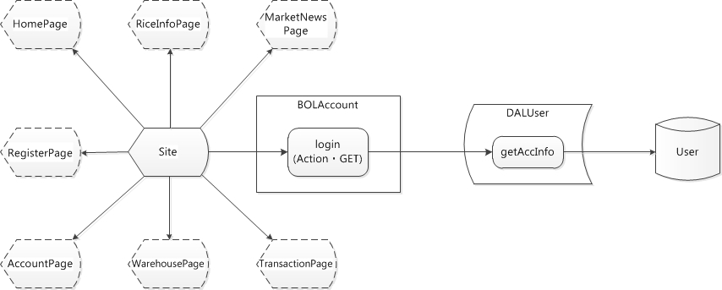

Figure ‑ Site Master Object transition diagram

**Table 4‑13** Site Master Object list

|  |  |  |  |  |  |  |  |  |  |  |  |  |  |  |  |  |  |  |  |  |  |
| --- | --- | --- | --- | --- | --- | --- | --- | --- | --- | --- | --- | --- | --- | --- | --- | --- | --- | --- | --- | --- | --- |
| **No.** | **Object name** | | |  |  |  |  |  | **Object type** | | | |  |  | **Note** | |  |  |  |  |  |
| 1 | Site |  |  |  |  |  |  |  | Presentation | | | |  |  | Site Master | | |  |  |  |  |
| 2 | BOLAccount | | |  |  |  |  |  | Business | | |  |  |  |  |  |  |  |  |  |  |
| 3 | login |  |  |  |  |  |  |  | Action・GET | | | |  |  |  |  |  |  |  |  |  |
| 4 | DALUser | |  |  |  |  |  |  | Data | |  |  |  |  |  |  |  |  |  |  |  |
| 5 | User |  |  |  |  |  |  |  | DB |  |  |  |  |  |  |  |  |  |  |  |  |
| 6 | HomePage | |  |  |  |  |  |  | Presentation | | | |  |  |  |  |  |  |  |  |  |
| 7 | RiceInfoPage | | |  |  |  |  |  | Presentation | | | |  |  |  |  |  |  |  |  |  |
| 8 | MarketNewsPage | | | |  |  |  |  | Presentation | | | |  |  |  |  |  |  |  |  |  |
| 9 | RegisterPage | | |  |  |  |  |  | Presentation | | | |  |  |  |  |  |  |  |  |  |
| 10 | AccountPage | | |  |  |  |  |  | Presentation | | | |  |  |  |  |  |  |  |  |  |
| 11 | WarehousePage | | | |  |  |  |  | Presentation | | | |  |  |  |  |  |  |  |  |  |
| 12 | TransactionPage | | | |  |  |  |  | Presentation | | | |  |  |  |  |  |  |  |  |  |

#### Home Page

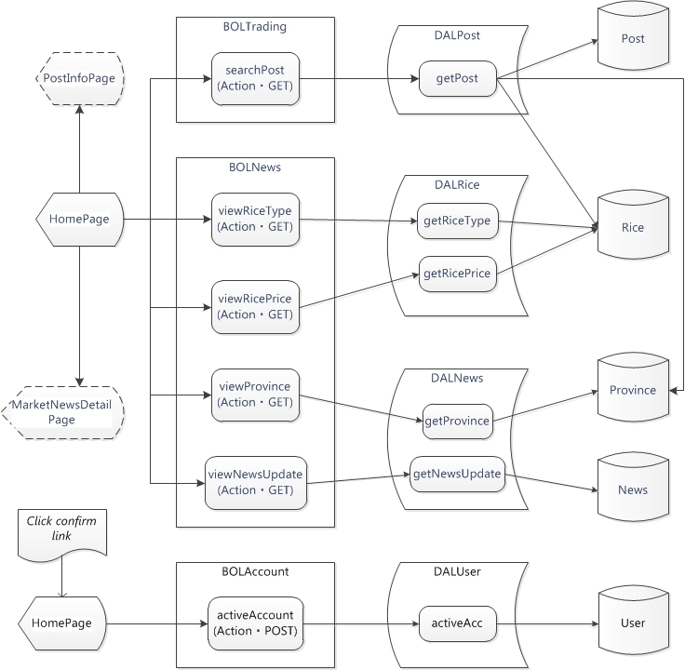

Figure ‑ Home page Object transition diagram

**Table 4‑14** Home page Object list

|  |  |  |  |  |  |  |  |  |  |  |  |  |  |  |  |  |  |  |  |  |  |
| --- | --- | --- | --- | --- | --- | --- | --- | --- | --- | --- | --- | --- | --- | --- | --- | --- | --- | --- | --- | --- | --- |
| **No.** | **Object name** | | | |  |  |  |  |  | **Object type** | | | |  |  | **Note** | |  |  |  |  |
| 1 | HomePage | | |  |  |  |  |  |  | Presentation | | | |  |  |  |  |  |  |  |  |
| 2 | BOLTrading | | | |  |  |  |  |  | Business | | |  |  |  |  |  |  |  |  |  |
| 3 | searchPost | | |  |  |  |  |  |  | Action・GET | | | |  |  |  |  |  |  |  |  |
| 4 | DALPost | | |  |  |  |  |  |  | Data | |  |  |  |  |  |  |  |  |  |  |
| 5 | Post | |  |  |  |  |  |  |  | DB |  |  |  |  |  |  |  |  |  |  |  |
| 6 | BOLNews | | |  |  |  |  |  |  | Business | | |  |  |  |  |  |  |  |  |  |
| 7 | viewRiceType | | | |  |  |  |  |  | Action・GET | | | |  |  |  |  |  |  |  |  |
| 8 | viewRicePrice | | | |  |  |  |  |  | Action・GET | | | |  |  |  |  |  |  |  |  |
| 9 | viewProvince | | | |  |  |  |  |  | Action・GET | | | |  |  |  |  |  |  |  |  |
| 10 | viewNewsUpdate |  |  |  |  |  |  |  |  | Action・GET | | | |  |  |  |  |  |  |  |  |
| 11 | DALRice | | |  |  |  |  |  |  | Data | |  |  |  |  |  |  |  |  |  |  |
| 12 | Rice | |  |  |  |  |  |  |  | DB |  |  |  |  |  |  |  |  |  |  |  |
| 13 | DALNews | | |  |  |  |  |  |  | Data | |  |  |  |  |  |  |  |  |  |  |
| 14 | Province |  |  |  |  |  |  |  |  | DB |  |  |  |  |  |  |  |  |  |  |  |
| 15 | News | |  |  |  |  |  |  |  | DB |  |  |  |  |  |  |  |  |  |  |  |
| 16 | BOLAccount | | | |  |  |  |  |  | Business | | |  |  |  |  |  |  |  |  |  |
| 17 | activeAccount | | | |  |  |  |  |  | Action・POST | | | |  |  |  |  |  |  |  |  |
| 18 | DALUser | | |  |  |  |  |  |  | Data | |  |  |  |  |  |  |  |  |  |  |
| 19 | User | |  |  |  |  |  |  |  | DB |  |  |  |  |  |  |  |  |  |  |  |
| 20 | PostInfoPage | | | |  |  |  |  |  | Presentation | | | |  |  |  |  |  |  |  |  |
| 21 | MarketNewsDetailPage | | | | | |  |  |  | Presentation | | | |  |  |  |  |  |  |  |  |

#### Registration Page

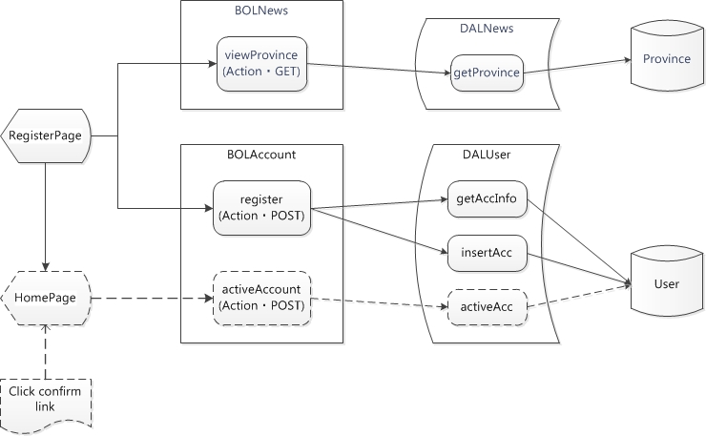

Figure ‑ Registration page Object transition diagram

**Table 4‑15** Registration page Object list

|  |  |  |  |  |  |  |  |  |  |  |  |  |  |  |  |  |  |  |  |  |  |  |
| --- | --- | --- | --- | --- | --- | --- | --- | --- | --- | --- | --- | --- | --- | --- | --- | --- | --- | --- | --- | --- | --- | --- |
| **No.** | **Object name** | | |  |  |  |  |  | **Object type** | | | |  |  | **Note** | |  |  |  |  |  |  |
| 1 | RegisterPage | | |  |  |  |  |  | Presentation | | | |  |  |  |  |  |  |  |  |  |  |
| 2 | BOLNews | |  |  |  |  |  |  | Business | | |  |  |  |  |  |  |  |  |  |  |  |
| 3 | viewProvince | | |  |  |  |  |  | Action・GET | | | |  |  |  |  |  |  |  |  |  |  |
| 4 | DALNews | |  |  |  |  |  |  | Data | |  |  |  |  |  |  |  |  |  |  |  |  |
| 5 | Province | |  |  |  |  |  |  | DB |  |  |  |  |  |  |  |  |  |  |  |  |  |
| 6 | BOLAccount | | |  |  |  |  |  | Business | | |  |  |  |  |  |  |  |  |  |  |  |
| 7 | register | |  |  |  |  |  |  | Action・POST | | | |  |  |  |  |  |  |  |  |  |  |
| 8 | DALUser | |  |  |  |  |  |  | Data | |  |  |  |  |  |  |  |  |  |  |  |  |
| 9 | User |  |  |  |  |  |  |  | DB |  |  |  |  |  |  |  |  |  |  |  |  |  |
| 10 | HomePage | |  |  |  |  |  |  | Presentation | | | |  |  |  |  |  |  |  |  |  |  |

#### Account Page

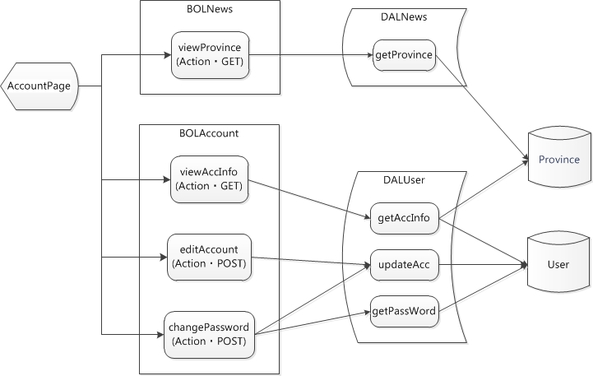

Figure ‑ Account page Object transition diagram

**Table 4‑16** Account page Object list

|  |  |  |  |  |  |  |  |  |  |  |  |  |  |  |  |  |  |  |  |  |  |  |
| --- | --- | --- | --- | --- | --- | --- | --- | --- | --- | --- | --- | --- | --- | --- | --- | --- | --- | --- | --- | --- | --- | --- |
| **No.** | **Object name** | | |  |  |  |  |  | **Object type** | | | |  |  | **Note** | |  |  |  |  |  |  |
| 1 | AccountPage | | |  |  |  |  |  | Presentation | | | |  |  |  |  |  |  |  |  |  |  |
| 2 | BOLNews | |  |  |  |  |  |  | Business | | |  |  |  |  |  |  |  |  |  |  |  |
| 3 | viewProvince | | |  |  |  |  |  | Action・GET | | | |  |  |  |  |  |  |  |  |  |  |
| 4 | DALNews | |  |  |  |  |  |  | Data | |  |  |  |  |  |  |  |  |  |  |  |  |
| 5 | Province | |  |  |  |  |  |  | DB |  |  |  |  |  |  |  |  |  |  |  |  |  |
| 6 | BOLAccount | | |  |  |  |  |  | Business | | |  |  |  |  |  |  |  |  |  |  |  |
| 7 | viewAccInfo | | |  |  |  |  |  | Action・GET | | | |  |  |  |  |  |  |  |  |  |  |
| 8 | editAccount | | |  |  |  |  |  | Action・POST | | | |  |  |  |  |  |  |  |  |  |  |
| 9 | changePassword | | | |  |  |  |  | Action・POST | | | |  |  |  |  |  |  |  |  |  |  |
| 10 | DALUser | |  |  |  |  |  |  | Data | |  |  |  |  |  |  |  |  |  |  |  |  |
| 11 | User |  |  |  |  |  |  |  | DB |  |  |  |  |  |  |  |  |  |  |  |  |  |

#### Warehouse Page

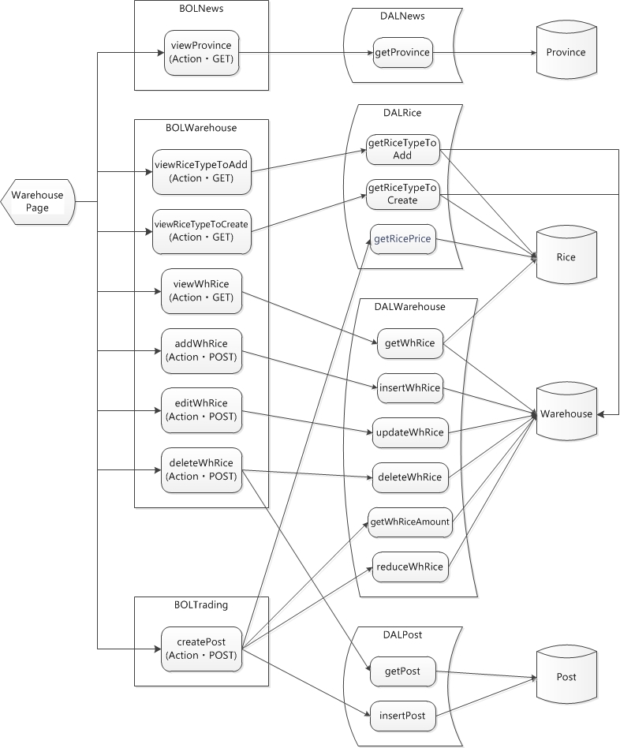

Figure ‑ Warehouse page Object transition diagram

**Table 4‑17** Warehouse page Object list

|  |  |  |  |  |  |  |  |  |  |  |  |  |  |  |  |  |  |  |  |  |  |  |
| --- | --- | --- | --- | --- | --- | --- | --- | --- | --- | --- | --- | --- | --- | --- | --- | --- | --- | --- | --- | --- | --- | --- |
| **No.** | **Object name** | | |  |  |  |  |  | **Object type** | | | |  |  | **Note** | |  |  |  |  |  |  |
| 1 | WarehousePage | | | |  |  |  |  | Presentation | | | |  |  |  |  |  |  |  |  |  |  |
| 2 | BOLNews | |  |  |  |  |  |  | Business | | |  |  |  |  |  |  |  |  |  |  |  |
| 3 | viewProvince | | |  |  |  |  |  | Action・GET | | | |  |  |  |  |  |  |  |  |  |  |
| 4 | DALNews | |  |  |  |  |  |  | Data | |  |  |  |  |  |  |  |  |  |  |  |  |
| 5 | Province | |  |  |  |  |  |  | DB |  |  |  |  |  |  |  |  |  |  |  |  |  |
| 6 | BOLWarehouse | | |  |  |  |  |  | Business | | |  |  |  |  |  |  |  |  |  |  |  |
| 7 | viewRiceTypeToAdd | | | | |  |  |  | Action・GET | | | |  |  |  |  |  |  |  |  |  |  |
| 8 | viewRiceTypeToCreate | | | | |  |  |  | Action・GET | | | |  |  |  |  |  |  |  |  |  |  |
| 9 | viewWhRice | | |  |  |  |  |  | Action・GET | | | |  |  |  |  |  |  |  |  |  |  |
| 10 | addWhRice | |  |  |  |  |  |  | Action・POST | | | |  |  |  |  |  |  |  |  |  |  |
| 11 | editWhRice | |  |  |  |  |  |  | Action・POST | | | |  |  |  |  |  |  |  |  |  |  |
| 12 | deleteWhRice | | |  |  |  |  |  | Action・POST | | | |  |  |  |  |  |  |  |  |  |  |
| 13 | DALRice | |  |  |  |  |  |  | Data | |  |  |  |  |  |  |  |  |  |  |  |  |
| 14 | Rice |  |  |  |  |  |  |  | DB |  |  |  |  |  |  |  |  |  |  |  |  |  |
| 15 | DALWarehouse | | |  |  |  |  |  | Data | |  |  |  |  |  |  |  |  |  |  |  |  |
| 16 | Warehouse | |  |  |  |  |  |  | DB |  |  |  |  |  |  |  |  |  |  |  |  |  |
| 17 | BOLTrading | | |  |  |  |  |  | Business | | |  |  |  |  |  |  |  |  |  |  |  |
| 18 | createPost | |  |  |  |  |  |  | Action・POST | | | |  |  |  |  |  |  |  |  |  |  |
| 19 | DALPost | |  |  |  |  |  |  | Data | |  |  |  |  |  |  |  |  |  |  |  |  |
| 20 | Post |  |  |  |  |  |  |  | DB |  |  |  |  |  |  |  |  |  |  |  |  |  |

#### Transaction Page

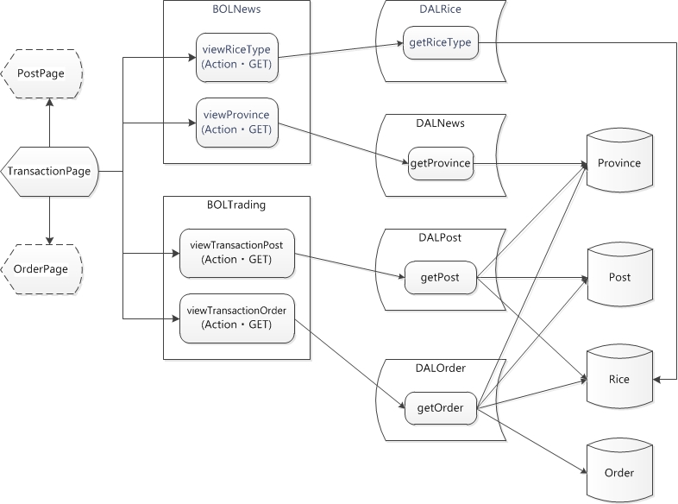

Figure ‑ Transaction page Object transition diagram

**Table 4‑18** Transaction page Object list

|  |  |  |  |  |  |  |  |  |  |  |  |  |  |  |  |  |  |  |  |  |  |  |
| --- | --- | --- | --- | --- | --- | --- | --- | --- | --- | --- | --- | --- | --- | --- | --- | --- | --- | --- | --- | --- | --- | --- |
| **No.** | **Object name** | | |  |  |  |  |  | **Object type** | | | |  |  | **Note** | |  |  |  |  |  |  |
| 1 | TransactionPage | | | |  |  |  |  | Presentation | | | |  |  |  |  |  |  |  |  |  |  |
| 2 | BOLNews | |  |  |  |  |  |  | Business | | |  |  |  |  |  |  |  |  |  |  |  |
| 3 | viewRiceType | | |  |  |  |  |  | Action・GET | | | |  |  |  |  |  |  |  |  |  |  |
| 4 | viewProvince | | |  |  |  |  |  | Action・GET | | | |  |  |  |  |  |  |  |  |  |  |
| 5 | DALRice | |  |  |  |  |  |  | Data | |  |  |  |  |  |  |  |  |  |  |  |  |
| 6 | Rice |  |  |  |  |  |  |  | DB |  |  |  |  |  |  |  |  |  |  |  |  |  |
| 7 | DALNews | |  |  |  |  |  |  | Data | |  |  |  |  |  |  |  |  |  |  |  |  |
| 8 | Province | |  |  |  |  |  |  | DB |  |  |  |  |  |  |  |  |  |  |  |  |  |
| 9 | BOLTrading | | |  |  |  |  |  | Business | | |  |  |  |  |  |  |  |  |  |  |  |
| 10 | viewTransactionPost | | | | |  |  |  | Action・GET | | | |  |  |  |  |  |  |  |  |  |  |
| 11 | viewTransactionOrder | | | | |  |  |  | Action・GET | | | |  |  |  |  |  |  |  |  |  |  |
| 12 | DALPost | |  |  |  |  |  |  | Data | |  |  |  |  |  |  |  |  |  |  |  |  |
| 13 | Post |  |  |  |  |  |  |  | DB |  |  |  |  |  |  |  |  |  |  |  |  |  |
| 14 | DALOrder | |  |  |  |  |  |  | Data | |  |  |  |  |  |  |  |  |  |  |  |  |
| 15 | Order |  |  |  |  |  |  |  | DB |  |  |  |  |  |  |  |  |  |  |  |  |  |
| 16 | PostPage | |  |  |  |  |  |  | Presentation | | | |  |  |  |  |  |  |  |  |  |  |
| 17 | OrderPage | |  |  |  |  |  |  | Presentation | | | |  |  |  |  |  |  |  |  |  |  |

#### Post Page

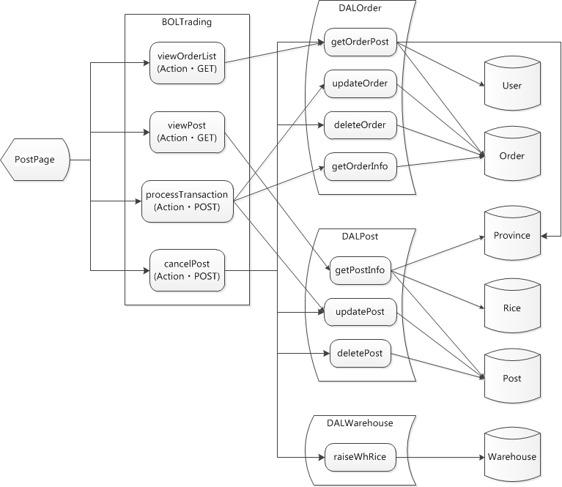

Figure ‑ Post page Object transition diagram

**Table 4‑19** Post page Object list

|  |  |  |  |  |  |  |  |  |  |  |  |  |  |  |  |  |  |  |  |  |  |  |
| --- | --- | --- | --- | --- | --- | --- | --- | --- | --- | --- | --- | --- | --- | --- | --- | --- | --- | --- | --- | --- | --- | --- |
| **No.** | **Object name** | | |  |  |  |  |  | **Object type** | | | |  |  | **Note** | |  |  |  |  |  |  |
| 1 | PostPage | |  |  |  |  |  |  | Presentation | | | |  |  |  |  |  |  |  |  |  |  |
| 2 | BOLTrading | | |  |  |  |  |  | Business | | |  |  |  |  |  |  |  |  |  |  |  |
| 3 | viewPost | |  |  |  |  |  |  | Action・GET | | | |  |  |  |  |  |  |  |  |  |  |
| 4 | viewOrderList | | |  |  |  |  |  | Action・GET | | | |  |  |  |  |  |  |  |  |  |  |
| 5 | processTransaction | | | |  |  |  |  | Action・POST | | | |  |  |  |  |  |  |  |  |  |  |
| 6 | cancelPost | |  |  |  |  |  |  | Action・POST | | | |  |  |  |  |  |  |  |  |  |  |
| 7 | DALOrder | |  |  |  |  |  |  | Data | |  |  |  |  |  |  |  |  |  |  |  |  |
| 8 | User |  |  |  |  |  |  |  | DB |  |  |  |  |  |  |  |  |  |  |  |  |  |
| 9 | Order |  |  |  |  |  |  |  | DB |  |  |  |  |  |  |  |  |  |  |  |  |  |
| 10 | DALPost | |  |  |  |  |  |  | Data | |  |  |  |  |  |  |  |  |  |  |  |  |
| 11 | Rice |  |  |  |  |  |  |  | DB |  |  |  |  |  |  |  |  |  |  |  |  |  |
| 12 | Post |  |  |  |  |  |  |  | DB |  |  |  |  |  |  |  |  |  |  |  |  |  |
| 13 | Province | |  |  |  |  |  |  | DB |  |  |  |  |  |  |  |  |  |  |  |  |  |
| 14 | DALWarehouse | | |  |  |  |  |  | Data | |  |  |  |  |  |  |  |  |  |  |  |  |
| 15 | Warehouse | |  |  |  |  |  |  | DB |  |  |  |  |  |  |  |  |  |  |  |  |  |

#### Order Page

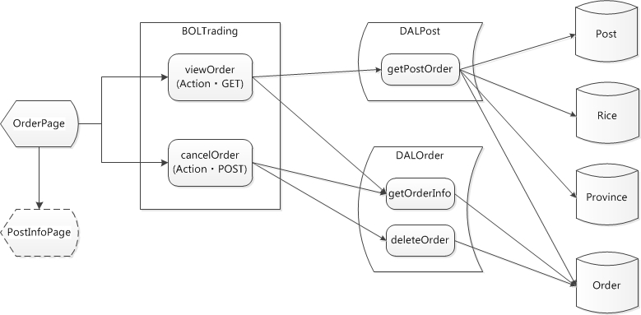

Figure ‑ Order page Object transition diagram

**Table 4‑20** Order page Object list

|  |  |  |  |  |  |  |  |  |  |  |  |  |  |  |  |  |  |  |  |  |  |  |
| --- | --- | --- | --- | --- | --- | --- | --- | --- | --- | --- | --- | --- | --- | --- | --- | --- | --- | --- | --- | --- | --- | --- |
| **No.** | **Object name** | | |  |  |  |  |  | **Object type** | | | |  |  | **Note** | |  |  |  |  |  |  |
| 1 | OrderPage | |  |  |  |  |  |  | Presentation | | | |  |  |  |  |  |  |  |  |  |  |
| 2 | BOLTrading | | |  |  |  |  |  | Business | | |  |  |  |  |  |  |  |  |  |  |  |
| 3 | viewOrder | |  |  |  |  |  |  | Action・GET | | | |  |  |  |  |  |  |  |  |  |  |
| 4 | cancelOrder | | |  |  |  |  |  | Action・GET | | | |  |  |  |  |  |  |  |  |  |  |
| 5 | DALOrder | |  |  |  |  |  |  | Data | |  |  |  |  |  |  |  |  |  |  |  |  |
| 6 | DALPost | |  |  |  |  |  |  | Data | |  |  |  |  |  |  |  |  |  |  |  |  |
| 7 | Order |  |  |  |  |  |  |  | DB |  |  |  |  |  |  |  |  |  |  |  |  |  |
| 8 | Post |  |  |  |  |  |  |  | DB |  |  |  |  |  |  |  |  |  |  |  |  |  |
| 9 | Rice |  |  |  |  |  |  |  | DB |  |  |  |  |  |  |  |  |  |  |  |  |  |
| 10 | Province | |  |  |  |  |  |  | DB |  |  |  |  |  |  |  |  |  |  |  |  |  |
| 11 | PostInfoPage | | |  |  |  |  |  | Presentation | | | |  |  |  |  |  |  |  |  |  |  |

#### Post Information Page

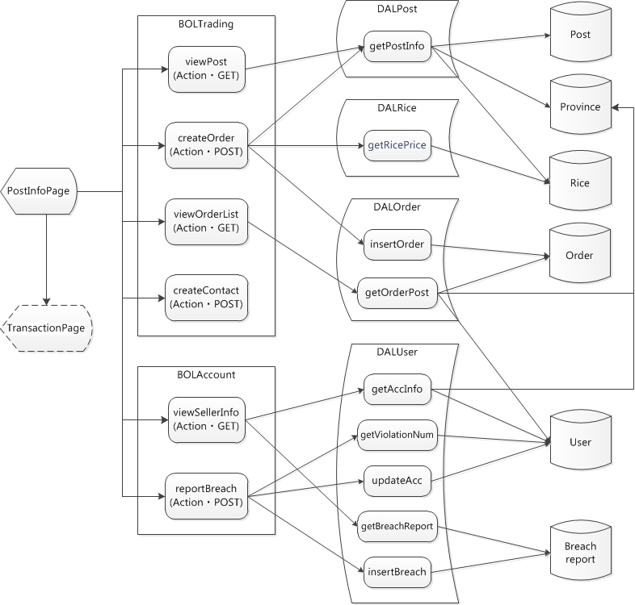

Figure ‑ Post information page Object transition diagram

**Table 4‑21** Post information page Object list

|  |  |  |  |  |  |  |  |  |  |  |  |  |  |  |  |  |  |  |  |  |  |  |
| --- | --- | --- | --- | --- | --- | --- | --- | --- | --- | --- | --- | --- | --- | --- | --- | --- | --- | --- | --- | --- | --- | --- |
| **No.** | **Object name** | | |  |  |  |  |  | **Object type** | | | |  |  | **Note** | |  |  |  |  |  |  |
| 1 | PostInfoPage | | |  |  |  |  |  | Presentation | | | |  |  |  |  |  |  |  |  |  |  |
| 2 | BOLTrading | | |  |  |  |  |  | Business | | |  |  |  |  |  |  |  |  |  |  |  |
| 3 | viewPost | |  |  |  |  |  |  | Action・GET | | | |  |  |  |  |  |  |  |  |  |  |
| 4 | viewOrderList | | |  |  |  |  |  | Action・GET | | | |  |  |  |  |  |  |  |  |  |  |
| 5 | createOrder | | |  |  |  |  |  | Action・POST | | | |  |  |  |  |  |  |  |  |  |  |
| 6 | createContact | | |  |  |  |  |  | Action・POST | | | |  |  |  |  |  |  |  |  |  |  |
| 7 | DALPost | |  |  |  |  |  |  | Data | |  |  |  |  |  |  |  |  |  |  |  |  |
| 8 | Post |  |  |  |  |  |  |  | DB |  |  |  |  |  |  |  |  |  |  |  |  |  |
| 9 | Province | |  |  |  |  |  |  | DB |  |  |  |  |  |  |  |  |  |  |  |  |  |
| 10 | DALRice | |  |  |  |  |  |  | Data | |  |  |  |  |  |  |  |  |  |  |  |  |
| 11 | Rice |  |  |  |  |  |  |  | DB |  |  |  |  |  |  |  |  |  |  |  |  |  |
| 12 | DALOrder | |  |  |  |  |  |  | Data | |  |  |  |  |  |  |  |  |  |  |  |  |
| 13 | Order |  |  |  |  |  |  |  | DB |  |  |  |  |  |  |  |  |  |  |  |  |  |
| 14 | BOLAccount | | |  |  |  |  |  | Business | | |  |  |  |  |  |  |  |  |  |  |  |
| 15 | viewSellerInfo | | |  |  |  |  |  | Action・GET | | | |  |  |  |  |  |  |  |  |  |  |
| 16 | reportBreach | | |  |  |  |  |  | Action・POST | | | |  |  |  |  |  |  |  |  |  |  |
| 17 | DALUser | |  |  |  |  |  |  | Data | |  |  |  |  |  |  |  |  |  |  |  |  |
| 18 | User |  |  |  |  |  |  |  | DB |  |  |  |  |  |  |  |  |  |  |  |  |  |
| 19 | Breach report | | |  |  |  |  |  | DB |  |  |  |  |  |  |  |  |  |  |  |  |  |
| 20 | TransactionPage | | | |  |  |  |  | Presentation | | | |  |  |  |  |  |  |  |  |  |  |

#### Rice Information Page

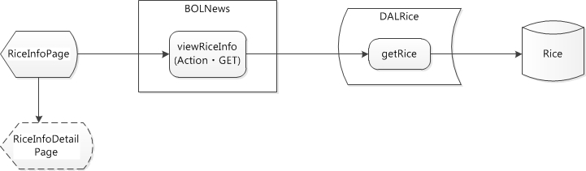

Figure ‑ Rice information page Object transition diagram

**Table 4‑22** Rice information page Object list

|  |  |  |  |  |  |  |  |  |  |  |  |  |  |  |  |  |  |  |  |  |  |  |
| --- | --- | --- | --- | --- | --- | --- | --- | --- | --- | --- | --- | --- | --- | --- | --- | --- | --- | --- | --- | --- | --- | --- |
| **No.** | **Object name** | | |  |  |  |  |  | **Object type** | | | |  |  | **Note** | |  |  |  |  |  |  |
| 1 | RiceInfoPage | | |  |  |  |  |  | Presentation | | | |  |  |  |  |  |  |  |  |  |  |
| 2 | BOLNews | |  |  |  |  |  |  | Business | | |  |  |  |  |  |  |  |  |  |  |  |
| 3 | viewRiceInfo | | |  |  |  |  |  | Action・GET | | | |  |  |  |  |  |  |  |  |  |  |
| 4 | DALRice | |  |  |  |  |  |  | Data | |  |  |  |  |  |  |  |  |  |  |  |  |
| 5 | Rice |  |  |  |  |  |  |  | DB |  |  |  |  |  |  |  |  |  |  |  |  |  |
| 6 | RiceInfoDetailPage | | | |  |  |  |  | Presentation | | | |  |  |  |  |  |  |  |  |  |  |

#### Rice Info Detail Page

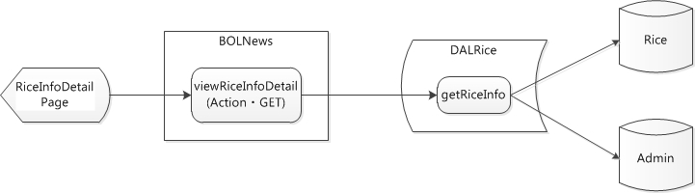

Figure ‑ Rice info detail page Object transition diagram

**Table 4‑23** Rice info detail page Object list

|  |  |  |  |  |  |  |  |  |  |  |  |  |  |  |  |  |  |  |  |  |  |  |
| --- | --- | --- | --- | --- | --- | --- | --- | --- | --- | --- | --- | --- | --- | --- | --- | --- | --- | --- | --- | --- | --- | --- |
| **No.** | **Object name** | | |  |  |  |  |  | **Object type** | | | |  |  | **Note** | |  |  |  |  |  |  |
| 1 | RiceInfoDetailPage | | | |  |  |  |  | Presentation | | | |  |  |  |  |  |  |  |  |  |  |
| 2 | BOLNews | |  |  |  |  |  |  | Business | | |  |  |  |  |  |  |  |  |  |  |  |
| 3 | viewRiceInfoDetail | | | |  |  |  |  | Action・GET | | | |  |  |  |  |  |  |  |  |  |  |
| 4 | DALRice | |  |  |  |  |  |  | Data | |  |  |  |  |  |  |  |  |  |  |  |  |
| 5 | Rice |  |  |  |  |  |  |  | DB |  |  |  |  |  |  |  |  |  |  |  |  |  |
| 6 | Admin |  |  |  |  |  |  |  | DB |  |  |  |  |  |  |  |  |  |  |  |  |  |

#### Market News Page

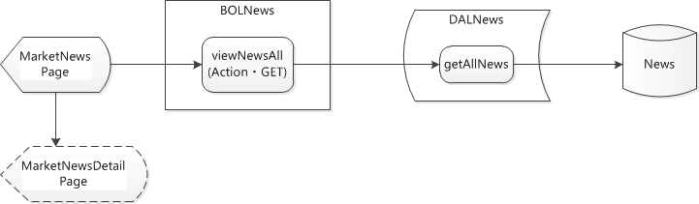

Figure ‑ Market news page Object transition diagram

**Table 4‑24** Market news page Object list

|  |  |  |  |  |  |  |  |  |  |  |  |  |  |  |  |  |  |  |  |  |  |  |
| --- | --- | --- | --- | --- | --- | --- | --- | --- | --- | --- | --- | --- | --- | --- | --- | --- | --- | --- | --- | --- | --- | --- |
| **No.** | **Object name** | | |  |  |  |  |  | **Object type** | | | |  |  | **Note** | |  |  |  |  |  |  |
| 1 | MarketNewsPage | | | |  |  |  |  | Presentation | | | |  |  |  |  |  |  |  |  |  |  |
| 2 | BOLNews | |  |  |  |  |  |  | Business | | |  |  |  |  |  |  |  |  |  |  |  |
| 3 | viewNews | |  |  |  |  |  |  | Action・GET | | | |  |  |  |  |  |  |  |  |  |  |
| 4 | DALNews | |  |  |  |  |  |  | Data | |  |  |  |  |  |  |  |  |  |  |  |  |
| 5 | News |  |  |  |  |  |  |  | DB |  |  |  |  |  |  |  |  |  |  |  |  |  |
| 6 | MarketNewsDetailPage | | | | |  |  |  | Presentation | | | |  |  |  |  |  |  |  |  |  |  |

#### Market News Detail Page

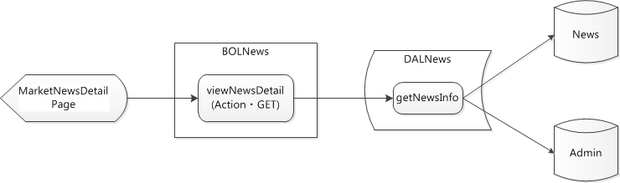

Figure ‑ Market news detail page Object transition diagram

**Table 4‑25** Market news detail page Object list

|  |  |  |  |  |  |  |  |  |  |  |  |  |  |  |  |  |  |  |  |  |  |  |
| --- | --- | --- | --- | --- | --- | --- | --- | --- | --- | --- | --- | --- | --- | --- | --- | --- | --- | --- | --- | --- | --- | --- |
| **No.** | **Object name** | | |  |  |  |  |  | **Object type** | | | |  |  | **Note** | |  |  |  |  |  |  |
| 1 | MarketNewsDetailPage | | | | |  |  |  | Presentation | | | |  |  |  |  |  |  |  |  |  |  |
| 2 | BOLNews | |  |  |  |  |  |  | Business | | |  |  |  |  |  |  |  |  |  |  |  |
| 3 | viewNewsDetail | | |  |  |  |  |  | Action・GET | | | |  |  |  |  |  |  |  |  |  |  |
| 4 | DALNews | |  |  |  |  |  |  | Data | |  |  |  |  |  |  |  |  |  |  |  |  |
| 5 | News |  |  |  |  |  |  |  | DB |  |  |  |  |  |  |  |  |  |  |  |  |  |
| 6 | Admin |  |  |  |  |  |  |  | DB |  |  |  |  |  |  |  |  |  |  |  |  |  |

### Model Design

Below is model design for some modules of MAA. All model designs and detail pseudo-code of each model for MAA refer to [MAA class specification](../Report%204%20Design/MAA_Detail_Design) folder.

#### Site Master

##### Presentation Layer

**Table 4‑26** Site master event list



**Table 4‑27** On click LinkButton Login



##### Business Operation Layer

**Table 4‑28** Site master – BOL list



**Table 4‑29** login action detail



##### Data Access Layer

**Table 4‑30** Site master – DAL list



**Table 4‑31** getAccInfo method detail



#### Home Page

##### Presentation Layer

**Table 4‑32** Home page event list

Japanese version



English version



**Table 4‑33** On click Button Search event detail

Japanese version



English version



##### Business Operation Layer

**Table 4‑34** Home page – BOL list

Japanese version



English version



**Table 4‑35** searchPost action detail

Japanese version



English version





##### Data Access Layer

**Table 4‑36** Home page – DAL list

Japanese version



English version



**Table 4‑37** getPost method detail





#### Registration Page

##### Presentation Layer

**Table 4‑38** Registration page event list



**Table 4‑39** On click Button Register event detail



##### Business Operation Layer

**Table 4‑40** Registration page – BOL list



**Table 4‑41** register action detail



##### Data Access Layer

**Table 4‑42** Registration page – DAL list



**Table 4‑43** insertAcc method detail



#### Account Page

##### Presentation Layer

**Table 4‑44** Account page event list



**Table 4‑45** On click Button Save Edit event detail



##### Business Operation Layer

**Table 4‑46** Account page – BOL list



**Table 4‑47** editAccount action detail



##### Data Access Layer

**Table 4‑48** Account page – DAL list



**Table 4‑49** updateAcc method detail



#### Warehouse Page

##### Presentation Layer

**Table 4‑50** Warehouse page event list



**Table 4‑51** On click Button Add event detail



##### Business Operation Layer

**Table 4‑52** Warehouse page – BOL list



**Table 4‑53** addWhRice action detail



##### Data Access Layer

**Table 4‑54** Warehouse page – DAL list



**Table 4‑55** insertWhRice method detail





#### Transaction Page

##### Presentation Layer

**Table 4‑56** Transaction page event list



##### Business Operation Layer

**Table 4‑57** Transaction page – BOL list



##### Data Access Layer

**Table 4‑58** Transaction page – DAL list



#### Post Page

##### Presentation Layer

**Table 4‑59** Post page event list



**Table 4‑60** On click Button in dgvOrderBuyer event detail



##### Business Operation Layer

**Table 4‑61** Post page – BOL list



**Table 4‑62** processTransaction action detail





##### Data Access Layer

**Table 4‑63** Transaction page – DAL list



**Table 4‑64** updatePost method detail



#### Order Page

##### Presentation Layer

**Table 4‑65** Order page event list



**Table 4‑66** On click Button Cancel Order





##### Business Operation Layer

**Table 4‑67** Order page – BOL list



**Table 4‑68** cancelOrder action detail





##### Data Access Layer

**Table 4‑69** Order page – DAL list



**Table 4‑70** deleteOrder method detail



#### Post Information Page

##### Presentation Layer

**Table 4‑71** Post information page event list



**Table 4‑72** On click Button Order event detail



##### Business Operation Layer

**Table 4‑73** Post information page – BOL list



**Table 4‑74** createOrder action detail





##### Data Access Layer

**Table 4‑75** Post information page – DAL list



**Table 4‑76** insertOrder method detail



#### Rice Information Page

##### Presentation Layer

**Table 4‑77** Rice information page event list



##### Business Operation Layer

**Table 4‑78** Rice information page – BOL list



##### Data Access Layer

**Table 4‑79** Rice information page – DAL list



## Database design

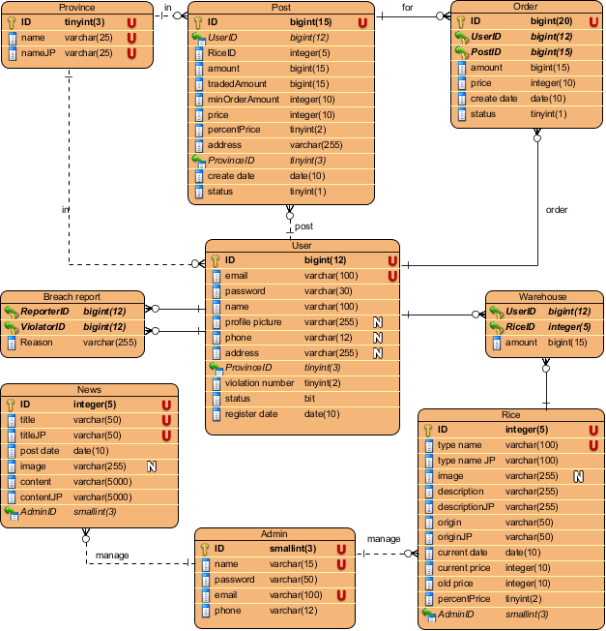

Figure ‑ RTF Table design diagram

# Software Source Code

*Main Application – Website RTF*

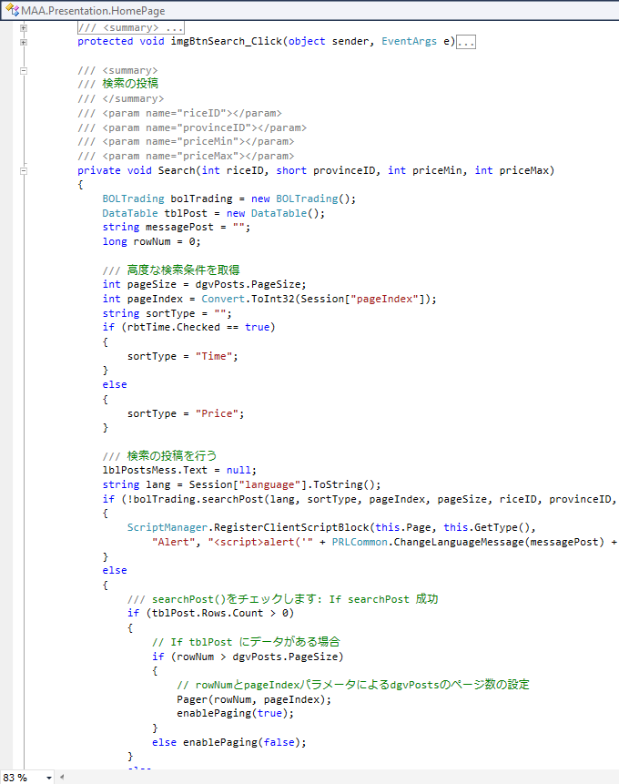

Figure ‑ Sample of Source code (Home page)

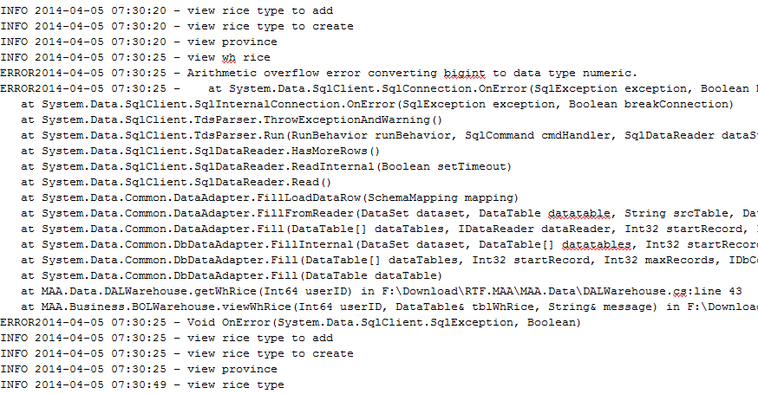

Figure ‑ Sample of Log-4-net

# Software Test Documentation

## Test Overview

### Test Approach

We use V-model to implement testing process.

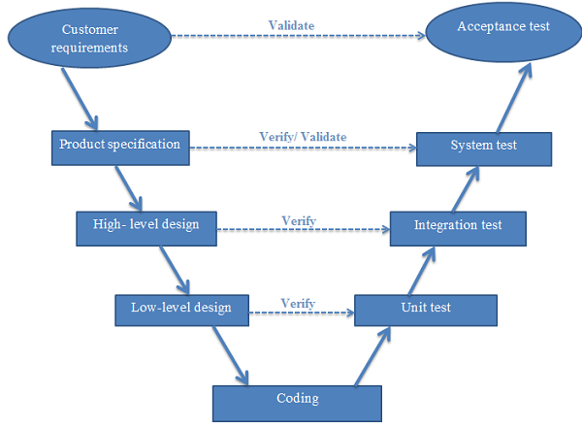

Figure ‑ V-model

Due to requirement of project must be always suitable with user, we choose V-model to implement testing process. With V-Model, software development is separated into two appropriate phase’s groups: development and testing. In this model, the verification and validation will be done side by side. It emphasizes the strict process flow to develop a quality product. The errors occurred in any phase will be corrected in that phase. Proactive defect tracking defects which are found at early stages even may be in the development phase before application being tested (Unit test).

Testing progress is divided to 4 phases include: Unit test, Integration test, System test and Acceptance test.

#### Unit testing

* The purpose is to verify the internal logic code by testing every possible branch within the function, also known as test coverage.
* Unit test will be done by the developers and will be approved by the implementing team leader to ensure that the building blocks of the system uses work independently of each other and the specific function is working as expected. One function might have multiple tests to catch corner cases in the code

#### Integration testing

* The separate modules will be tested together to expose faults in the interfaces and in the interaction between integrated components.
* Integration testing will be done by tester.

#### System testing

* Compare the system specifications against the actual system.
* System testing checks if the integrated product meets the specified requirements.

#### Acceptance testing

* Acceptance testing will be performed by the test manager and development team leader.
* The acceptance test will be done for a period of 1 week after completion of the System/Integration test process.
* Programs will enter into Acceptance test after all critical and major defects have been corrected.
* Prior to final completion of acceptance testing all open critical and major defects must be corrected.

### Test Strategy

#### Functional Test

Functional testing bases its test cases on the specifications of the component under test. Functions are tested by feeding them input and examining the output.  
Functional testing typically involves four steps:

* The creation of input data based on the function's specifications
* The determination of output based on the function's specification
* The execution of the test case
* The comparison of actual and expected outputs

#### User Interface Test

During testing, focus is shifted towards application specific aspects of user interaction as they are manifested by interface syntax and semantics. The goal of interface testing is to:

* Uncover errors related to specific interface mechanism.
* Uncover errors in the way interface implements semantics of navigation, web application functionality or content display.

Objectives that should be achieved are:

* Interface features are tested to ensure that design rules, aesthetics, and related visual content are available for user without error.
* Individual interface mechanisms are tested in a manner that is analogous to unit testing.
* Each interface mechanism is tested within the context of a use case or navigation semantic units for a specific user category.
* The complete interface is tested against selected use cases and navigation semantic units to uncover errors in the semantics of the interface.

## Test Plan

### Feature to be tested

Developers will be performed unit test to ensure that all functions are working as expected.

The test team will be undertaking the responsibility of testing and validating the operation of the part that developed. The functions developed require completing design and execution of function tests to ensure proper coverage.

Following are items that will need to be tested by testers:

**Table 6‑1** Feature to be tested

|  |  |  |  |  |  |
| --- | --- | --- | --- | --- | --- |
| No. | Component | | Feature Name | | Feature to be tested |
|  | Interface | MAA | Screen elements | | Check the display of elements. |
| ADA |
|  | Function | Main application |  | Login | Login |
|  |  | Logout | Logout |
|  | Account management |  | Register account |
|  |  | Modify account information |
|  | Warehouse management |  | Add rice information |
|  | Edit rice information |
|  | Delete rice information |
|  | Trading floor | Work with posts | Search selling posts |
|  | Sort selling posts |
|  | Post processing | Create post |
|  | View post |
|  | Delete post |
|  | Order processing | Create order |
|  | View order |
|  | Delete order |
|  | Transaction processing | View the buyers |
|  | Accept transaction |
|  | Report breach |  |
|  | Contact |  |
|  | View news | View rice type’s information |  |
|  | View updated rice price |  |
|  | View market’s news |  |
|  | Administration application |  | Login |  |
|  |  | Logout |  |
|  | Account management | Manage Admin account | Add admin accounts |
|  | Delete admin accounts |
|  | Delete user account |  |
|  | Change password |  |
|  | Trading floor | Delete user’s post |  |
|  | News management | Rice type’s information processing | Add rice type’s information |
|  | Edit rice type’s information |
|  | Delete rice type’s information |
|  | Update rice price |  |
|  | Market’s news processing | Add market’s news |
|  | Edit market’s news |
|  | Delete market’s news |
|  | Performance | MAA | Response time | | |

### Feature not to be tested

* Maintainability.
* Security testing

### Create test case plan

**Table 6‑2** Create test cases plan

|  |  |  |  |  |  |  |  |  |  |  |  |  |  |
| --- | --- | --- | --- | --- | --- | --- | --- | --- | --- | --- | --- | --- | --- |
| Date | Mar-14 | | | | | | | | | | | | Total |
| 5 | 6 | 7 | 10 | 11 | 12 | 13 | 14 | 17 | 18 | 19 | 20 |
| Create TC | 30 | 40 | 42 | 19 | 22 | 33 | 14 | 13 | 30 | 30 | 18 | 19 | 310 |
| AnhLTN | x | x | x | x | x | x | x | x | x | x | x | x |  |

### Execute test plan

**Table 6‑3** Execute test plan

|  |  |  |  |  |  |  |  |  |  |  |
| --- | --- | --- | --- | --- | --- | --- | --- | --- | --- | --- |
| Date | Round 1 | | | | | | | | | |
| Mar-14 | | | | | | | | | |
| 21 | | 24 | | 25 | | 26 | | 27 | |
| Execute Test (TC) | 25 | 16 | 21 | 18 | 18 | 17 | 23 | 15 | 25 | 13 |
| AnhLTN |  | x |  | x |  | x |  | x | x |  |
| HienLM | x |  | x |  | x |  | x |  |  | x |
| Bug | 6 | 5 | 6 | 5 | 5 | 6 | 6 | 6 | 6 | 3 |
| Method | GUI | Home | GUI | Home | GUI | Home | GUI | Home | Account | Performance |

|  |  |  |  |  |  |  |  |  |  |  |
| --- | --- | --- | --- | --- | --- | --- | --- | --- | --- | --- |
| Date | Round 1 | | | | | | Round 2 | | | Total |
| Mar-14 | | | Apr-14 | | | Apr-14 | | |
| 28 | | 31 | 1 | 2 | 3 | 4 | 5 | 6 |
| Execute Test (TC) | 30 | 4 | 34 | 24 | 20 | 7 | 106 | 88 | 116 | 620 |
| AnhLTN | x |  | x | x | x | x | x | x | x | x |
| HienLM |  | x |  |  |  |  |  |  |  |  |
| Bug | 7 | 1 | 7 | 6 | 6 | 2 | 0 | 0 | 0 | 83 |
| Method | Account | Info | Account | Transaction | | Common | All | | |  |

### Testing Environments

#### Software

**Table 6‑4** Software needed for testing

|  |  |  |
| --- | --- | --- |
| Category | Software name | Version |
| Operating System | Microsoft Windows 7 | Professional |
| Microsoft Windows 8 | Professional |
| Development framework | Microsoft .NET | 4.0 |
| Development tools | Microsoft Visual Studio | 2010 |
| Notepad++ | Newest |
| Database tools | Microsoft SQL Server | 2008 R2 Enterprise |
| Data managing tools | TortoiseSVN | Newest |
| Support tools | Chrome, Internet Explorer | Newest |
| Assign task and tracking bug | Clocking IT | Newest |
| Testing tools | Add-ons YSlow, JUnit | Newest |

#### Hardware

At server: using local-host to test web application.

Window PC1:

* Windows 8 Pro 64-bit
* Intel® Core™ 2Duo CPU P8700 @ 2.53Ghz 2.53 Ghz
* Install memory (RAM) : 2.00GB

Window PC2:

* Windows 7 Professional 32-bit, Service Pack 1
* Intel® Core™ Duo CPU T6670 @ 2.20Ghz 2.20 Ghz
* Install memory (RAM) : 2.00GB

### Resource

Developer, tester and project manager has to join in testing process.

**Table 6‑5** Resource and Responsibility in Test process

|  |  |
| --- | --- |
| Resource | Responsibility |
| Developers | Unit test, fix all bugs after testing |
| Tester | Create test cases, test plan, test report, bug list report |
| Prepare data to test |
| Log bugs |
| Test and retest to limit maximize bugs |
| Project manager | Responsible for project schedules |

### Test Milestones

**Table 6‑6** Test milestones

|  |  |  |  |
| --- | --- | --- | --- |
| Milestone Task | Resource | Start Date | Finish date |
| Test plan | Test leader | 2014/02/10 | 2014/02/14 |
| Create Unit Test cases | Developer | 2014/02/19 | 2014/03/05 |
| Create Integration Test cases | Tester | 2014/03/05 | 2014/03/17 |
| Create System Test cases | Tester | 2014/03/17 | 2014/03/25 |
| Review Unit Test cases | Project Team | 2014/03/02 | 2014/03/05 |
| Review Integration Test cases | Project Team | 2014/03/12 | 2014/03/17 |
| Review System Test cases | Project Team | 2014/03/22 | 2014/03/25 |
| Update Test cases | Tester | 2014/03/25 | 2014/03/27 |
| Create data test | Tester | 2014/03/25 | 2014/03/27 |
| Execute Unit Test | Developer | 2014/02/28 | 2014/03/27 |
| Execute Integration Test | Tester | 2014/03/28 | 2014/04/07 |
| Execute System Test | Tester | 2014/04/08 | 2014/04/14 |

## Test Cases

### Unit Test Cases

**Table 6‑7** Unit Test Cases

Japanese version

|  |  |  |  |  |  |  |
| --- | --- | --- | --- | --- | --- | --- |
| モジュールコード | ユニットテスト | | | |  |  |
| **テスト要求** |  | | | |  |  |
| **テスター** | TanTM | | | |  |  |
| **ID** | **テストケースデスクリプション** | **入力** | **所期出力** | **リアル出力** | **結果** | **テスト日付** |
|  | **レジスター** |  |  |  |  |  |
| [UT-1] | レジスター方法テスト | 新鮮ユーザー: userTest_normal 氏名: user test パースワード: 1234567 メール: userTest_nomal@sangao.com レジスター日付: today 状態: true | "Tài khoản đã tồn tại"という  エラーメッセージを表示します | "Tài khoản đã tồn tại"という  エラーメッセージを表示します | OK | 26/03/2014 |
| [UT-2] | レジスター方法テスト | 新鮮ユーザー: userTest_register 氏名: userRegister パースワード: datbeo92 メール: userTest_register@sangao.com 県ID: 1 | 成功レジスター | 成功レジスター | OK | 26/03/2014 |
|  | **活性アルミナアカウント** |  |  |  |  |  |
| [UT-3] | ActiveAccount方法テスト | 新鮮ユーザー: userTest_notConfirm 氏名: user test パースワード: 1234567 メール: userTest_notConfirm@sangao.com レジスター日付: today 状態: false | [userTest_notConfirm@sangao.com](mailto:userTest_notConfirm@sangao.com)という確認メッセージを表示します | [userTest_notConfirm@sangao.com](mailto:userTest_notConfirm@sangao.com)  という確認メッセージを表示します | OK | 26/03/2014 |
|  | **ロギイン** |  |  |  |  |  |
| [UT-4] | ロギインテスト | メール: ブランク パースワード: ブランク | "Phải nhập email và mật khẩu"というエラーメッセージを表示します | "Phải nhập email và mật khẩu"というエラーメッセージを表示します | OK | 26/03/2014 |
| [UT-5] | ロギインテスト | メール: userTest_nomal@sangao.com パースワード: 1234567abc | "Mật khẩu không chính xác"というエラーメッセージを表示します | "Mật khẩu không chính xác"というエラーメッセージを表示します | OK | 26/03/2014 |
| [UT-6] | ロギインテスト | メール: userTest_notConfirm@sangao.com パースワード: 1234567 | "Tài khoản chưa được xác nhận"というエラーメッセージを表示します | "Tài khoản chưa được xác nhận"というエラーメッセージを表示します | OK | 26/03/2014 |
| [UT-7] | ロギインテスト | メール: userTest_locked@sangao.com パースワード: 1234567 | "Tài khoản đã bị khóa"というエラーメッセージを表示します | "Tài khoản đã bị khóa"というエラーメッセージを表示します | OK | 26/03/2014 |
| [UT-8] | ロギインテスト | メール: userTest_nomal@sangao.com パースワード: 1234567 | 成功ロギイン | 成功ロギイン | OK | 26/03/2014 |
|  | **アカウント修正** |  |  |  |  |  |
| [UT-9] | アカウント修正テスト | 新鮮ユーザー: userTest_normal 氏名: user test パースワード: 1234567 メール: userTest_normal@sangao.com レジスター日付: today 状態: true "user test 1"に氏名を変更します | 成功修正 | 成功修正 | OK | 26/03/2014 |
|  | 違反レポート |  |  |  |  |  |
| [UT-10] | 違反レポートテスト | ユーザーID：2 違反者ID: 3 理由: 悪いメンバー | BreachReportテーブルに新しい行を増加します | BreachReportテーブルに新しい行を増加します | OK | 26/03/2014 |

English version

|  |  |  |  |  |  |  |
| --- | --- | --- | --- | --- | --- | --- |
| Module Code | Unit Test | | | |  |  |
| **Test requirement** |  | | | |  |  |
| **Tester** | TanTM | | | |  |  |
| **ID** | **Test Case Description** | **Input** | **Expected Output** | **Actual Output** | **Result** | **Test date** |
|  | **Register** |  |  |  |  |  |
| [UT-1] | Test method Register | new User: userTest_normal Name: user test Password: 1234567 Email: userTest_nomal@sangao.com RegisterDate: today Status: true | Show err message: "Tài khoản đã tồn tại" | Show err message: "Tài khoản đã tồn tại" | OK | 26/03/2014 |
| [UT-2] | Test method Register | new User: userTest_register Name: userRegister Password: datbeo92 Email: userTest_register@sangao.com ProvinceID: 1 | Register successfully | Register successfully | OK | 26/03/2014 |
|  | **ActiveAccount** |  |  |  |  |  |
| [UT-3] | Test method ActiveAccount | new User: userTest_notConfirm Name: user test Password: 1234567 Email: userTest_notConfirm@sangao.com RegisterDate: today Status: false | Sent confirm email to userTest_notConfirm@sangao.com | Sent confirm email to userTest_notConfirm@sangao.com | OK | 26/03/2014 |
|  | **Login** |  |  |  |  |  |
| [UT-4] | Test method Login | Email: blank Password: blank | Show err message: "Phải nhập email và mật khẩu" | Show err message: "Phải nhập email và mật khẩu" | OK | 26/03/2014 |
| [UT-5] | Test method Login | Email: userTest_nomal@sangao.com Password: 1234567abc | Show err message: "Mật khẩu không chính xác" | Show err message: "Mật khẩu không chính xác" | OK | 26/03/2014 |
| [UT-6] | Test method Login | Email: userTest_notConfirm@sangao.com Password: 1234567 | Show err message: "Tài khoản chưa được xác nhận" | Show err message: "Tài khoản chưa được xác nhận" | OK | 26/03/2014 |
| [UT-7] | Test method Login | Email: userTest_locked@sangao.com Password: 1234567 | Show err message: "Tài khoản đã bị khóa" | Show err message: "Tài khoản đã bị khóa" | OK | 26/03/2014 |
| [UT-8] | Test method Login | Email: userTest_nomal@sangao.com Password: 1234567 | Login successfully | Login successfully | OK | 26/03/2014 |
|  | **Edit Account** |  |  |  |  |  |
| [UT-9] | Test method Edit Account | new User: userTest_normal Name: user test Password: 1234567 Email: userTest_normal@sangao.com RegisterDate: today Status: true Edit name to "user test 1" | Edit successfully | Edit successfully | OK | 26/03/2014 |
|  | **ReportBreach** |  |  |  |  |  |
| [UT-10] | Test method ReportBreach | UserID 2 violatorID: 3 Reason: bad member | Add new row in BreachReport table | Add new row in BreachReport table | OK | 26/03/2014 |

### GUI Test Cases

Refer to [Test Case](../Report_5_Test/Testcases) to know all GUI test cases.

### Function Test Cases

Below are test cases of **Homepage Screen** and **Post Information Screen** modules. Refer to [Test Case](../Report_5_Test/Testcases) to see all other test cases.

#### Homepage Screen

**Table 6‑8** Homepage Screen test cases

Japanese Version

|  |  |  |  |  |  |  |  |  |
| --- | --- | --- | --- | --- | --- | --- | --- | --- |
| モジュールコード | ホームページ | | | | | |  |  |
| **テスト要求** |  | | | | | |  |  |
| **テスター** | AnhLTN | | | | | |  |  |
| **ID** | **テスト項目説明** | **テスト項目手順** | **期待結果** | **依存テスト項目** | **結果1** | **結果2** | **テスト実施日** | **備考** |
| [ホームページ-34] | メールとパスワードを挟み込みません | 1.メールとパスワードを挟み込みません 2. "Đăng nhập" というボタンをクリックします | 3. "Phải nhập email và password"というエラーメッセージを示す |  | 失敗 | 合格 | 2014/03/24 |  |
| [ホームページ-35] | メールを挟み込んでパスワードを挟み込みません | 1.メールを挟み込んでパスワードを挟み込みません 2. "Đăng nhập" というボタンをクリックします | 3. "Phải nhập password"というエラーメッセージを示す |  | 失敗 | 合格 | 2014/03/24 |  |
| [ホームページ-36] | パスワードを挟み込んでメールを挟み込みません | 1.パスワードを挟み込んでメールを挟み込みません 2. "Đăng nhập" というボタンをクリックします | 3. "Phải nhập email"というエラーメッセージを示す |  | 失敗 | 合格 | 2014/03/24 |  |
| [ホームページ-37] | データベースにいないメールを挟み込みます | 1.データベースにいないメールとパースワードを挟み込みます 2. "Đăng nhập" というボタンをクリックします | 3. "Tài khoản không tồn tại"というエラーメッセージを示す |  | 合格 | 合格 | 2014/03/24 |  |
| [ホームページ-38] | 正しくないパースワードを挟み込みます | 1. ありメールと正しくないパースワードを挟み込みます 2. "Đăng nhập" というボタンをクリックします | 3. "Password không chính xác"というエラーメッセージを示す |  | 失敗 | 合格 | 2014/03/24 |  |
| [ホームページ-39] | パスワード のテキストボックスの表現のチェック | 1. パースワードを挟み込みます | 2. "*******"で表現します |  | 合格 | 合格 | 2014/03/24 |  |
| [ホームページ-40] | 大文字 でメール のチェック | 1. 正しい大文字 でメールとパースワードを挟み込みます 2. "Đăng nhập" というボタンをクリックします | 3. ログイン成功 |  | 合格 | 合格 | 2014/03/24 |  |
| [ホームページ-41] | 小文字 でメール のチェック | 1. 正しい小文字 でメールとパースワードを挟み込みます 2. "Đăng nhập" というボタンをクリックします | 3. ログイン成功 |  | 合格 | 合格 | 2014/03/24 |  |
| [ホームページ-42] | 正しいメールとパースワードを挟み込みます | １．正しいメールとパースワードを挟み込みます 2. "Đăng nhập" というボタンをクリックします | 2. - ログイン成功 - 取引ページを開きます |  | 合格 | 合格 | 2014/03/24 |  |

English Version

|  |  |  |  |  |  |  |  |  |
| --- | --- | --- | --- | --- | --- | --- | --- | --- |
| Module Code | Homepage | | | | | |  |  |
| **Test requirement** |  | | | | | |  |  |
| **Tester** | AnhLTN | | | | | |  |  |
| **ID** | **Test Case Description** | **Test Case Procedure** | **Expected Output** | **Inter-test case Dependence** | **Result1** | **Result2** | **Test date** | **Note** |
|  | **Login** |  |  |  |  |  |  |  |
| [Home Page-35] | Input email and password blank | 1. Input at email and password blank 2. Click "Đăng nhập" button | 3. Show error message: "Phải nhập email và password" |  | Fail | Pass | 2014/03/24 |  |
| [Home Page-36] | Input email and don't input password | 1. Input email and don't input password 2. Click "Đăng nhập" button | 3. Show error message: "Phải nhập password" |  | Fail | Pass | 2014/03/24 |  |
| [Home Page-37] | Don't input email and input password | 1.Don't input email and input password 2. Click "Đăng nhập" button | 3. Show error message: "Phải nhập email" |  | Fail | Pass | 2014/03/24 |  |
| [Home Page-38] | Input email not exist | 1. Input email not exist and password  2. Click "Đăng nhập" button | 3.Show error message: "Tài khoản không tồn tại" |  | Pass | Pass | 2014/03/24 |  |
| [Home Page-39] | Input incorrect password | 1. Input incorrect password and email exist 2. Click "Đăng nhập" button | 3.Show error message: "Password không chính xác" |  | Fail | Pass | 2014/03/24 |  |
| [Home Page-40] | Check data format at text box “password” | 1. Input password | 2.Display password have format "*******" |  | Pass | Pass | 2014/03/24 |  |
| [Home Page-41] | Check email upper case | 1. Input email upper case and correct password 2. Click "Đăng nhập" button | 3.Login successfully |  | Pass | Pass | 2014/03/24 |  |
| [Home Page-42] | Check email lower case | 1. Input email lower case and correct password 2. Click "Đăng nhập" button | 3.Login successfully |  | Pass | Pass | 2014/03/24 |  |
| [Home Page-43] | Input correct email and password | 1. Input correct email and correct password 2. Click "Đăng nhập" button | 2. - Login successfully - Redirect to Transaction page |  | Pass | Pass | 2014/03/24 |  |

#### Post information Screen

**Table 6‑9** Post information Screen test cases

Japanese Version

|  |  |  |  |  |  |  |  |  |
| --- | --- | --- | --- | --- | --- | --- | --- | --- |
| モジュールコード | *ホームページ* | | | | | |  |  |
| **テスト要求** |  | | | | | |  |  |
| **テスター** | AnhLTN | | | | | |  |  |
| **ID** | **テスト項目説明** | **テスト項目手順** | **期待結果** | **依存テスト項目** | **結果1** | **結果2** | **テスト実施日** | **備考** |
| [取引ページ-19] | 訪問者ロールでポストの詳細 を表示します | 1. ”Trang chủ”タブをクリックします。  2. ポストテーブルの任意の行をクリックします | 2. 次の情報をポスト情報ページに表現します: a, 販売ポスト詳細情報辺  お米の種類, 量, 取引量, 販売価格, 価格差パーセント, 販売住所, 作成日付 e,販売者情報辺り  氏名, プロフィール写真, 住所 |  | 合格 | 合格 | 2014/03/29 |  |
| [取引ページ-20] | ユーザロールでポストの詳細 を表示します | 1. "Đăng nhập" というボタンをクリックします 2. 成功裏にログイン.  3.”Trang chủ”タブをクリックします。  4. ポストテーブルの任意の行をクリックします | 2. 次の情報をポスト情報ページに表現します: a, 販売ポスト詳細情報辺  お米の種類, 量, 取引量, 販売価格, 価格差パーセント, 販売住所, 作成日付 b, オーダーを作成 受注金額テキストボックス, 商品の価格のテキストボックス,オーダーボタン c,連絡辺  内容キストボックス,”SEND”ボタン d,買収者リスト辺 e,販売者情報辺り  氏名, プロフィール写真, 住所, メール, 電話番号, 状態, "Report breach" ボタン |  | 失敗 | 合格 | 2014/03/29 |  |
| [取引ページ-21] | ユーザロールでポストの詳細 を表示します | 1. "Đăng nhập" というボタンをクリックします 2. 成功裏にログイン.  3.”Trang chủ”タブをクリックします。  4. ポストテーブルの任意の行をクリックします 5. 買収者リストを見ます 6. "Danh sach người mua hiện tại"　リンクをクリックします | 4.取引買収リストを表現します |  | 失敗 | 合格 | 2014/03/29 |  |
| [取引ページ-22] | Check create order area | 1. "Đăng nhập" というボタンをクリックします 2. 成功裏にログイン.  3.”Trang chủ”タブをクリックします。  4. ポストテーブルの任意の行をクリックします 5. 買収量に字を挟み込みます 6. "Đặt hàng" ボタンをクリックします | 6. "Số lượng phải là số từ 1-->1,000,000,000 Kg "というエラーメッセージを表現します |  | 失敗 | 合格 | 2014/03/29 |  |
| [取引ページ-23] |  | 1. "Đăng nhập" というボタンをクリックします 2. 成功裏にログイン.  3.”Trang chủ”タブをクリックします。  4. ポストテーブルの任意の行をクリックします 5. 買収量にスペースを挟み込みます 6. "Đặt hàng" ボタンをクリックします | 6. "Bạn phải nhập số lượng"というエラーメッセージを表現します |  | 合格 | 合格 | 2014/03/29 |  |
| [取引ページ-24] |  | 1. "Đăng nhập" というボタンをクリックします 2. 成功裏にログイン.  3.”Trang chủ”タブをクリックします。  4. ポストテーブルの任意の行をクリックします 5. 買収量に10以下文字数を挟み込みます 6. "Đặt hàng" ボタンをクリックします | 5. オーダーが受け入れます |  | 合格 | 合格 | 2014/03/29 |  |
| [取引ページ-25] |  | 1. "Đăng nhập" というボタンをクリックします 2. 成功裏にログイン.  3.”Trang chủ”タブをクリックします。  4. ポストテーブルの任意の行をクリックします 5. 買収量に10以上文字数を挟み込みます 6. "Đặt hàng" ボタンをクリックします | 6.ブロックキーボード、まだ挟み込めません。 |  | 合格 | 合格 | 2014/03/29 |  |
| [取引ページ-26] |  | 1. "Đăng nhập" というボタンをクリックします 2. 成功裏にログイン.  3.”Trang chủ”タブをクリックします。  4. ポストテーブルの任意の行をクリックします 5. 買収量にを挟み込みません 6. "Đặt hàng" ボタンをクリックします | 6. "Bạn phải nhập số lượng"というエラーメッセージを表現します |  | 合格 | 合格 | 2014/03/29 |  |
| [取引ページ-27] |  | 1. "Đăng nhập" というボタンをクリックします 2. 成功裏にログイン.  3.”Trang chủ”タブをクリックします。  4. ポストテーブルの任意の行をクリックします 5. 買収量にを負の数を挟み込みます 6. "Đặt hàng" ボタンをクリックします | 6. "Số lượng phải là số từ 1-->1,000,000,000 Kg "というエラーメッセージを表現します |  | 失敗 | 合格 | 2014/03/29 |  |
| [取引ページ-28] |  | 1. "Đăng nhập" というボタンをクリックします 2. 成功裏にログイン.  3.”Trang chủ”タブをクリックします。  4. ポストテーブルの任意の行をクリックします 5. 価格に字を挟み込みます 6. "Đặt hàng" ボタンをクリックします | 6. "Giá phải là số từ 1-->1,000,000,000 Kg "というエラーメッセージを表現します |  | 失敗 | 合格 | 2014/03/29 |  |
| [取引ページ-29] |  | 1. "Đăng nhập" というボタンをクリックします 2. 成功裏にログイン.  3.”Trang chủ”タブをクリックします。  4. ポストテーブルの任意の行をクリックします 5. 価格に10以下文字数を挟み込みます 6. "Đặt hàng" ボタンをクリックします | 5. オーダーが受け入れます |  | 合格 | 合格 | 2014/03/29 |  |
| [取引ページ-30] |  | 1. "Đăng nhập" というボタンをクリックします 2. 成功裏にログイン.  3.”Trang chủ”タブをクリックします。  4. ポストテーブルの任意の行をクリックします 5. 価格に10以上文字数を挟み込みます 6. "Đặt hàng" ボタンをクリックします | 6.ブロックキーボード、まだ挟み込めません。 |  | 失敗 | 合格 | 2014/03/29 |  |
| [取引ページ-31] |  | 1. "Đăng nhập" というボタンをクリックします 2. 成功裏にログイン.  3.”Trang chủ”タブをクリックします。  4. ポストテーブルの任意の行をクリックします 5. 価格にを挟み込みません 6. "Đặt hàng" ボタンをクリックします | 6. "Bạn phải nhập giá mua"というエラーメッセージを表現します |  | 合格 | 合格 | 2014/03/29 |  |
| [取引ページ-32] |  | 1. "Đăng nhập" というボタンをクリックします 2. 成功裏にログイン.  3.”Trang chủ”タブをクリックします。  4. ポストテーブルの任意の行をクリックします 5. 価格にを負の数を挟み込みます 6. "Đặt hàng" ボタンをクリックします | 6. "Bạn phải nhập giá mua"というエラーメッセージを表現します |  | 合格 | 合格 | 2014/03/29 |  |
| [取引ページ-33] |  | 1. "Đăng nhập" というボタンをクリックします 2. 成功裏にログイン.  3.”Trang chủ”タブをクリックします。  4. ポストテーブルの任意の行をクリックします 5. 価格にを負の数を挟み込みます 6. "Đặt hàng" ボタンをクリックします | 6. "Giá mua phải là số từ 1-->1000000000VNĐ"というエラーメッセージを表現します |  | 失敗 | 合格 | 2014/03/29 |  |
| [取引ページ-34] |  | 1. "Đăng nhập" というボタンをクリックします 2. 成功裏にログイン.  3.”Trang chủ”タブをクリックします。  4. ポストテーブルの任意の行をクリックします 5. 価格に字を挟み込みます 6. "Đặt hàng" ボタンをクリックします | 6. "Giá mua phải là số từ 1-->1000000000VNĐ"というエラーメッセージを表現します |  | 失敗 | 合格 | 2014/03/29 |  |
| [取引ページ-35] |  | 1. "Đăng nhập" というボタンをクリックします 2. 成功裏にログイン.  3.”Trang chủ”タブをクリックします。  4. ポストテーブルの任意の行をクリックします 5. 範囲以上の価格に字を挟み込みます 6. "Đặt hàng" ボタンをクリックします | 6. "Giá không hợp lệ "というエラーメッセージを表現します |  | 失敗 | 合格 | 2014/03/29 |  |
| [取引ページ-36] |  | 1. "Đăng nhập" というボタンをクリックします 2. 成功裏にログイン.  3.”Trang chủ”タブをクリックします。  4. ポストテーブルの任意の行をクリックします 5. 範囲以下の価格に字を挟み込みます 6. "Đặt hàng" ボタンをクリックします | 6. "Giá không hợp lệ"というエラーメッセージを表現します |  | 失敗 | 合格 | 2014/03/29 |  |
| [取引ページ-37] |  | 1. "Đăng nhập" というボタンをクリックします 2. 成功裏にログイン.  3.”Trang chủ”タブをクリックします。  4. ポストテーブルの任意の行をクリックします 5. 範囲以内の価格に字を挟み込みます 6. "Đặt hàng" ボタンをクリックします | 6. 新鮮な情報の取引ページを開きます |  | 合格 | 合格 | 2014/03/29 |  |

English Version

|  |  |  |  |  |  |  |  |  |
| --- | --- | --- | --- | --- | --- | --- | --- | --- |
| Module Code | Transaction | | | | | |  |  |
| **Test requirement** |  | | | | | |  |  |
| **Tester** | AnhLTN | | | | | |  |  |
| **ID** | **Test Case Description** | **Test Case Procedure** | **Expected Output** | **Inter-test case Dependence** | **Result1** | **Result2** | **Test date** | **Note** |
| [Transaction Page-19] | Show the Post detail with Visiter role | 1. Click "Giao dịch " tab 2. Click any row at Sell table | 2. Display Post information view with following information: a, Selling post detail information area  Loại gạo, Số lượng, Số lượng đã bán, Giá bán, Tỷ lệ chênh lệch giá bán, Địa chỉ bán, Ngày đăng e, Seller information area  Name, Profile picture, Address |  | Pass | Pass | 2014/03/29 |  |
| [Transaction Page-20] | Show the Post detail with User role | 1. Click "Login" button in the menu. 2. Login successfully 3. Click "Giao dịch " tab 4. Click any row at Sell table | 4. Display Post information view with following information: a, Selling post detail information area  Loại gạo, Số lượng, Số lượng đã bán, Giá bán, Tỷ lệ chênh lệch giá bán, Địa chỉ bán, Ngày đăng b, Create order  Order amount textbox, Order price textbox, "Order" button c, Contact area  Content textbox, "Send" button d, Buyer list area e, Seller information area  Name, Profile picture, Address f, Report breach area  Reason textbox, “Report breach” button |  | Fail | Pass | 2014/03/29 |  |
| [Transaction Page-21] | Show the Post detail with User role | 1. Click "Login" button in the menu. 2. Login successfully 3. Click "Giao dịch " tab 4. Click any row at Sell table 5. See Buyer list area 6. Click link "Danh sách người mua hiện tại" | 6. Show Processing order list |  | Fail | Pass | 2014/03/29 |  |
| [Transaction Page-22] | Check create order area | 1. Click "Login" button in the menu. 2. Login successfully 3. Click "Giao dịch " tab 4. Click any row at Sell table 5. Input order amount is text 6. Click "Order" button | 6. Show error message: "Số lượng phải là số từ 1-->1,000,000,000 Kg " |  | Fail | Pass | 2014/03/29 |  |
| [Transaction Page-23] |  | 1. Click "Login" button in the menu. 2. Login successfully 3. Click "Giao dịch " tab 4. Click any row at Sell table 5. Input only space at order mount textbox 6. Click "Order" button | 6. Show error message: "Bạn phải nhập số lượng" |  | Pass | Pass | 2014/03/29 |  |
| [Transaction Page-24] |  | 1. Click "Login" button in the menu. 2. Login successfully 3. Click "Giao dịch " tab 4. Click any row at Sell table 5. Input <= 10 characters at order mount textbox | 5. Can input |  | Pass | Pass | 2014/03/29 |  |
| [Transaction Page-25] |  | 1. Click "Login" button in the menu. 2. Login successfully 3. Click "Giao dịch " tab 4. Click any row at Sell table 5. Input > 10 characters at order mount textbox | 6. block keyboard |  | Pass | Pass | 2014/03/29 |  |
| [Transaction Page-26] |  | 1. Click "Login" button in the menu. 2. Login successfully 3. Click "Giao dịch " tab 4. Click any row at Sell table 5. order mount textbox blank 6. Click "Order" button | 6. Show error message: "Bạn phải nhập số lượng" |  | Pass | Pass | 2014/03/29 |  |
| [Transaction Page-27] |  | 1. Click "Login" button in the menu. 2. Login successfully 3. Click "Giao dịch " tab 4. Click any row at Sell table 5. Input order amount is negative 6. Click "Order" button | 6. Show error message: "Số lượng phải là số từ 1-->1,000,000,000 Kg " |  | Fail | Pass | 2014/03/29 |  |
| [Transaction Page-28] |  | 1. Click "Login" button in the menu. 2. Login successfully 3. Click "Giao dịch " tab 4. Click any row at Sell table 5. Input order amount is text 6. Click "Order" button | 6. Show error message: "Số lượng phải là số từ 1-->1,000,000,000 Kg " |  | Fail | Pass | 2014/03/29 |  |
| [Transaction Page-29] |  | 1. Click "Login" button in the menu. 2. Login successfully 3. Click "Giao dịch " tab 4. Click any row at Sell table 5. Input <= 10 characters at order price textbox 6. Click "Order" button | 6. Can input |  | Pass | Pass | 2014/03/29 |  |
| [Transaction Page-30] |  | 1. Click "Login" button in the menu. 2. Login successfully 3. Click "Giao dịch " tab 4. Click any row at Sell table 5. Input > 10 characters at order price textbox 6. Click "Order" button | 6. block keyboard |  | Fail | Pass | 2014/03/29 |  |
| [Transaction Page-31] |  | 1. Click "Login" button in the menu. 2. Login successfully 3. Click "Giao dịch " tab 4. Click any row at Sell table 5. Input only space at order price textbox 6. Click "Order" button | 6. Show error message: "Bạn phải nhập giá mua" |  | Pass | Pass | 2014/03/29 |  |
| [Transaction Page-32] |  | 1. Click "Login" button in the menu. 2. Login successfully 3. Click "Giao dịch " tab 4. Click any row at Sell table 5. order price textbox blank 6. Click "Order" button | 6. Show error message: "Bạn phải nhập giá mua" |  | Pass | Pass | 2014/03/29 |  |
| [Transaction Page-33] |  | 1. Click "Login" button in the menu. 2. Login successfully 3. Click "Giao dịch " tab 4. Click any row at Sell table 5. Input order price is negative 6. Click "Order" button | 6. Show error message: "Giá mua phải là số từ 1-->1000000000VNĐ" |  | Fail | Pass | 2014/03/29 |  |
| [Transaction Page-34] |  | 1. Click "Login" button in the menu. 2. Login successfully 3. Click "Giao dịch " tab 4. Click any row at Sell table 5. Input order price is text 6. Click "Order" button | 6. Show error message: "Giá mua phải là số từ 1-->1000000000VNĐ" |  | Fail | Pass | 2014/03/29 |  |
| [Transaction Page-35] |  | 1. Click "Login" button in the menu. 2. Login successfully 3. Click "Giao dịch " tab 4. Click any row at Sell table 5. Input Order price > PostPrice + (Postprice * PostPercent/100) 6. Click "Order" button | 6. Show error message: "Giá không hợp lệ " |  | Fail | Pass | 2014/03/29 |  |
| [Transaction Page-36] |  | 1. Click "Login" button in the menu. 2. Login successfully 3. Click "Giao dịch " tab 4. Click any row at Sell table 5. Input Order price < PostPrice - (Postprice * PostPercent / 100) 6. Click "Order" button | 6. Show error message: "Giá không hợp lệ" |  | Fail | Pass | 2014/03/29 |  |
| [Transaction Page-37] |  | 1. Click "Login" button in the menu. 2. Login successfully 3. Click "Giao dịch " tab 4. Click any row at Sell table 5. Input PostPrice - (Postprice * PostPercent / 100) <= Order price <= PostPrice + (Postprice * PostPercent / 100) and valid another information 6. Click "Order" button | 6. Open Transaction page with new information |  | Pass | Pass | 2014/03/29 |  |

### Check List

**Table 6‑10** Check list

|  |  |  |  |
| --- | --- | --- | --- |
| No. | | Check Point | Yes/No |
| 1 | FUNCTIONALITY | |  |
| 1.1 | LINKS | |  |
| 1.1.1 | Check that the link takes you to the page it said it would. | | Yes |
| 1.1.2 | Ensure to have no orphan pages (a page that has no links to it) | | Yes |
| 1.2 | FORMS | |  |
| 1.2.1 | Acceptance of invalid input | | Yes |
| 1.2.2 | Optional versus mandatory fields | | Yes |
| 1.2.3 | Input longer than field allows | | Yes |
| 2 | APPLICATION SPECIFIC FUNCTIONAL REQUIREMENTS | |  |
| 2.1 | DATA INTEGRATION | |  |
| 2.1.1 | Check the maximum field lengths to ensure that there are no truncated characters. | | Yes |
| 2.1.2 | If a particular, set of data is saved to the database check that each value is saved fully to the database. (i.e.) Beware of truncation (of strings) and rounding of numeric values. | | Yes |
| 2.2 | ALPHANUMERIC FIELD CHECKS | |  |
| 2.2.1 | Use blank and non-blank data. | | Yes |
| 2.2.2 | Include lowest and highest values. | | Yes |
| 2.2.3 | Include invalid characters & symbols. | | Yes |
| 2.2.4 | Include valid characters. | | Yes |
| 2.2.5 | Include data items with first position blank. | | Yes |
| 2.2.6 | Include data items with last position blank. | | Yes |
| 3 | COMPATIBILITY | |  |
| 3.1 | BROWSERS | |  |
| 3.1.1 | Is the HTML version being used compatible with appropriate browser versions? | | Yes |
| 3.1.2 | Do images display correctly with browsers under test? | | Yes |
| 3.1.3 | Verify the fonts are usable on any of the browsers | | Yes |
| 3.1.4 | Have you tested Animated GIFs across browsers? | | Yes |
| 3.2 | CONNECTION SPEED | |  |
| 3.2.1 | Does the site load quickly enough in the viewer's browser within 8 Seconds? | | Yes |

## Test Report

### Defect Log

Below is bug list of **Homepage Screen**. Refer to [Defect Log](../Report_5_Test/DefectLogs) to see all Bug List.

**Table 6‑11** Bug list of Homepage Screen

Japanese Version

|  |  |  |  |  |  |  |  |  |
| --- | --- | --- | --- | --- | --- | --- | --- | --- |
| 欠陥 ID | モジュール | デスクリプション | タイプ | 厳粛 | 優先 | 状態 | 作成日付 | 弊店日付 |
| 1 | ポスト情報ビュウ | ポスト情報ページを開きます-->  量で字を挟み込みます--> ”Đặt hàng”ボタンをクリックします 予想される結果: "Số lượng phải là số từ 1-->1,000,000,000 Kg"というエラーメッセージを表現します | ユーザーインターフェース | コスメチック | 低 | 終幕 | 27/03/2014 | 11/04/2014 |
| 2 | ポスト情報ビュウ | ポスト情報ページを開きます-->  量で負の数を挟み込みます--> ”Đặt hàng”ボタンをクリックします 予想される結果: "Số lượng phải là số từ 1-->1,000,000,000 Kg"というエラーメッセージを表現します | ユーザーインターフェース | コスメチック | 低 | 終幕 | 27/03/2014 | 11/04/2014 |
| 3 | ポスト情報ビュウ | ポスト情報ページを開きます-->  販売情報辺を見ます 予想される結果:  - 氏名 - プロフィール写真 - 住所 を表現します | 機能不足 | メディア | 低 | 終幕 | 27/03/2014 | 11/04/2014 |
| 4 | ポスト情報ビュウ | ポスト情報ページを開きます-->  販売ポスト詳細情報辺を見ます 予想される結果: yyyy/mm/ddという作成日付フォーマットを表現します | ユーザーインターフェース | コスメチック | 低 | 終幕 | 27/03/2014 | 11/04/2014 |
| 5 | ポスト情報ビュウ | ポスト情報ページを開きます-->  オーダー作成辺--> １０文字の価格を挟み込みます  予想される結果: ブロックキーボード | 機能不足 | メディア | 中 | 終幕 | 27/03/2014 | 11/04/2014 |
| 6 | ポスト情報ビュウ | ポスト情報ページを開きます-->  買収者リストを見ます--> "Danh sách người mua hiện tại"リンクをクリックしません 予想される結果: おーだーリストを表現しません | ビジネスロジック | メディア | 中 | 終幕 | 30/03/2014 | 11/04/2014 |
| 7 | ポスト情報ビュウ | ポスト情報ページを開きます-->  オーダー作成辺を見ます-->負の数を挟み込みます-->"Đặt hàng" ボタンをクリックします 予想される結果: "Giá mua phải là số từ 1-->1000000000"というエラーメッセージを表現します | ユーザーインターフェース | コスメチック | 低 | 終幕 | 30/03/2014 | 11/04/2014 |
| 8 | ポスト情報ビュウ | ポスト情報ページを開きます-->  オーダー作成辺を見ます-->字を価格に挟み込みます--> "Đặt hàng"ボタンをクリックします 予想される結果: "Giá mua phải là số từ 1-->1000000000"というエラーメッセージを表現します | ユーザーインターフェース | コスメチック | 低 | 終幕 | 30/03/2014 | 11/04/2014 |
| 9 | ポスト情報ビュウ | ポスト情報ページを開きます-->  オーダー作成辺を見ます-->範囲外の価格を挟み込みます--> "Đặt hàng"ボタンをクリックします 予想される結果: "Giá không hợp lệ"というエラーメッセージを表現します | ユーザーインターフェース | コスメチック | 低 | 終幕 | 30/03/2014 | 11/04/2014 |
| 10 | ポスト情報ビュウ | ポスト情報ページを開きます-->  違反報告辺を見ます--> ２５５文字以上の理由を挟み込みます 予想される結果: ブロックキーボード | ユーザーインターフェース | コスメチック | 低 | 終幕 | 30/03/2014 | 11/04/2014 |

English Version

|  |  |  |  |  |  |  |  |  |
| --- | --- | --- | --- | --- | --- | --- | --- | --- |
| Defect ID | Module | Description | Type | Severity | Priority | Status | Created Date | Close Date |
| 1 | Post information view | *Open Post information page-->  Input số lượng is text--> Click Đặt hàng button Expected result: Show error message "Số lượng phải là số từ 1-->1,000,000,000 Kg"* | *User Interface* | *Cosmetic* | *Low* | *Closed* | *27/03/2014* | *11/04/2014* |
| 2 | Post information view | *Open Post information page-->  Input số lượng is negative--> Click Đặt hàng button Expected result: Show error message "Số lượng phải là số từ 1-->1,000,000,000 Kg"* | *User Interface* | *Cosmetic* | *Low* | *Closed* | *27/03/2014* | *11/04/2014* |
| 3 | Post information view | *Open Post information page-->  See seller information area Expected result: Must display: - Name - Profile picture - Address* | *Feature missing* | *Medium* | *Low* | *Closed* | *27/03/2014* | *11/04/2014* |
| 4 | Post information view | *Open Post information page-->  See selling post detail information area Expected result: Show create date format yyyy/mm/dd* | *User Interface* | *Cosmetic* | *Low* | *Closed* | *27/03/2014* | *11/04/2014* |
| 5 | Post information view | *Open Post information page-->  See create order area--> Input price > 10 characters Expected result: block keyboard* | *Feature missing* | *Medium* | *Medium* | *Closed* | *27/03/2014* | *11/04/2014* |
| 6 | Post information view | *Open Post information page-->  See Buyer list area--> Not yet click link "Danh sách người mua hiện tại" Expected result: Don't show Processing order list* | *Business Logic* | *Medium* | *Medium* | *Closed* | *30/03/2014* | *12/04/2014* |
| 7 | Post information view | *Open Post information page-->  See create order area--> Input price is negative--> Click "Đặt hàng" button Expected result: Show err message: "Giá mua phải là số từ 1-->1000000000"* | *User Interface* | *Cosmetic* | *Low* | *Closed* | *30/03/2014* | *11/04/2014* |
| 8 | Post information view | *Open Post information page-->  See create order area--> Input price is text--> Click "Đặt hàng" button Expected result: Show err message: "Giá mua phải là số từ 1-->1000000000"* | *User Interface* | *Cosmetic* | *Low* | *Closed* | *30/03/2014* | *11/04/2014* |
| 9 | Post information view | *Open Post information page-->  See create order area--> Input price not belong valid order price--> Click "Đặt hàng" button Expected result: Show err message:"Giá không hợp lệ"* | *User Interface* | *Cosmetic* | *Low* | *Closed* | *30/03/2014* | *11/04/2014* |
| 10 | Post information view | *Open Post information page-->  See Report Breach area--> Input reson more than 255 characters Expected result: Block keyboard* | *User Interface* | *Cosmetic* | *Low* | *Closed* | *30/03/2014* | *12/04/2014* |

### Test Report

**Table 6‑12** Test report

|  |  |  |  |  |  |  |
| --- | --- | --- | --- | --- | --- | --- |
| Module Code | | Pass | Fail | Untested | N/A | Number of Test Cases |
| Total of Test Case | | 324 | 0 | 0 | 0 | 324 |
| Unit test | | 36 | 0 | 0 | 0 | 36 |
| Function | | 206 | 0 | 0 | 0 | 206 |
| MAA’s features | Home page | 67 | 0 | 0 | 0 | 67 |
| Account | 85 | 0 | 0 | 0 | 85 |
| Transaction | 50 | 0 | 0 | 0 | 50 |
| Info page | 4 | 0 | 0 | 0 | 4 |
| Performance | | 13 | 0 | 0 | 0 | 13 |
| GUI | | 96 | 0 | 0 | 0 | 96 |
| Common | | 9 | 0 | 0 | 0 | 9 |

# Software User Manual

## Installation Guide

### Deployment website at Server side

#### Setting up the environment at server side

The following software must be installed into the server machine:

* Windows 7 operating system
* Internet Information Services (IIS) 6
* SQL Server 2008
* .NET Framework 4.0

#### Prepare deployment package

Extract the deployment package to a folder on the server:

1. Right mouse click on file **RTFWeb.rar**
2. Choose **Extract Here.**

Following the below picture. Do the same with file **DatabaseRTFWeb.rar.**

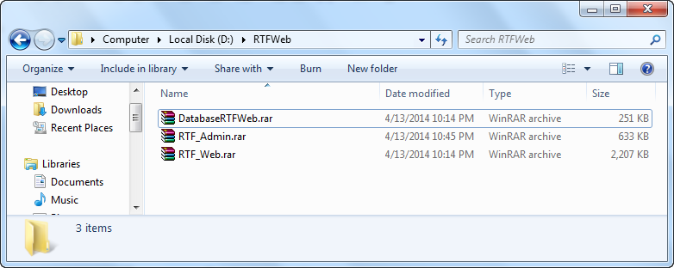

1. **Result** following picture

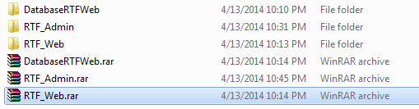

#### Attach Database

1. Open**Microsoft SQL Server Management Studio (SSMS)**
2. Copy two files **RTF_db.mdf** and **RTF_db_log.ldf** to folder:

C:\Program Files\Microsoft SQL Server\ MSSQL10_50.MSSQLSERVER\MSSQL\DATA

Following the below picture.

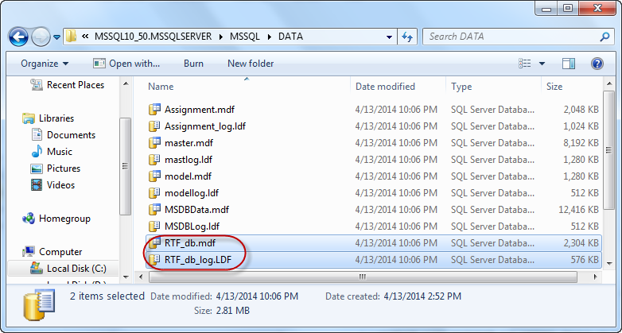

1. Right click on **Database** in left menu **SQL Server 2008,** choose **Attach…**

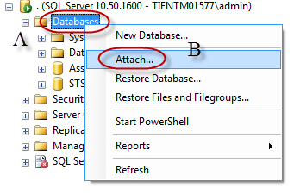

Attach Database windows is open:

1. Click **Add** button
2. Locate Database Files windows is open, choose path database path: C:\Program Files\Microsoft SQL Server\MSSQL 10_50.MSSQLSERVER\MSSQL\DATA\
3. Click **OK** button
4. Click **OK** button

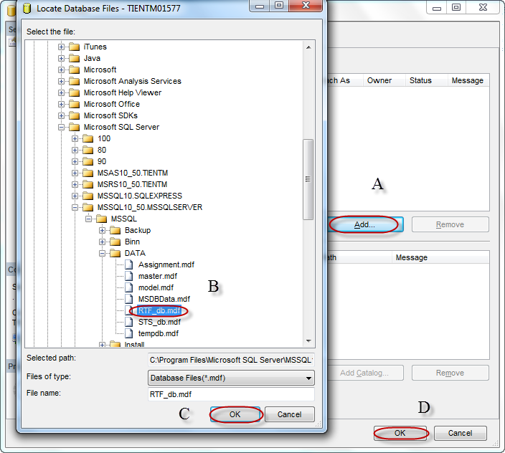

After attach success, the **result** is following below picture.

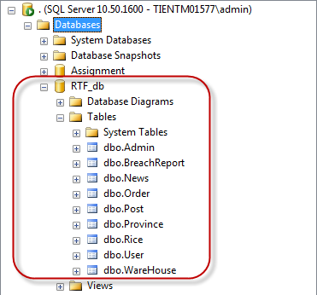

#### Deploy web application

Register ASP.NET with IIS: open command line tool with admin privilege.

Change working folder to C:\Windows\Microsoft.NET\Framework64\v4.0.30319 by using command **“CD C:\Windows\Microsoft.NET\Framework64\v4.0.30319”** with Window 64-bit or **“CD C:\Windows\Microsoft.NET\Framework\v4.0.30319”** with Window 32-bit.

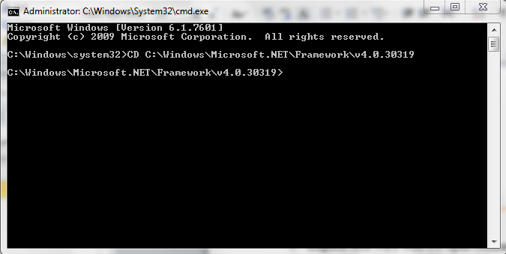

Type **“aspnet_regiis.exe -i”** and press enter to register ASP.NET 4.0 to IIS

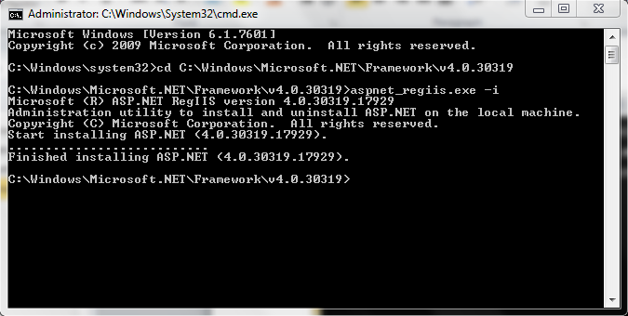

Open IIS Manager by opening start menu, type IIS and press enter, then:

1. Choose: **Application Pools** in the left menu **IIS Manager**
2. Choose: **DefaultAppPool**
3. Click: **Advance Setting**.
4. Choose **.Net Framework Version v4.0**
5. Identify: **Choose LocalSystem**
6. Click **OK** button.

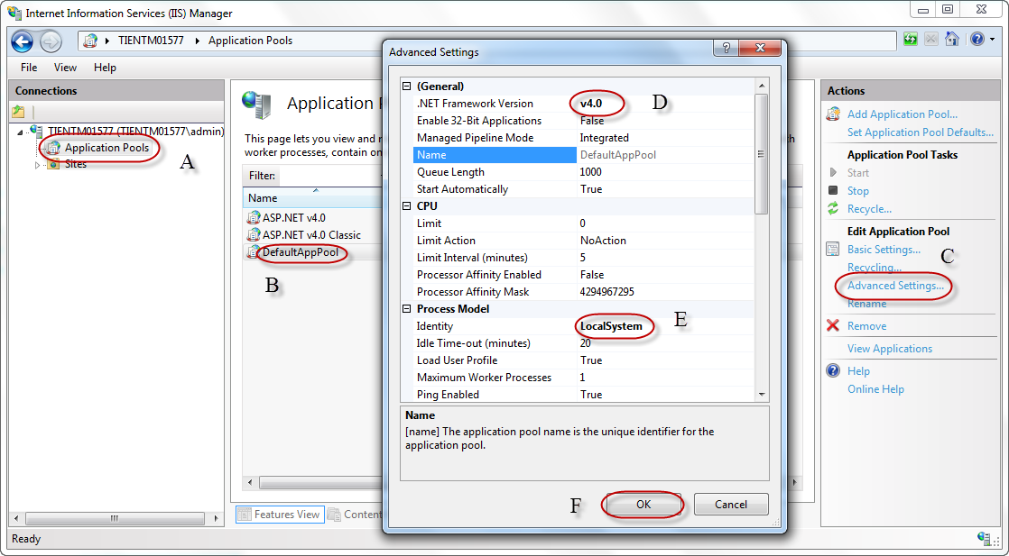

Add a new Web Site:

1. Right click **Sites**
2. Choose **Add Web Site**…

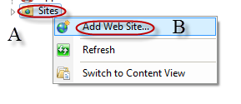

In Add Web Site Windows

1. In Site name: type “RTFWeb”
2. Physical path: is a path that you place your package.
3. Set your port: Example 8081.

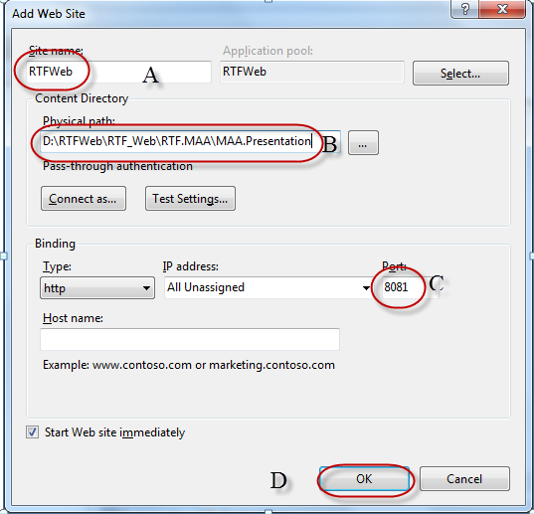

1. After click OK button

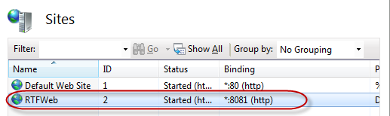

Example: D:\RTFWeb\RTF_Web\RTF.MAA\MAA.Presentation below picture.

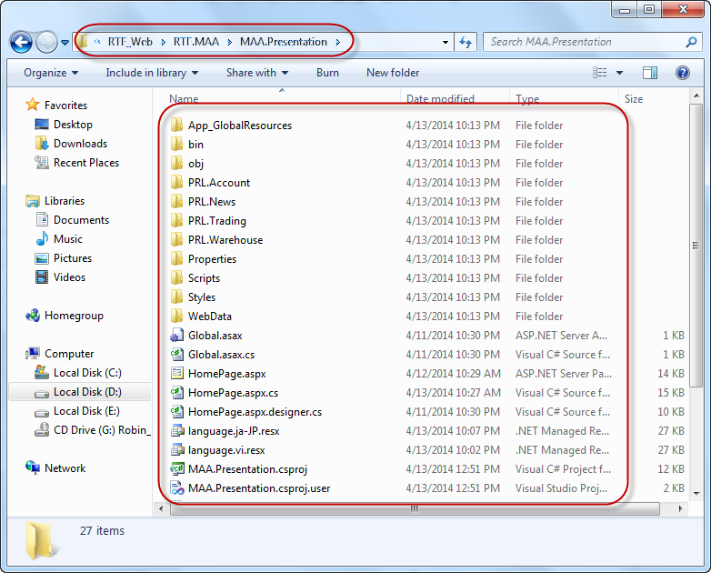

Change Advanced Setting for RTFWeb

1. Choose **Application Pools**
2. Choose **RTFWeb**
3. Click **Advanced Setting**
4. Change **.NET Frameword Version v4.0**
5. Identify: Click “…” at the right
6. Choose: **LocalSystem**
7. Click **OK button**

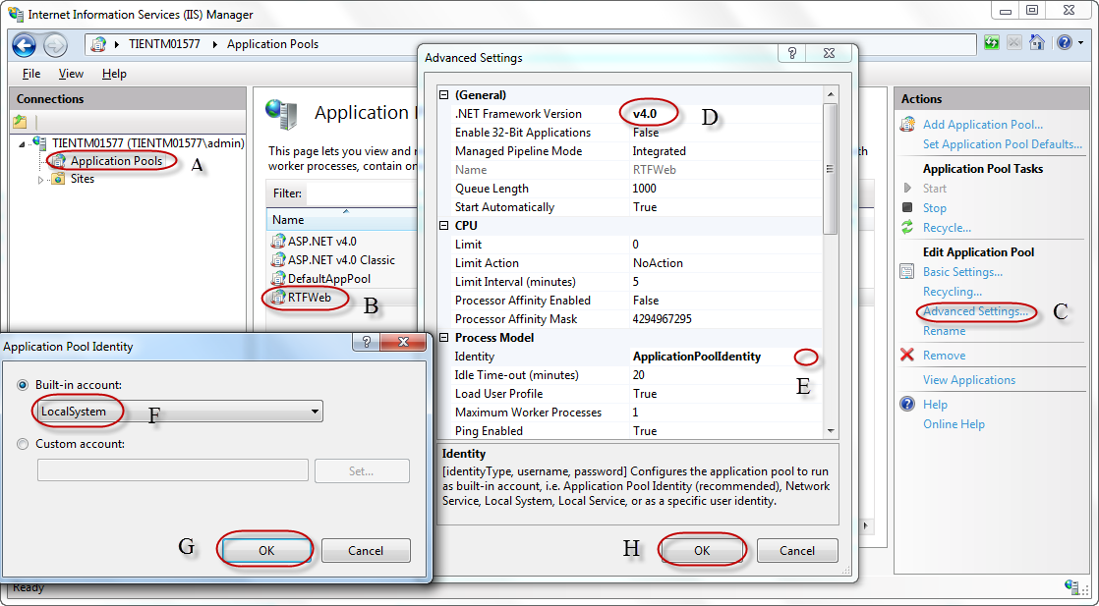

Enable RTFWeb

1. Choose RTFWeb
2. Double click to **Directory Browsing**

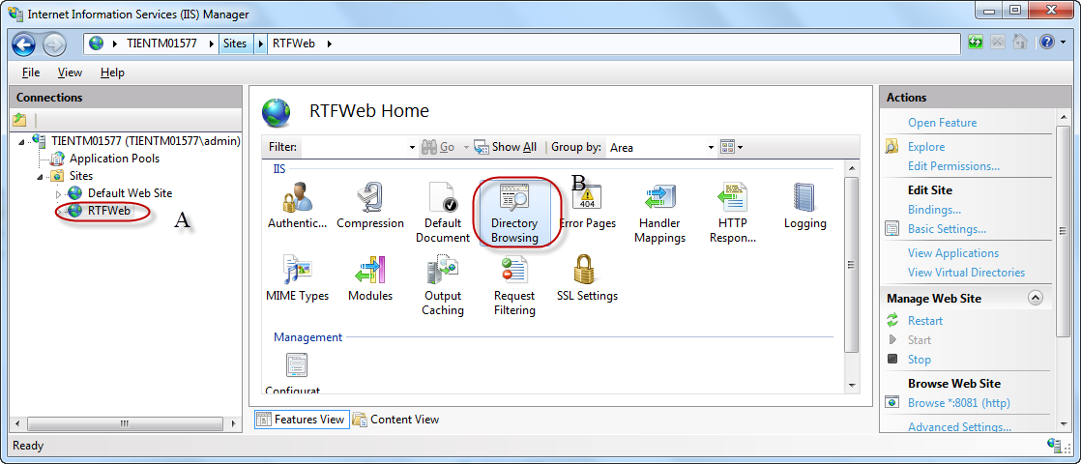

1. Click **Enable**.

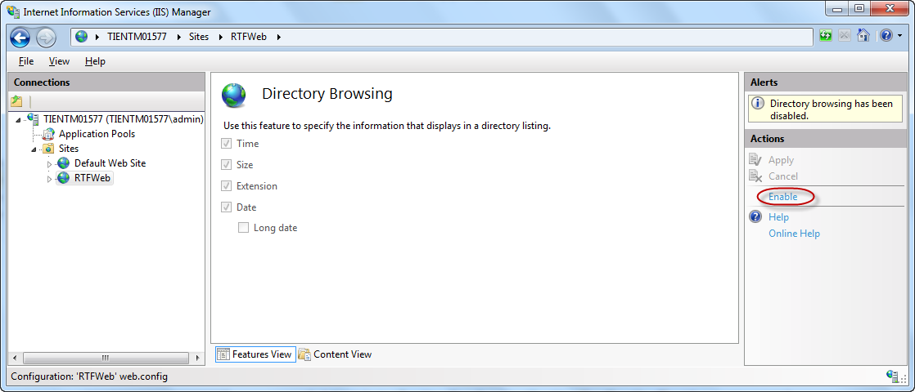

Set default HomePage

1. Choose RTFWeb
2. Double click **Default Document**

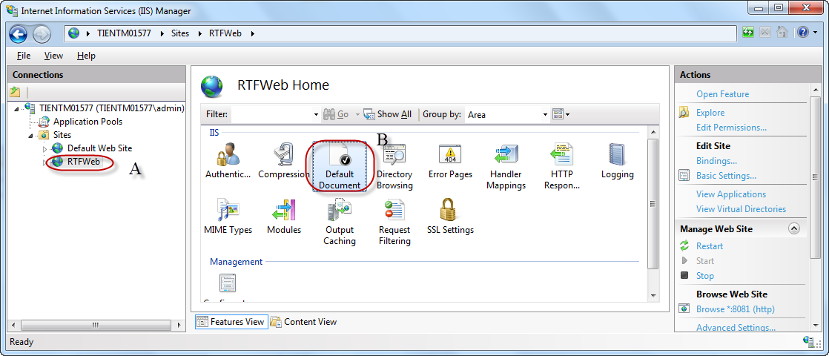

1. Click Add
2. Type **HomePage.aspx**

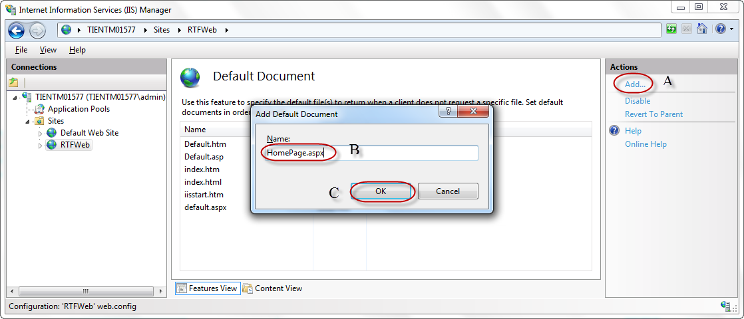

1. Click **Ok button**

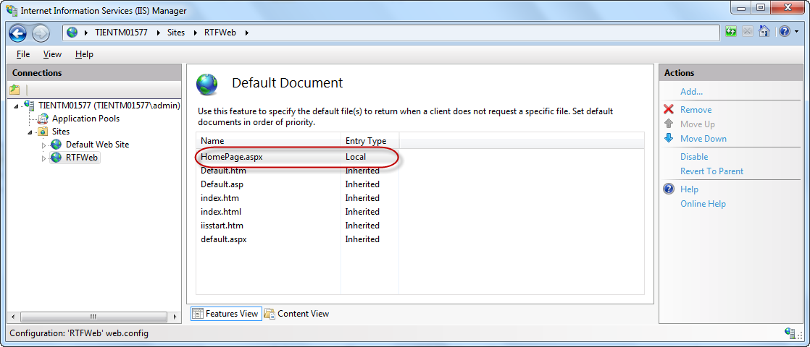

Open RTFWeb Browse

1. Choose RTFWeb
2. Choose **Manage Web Site**
3. Choose **Browse**.

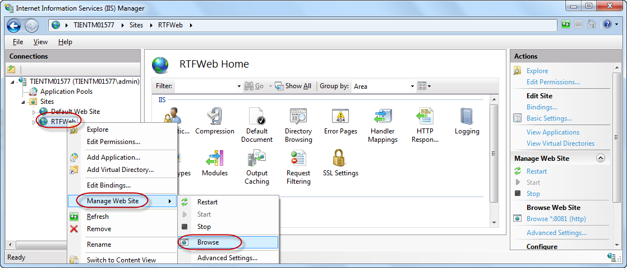

Result:

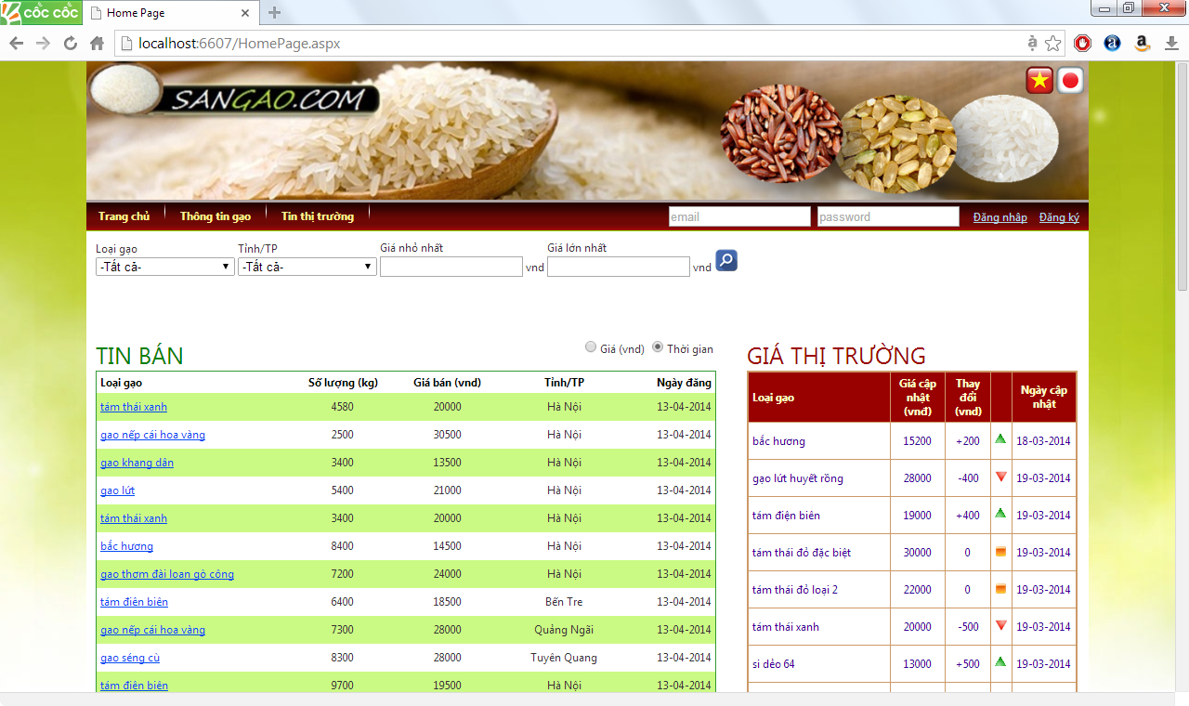

Change system config

Change appSettings.

1. Open Web.config file in your RTFWeb folder.
2. Change information.

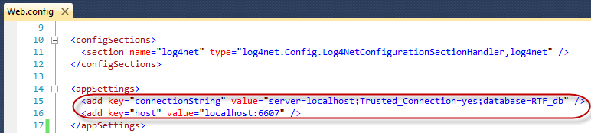

### Setting up the environment at Client side

The system is accessed via web browsers. The client machine should be installed with popular browsers.

### Setup administration application

1. Open your package folder.

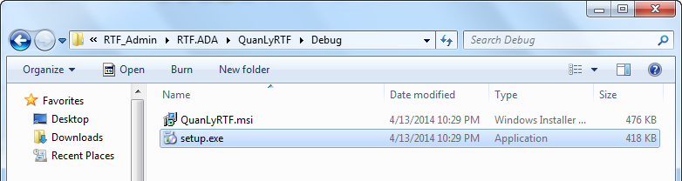

1. Double click to setup.exe file.

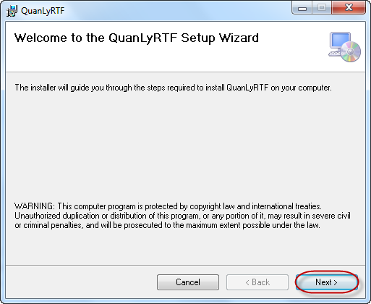

1. Click Next button

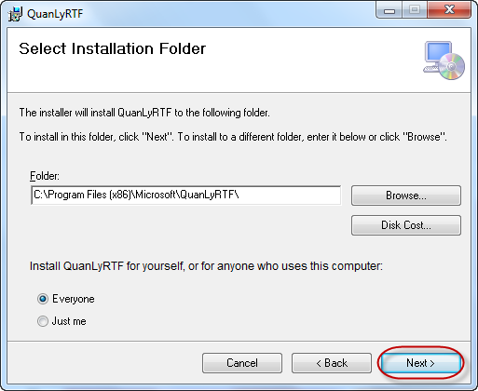

1. Click Next button

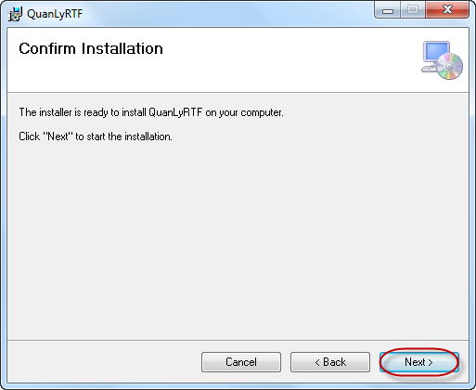

1. Click Next button

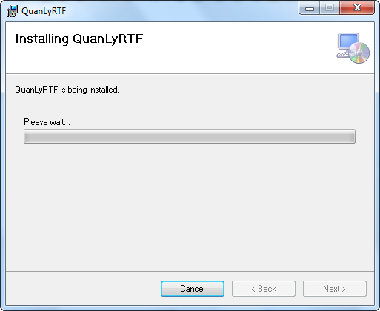

1. Click Close button

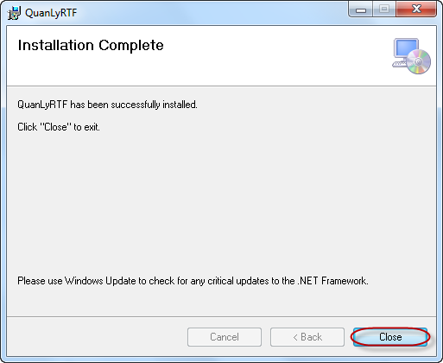***.***

After setup success then go to: C:\Program Files (x86)\Microsoft\QuanLyRTF

1. Run ADA.Presentation.exe

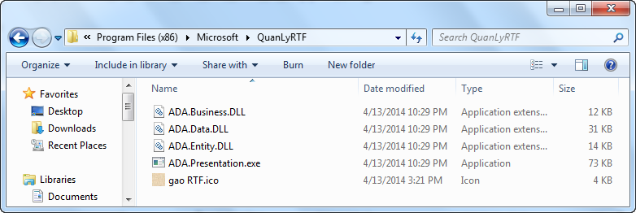

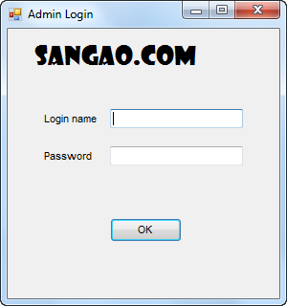

## User Guide

RTF website user guide

Firstly, you will see the start-up screen: Home page

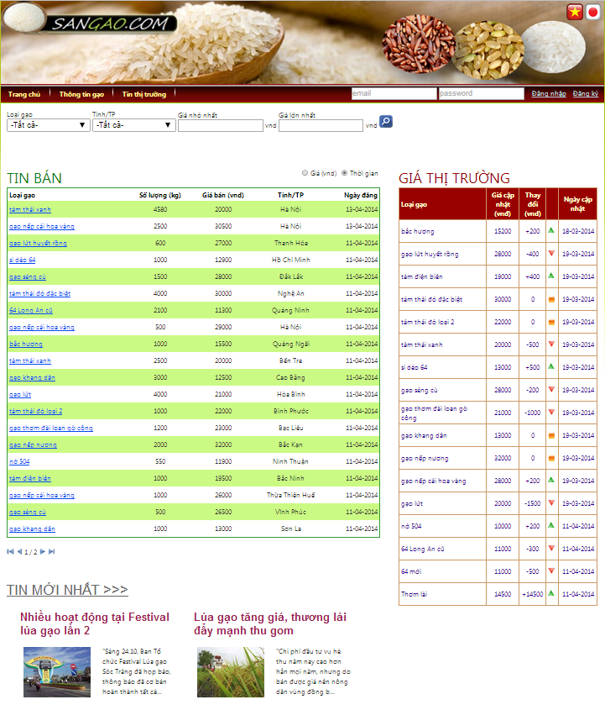

At Home page, you can see:

* All trading selling post on trading floor
* Newest update market price of all rice type on trading floor
* 6 newest market news

You can search selling posts as you want by rice type, province, and price range:

1. Input search condition



1. Click on button 

You can sort selling posts by time or selling price:

1. 

If you want to join trading floor, you must login, or register (see section 2.1.2.1) if you don’t have account. In order to login:

1. Input your email and password



1. Click on link “Đăng nhập”

### Account management

#### Register account

In order to register a new account:

1. At Site master: Click on link “Đăng ký”. The **Registration page** will be redirected to

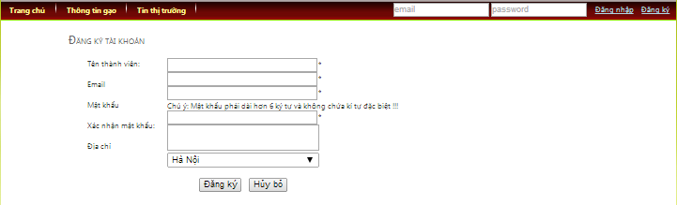

1. Input information.
2. Click on button “Đăng ký”
3. Access your e-mail
4. Click on confirm link

#### Account information

After login the Site master will look as below:

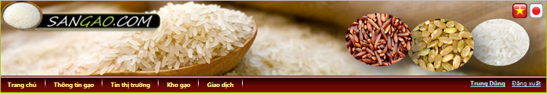

Click on link Account (your name is displayed here) at Site master. The **Account page** will be redirected to as bellow:

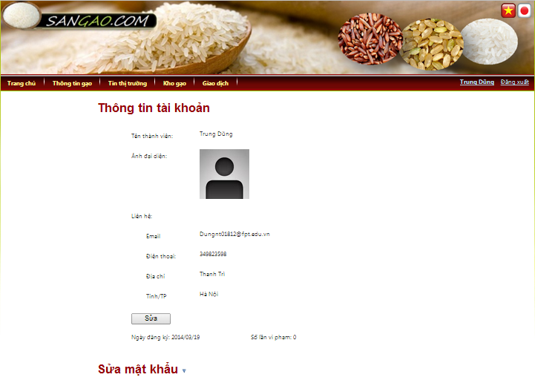

At Account page, you can see your account information

You can modify your information:

1. Click on button “Sửa”

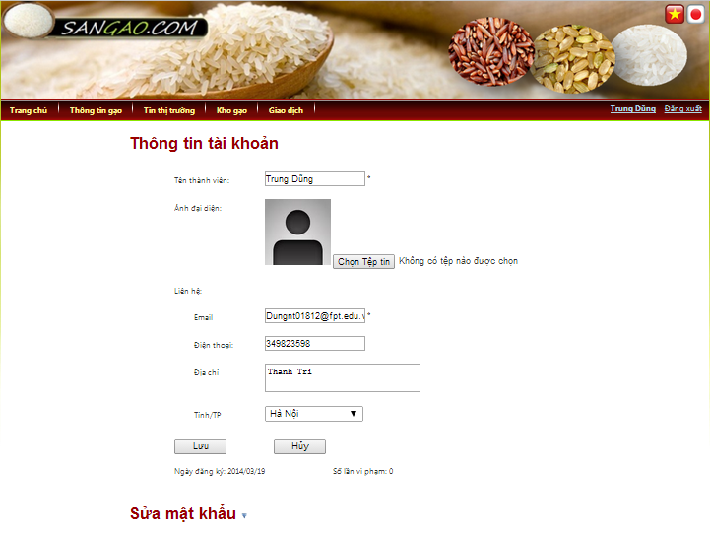

1. Input information
2. Click on button “Lưu”

You can change password:

1. Click on tab “Sửa mật khẩu”

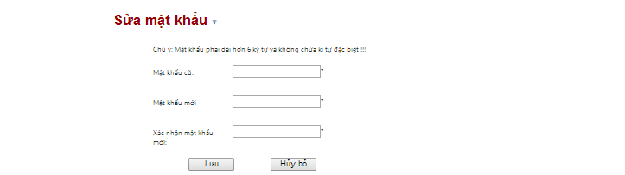

1. Input data
2. Click on button “Lưu”

### Warehouse management

Click on tab “Kho gạo” at Site master. The **Warehouse page** will be redirected to as bellow:

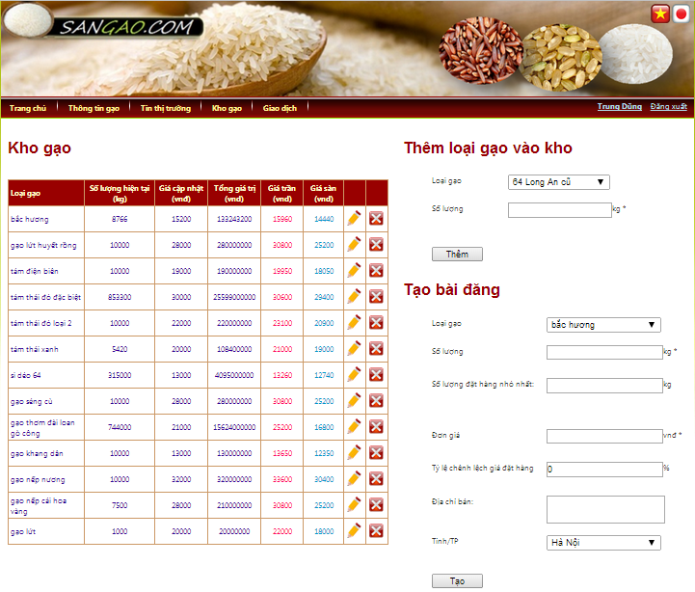

At Warehouse page, you can see your virtual rice warehouse

You can modify amount of rice in warehouse:

1. Click on button 

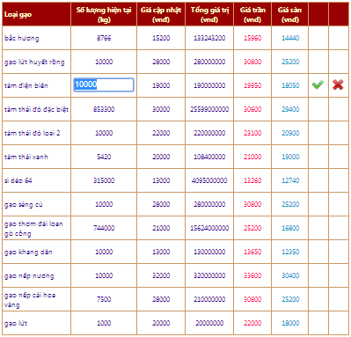

1. Input new amount
2. Click on button 

You can remove a rice type form warehouse:

1. Click on button 

Important notice: if you have trading post with this rice type, you cannot remove that rice type away.

You can add more other rice type (available on trading floor) to warehouse:

1. At tab “Thêm loại gạo vào kho”: Choose rice type & input amount of that rice
2. Click on button “Thêm”

You can create a new selling post (see section 2.1.3.1)

### Trading floor

Click on tab “Giao dịch” at Site master. The **Transaction page** will be redirected to as bellow:

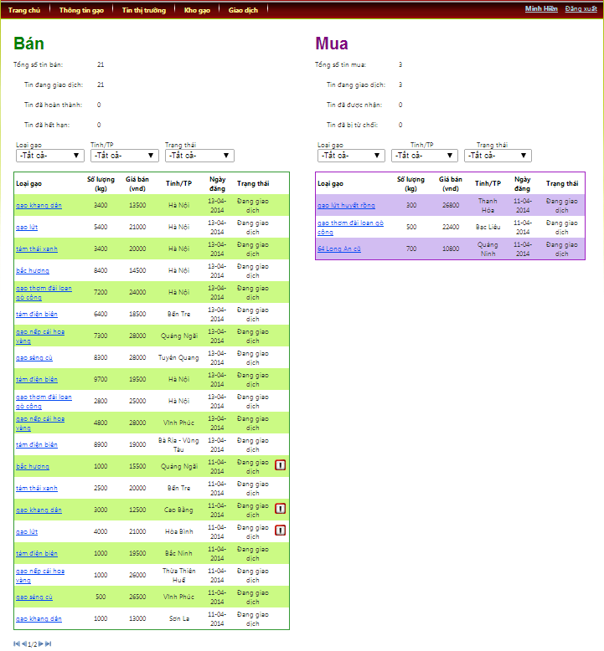

At Transaction page, you can see all of your posts and orders with statistics numbers

You can filter selling posts or orders as you want by rice type, province, and status:

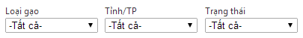

Click on link Rice type of a Post row in Post table at Home page. The **Post information page** will be redirected to as bellow:

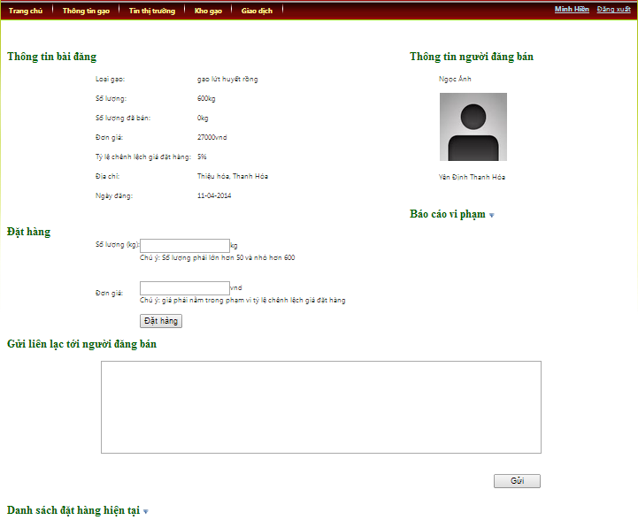

At Post information page, you can see:

* Detail information of a selling post.
* Information of seller
* Order list of that selling post by click on tab “Danh sách đặt hàng hiện tại”:

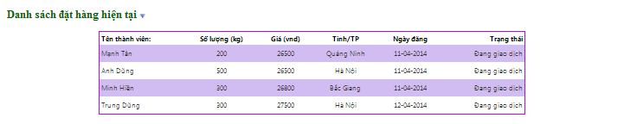

If you have already login and not be the seller of this post, you can use below features:

You can create a new order (see section 2.1.3.2)

You can report the seller is breach:

1. Click on tab “Báo cáo vi phạm”

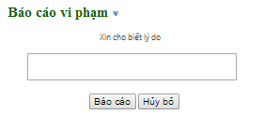

1. Input reason
2. Click on button “Báo cáo”

You can send contact to seller

1. At tab “Gửi liên lạc tới người đăng bán”: Input message content
2. Click on button “Gửi”

#### Process post

In order to create a new selling post:

1. At tab “Tạo bài đăng” of Warehouse page: Input information of post

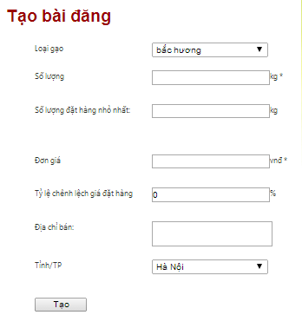

1. Click on button “Tạo”

Click on link Rice type of a Post row in Post table at Transaction page. The **Post page** will be redirected to as bellow:

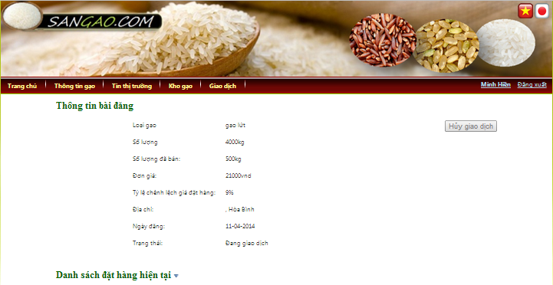

At Post page, you can see detail information of your selling post.

More, you can see order list of that selling post by click on tab “Danh sách đặt hàng hiện tại”:

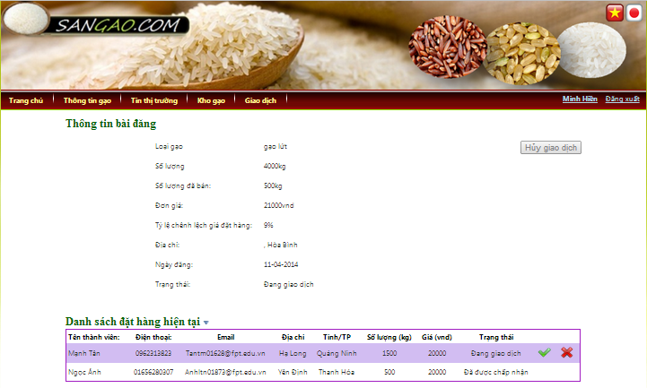

You can cancel transaction of this selling post:

1. Click button “Hủy giao dịch”

Important notice: if order list has pending order, you cannot cancel this post right now.

You can perform transaction, decide to accept or reject order (see section 2.1.3.3)

#### Process order

In order to create a new order:

1. At tab “Đặt hàng” of Post information page: Input amount and price of order

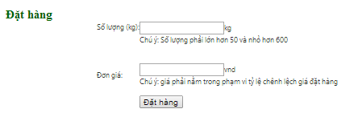

1. Click on button “Đặt hàng”

Click on link Rice type of an Order row in Order table at Transaction page. The **Order page** will be redirected to as bellow:

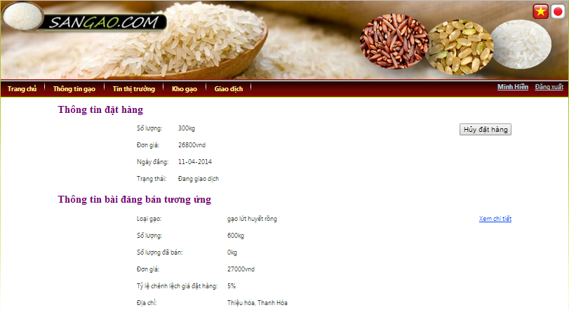

At Order page, you can see detail information of your order and the corresponding selling post.

You can cancel this order:

1. Click button “Hủy đặt hàng”

Important notice: if the seller has already performed transaction with this order, you cannot cancel this order.

#### Process transaction

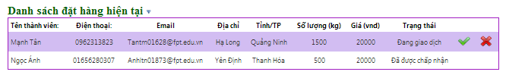

In order to accept transaction with an order:

1. At tab “Danh sách đặt hàng hiện tại” of Post page: Click button 

In order to reject transaction with an order:

1. At tab “Danh sách đặt hàng hiện tại” of Post page: Click button

### View news

#### View rice information

Click on tab “Thông tin gạo” at Site master. The **Rice information page** will be redirected to as bellow:

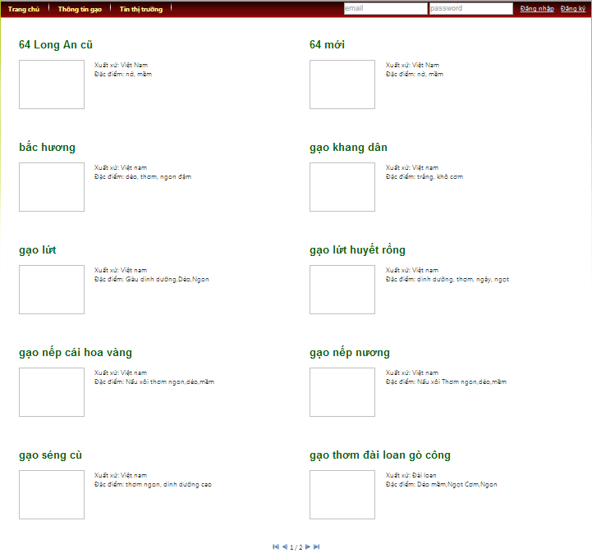

At Rice information page, you can see all rice type of market that available on trading floor

#### View market news

Click on tab “Tin thị trường” at Site master. The **Market news page** will be redirected to as bellow:

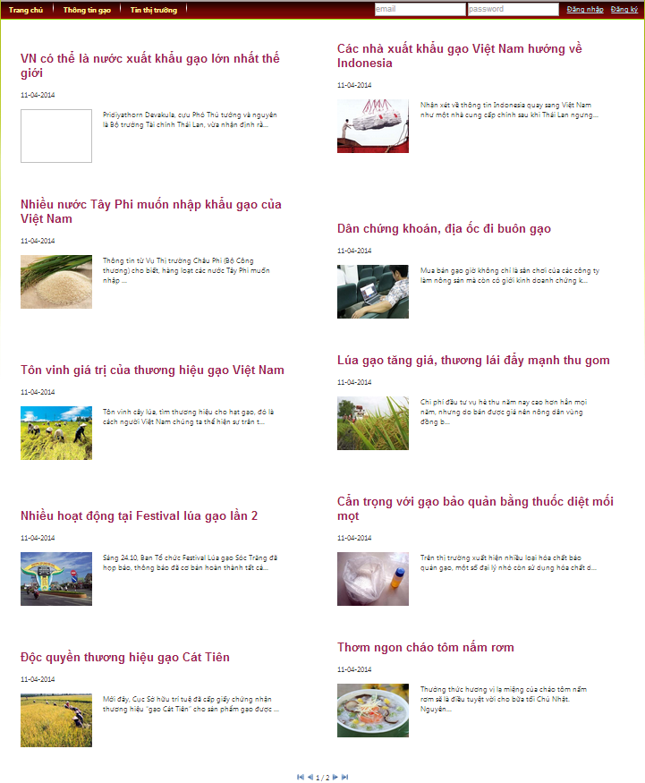

At Market news page, you can see all market news sorted by posted date.

# Reference

**Software Project Management**

1. Template Template_Project_Plan, (2010), FPT University, Hanoi, Vietnam.
2. Ian Sommerville, Software Engineering, 8th edition, (2007), USA.
3. Kathy Schwalbe, Managing Information Technology Projects, 6th edition, Cengage Learning, (2009), Canada.
4. Rational Unified Process - *Best Practices for Software Development Teams*, Rational Software Corporation (1998), Canada.
5. Standard ASP Coding Convention, version 1.0, (2003/10/15), FPT Software, Hanoi, Vietnam.
6. Standard CSharp Coding Convention, version 1.1, (2013/05/10), FPT Software, Hanoi, Vietnam.
7. <http://en.wikipedia.org/wiki/IBM_Rational_Unified_Process>
8. <http://en.wikibooks.org/wiki/RUP_-_IBM_Rational_Unified_Process/Phases>
9. <http://msdn.microsoft.com/en-us/library/ff926074.aspx>

**Software Requirement Specification**

1. Template Software_Requirements_Specification, (2010), FPT Software, Hanoi, Vietnam.

**Software Design Description**

1. Template Software_Design_Template, (2010), FPT Software, Hanoi, Vietnam.
2. Internal_Design_Template, FPT Software, Hanoi, Vietnam.
3. Kai Qian, Software Architecture and Design Illuminated, Jones & Bartlett Learning, (2010), USA.

**Software Test Documentation**

1. Templates for Test case & Defect log, FPT Software, Hanoi, Vietnam.